The Cavaticcio Hydroelectric Power Plant is located near Via Riva di Reno in Bologna, and is a fascinating example of the city's hydraulic and industrial history.
⚡ The Cavaticcio Hydroelectric Power Plant
- Location: It is located in the basement of Largo Caduti del Lavoro , an area that extends between Via Marconi and Via Azzo Gardino, where the ancient port of Bologna once stood.
- Function: It exploits a natural drop of approximately 15 metres in the Cavaticcio Canal to generate clean electricity (hydroelectric).
- Historical Importance: The Cavaticcio Canal, a branch of the Reno Canal, is crucial: before electricity, this waterway powered mills and artisanal/proto-industrial machinery, contributing to the city's prosperity. The modern power plant continues to exploit this historic resource.
- Power: The maximum power of the plant is 1890 kW , with an estimated production of millions of kWh per year.
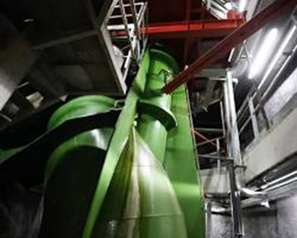
[SPLIT_BLOCK:Turbina_Centrale_Cavaticcio.jpg]

🛶 The Cavaticcio Canal and the Ancient Port
The name of the power plant derives from the Cavaticcio Canal , a short but crucial canal in the Bologna hydraulic system:
- Route: The Cavaticcio branches off from the Reno Canal under Via Riva di Reno and, after the waterfall that feeds the power plant, reaches the area of the ancient port (now Largo Caduti del Lavoro, near the Salara), to then continue under the name of Canale Navile , which was the waterway for the transport of goods towards the north-east.
- History of the Canal: Until the 1930s, much of the Cavaticcio was uncovered. Subsequently, it was gradually filled in for urban planning reasons, particularly during construction work to open Via Roma (now Via Marconi).
- The Port: The area where the power plant is located today, between the Salara and the current Cavaticcio Park, was the ancient Port of Bologna , the terminal point of the Navile Canal.

🏗️ The Central Today
- Management and Ownership: The work was carried out by the Municipality of Bologna and is currently owned and managed by the Consortium of the Casalecchio Dam and the Reno Canal .
- Revamping: The plant has undergone major restoration and modernization (revamping) in recent years, to bring it up to the most modern technological standards and maximize clean energy production.
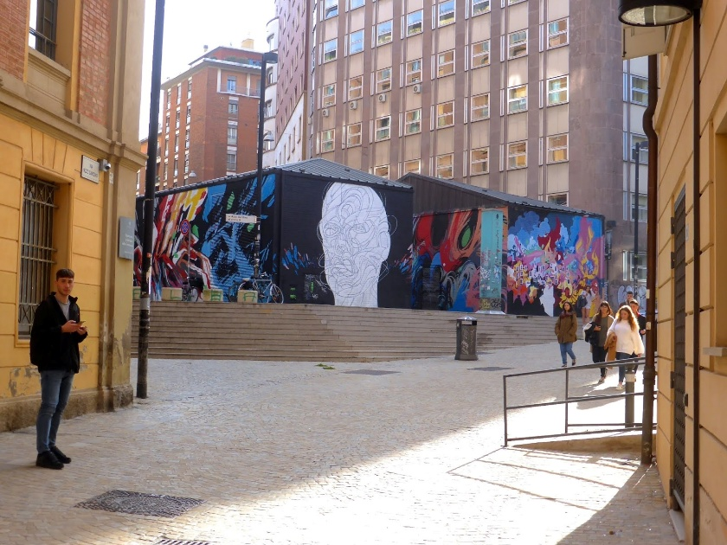
[SPLIT_BLOCK:Edificio_Centrale_Cavaticcio.jpg]

💡 Curiosity
The Cavaticcio Power Plant is sometimes cited as one of the very few, if not the only, hydroelectric plant of this size located in the historic center of a European city.

Would you like to know the opening times and visiting methods (for example, to the underground passages of the ancient port and the canals) organized by the Consorzio dei Canali di Bologna?
Absolutely! Visiting the Cavaticcio Power Plant and, especially, the underground canals is a highly sought-after experience, as it allows you to discover Bologna's hidden hydraulic heart.
Here are the main visiting options, managed by the Casalecchio Dam and Reno Canal Consortium (Bologna Canals):
🏛️ Visits to the Cavaticcio Hydroelectric Power Plant
A visit to the power plant itself (the underground engine room) is usually possible in two ways :
- Visits for Organized Groups:
  - The power plant can be visited by reservation for private groups (generally at least 10 people).
  - For information on availability and rates, please contact the Consorzio dei Canali di Bologna directly.
- Special Visits (Occasional Events):
  - The plant is open to the public on special occasions, such as the European Researchers' Night or other thematic events organized by the Consortium.
  - These events have limited places and require reservations. It's essential to check the "News" or "Events" section on the Canali di Bologna website to ensure you don't miss out.
Booking contacts:
- Email : ordini@canalidibologna.it
- Telephone: 389.5950213 (Generally Mon - Thu 8.30-12.00, Fri 8.30-12.30)
🛶 "The Underground of Bologna" - Porto Experience (Canale Cavaticcio)
Although the power plant can be visited upon request, the Cavaticcio Canal and ancient port area is often included in the more popular underground canal tour.
- Special Period ("Secca"): Visits to the underground canals (both the Canale Reno/Moline and the Cavaticcio) take place in a massive and organised way only once a year, during the period in which the water supply to the canals is interrupted for maintenance (the so-called "secca"), which usually falls in autumn (often between October and November).
- "Porto Experience" Itinerary: This specific tour allows you to descend from the Salara (the ancient Salt Warehouse) and explore the underground section of the Cavaticcio Canal , retracing the history of the ancient port of Bologna.
- Reservations: Reservations for the "Undergrounds of Bologna" open well in advance of the fall event, and they sell out quickly. You should monitor the Canali di Bologna or Bologna Welcome websites for exact dates and when reservations open.

Other Visit Options
The Canali di Bologna Consortium also organizes:
- Opificio delle Acque: A permanent museum/documentation center on the city's hydraulic history, occasionally offering special tours of the underground room containing the remains of the former hydroelectric plant. It is located at Via Monaldo Calari , 15.
- Surface Tours: Guided walks along the route of the exposed and covered canals (such as the Reno Canal tour), which include an external view of the Cavaticcio Power Station.
I highly recommend visiting the official Canali di Bologna website for the latest events and reservations, especially for underground tours in the fall!

Tabella delle Fonti e Certificazione
Affermazione del testo | Fonte Certificata
The Cavaticcio Hydroelectric Power Plant is located underground at Largo Caduti del Lavoro and utilizes a 15-meter waterfall to generate energy with a maximum capacity of 1890 kW. | Consorzio dei Canali di Bologna
The Cavaticcio Canal branches off the Reno Canal under Via Riva di Reno, powers the plant, and continues to the ancient Port (near the Salara) becoming the Navile Canal. | Historical Archive of the Municipality of Bologna / Canali di Bologna
Most of the Cavaticcio Canal was progressively covered starting in the 1930s for urban development during the construction of Via Roma (now Via Marconi). | Historical Cartography and Urban Plans of Bologna
The facility is managed by the Consorzio della Chiusa di Casalecchio e del Canale di Reno and can be visited by reservation or during the autumn maintenance drain ("secca"). | Consorzio dei Canali di Bologna / Opificio delle Acque

