The Church of San Benedetto in Bologna
Line spacing: 1.15
The Church of San Benedetto in Bologna, located on Via Indipendenza, has a long and complex history:
- Origins: Its origins date back to the 13th century (some documents mention it as a parish as early as 1202). It was initially located just outside Bologna's second ring of city walls.
- 17th-Century Reconstruction: It was completely rebuilt in 1606 based on a design by Giovanni Battista Ballerini. During this period, it was officiated by the Minim Friars of St. Francis of Paola (known as the "Paolotti"), to whom it had been assigned in 1529.
- Original Orientation: Until the end of the 19th century, the church faced Via Galliera, where the ancient facade (later remodeled in 1932) flanked by the bell tower is still visible today.
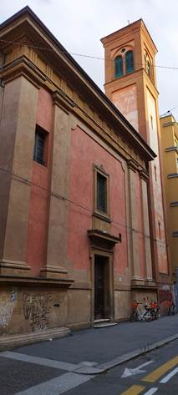
[SPLIT_BLOCK:san_benedetto_galliera.jpg]
- The Opening of Via Indipendenza: The major transformation took place in 1892 with the opening of the new Via dell'Indipendenza. To adapt to the new urban layout and the new street, the orientation of the church was reversed: the apse became the new facade, which was rebuilt with the addition of a portico.
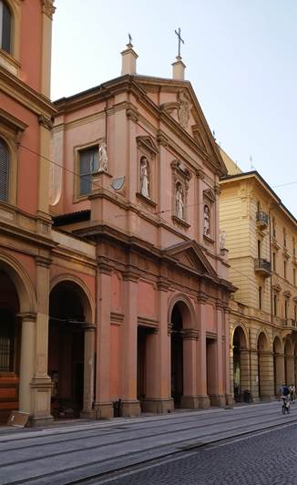
[SPLIT_BLOCK:san_benedetto_indipendenza.jpg]

- Interior: Despite the external transformations, the interior preserves important works by leading artists of the Bolognese Manierism and Baroque periods, including paintings by Giacomo Cavedoni, Alessandro Tiarini, and Lucio Massari.
In summary, the current appearance of the church is the result of its 17th-century reconstruction and the radical reorientation at the end of the 19th century, when it was "turned around" to face the modern Via Indipendenza.

Curiosities and Anecdotes
In addition to its architectural significance, the church holds unique stories. The 1892 transformation represented a true urban "flip": the original entrance on Via Galliera became the back wall of the altar, while the apse was demolished to make room for the new facade on Via Indipendenza. Furthermore, the complex was historically managed by the Minim Friars (called "Paolotti"), famous in Bologna for their strict dietary rule that forbade meat and animal products, forcing them to invent ingenious "lean" recipes in the heart of the ultimate gastronomic city. Despite the severe bombings that hit the area in 1943, the precious internal paintings were miraculously saved.

Tabella delle Fonti e Certificazione
Affermazione del testo | Fonte Certificata
The origins of the Church of San Benedetto date back to the 13th century (cited as a parish in 1202) and it was rebuilt in 1606 based on a project by Giovanni Battista Ballerini. | Bologna Online / Salaborsa Library
With the opening of Via Indipendenza in 1892, the church's orientation was reversed: the original entrance on Via Galliera became the altar backwall and the apse was replaced by a new facade with a portico. | Historical Archive of the Municipality of Bologna / Historical Cartography
From 1529, the church was served by the Minim Friars of St. Francis of Paola (known as "Paolotti"), renowned for their strict dietary rules. | Historical-Religious Dictionary of Bologna
The interior houses prominent Mannerist and Baroque paintings by artists such as Giacomo Cavedoni, Alessandro Tiarini, and Lucio Massari, which survived WWII bombings in 1943. | Ministry of Culture - Superintendence of Artistic Heritage Bologna

