The wooden building in Via del Porto: A work by Aldo Vandini
Welcome to Via del Porto 11. In front of you stands one of the most significant examples of sustainable architecture in the heart of Bologna. This building, designed by architect Aldo Vandini, represents a successful challenge: integrating a modern and technologically advanced structure into a stratified historical context.
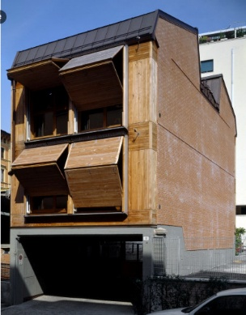
[SPLIT_BLOCK:stable-wooden-washbasins-one]
Made with a wooden load-bearing structure (X-technologyLam), the building stands out for its high energy performance and the use of natural materials. Aldo Vandini wanted to create a "material dialogue": the warmth of wood inside and an external facade which, despite being contemporary, respects the rhythms and proportions of the surrounding Bolognese buildings.

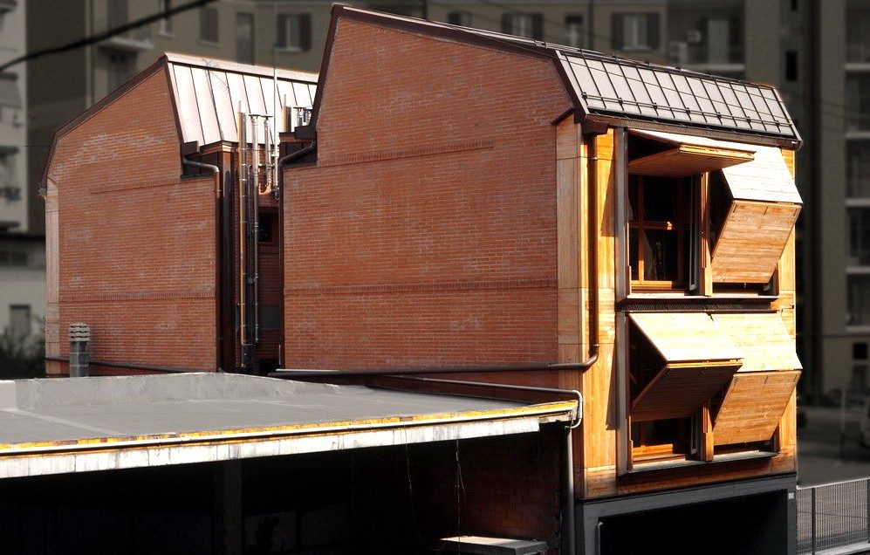
[SPLIT_BLOCK: image_name_two.jpg]
Despite the solid and perfectly integrated appearance, the choice of wood allowed for rapid construction and minimized environmental impact. It is a building that "breathes", capable of maintaining an ideal temperature in every season without wasting energy, demonstrating thatAlsoin the historic center you can build while looking to the future of the planet.
The technologyX-Lam(also known asCLT, from EnglishCrossesLaminatedTimber) represents one of the most significant innovations in the field of sustainable construction. It is a construction system based on cross-laminated solid wood laminated panels.

How an X-panel is madeLam?
An X-panelLamit is composed of several layers (usually 3, 5 or 7) of conifer wood boards (often fir), dried and overlapped so that the grain of each layer isrotated 90°compared to the adjacent one. The layers are then glued together under strong pressure.
This "crossed" configuration gives the material exceptional properties:
- Dimensional stability:The variations in the wood due to humidity are canceled out by the orthogonal arrangement of the layers.
- Mechanical resistance:The panel can withstand very high loads, behaving like a rigid "slab", similar to reinforced concrete but much lighter.

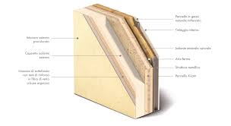
[SPLIT_BLOCK: X-Lam technology.jpg]

{replace this phrase delimited by curly brackets(including curly braces)with the text of the document that needs to be placedbetween the second and the thirdimage}

The main advantages
The use of theLamis revolutionizing the way of building for several reasons:
- Sustainability:The wood seizesCO₂instead of emitting them during production. It is a renewable resource and requires much less energy to process than steel or concrete.
- Seismic Safety:Thanks to the natural elasticity of the wood and the ability of the mechanical joints to dissipate energy, the structures inLamthey are among the safest in the event of an earthquake.
- Fire Resistance:Contrary to popular belief, solid wood burns slowly and predictably. The outer carbonized layer protects the panel core, maintaining load-bearing capacity longer than a steel beam.
- Construction speed:The panels arrive at the construction site already cut to size (thanks to precision CNC machinery) with holes for doors and windows. This allows the structure of a house to be assembled in just a few days.

Areas of application
While in the past wood was limited to cabins or small buildings, theLamtoday allows the construction of:
- Multi-storey buildings:There are already wooden skyscrapers that exceed 20 floors.
- Schools and public facilities:Thanks to the excellent thermal and acoustic performance.
- Superelevations:Being lightweight, it is perfect for adding floors to existing buildings without overloading the foundation.
In summary, theLamit is considered the "concrete of the future", combining the strength of massive structures with the flexibility and warmth of wood.

Who was Aldo Vandini?
Aldo Vandini was an important Italian architect and urban planner, whose activity was concentrated mainly in the second half of the twentieth century, leaving a significant imprint especially on the urban fabric ofBologna.
His figure is closely linked to a vision of architecture understood ascivil serviceand social redevelopment tool, often operating in contexts of public housing and urban planning.

Areas of Intervention and Style
Vandini interpreted the language of Modernism filtering it through the practical needs of the post-war period and the urban growth of the 60s and 70s. Its distinctive features include:
- Functional Rigor:An approach that favors the rationality of spaces and the solidity of materials.
- Participatory Urban Planning:Particular attention to the integration of the buildings into the pre-existing social context, avoiding the "cathedral in the desert" effect.
- Typological experimentation:The search for new forms of collective living that would guarantee dignity and services to the inhabitants.
Significant Works and Projects
Although his signature appears in numerous master plans and technical consultancy, some Bolognese projects define his career:
- The Barca District:He collaborated on one of the most ambitious urban planning projects in Bologna, initially coordinated by Giuseppe Vaccaro. Vandini contributed to the definition of this self-sufficient "piece of the city".
- Public Residential Construction:He was a key figure for the Istituto Autonomo Case Popolari (IACP), designing complexes that sought to overcome the concept of "dormitory" through the inclusion of greenery and common spaces.
- Restoration and Conservation:In addition to the new construction, Vandini dealt with the protection of the architectural heritage, participating in the debate on the recovery of historic centres.

A Civil Heritage
Aldo Vandini is not only remembered for individual buildings, but for his commitment to themprofessional institutions. He has long been active in the Order of Architects, fighting for the quality of the project as a citizen's right and for transparency in building processes.
His work represents that trend of Italian architecture capable of combining the aesthetics of concrete and brick with a profound ethic of building.

