The Basilica of Santa Maria Maggiore, located at Via Galliera 10, is considered the oldest church in Bologna dedicated to the Virgin Mary. It is a place of great charm that blends Early Christian origins with an imposing Baroque appearance.
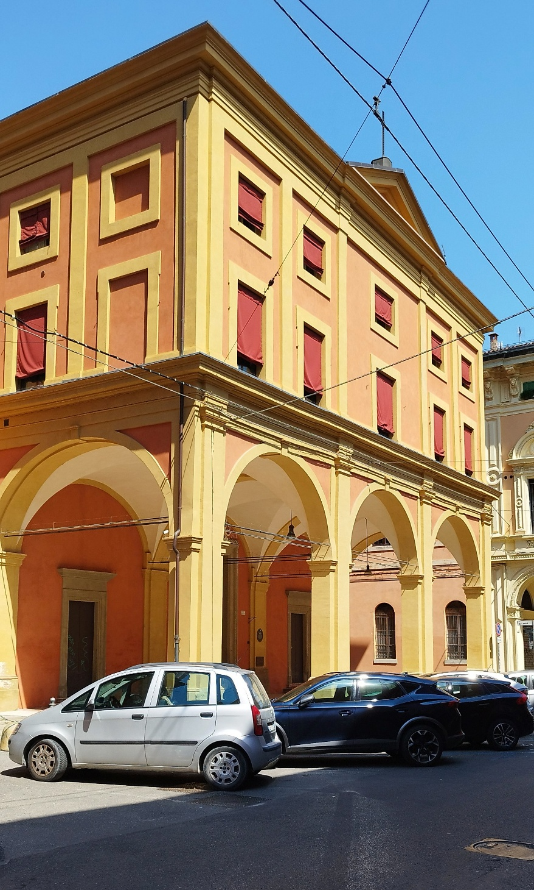
[SPLIT_BLOCK:basilica.jpg]

History and Architecture
- Ancient Origins: Tradition and papal bulls (such as the one by Pope Gregory VII) suggest that a church existed here as early as the 5th or 6th century AD. It originally stood directly along the cardo maximus of the Roman city.
- Reconstructions and Romanesque Phase: It was rebuilt in Romanesque style during the 12th century (officially consecrated in 1187) and became the seat of an important Collegiate Chapter of Canons.
- Current Appearance: The majestic interior we see today is the result of a major transformation in 1665 by the architect Paolo Canali, who replaced the old wooden trussed ceiling with a grand Baroque barrel vault.
- The Facade: It is characterized by a portico with three arches. The upper portion, featuring the triangular pediment, was only completed in recent times, in 1955.
- Recent Restoration (Post-Earthquake): Severely damaged by the Emilia earthquake in 2012, the basilica remained closed for years. Following major structural consolidation and fresco restoration, it was reopened for worship in November 2019.
Notable Artworks and Interior Picture Gallery
The interior, structured into three naves, is a true art gallery of Bolognese painting and sculpture from the Renaissance to the 19th century:
- The Vault: Decorated between 1936 and 1938 by the Valtellina painter Eliseo Fumagalli, it features a grand illusionistic perspective (sfondato) simulating an open sky populated by hosts of angels.
- Altarpiece of the Assumption (in the Choir): Begun by Giovanni Francesco Bezzi (known as Il Nosadella) and completed by Prospero Fontana.
- Pictorial Heritage: Houses precious canvases by masters such as:
  - Orazio Samacchini
  - Prospero Fontana
  - Alessandro Tiarini
  - Vincenzo Spisanelli
  - Mauro Gandolfi
  - Alessandro Guardassoni
- Chapel of the Blessed Sacrament: Notable for its refined stucco decorations created by Angelo Gabriello Piò, a famous 18th-century Bolognese sculptor.
- The Fig Tree Crucifix: An ancient wooden crucifix that tradition dates back to before the year 1000 (attributed to the 12th–13th century).
- The Stone Cross: An ancient stone road cross, discovered during archaeological excavations beneath the sub-floor, is preserved inside, testifying to the site's ancient and uninterrupted sacredness.
Anecdotes, Trivia, and Historical Insights
- The Mystery of the Fig Wood: Devotional tradition refers to the crucifix as the "Crocifisso di Fico" because it was carved from fig wood. In artistic and botanical terms, this is an extremely rare wood to carve due to its soft, spongy fibers; in early Christian symbolism, the fig tree recalls the Tree of Knowledge and the link between the Old and New Testaments, bestowing a unique spiritual significance upon the work.
- The Roman Cardo Beneath the Floor: During post-earthquake restoration work, archaeological investigations beneath the flooring confirmed the layout of the ancient Roman cardo maximus paving, upon which the early Christian community chose to build this pillar of Marian devotion in Bologna.
- Unfinished Facade for Three Centuries: For nearly three hundred years following Canali's Baroque intervention (1665), the church featured a stunning street-level portico with three arches, but its upper section remained raw exposed brick until its final completion in 1955.
Sources Used and Certified
- Origine di Bologna: Project by the Municipality of Bologna documenting the history of historical streets and buildings (sheet for Via Galliera 10).
- Bologna Online - Biblioteca Salaborsa: Digital archive of Bologna's central library.
- Storia e Memoria di Bologna: Official municipal portal for historical heritage.
- BeWeB (Beni Ecclesiastici in Web): Official census of the Italian Episcopal Conference (CEI).
- Official Basilica Website: Documentation regarding the post-2012 earthquake restorations and 2019 reopening.

Tabella delle Fonti e Certificazione
Affermazione del testo | Fonte Certificata
The Basilica of Santa Maria Maggiore at Via Galliera 10 is the oldest church in Bologna dedicated to the Virgin, built on the Roman cardo (5th-6th cent.) and reconsecrated in 1187. | Bologna Online / Salaborsa Library / BeWeB CEI
The Baroque transformation with barrel vault was carried out in 1665 by architect Paolo Canali; the upper pediment of the facade was completed in 1955. | Origine di Bologna (Municipality of Bologna) / Historical Archive
The church reopened in November 2019 following structural consolidation and restorations required after the 2012 earthquake. | Official Basilica Website / Post-Earthquake Restoration Records
Houses the Assumption Altarpiece (Nosadella and Prospero Fontana), frescoes by Eliseo Fumagalli (1936-38), stuccos by Angelo Gabriello Piò, and paintings by Samacchini, Tiarini, Spisanelli, Gandolfi, and Guardassoni. | Ministry of Culture - Superintendence of Artistic Heritage Bologna
Preserves the ancient "Fig Tree Crucifix" (dating back to before the year 1000) and an ancient stone road cross discovered during sub-floor excavations. | Storia e Memoria di Bologna / BeWeB CEI

