The Sanctuary of the Madonna della Pioggia , whose full name is Sanctuary of San Bartolomeo di Reno or Madonna della Pioggia and is located at the intersection of via Galliera and via Riva di Reno in Bologna.
Here are some key information:
- Origin: It was originally known as the Church of San Bartolomeo di Reno and dates back to the 13th century as an Oratory.
- Name: The nickname "Madonna della Pioggia" (Our Lady of the Rain) derives from an event in 1561, when a procession carrying the statue of the Madonna was associated with the end of a severe drought that had struck Bologna, bringing beneficial rains. Following this miraculous event, it was dedicated to the Saint and the Madonna.
- Structure and Works: The church, which has undergone several renovations over the centuries, features a façade preceded by a portico with three arches. It houses works of art by artists such as Agostino Carracci, Francesco Monti, Ludovico Mattioli (his fresco Landscape with Saint Bartholomew is located on the eighteenth-century staircase leading to the oratory), and a terracotta sculpture by Alfonso Lombardi ( Saint Bartholomew ).
- Interior: The interior has a single nave with three side chapels and features a frescoed barrel vault.
- Statue: It houses the 13th-century statue of the Madonna della Provvidenza (also known as the Madonna della Pioggia), placed to the left of the main altar and donated in 1435 by the Bolognese Senate.
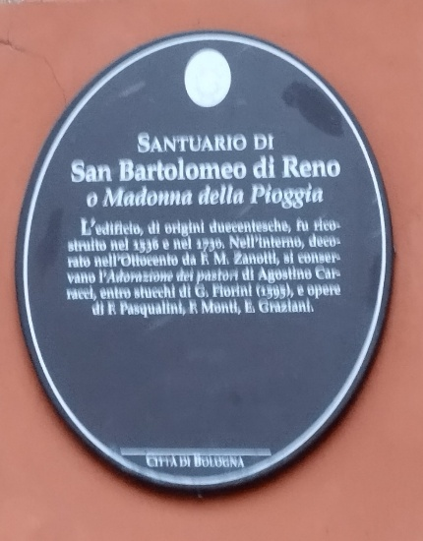
[SPLIT_BLOCK:ovale_santuario_pioggia.jpg]
History:
The sanctuary, originally dedicated to Saint Bartholomew, houses a painting of the Madonna and Child, attributed to the 15th-century Bolognese painter Michele di Matteo. The panel has been considered miraculous since its discovery; in fact, it was found completely intact under the rubble of a building destroyed by fire. Other miracles are attributed to the panel, such as restoring sight to a blind man and helping the people of Bologna during a long drought in the 16th century (hence the dedication to the Madonna della Pioggia).
Sanctuary:
Initially (1449) the miraculous image was placed on the first floor of the oratory. A few centuries later (1732) the sanctuary was rebuilt and the painting was placed in the niche above the altar. In the same year the procession was celebrated and was attended by Cardinal Lambertini, the future Pope Benedict XIV.

The building's façade features a tall colonnaded portico. The interior has a single nave covered by a barrel vault decorated with frescoes, and four modest-sized chapels on the sides. The decorations, which adorn both the chapels and the main altar, are the result of the 1929-31 restoration.
The first chapel on the left houses a painting by the Bolognese painter and engraver Agostino Carracci, depicting the Adoration of the Shepherds. Unfortunately, the work was damaged in a fire during World War II. In the opposite chapel, there is a 16th-century painting attributed to Lorenzo Sabbatini depicting the Madonna and Child Enthroned between Saints Catherine and Lucy.
The Sanctuary also houses the nursing robe that belonged to Saint Camillus de Lellis, who founded the Camillian Order in 1575. To the left of the main altar is the 13th-century statue of Our Lady of Providence, also known as Our Lady of the Serraglio.
Public and institutional sources on the history and places of worship in Bologna:
- Official Tourism and Culture Websites: such as Bologna Welcome and BolognaBO , which provide details on the location, opening hours, and history of the sanctuary.
- Online Encyclopedias and Historical Archives: such as Wikipedia and Bologna Online/Biblioteca Salaborsa , which offer insights into the 13th-century origins, the reconstruction, the miracle of the rain of 1561 that gave the Sanctuary its name, and the list of works of art housed there (such as those by Agostino Carracci, Francesco Monti, Ludovico Mattioli and Alfonso Lombardi).
- Art Guides and Portals: which confirm the full names (Sanctuary of the Madonna della Pioggia, Church of Santa Maria della Pioggia and of San Bartolomeo di Reno) and the most important works of art.
These sources agree on key information regarding the location (at the intersection of Via Galliera and Via Riva di Reno), the original name (San Bartolomeo di Reno) and the double dedication following the miracle of the rain.

Tabella delle Fonti e Certificazione
Affermazione del testo | Fonte Certificata
Location of the Sanctuary (San Bartolomeo di Reno or Madonna della Pioggia) at the intersection of Via Galliera and Via Riva di Reno in Bologna; 13th-century origins. | Bologna Welcome; Bologna BO Portal; Salaborsa Library (Bologna Online).
Origin of the name "Madonna della Pioggia" linked to the 1561 miracle during a procession that ended a severe drought. | Online historical archives; Chronicles of the Church of San Bartolomeo di Reno; Wikipedia / Salaborsa.
Painting of the Virgin and Child attributed to Michele di Matteo (15th century), recovered intact from ruins and deemed miraculous (Madonna della Provvidenza/Serraglio). | Emilia-Romagna Cultural Heritage Catalogue; Art history guides and institutional databases.
Reconstruction of the sanctuary in 1732 and solemn procession led by Cardinal Prospero Lambertini (later Pope Benedict XIV). | Archival documentation of the Diocese of Bologna and local history portals.
Internal artistic heritage: works by Agostino Carracci (Adoration of the Shepherds), Lorenzo Sabbatini, Ludovico Mattioli, Alfonso Lombardi, and the vestment of Saint Camillus de Lellis. | Recognized Art Portals; Catalogues of the Superintendence for Fine Arts of Bologna.

