The Adoration of the Shepherds
The Adoration of the Shepherds (also known as the Nativity) is a masterpiece preserved in the first chapel on the left within the Sanctuary of Santa Maria della Pioggia.
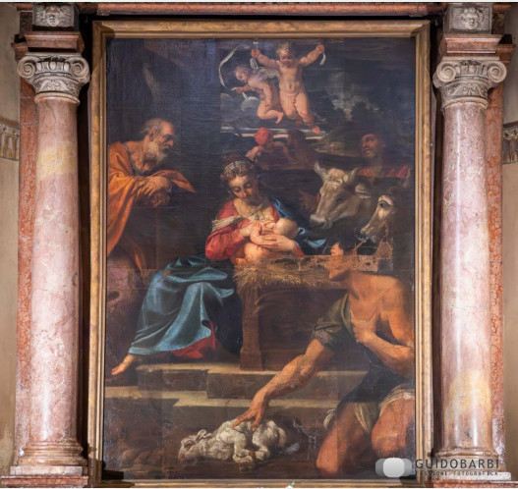
[SPLIT_BLOCK:AdorazionePastori.jpg]

Artist and Dating
Painted around 1595, the work bears the signature of Agostino Carracci (Bologna, 1557 – Parma, 1602). Agostino, the intellectual mind of the family, co-founded the famous Accademia degli Incamminati in Bologna alongside his brother Annibale and cousin Ludovico, spearheading a reform in Italian painting toward a new naturalism.
"Excessive Realism" and Period Criticism
The painting is renowned for its extraordinary truthfulness and almost Flemish attention to detail. However, this expressive choice was not immediately welcomed with favor.
As remembered by the Baroque historiographer Carlo Cesare Malvasia in his Felsina Pittrice (1678), contemporaries were unsettled by the "humble" naturalism of the Carracci. At the time, portraying shepherds with faces marked by hardship, modest clothing, or overly realistic physical details (such as the famous calloused feet criticized in St. Francis in other Carracci altarpieces) was deemed "excessive" and lacking religious decorum.
For modern criticism, however, this approach strips the sacred scene of rhetorical stiffness, grounding the divine event in everyday reality and establishing the Carracci as great pioneers of European Baroque painting.
Trivia and Insights
- Agostino the Engraver: Agostino was not only a painter, but also one of the greatest engravers of the Renaissance and Baroque eras. His mastery of technical drawing and light rendition is clearly reflected in the chiaroscuro contrasts of this work, where light seems to emanate directly from the Infant Jesus to illuminate the rugged faces of the shepherds.
- Masters of Detail: Compared to his brother Annibale (more emotional and direct) and his cousin Ludovico (more dramatic), Agostino was the scholar of the group: he rigorously studied anatomy, perspective, and classical sources, infusing this work with a perfect compositional balance.
War Tragedy and Restoration
During World War II, the church was hit by Allied bombardments that triggered a devastating fire inside the chapel. The artwork came close to permanent destruction: the canvas suffered severe damage from heat, smoke, and burns. Subsequent restoration successfully restored the painting's visibility, while leaving visible scars on the surface as a testament to local history and memory.

Tabella delle Fonti e Certificazione
Affermazione del testo | Fonte Certificata
The Adoration of the Shepherds in the first chapel on the left is by Agostino Carracci, dating to around 1595. | Ministry of Culture - Superintendence of Artistic Heritage Bologna / Bologna Online
The stark realism of the Carracci was criticized by contemporaries for lack of decorum, as documented by Carlo Cesare Malvasia in "Felsina Pittrice" (1678). | Carlo Cesare Malvasia, "Felsina Pittrice" (1678) / Italian Art Historiography
Agostino Carracci co-founded the Academy of the Incamminati with Annibale and Ludovico, and was a renowned master engraver. | Biographical Dictionary of Italians - Treccani
The painting was severely damaged by fire during WWII bombings and subsequently restored. | Historical Archive of the Archdiocese of Bologna / Cultural Heritage Catalog

