The statue was located on the main altar of the church of San Bartolomeo { Sanctuary of S. Maria della Pioggia }. It was moved into the oratory in 1732, after the building was restored following its collapse in 1729. In its place, in the church, the image of the Madonna della Pioggia was placed.
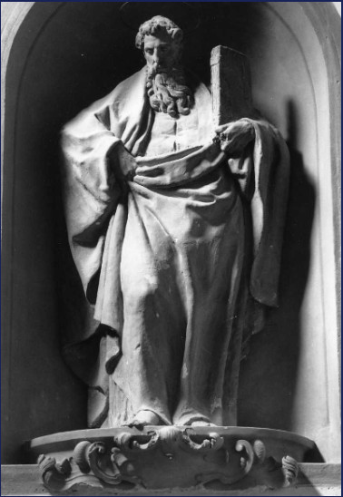
[SPLIT_BLOCK:San_Bartolomeo.jpg]
The statue of Saint Bartholomew is a polychrome terracotta work attributed to Alfonso Lombardi (Ferrara, ca. 1497 – Bologna, 1537), one of the major sculptors active in Bologna in the sixteenth century.
Here are the main details:
🗿 Statue of St. Bartholomew
- Artist: Alfonso Lombardi .
- Dating: Circa 1530 (first half of the 16th century).
- Technique and Material: Modeled and painted terracotta statue (polychrome). Height: approximately 225 cm.
- Subject: It depicts Saint Bartholomew the Apostle, traditionally martyred by flaying.
- Original Location: The statue occupied a position of great prominence, being found on the main altar of the church, which was originally dedicated only to Saint Bartholomew.
- Current Location: Following the church's renovation after its collapse in 1729 and its reconstruction in 1732, the image of the Madonna della Pioggia was placed on the high altar to highlight the cult of miracles. The statue of Saint Bartholomew was then moved and is now located in the Oratory of San Bartolomeo di Reno (on the upper floor of the complex), in a space also enriched by decorations and other statues by Alfonso Lombardi.
The sculpture is a fine example of Lombardi's terracotta production, known for its expressiveness and powerful modeling. It represents one of the most historically significant works of art associated with the complex of the Church of San Bartolomeo di Reno/Madonna della Pioggia.
Anecdotes and Curiosities
- The "Mystery" of the 1732 Move: For over two centuries, the majestic statue of Saint Bartholomew (standing a full 225 cm tall) was the undisputed queen of the high altar. However, after the church's disastrous collapse in 1729 and its subsequent reconstruction in 1732, the explosion of popular worship of the miraculous painting of the Madonna della Pioggia forced the brothers to undergo a "changing of the guard": the titular saint had to cede the place of honor to the Virgin and was moved to the upper floor, in the Oratory.
- Alfonso Lombardi, the Master of Terracotta: Alfonso Lombardi was considered a true "starchitect" of the Early Renaissance in Bologna for terracotta sculpture. His skill in modeling clay at life-size (and beyond) rivaled the great masters of marble. It is said that the expressive force and anatomical rendering of his Saint Bartholomew astonished his contemporaries with the realism of the details of the body and cloak.
- The Anatomy of Martyrdom and Polychrome Terracotta: Saint Bartholomew is traditionally associated with his dramatic martyrdom by flaying. Lombardi chose to depict the Apostle not in the act of torture, but with classical grandeur and solemn dignity, entrusting the drama to the vivid original polychrome of the painted terracotta, which made the statue appear almost "alive" in the candlelight.
- A "Hidden" Museum in the Oratory: The statue's relocation in 1732 created an extraordinary concentration of Alfonso Lombardi's works on the upper floor of the complex. The Oratory of San Bartolomeo di Reno thus became a small Renaissance treasure trove where the statue of the Apostle still interacts with the other terracottas and decorations created by the Ferrarese master in the 16th century.

Tabella delle Fonti e Certificazione
Affermazione del testo | Fonte Certificata
The polychrome terracotta statue depicting St. Bartholomew Apostle (height approx. 225 cm) is by Alfonso Lombardi (c. 1497–1537), created around 1530. | Ministry of Culture - Superintendence of Artistic Heritage Bologna / General Cultural Heritage Catalog
Originally, the statue stood on the high altar of the church, which before the 16th century was dedicated solely to St. Bartholomew. | Bologna Online / Salaborsa Library / Historical Archive Archdiocese of Bologna
Following the building's collapse in 1729 and its 1732 restoration, the miraculous Madonna of the Rain image was placed on the main altar, and the St. Bartholomew statue was moved to the upper-floor Oratory. | Historical-Artistic Guide to the Churches of Bologna / BeWeB CEI
The Oratory of San Bartolomeo di Reno houses the statue alongside other Renaissance terracotta decorations modeled by Alfonso Lombardi. | Historiography of 16th-Century Bolognese Sculpture / Treccani Biographical Dictionary

