The author is Agostino Carracci
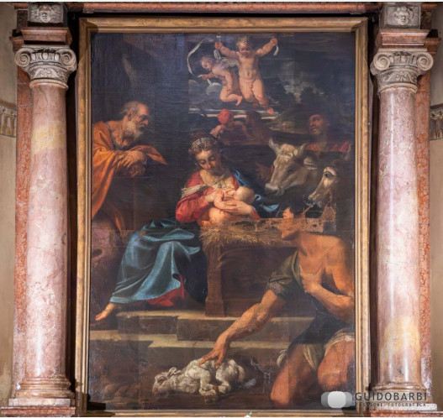
[SPLIT_ BLOCK:AdorazionePastori.jpg]

