Via Riva di Reno in Bologna covers the underground route of the Reno Canal .
Here are some important details:
- The Reno Canal: One of Bologna's main man-made canals, it originates from the Reno River near the Casalecchio Lock. This canal has been vital to the city's economy since the Middle Ages, powering mills, silk mills, and other industrial activities.
- The Covering: The canal in that section (and in much of the historic center) was progressively covered, or "tombato", starting from the mid-twentieth century for traffic and urban redevelopment needs, thus creating space for the current road.
- The Name: The name of the street itself ("Riva di Reno") recalls its original function as the bank or shore of the canal.
- Current Curiosity: In recent years, during the works for the new tram line, the rediscovery of some short stretches of the Reno Canal has been discussed and is in part being realised
The road covers the route of what was once an important open-air waterway.
From the 14th-century walls surrounding the city , at Via Sabotino, we find the Grada Church, which covers the Reno Canal. The grate that once served to stop floating objects entering the city from the canal can still be seen today. The bodies of people who drowned in the canal have also been found.
Continuing from Via della Grada to the intersection with Via San Felice, the road takes the name of Via di Riva Reno and ends in Piazza della Pioggia,
When walking along Via di Riva Reno, you arrive near the Piazzetta della Pioggia, at the height of Via Galliera and if you look up at the buildings, you will see that they are separated by the presence of the canal, while at the height of the street there is the portico with the Pioggia butcher's shop which belonged to the Carracci family, in particular to Ludovico's father, who was a butcher.

The Carraccis played a key role in the history of art, marking the transition from Mannerism to Baroque and founding the famous Bolognese school of painting.
The Carraccis had an enormous impact, not only for their painting, but also for having created an educational model (the Academy) that trained the major artists of seventeenth-century Bologna, such as Guido Reni and Domenichino.
The Carracci family, active in Bologna between the late 16th and early 17th centuries, are crucial figures in the history of Italian art, as they marked the transition from Mannerism to Baroque and founded the famous Bolognese school of painting.

🎨 The Protagonists: The Carracci Cousins
The group was composed of three artists, linked by family ties and a revolutionary artistic vision:
- Ludovico Carracci (1555–1619): The elder cousin, considered the initiator of the artistic reform and the spiritual leader of the group.
- Agostino Carracci (1557–1602): Brother of Annibale, he excelled as an engraver as well as a painter, and was the most erudite theoretician of the group.
- Annibale Carracci (1560–1609): Considered the most talented of the three, he was a versatile master, excelling in every pictorial genre.

🏛️ The Academy of the Incamminati
The most innovative contribution of the Carraccis was not only their painting, but the foundation, around 1582 , of an artistic workshop that later became known as the Accademia degli Incamminati (or Accademia del Naturale or dei Desiderosi ).
- Purpose: To overcome the formal excesses and artificiality of Mannerism.
- Teaching Method: The Academy introduced a modern teaching method based on:
  - Life study ( drawing of nude models and anatomy).
  - Copying the great masters of the Renaissance (such as Raphael, Titian and Correggio).
  - Discussions of art theory, literature, and poetry.
- Legacy: They trained the major artists of the seventeenth-century Bolognese school, including Guido Reni and Domenichino .

🖼️ The Artistic Reform and Style
The Carraccis advocated a "return to nature" and a clearer, more emotional and accessible painting , anticipating the principles of Counter-Reformation art.
- Historical and Religious Painting: Their religious and mythological works are characterized by a strong naturalism and a composition that combines the balance of the classical tradition (Raphael) with the colorism and sensitivity of Venetian light (Titian and Correggio).
- Frescoes of Palazzo Farnese (Rome): Annibale Carracci's masterpiece (with the help of Agostino) was the decoration of the Galleria Farnese in Rome (1597-1608), which became the model for Roman Baroque painting and the mythological fresco of the following centuries.
- Genre Painting: Annibale Carracci was also a pioneer in genre painting , elevating scenes of everyday life (such as The Bean Eater or the two versions of The Butcher's Shop ) to subjects of great artistic dignity through a careful realism free from excessive idealization.

The famous work known as "The Butcher's Shop" was painted by Annibale Carracci (1560–1609).
It is one of his most important genre paintings , that is, scenes depicting moments of everyday life. This work in particular is remarkable because, despite depicting a humble subject, it does so with great dignity, realism, and a complex, monumental composition.
Annibale is cited as an artist who also excelled in genre painting, citing The Bean Eater as an example of this realism. "The Butcher's Shop" is another splendid example of this sensibility.

It is a bit of a mystery, since the circumstances of its construction, dated around 1585 , are not known with certainty .
There are several hypotheses about the clients:
- Canobi Family : One hypothesis is that the work was intended for a well-known Bolognese family of wealthy meat traders, the Canobi , owners of a large butcher's shop in the city. However, archival research has not provided definitive proof.
- Butchers' Guild: Another theory is that the painting may have been commissioned by the butchers' guild ("beccai") to decorate its headquarters.
What is certain is that the painting, also known as the Great Butcher's Shop , passed from the Gonzaga family collection to the King of England Charles I Stuart in 1627 .
When we talk about "two paintings of the butcher's shop", we often refer to the two famous versions painted by Annibale Carracci (1560-1609):
- 🎨 The "Great Butcher's Shop" (or Butcher's Shop )
  - Author: Annibale Carracci
  - Period: circa 1585
  - Dimensions: The largest (approximately 190 x 271 cm)
  - Where is it: Christ Church Picture Gallery, Oxford (UK)

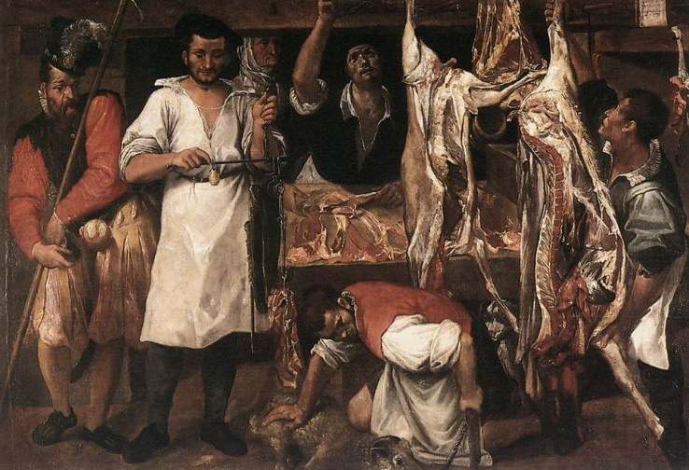

[ SPLIT_ BLOCK:grande_macelleria.jpg ]

- 🖼️ The "Little Butcher's Shop"
  - Author: Annibale Carracci
  - Period: circa 1582
  - Dimensions: The smallest (approximately 77 x 89 cm)
  - Where is it located: Kimbell Art Museum, Fort Worth, Texas (United States)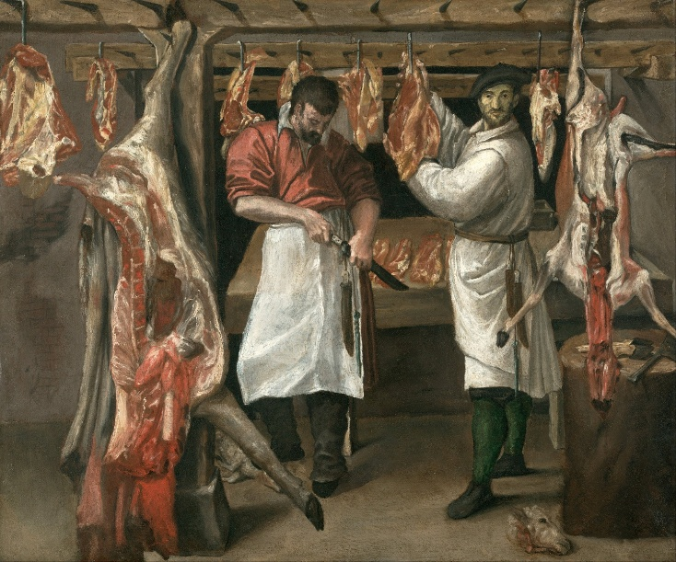
[ SPLIT_ BLOCK:piccola_macelleria.jpg ]

Both works are considered fundamental examples of genre painting (scenes of everyday life) in late sixteenth-century Italian art.
The Carracci: The Fathers of the Baroque in Bologna
The Carraccis were a family of Bolognese artists composed of three central figures: Ludovico Carracci (1555–1619), his cousin Agostino Carracci (1557–1602), and Agostino's brother, Annibale Carracci (1560–1609).
Their work and artistic philosophy are considered the foundation of Baroque painting, as they proposed a stylistic "reform" that overcame the artificiality of Mannerism to return to a vigorous naturalism and a revival of the great classical models of the Renaissance (such as Raphael and Titian).
1. The Foundation of the Academy of the Incamminati
The Carraccis' most revolutionary contribution was the foundation in Bologna, around 1582, of a private school that took the name of Accademia dei Desiderosi , later renamed Accademia degli Incamminati (that is, "those who are on the right path of art").
This academy is considered the first modern art institution in Italy for several reasons:
- Study of Life: He encouraged the direct study of nature and the human body (the "Life Drawing"), breaking with the Mannerist practice of copying only the models of previous masters.
- Complete Education : In addition to drawing and painting, the Academy offered lessons in anatomy, geometry, perspective, and literature, elevating the artist from a mere craftsman to a complete intellectual.
- Stylistic Summary : The Carraccis taught how to combine the rigorous drawing of the Tuscan-Roman tradition (Michelangelo, Raphael) with the colour and use of light typical of the Venetian school (Titian, Correggio).
2. The Main Works
The three Carraccis worked closely together for many years, often making it difficult to distinguish individual hands in the early fresco cycles in Bologna:
Bologna Period (Collaboration)
- Palazzo Fava, Bologna (1584): Frescoes with the Stories of Jason and Medea and the Stories of Aeneas .
- Palazzo Magnani, Bologna (1589-1592): The famous frieze depicting the Foundation of Rome , a masterpiece of narrative clarity.
Maturity in Rome (Hannibal)
In 1595, Annibale and Agostino were summoned to Rome by Cardinal Odoardo Farnese. Annibale in particular produced the work that would become the manifesto of Baroque classicism:
- Farnese Gallery , Rome (1597-1601): The frescoes depicting The Loves of the Gods . This cycle is considered a masterpiece of monumental fresco painting and was a point of reference for entire generations of subsequent artists, including Lanfranco and Pietro da Cortona.
3. The Three Artists
- Annibale Carracci (1560-1609): The most gifted and innovative of the trio. He excelled in both large-scale mythological frescoes (as in the Palazzo Farnese) and genre painting (such as The Bean Eater ), displaying a realism and sensitivity to everyday life that anticipated the work of Caravaggio. He is buried in the Pantheon next to Raphael.
- Ludovico Carracci (1555-1619): The eldest and the intellectual and theoretical leader of the group. He remained mainly in Bologna, focusing primarily on religious works of the Counter-Reformation, characterized by profound devotion and emotional intensity.
- Agostino Carracci (1557-1602): A versatile artist, also known as an engraver and theorist. He collaborated actively with his brother and cousin, contributing significantly to the decorations of Bologna and Rome.

This house was already owned by Giovanni Maria Carracci in 1563, who, coming from Cremona, had opened a butcher 's shop in Bologna .
Carracci was the founder of the Carracci family, which produced two generations of painters who lived and opened workshops in this very building for over half a century.
The emotional bond that the Carraccis had for this home of theirs is demonstrated by the fact that, even when fame took them to work elsewhere, this place remained a point of reference to which they always returned.
On 14 December 1619, in this palace where he was born and which still belonged to Paolo Carracci, son of Vincenzo, also known as a painter, Ludovico, the most famous artist of the family, died whose remains were later buried in the church of S. Maria Maggiore di Galliera.
Over the centuries, the factory underwent heavy renovations and only recently underwent a renovation that erased all the damage suffered during the war. These works have brought to light precious traces of the building's past.
The portal has a splayed lintel and its width, given the characteristics of the street, is still unusual.
The double door is made of solid wood. It is a fine example of cabinetmaking and originally had a pedestrian door, which has now been fixed and concealed with moldings. The handles are polished brass.

🥩 Meaning of "Beccaro"
"Beccaro" is a term of ancient dialectal origin (especially Lombard and Northern Italian ) which means:
- Butcher (the most common meaning).
- Butcher (synonym of butcher, although it sometimes indicated the breeder of cattle destined for slaughter).
In short, it indicated the person who slaughtered animals or sold meat for a living.

🌎 Origin and Etymology
The origin of the word " beccaro " is of a professional nature and is linked to the trade described above.
- It derives from the word "becco" which, in Latin ( beccus ), can mean "beak" (of the bird), but in the butcher's context refers to the male goat or, more generally, to cattle.
- One of the most popular hypotheses is that the term is linked to the meat of goat (beak) or farmyard animals, which was very popular in the Middle Ages.
- The form " beccaro " is considered the ancestor or dialectal form (ancient or regional) of the modern Italian "beccaio" .
This term, like many medieval trade names, is at the origin of numerous Italian surnames such as Beccari , Beccaro and the illustrious Beccaria (for example, Cesare Beccaria, the author of Dei delitti e delle pene ).

