The statue was located on the main altar of the church of San Bartolomeo { Sanctuary of S. Maria della Pioggia }. It was moved into the oratory in 1732, after the building was restored following its collapse in 1729. In its place, in the church, the image of the Madonna della Pioggia was placed.
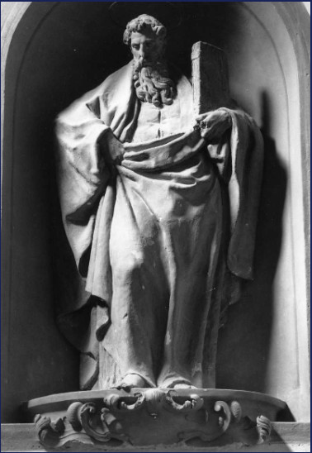
[SPLIT_BLOCK:San_Bartolomeo.jpg];
by the sculptor Lombardi Alfonso (1497 Ca./ 1537):

