There was a street in Bologna called Pugliole di San Bernardino . This street disappeared following the urban planning interventions of the 1930s which led to the creation of Via Guglielmo Marconi (then Via Roma).
The " Pugliole di San Bernardino" took their name from the Monastery or Convent of San Bernardino which was located in the area of the current Piazza dei Martiri 1943-1945. The street branched off from Borgo Polese (the current Via Polese) and wound its way up to Via del Porto, partly following the current route of Via Marconi.
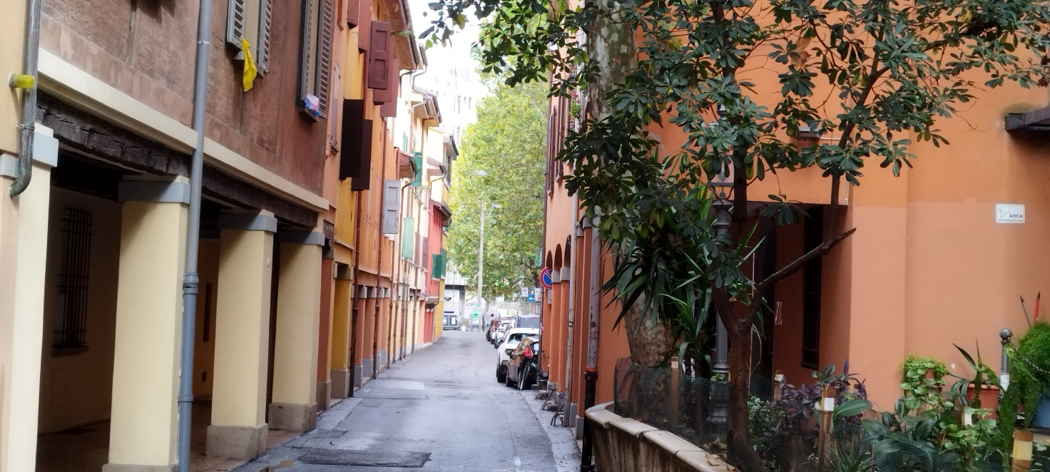
[ SPLIT_ BLOCK:viaPolese.jpg ];
The term "Pugliola" (or, in the plural, " Pugliole ") is an ancient term in Bolognese toponymy . It refers to an alley, a small street, or a small group of houses . It generally indicated a small road or a secondary residential area, often resulting from an ancient subdivision of the urban fabric.
Many streets and alleys in Bologna, such as " Pugliole di San Bernardino" or " Pugliole dello Spirito Santo," took their names from churches or monasteries that were located nearby, combining the name of the religious institution with the term " pugliola " to indicate the adjacent alley.

