12/29/2023

FINAL PROJECT OF TIC

WORD

MEMBERS :

-Chettou Mohamed

-Bellili Mohammed Mehdi

-Kaloune Rostom

-Benrahmani Mohamed Rayan

-Hacene Hamza

TABLE OF CONTENTS

**INTRODUCTION 2**

**1 Background 2**

**2 Objectives 3**

**OVERVIEW OF INFORMATION AND (TIC) 3**

**1 Definition of TIC 3**

**2 Importance of TIC 4**

**3 Evolution of TIC 4**

**GOOGLE SERVICES 4**

**1 Overview 4**

**2 Key Google Services 4**

**-Gmail : 4**

**- Google Drive 5**

**3 Applications in Business 6**

**-Google Workspace 6**

**MICROSOFT TOOLS 7**

**1 Introduction to Microsoft Tools 7**

**2 Popular Microsoft Tools 7**

**-Microsoft Office 365 7**

**-Microsoft Teams 8**

**Git and GitHub 8**

**1 Understanding Version Control 8**

**2 Introduction to Git 8**

**3 Collaboration with GitHub 9**

**CASE STUDIES 10**

**1 Real-world Applications 10**

**-Streamlining Development 10**

**-Agile Project Management 10**

**2 Success Stories 10**

**-Enhanced Collaboration at Google 10**

**- Internal Collaboration at Microsoft 11**

**CHALLENGES AND FUTURE TRENDS 11**

**1 Current Challenges 11**

**-Cybersecurity Threats 11**

**-Rapid Technological Changes 11**

**2 Emerging Trends 11**

**-Artificial Intelligence (AI) Integration 11**

**-5G Technology 12**

**o Improved mobile communication and data transfer speeds. 12**

**-Edge Computing 12**

**Growing utilization of edge computing to process data closer to the source, reducing latency and improving efficiency. 12**

**o Faster response times in data processing. 12**

**o Enhanced scalability for decentralized systems. 12**

**-Sustainable Technologies 12**

**Conclusion 12**

# INTRODUCTION

## Background

In an era defined by technological breakthroughs and interconnected digital landscapes, Information and Communication Technologies (TIC) stand as the backbone of modern civilization. The relentless evolution of TIC has revolutionized the way individuals, businesses, and societies communicate, collaborate, and process information.

The rapid integration of TIC has transcended traditional boundaries, shaping the very fabric of our daily lives. From the advent of the internet to the proliferation of smart devices, TIC has become synonymous with progress, efficiency, and innovation. As we navigate a world increasingly defined by the seamless exchange of information, it becomes imperative to delve into the intricacies of TIC and its various facets.

## Objectives

This report embarks on a comprehensive exploration of TIC and closely related technologies, shedding light on key components such as Google services, Microsoft tools, Git, and GitHub. The primary objectives are to unravel the significance of TIC in our contemporary landscape, dissect the functionalities of prominent technologies, and showcase their real-world applications.

By the end of this report, readers will gain a profound understanding of how TIC has evolved, the pivotal role it plays in diverse industries, and the nuanced dynamics of technologies shaping our digital future. As we navigate through the subsequent sections, we will unravel the layers of TIC, from its foundational concepts to its transformative impact on businesses and collaborative ventures.

Join us on this journey into the heart of Information and Communication Technologies, where the amalgamation of innovation and connectivity is steering us toward an era of unparalleled possibilities.

# OVERVIEW OF INFORMATION AND COMMUNICATION TECHNOLOGIES (TIC)

## Definition of TIC

Information and Communication Technologies (TIC) constitute a dynamic and multifaceted domain encompassing a broad spectrum of technologies that facilitate the acquisition, storage, processing, and dissemination of information. TIC serves as the backbone of modern communication, playing a pivotal role in connecting individuals, organizations, and societies across the globe.

At its core, TIC integrates various technologies, including telecommunications, computing, networking, and software development, to create an ecosystem where information flows seamlessly. It goes beyond traditional communication methods, incorporating cutting-edge technologies to enhance collaboration, efficiency, and innovation.

## Importance of TIC

The importance of TIC in contemporary society cannot be overstated. In a world driven by data and connectivity, TIC serves as the catalyst for advancements in nearly every sector. From healthcare and education to business and government, TIC empowers organizations to streamline processes, make informed decisions, and foster global collaboration.

TIC is instrumental in breaking down geographical barriers, enabling real-time communication and collaboration. The ability to access and share information instantaneously has transformed the way individuals interact, businesses operate, and governments deliver services. The efficiency gains and transformative impact on societal structures underscore the critical role that TIC plays in shaping the modern landscape.

## Evolution of TIC

The evolution of TIC traces a fascinating journey through the annals of technological progress. From the early days of telegraphy and telephony to the present era of cloud computing and artificial intelligence, TIC has undergone continuous transformation.

The first wave of TIC was marked by the development of basic communication systems, leading to the establishment of the internet. Subsequent waves witnessed the rise of mobile computing, the proliferation of smart devices, and the advent of the Internet of Things (IoT). Today, we stand at the cusp of the fourth industrial revolution, characterized by the integration of digital technologies into every aspect of our lives.

As we explore the various dimensions of TIC, it becomes evident that its evolution is synonymous with the relentless pursuit of connectivity, efficiency, and innovation. Understanding this evolution is crucial for grasping the current state of TIC and anticipating the future trajectory of technological advancements.

# GOOGLE SERVICES

## Overview

Google, a global technology giant, offers a comprehensive suite of services that have become integral to both individual users and businesses. These services cover a wide range of applications, from communication and collaboration to productivity and cloud computing. Google's commitment to innovation has positioned its services as cornerstones in the realm of Information and Communication Technologies (TIC).

## Key Google Services

### -Gmail :

***Overview:*** Gmail, Google's email service, has evolved from a simple communication platform to a powerful tool that integrates seamlessly with other Google services. With a user-friendly interface and robust features, Gmail has become a go-to choice for personal and professional communication.

***Key Features:***

|  |  |
| --- | --- |
| **Features** | **Description** |
| **Intuitive Interface** | **User-friendly design for easy navigation** |
| **Smart Filters and Labels** | **Automated categorization and customizable organization** |
| **Google Workspace Integration** | **Collaborative features with other Google tools** |

Screenshot of Gmail Interface :

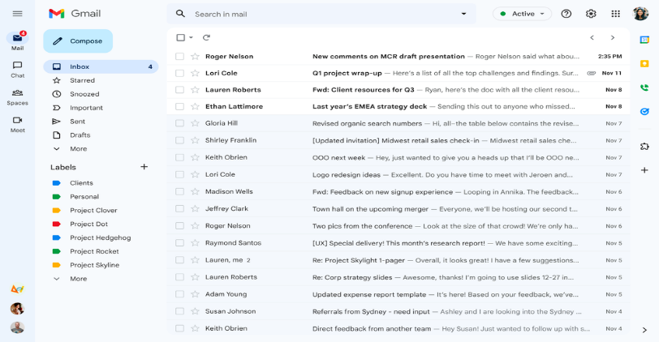

### - Google Drive

***Overview:***Google Drive is a cloud storage and file-sharing service that enables users to store, access, and collaborate on documents, spreadsheets, and multimedia content in real-time.

***Key Features:***

|  |  |
| --- | --- |
| **Features** | **Description** |
| **Cloud Storage** | **Secure storage of documents and files in the cloud** |
| **Real-time Collaboration** | **Simultaneous editing and commenting for teamwork** |
| **Integration with Third-Party Apps** | **Connects with various applications for flexibility** |

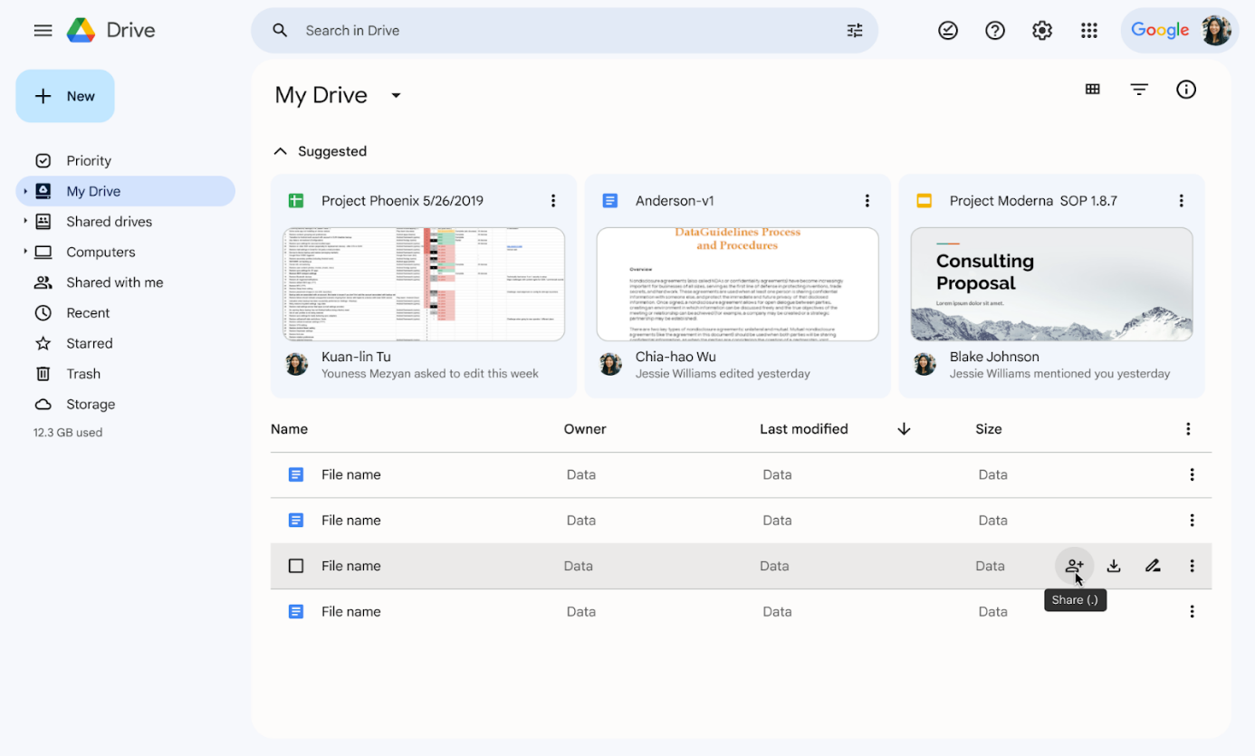Screenshot of Google Drive Interface :

## Applications in Business

Google services are not only popular among individual users but have also become indispensable tools for businesses. The seamless integration of these services in the business environment enhances collaboration, productivity, and communication.

### -Google Workspace

***Overview:***Formerly known as G Suite, Google Workspace is a suite of cloud-based productivity tools that includes Gmail, Google Drive, Google Meet, Google Docs, Google Sheets, and more.

***Key Features:***

* **Collaborative Editing:** Real-time editing and commenting on documents and spreadsheets.
* **Centralized Communication:** Unified communication through Gmail and Google Meet.
* **Security and Compliance:** Robust security features and compliance controls for business use.

Image of Workspace Interface :

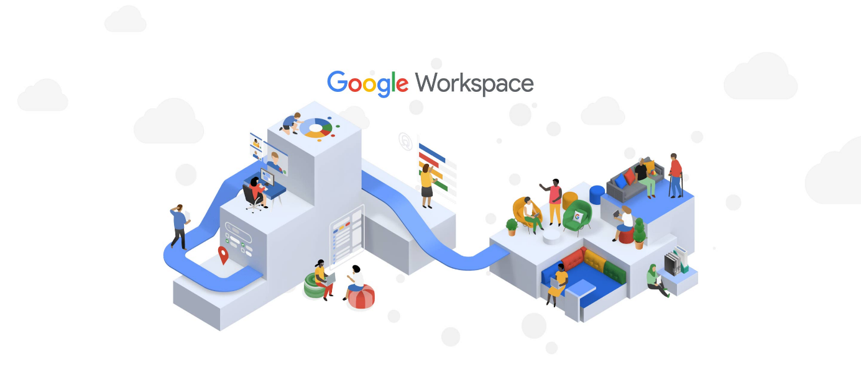

# MICROSOFT TOOLS

## Introduction to Microsoft Tools

Microsoft, a global technology leader, provides a suite of tools that cater to diverse needs, ranging from individual productivity to enterprise-level collaboration. These tools are designed to enhance efficiency, facilitate seamless communication, and empower users to achieve their goals. Below are some of the most popular Microsoft tools that have become integral components of the modern digital workspace.

## Popular Microsoft Tools

### -Microsoft Office 365

***Overview:*** Microsoft Office 365, now known as Microsoft 365, is a cloud-based suite that includes Word, Excel, PowerPoint, Outlook, and Teams, facilitating document creation, data analysis, presentations, email management, and collaboration.

***Key Components:***

* **Word:** Document creation and editing.
* **Excel:** Spreadsheet creation and data analysis.
* **PowerPoint:** Presentation design and delivery.
* **Outlook:** Email and calendar management.
* **Teams:** Collaboration hub for chat, video conferencing, and file sharing.

Image of Microsoft Office 365:



### -Microsoft Teams

***Overview:*** Microsoft Teams is a collaboration platform that brings together chat, video conferencing, file sharing, and application integration into a single workspace. It is designed to facilitate communication and teamwork among users within an organization.

***Key Features:***

* **Chat and Messaging**: Instant messaging and threaded conversations.
* **Video Conferencing:** High-quality audio and video meetings.
* **File Sharing:** Secure sharing of documents within the platform.

Image of Microsoft Teams:

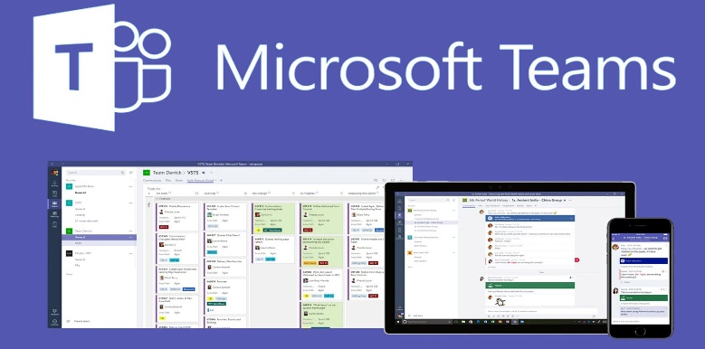

# Git and GitHub

## Understanding Version Control

Version control is a critical aspect of collaborative software development, allowing multiple developers to work on a project simultaneously without conflicts. Git, a distributed version control system, is widely used for managing and tracking changes in source code.

## Introduction to Git

***Overview:*** Git is a decentralized version control system that tracks changes in source code during software development. It enables collaboration, maintains a history of changes, and facilitates branching for parallel development***.***

***Key Concepts:***

* **Repository:** A collection of files and their history.
* **Commit:** A snapshot of changes made to files.
* **Branch:** An independent line of development.
* **Merge:** Combining changes from different branches.

***Basic Git Commands:***

|  |  |
| --- | --- |
| **Command** | **Description** |
| **“git init”** | **Initialize a new Git repository** |
| **“git add”** | **Add changes to the staging area** |
| **“git commit”** | **Record changes to the repository** |
| **“git branch”** | **List, create, or delete branches** |
| **“git merge”** | **Merge changes from different branches** |

Git Workflow Diagram:

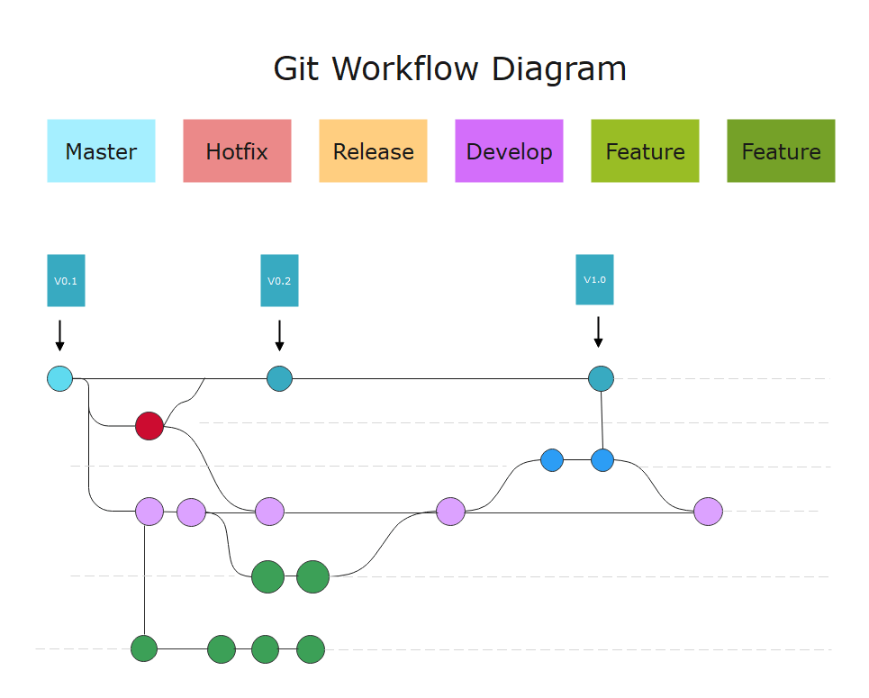

## Collaboration with GitHub

***Overview:*** GitHub is a web-based platform built on top of Git, providing additional collaboration features. It serves as a hosting service for Git repositories, offering tools for code review, issue tracking, and project management.

***Key Features:***

* **Repository Hosting:** Store and share Git repositories online.
* **Pull Requests:** Propose changes and initiate code review.
* **Issues:** Track and manage bugs, enhancements, and tasks.
* **Actions:** Automate workflows and testing.

GitHub Interface:

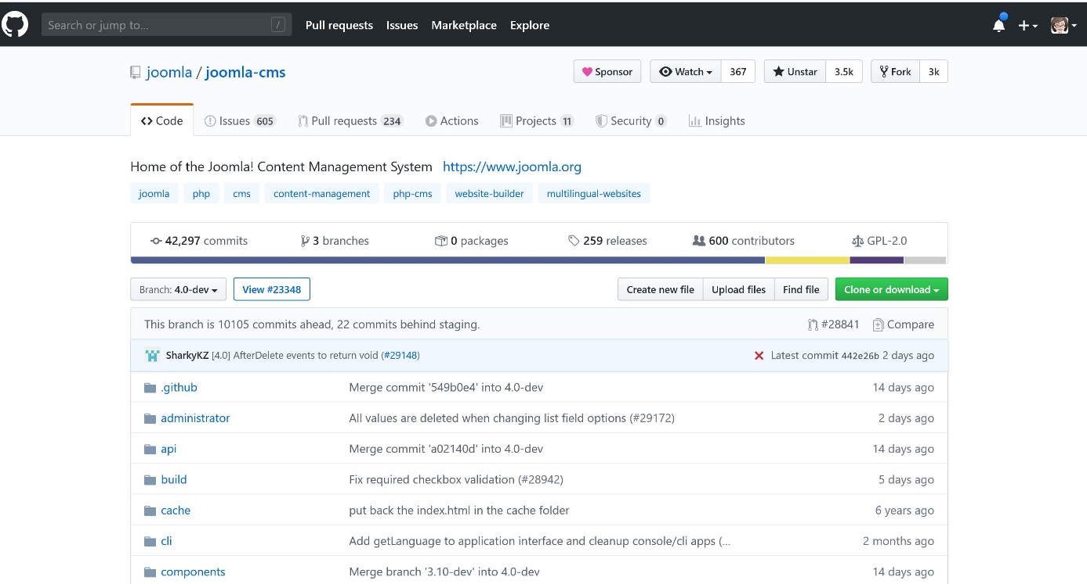

# CASE STUDIES

## Real-world Applications

### -Streamlining Development

* **Challenge:**

A software development team faced collaboration challenges leading to delays and errors.

* **Solution:**

Implemented streamlined development processes, reducing errors and improving efficiency.

* **Outcome:**
  + Accelerated feature development.
  + Significantly reduced errors.

### -Agile Project Management

* **Challenge:**

An Agile team struggled with communication gaps impacting project timelines.

* **Solution:**

Adopted effective project management strategies, improving communication and collaboration.

* **Outcome**
  + Enhanced collaboration and team communication.
  + Improved project timeline adherence.

## Success Stories

### -Enhanced Collaboration at Google

* **Challenge:**

Google aimed to improve collaboration and innovation across global teams.

* **Solution:**

Implemented collaborative tools, fostering real-time communication and innovation.

* **Outcome**
  + Streamlined global collaboration.
  + Accelerated innovation processes.

### - Internal Collaboration at Microsoft

* **Challenge:**

Microsoft sought improved internal communication and collaboration.

* **Solution:**

Adopted collaboration platforms, transforming internal communication and teamwork.

* **Outcome:**
  + Improved internal communication.
  + Increased productivity through centralized collaboration.

# CHALLENGES AND FUTURE TRENDS

## Current Challenges

### -Cybersecurity Threats

* **Challenge:**

The increasing frequency and sophistication of cyberattacks pose a significant threat to the security of information and communication systems.

* **Impact:**
  + Data breaches and loss of sensitive information.
  + Disruption of services and business operations.

### -Rapid Technological Changes

* **Challenge:**

The fast-paced evolution of technologies requires constant adaptation, posing challenges for organizations to keep up.

* **Impact:**
  + Skills gaps and workforce challenges.
  + Obsolescence of legacy systems.

## Emerging Trends

### -Artificial Intelligence (AI) Integration

* **Trend:**

Increased integration of AI across various applications, from automation and decision support to natural language processing.

* **Impact:**
  + Improved efficiency and automation.
  + Enhanced personalized user experiences.

### -5G Technology

* **Trend:**

The widespread adoption of 5G technology for faster and more reliable wireless communication.

* **Impact:**
  + Accelerated connectivity for IoT devices.
  + Improved mobile communication and data transfer speeds.

### -Edge Computing

* **Trend:**

Growing utilization of edge computing to process data closer to the source, reducing latency and improving efficiency.

* **Impact:**
  + Faster response times in data processing.
  + Enhanced scalability for decentralized systems.

### -Sustainable Technologies

* **Trend:**

A focus on developing and adopting environmentally sustainable technologies and practices.

* **Impact:**
  + Reduced environmental impact.
  + Meeting regulatory and social responsibility requirements.

# Conclusion

In the dynamic landscape of Information and Communication Technologies (TIC), the journey from streamlined development practices to enhanced collaboration and communication has been marked by both challenges and triumphs. Organizations have faced and overcome obstacles, adapting to rapid technological changes and embracing innovative solutions to foster efficiency and teamwork.

The implementation of technologies like Git, GitHub, Google Workspace, and Microsoft Tools has played a pivotal role in transforming how we communicate, collaborate, and develop software. From streamlining development workflows to providing centralized hubs for collaboration, these tools have become integral components of the modern digital workspace.

However, challenges such as cybersecurity threats, privacy concerns, and the need to keep pace with technological advancements persist. The TIC landscape requires ongoing vigilance, adaptation, and a commitment to addressing these challenges to ensure the security, privacy, and efficiency of digital systems.

Looking ahead, emerging trends such as the integration of Artificial Intelligence (AI), the widespread adoption of 5G technology, and the focus on sustainable technologies are shaping the future of TIC. These trends promise to bring about further advancements, enabling organizations to stay competitive, innovative, and environmentally responsible.

As we navigate the complexities of the digital era, the key lies in a proactive approach to embracing technological advancements, addressing challenges, and fostering a culture of continuous learning and improvement. The journey of TIC is an ever-evolving one, and organizations that stay agile, resilient, and forward-thinking will be well-positioned to thrive in the digital landscape of tomorrow.