Assemble

Interpretation Concrete-syntax  
(play {loop

**(assemble (** {note 67 1 2}  
 (list (synth-note “main” 10 67 {note 71 1 2}  
 (FRAME-RATE))) 1 2 1}

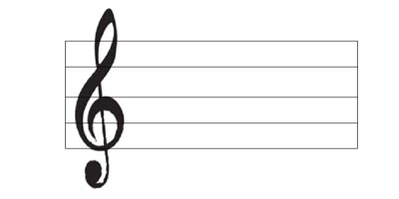 (synth-note “main” 10 71 …)



= 60 == FRAME-RATE