Silence

Interpretation Concrete-syntax  
(play {note 69 2 3}

(assemble (list (   
 **silence (\* FRAME-RATE 4) 0)**  
 (list (synth-note “main” 10 69   
 (FRAME-RATE) …))

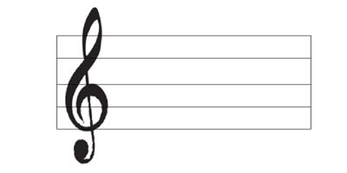

= 60 == FRAME-RATE