Rs-Append

Interpretation Concrete-syntax  
(play (**rs-append(** {loop

(assemble ( {note 67 1 2}  
 (list (synth-note “main” 10 67 …) {note 71 1 2}

(synth-note “main” 10 71 …) 1 2 2}

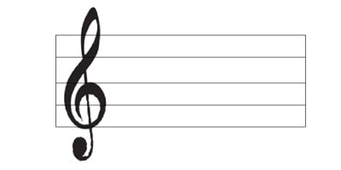 (assemble ( … ))))



= 60 == FRAME-RATE