Synth-note

Interpretation Concrete-syntax

(play {loop  
 **(synth-note** “main” 10 60 {note 60 1 1.25}  
 (* FRAME-RATE 0.5))) {note 64 1.25 1.5}  
 {note 67 1.5 2}  
 1 2 1}

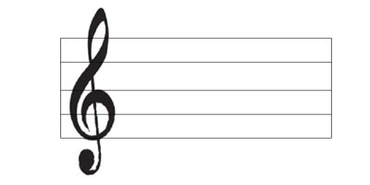  
   
= 60 == FRAME-RATE