Step 1: Loaded all 3 .csv file into power Bi.
Go to Home—>Get Data—>Text/CSV.
Select list of orders.csv.
Click load.
Repeat for order details.csv and sales target.csv.

Step 2: created Relationship between the tables.
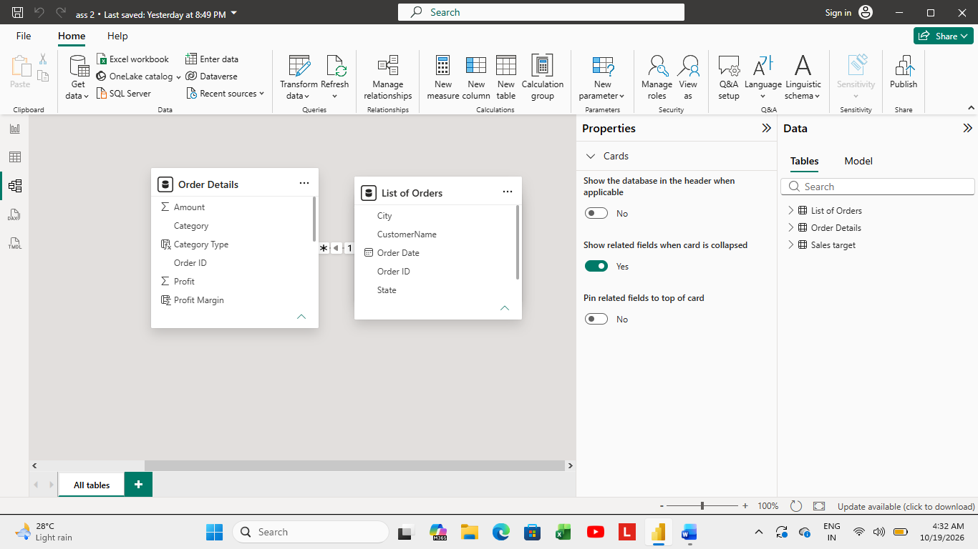

Need to create 3 calculated columns.
- Category type
- Revenue per order.
- Sales category.
Column 1:
Step 3: Go to Table viewselect order detailsin the Home Tabselect new Column.
Name the column as Category Type Enter formula to combine category and
Sub category into one column using concatenate function.
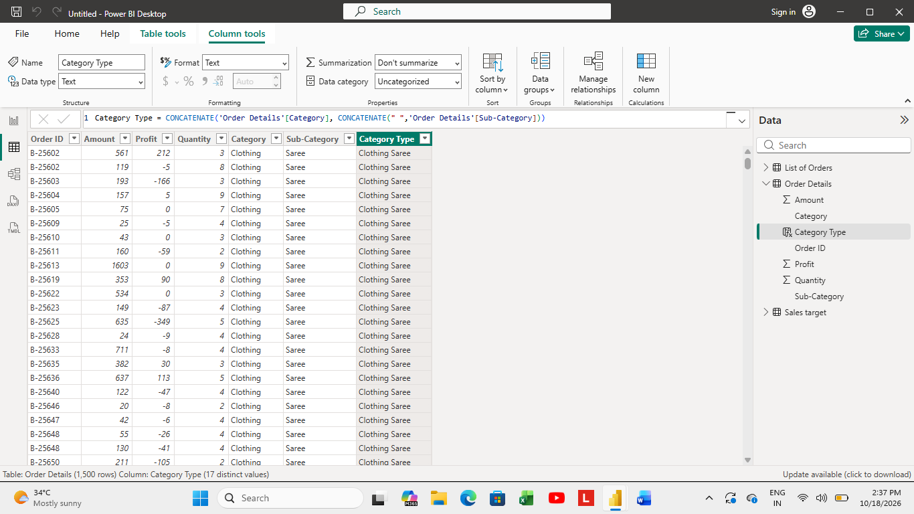
Column 2:
Step 4: new columnname as Revenue per Ordermultiply amount by quantity.
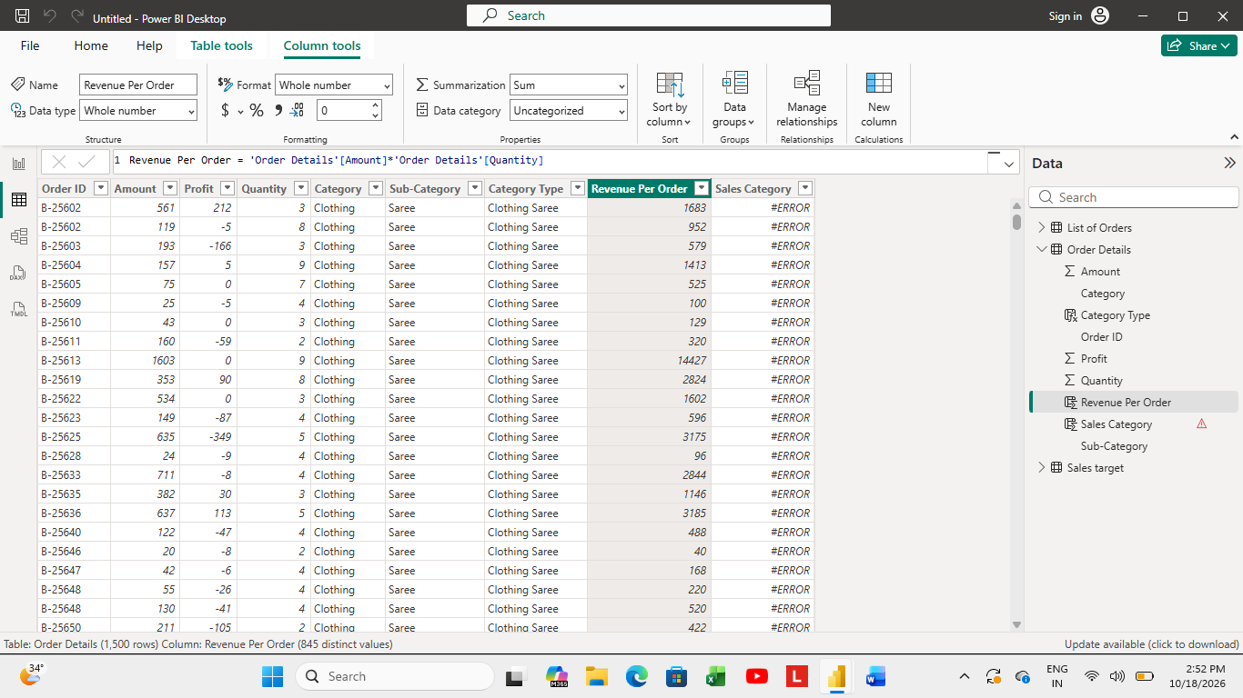
Column 3:
Step 5: New Columnname as Sales Categoryuse IF Function to classify each row as above or below average amount.
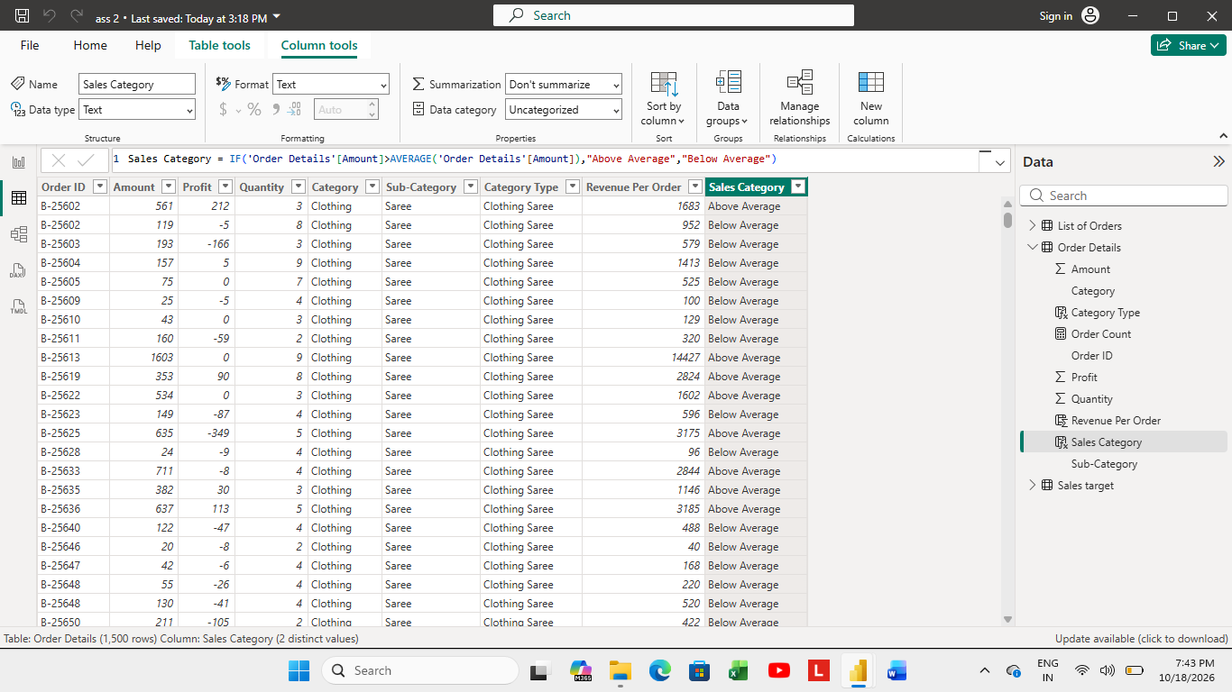

Now create 3 calculated measure columns:
- Order Count.
- Average profit in Delhi.
- Year-to-date sales.

Step 6: select the order details tablethen click on Modelling New Measurename as order count.
Meaasure1:
To count order id unique orders, I used DISTINCT FUNCTION.

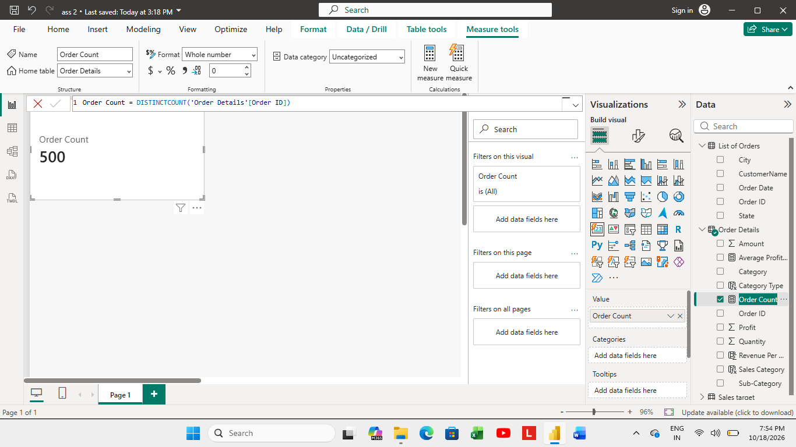
Measure 2:
New Measurename as Average Profit in Delhi.
Used CALCULATE FUNCTION; to find out average profit relationship built between list of orders and order details tables.
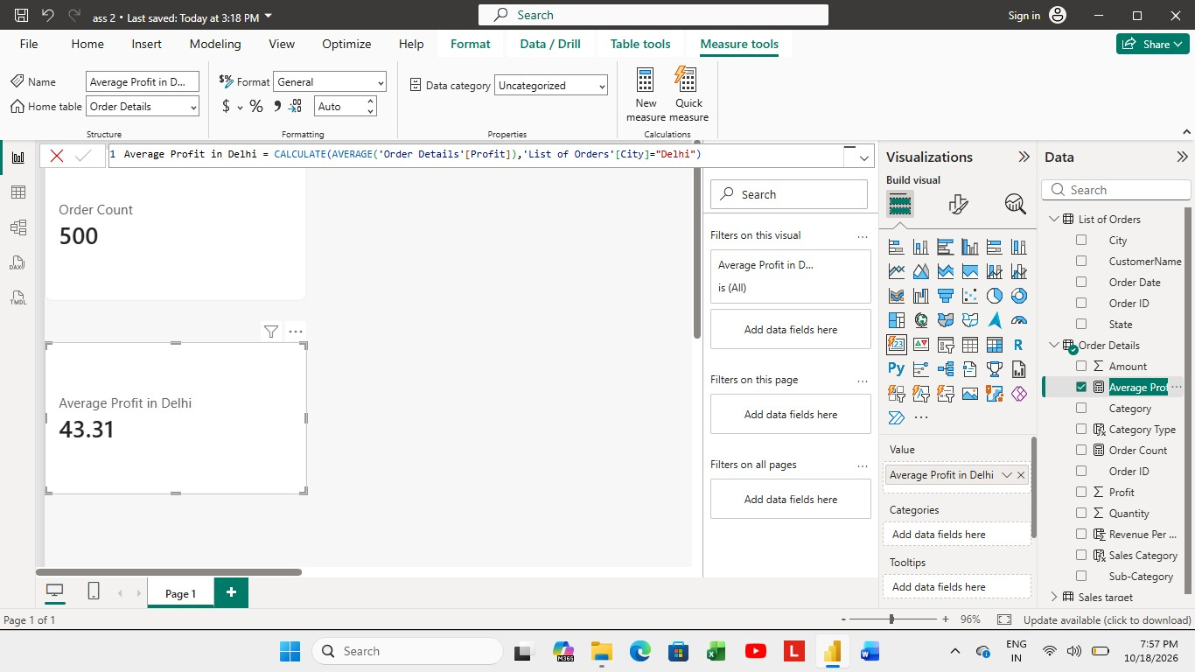
Measure 3: To create Year-to-date (YTD) sales.
First create a total sales measure using sum function: and then create YTD Sales using YTD sales Function. I changed the date formatting for this.
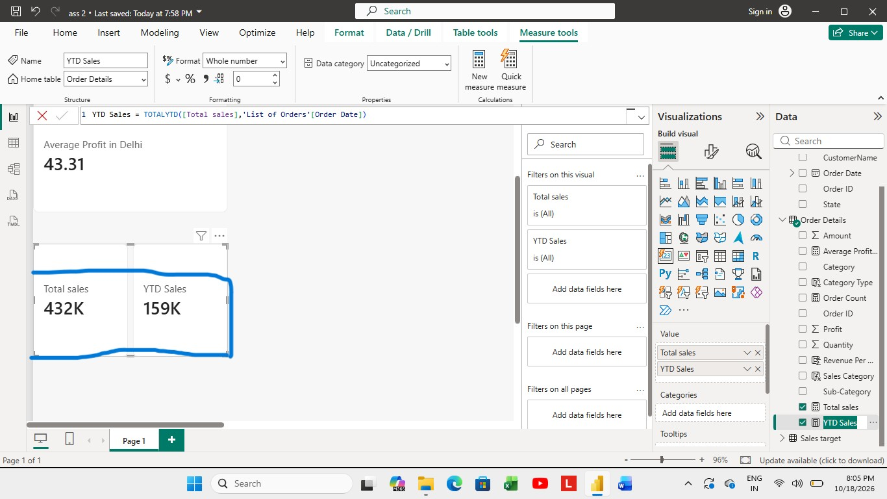
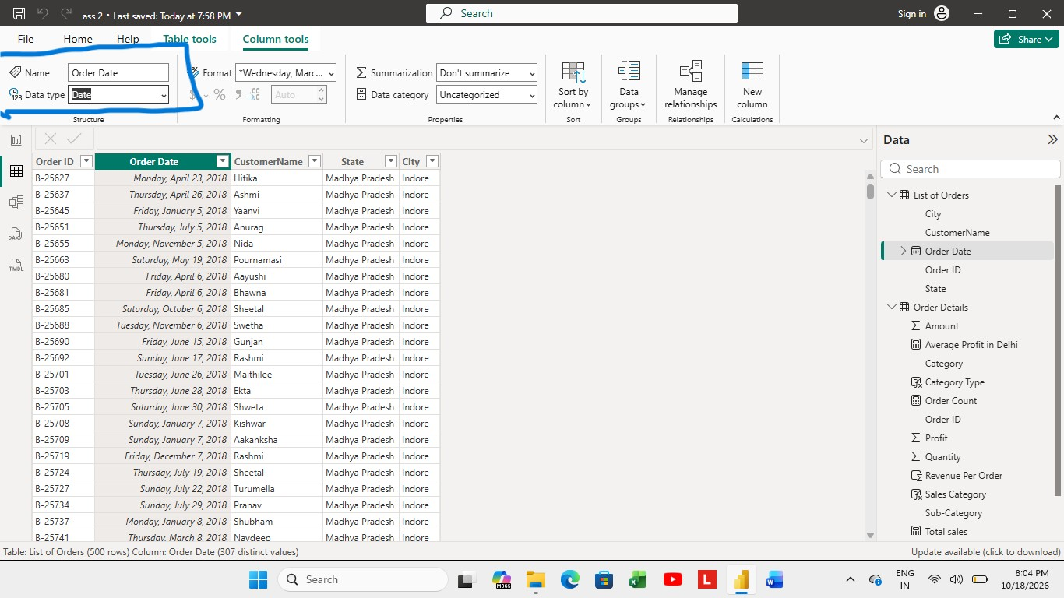
DATA VISUALIZATION:
- Sales Target Achievement by category: compared Actual Sales by Sales Target using Clustered Column chart.
I gave a tittle for Chart, underlined it, changed text font.
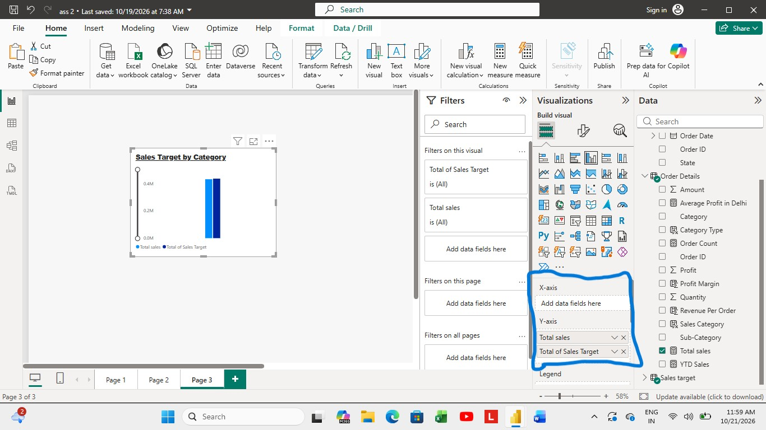
- Max Profit by Sub Category: to analyze the maximum profit margin for each sub category of products, to find max profit, I created a new calculated columns of max profit margin by dividing order details profit divided by order details amount.
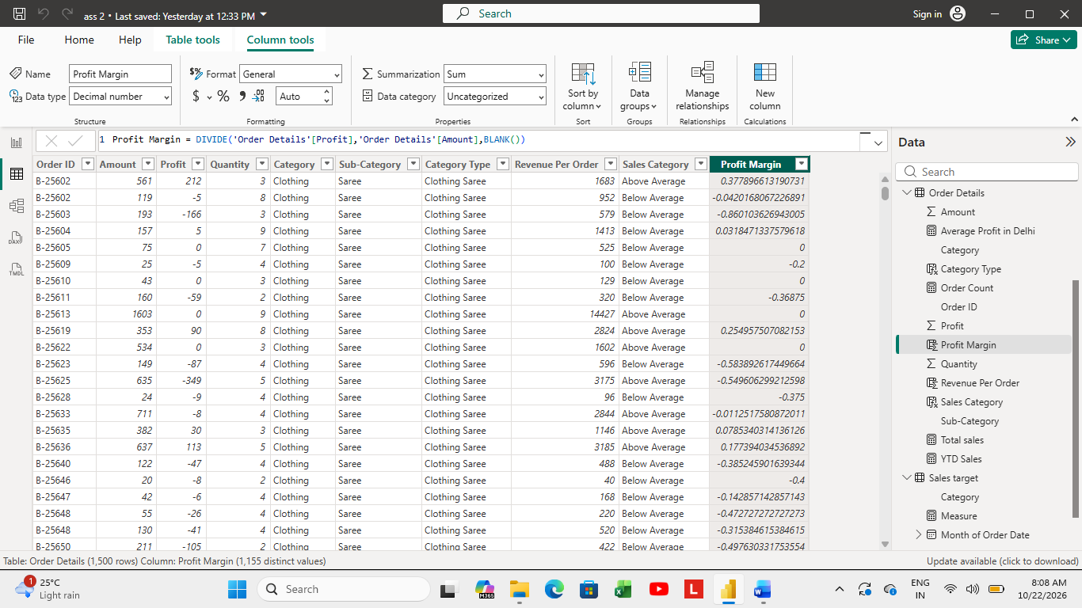
Shown how max profit is spread across sub-category.
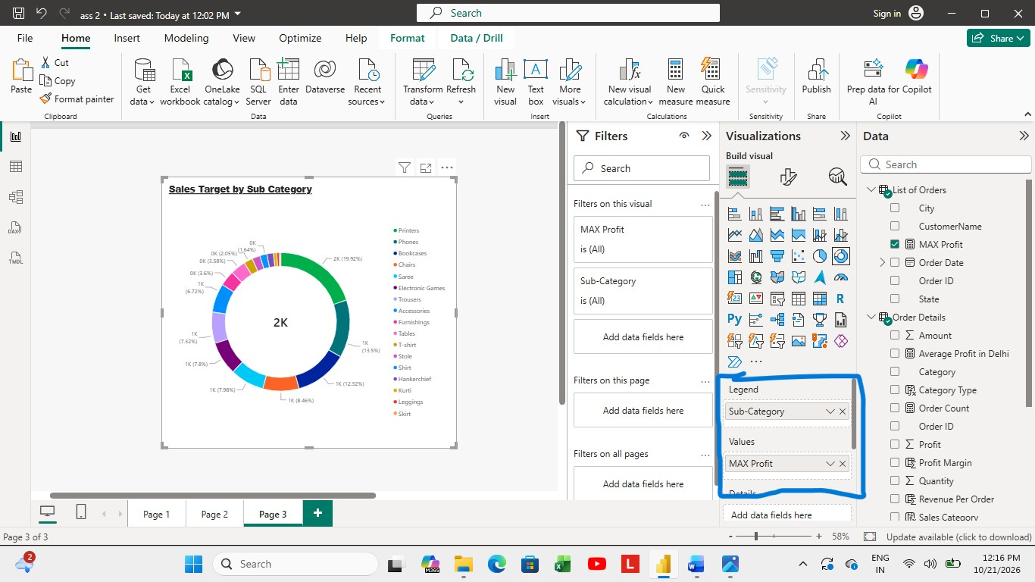

- Monthly sales Trend: To show the trend of monthly sales overtime through line chart, I added order date (month)to x-axis and total sales to y-axis.
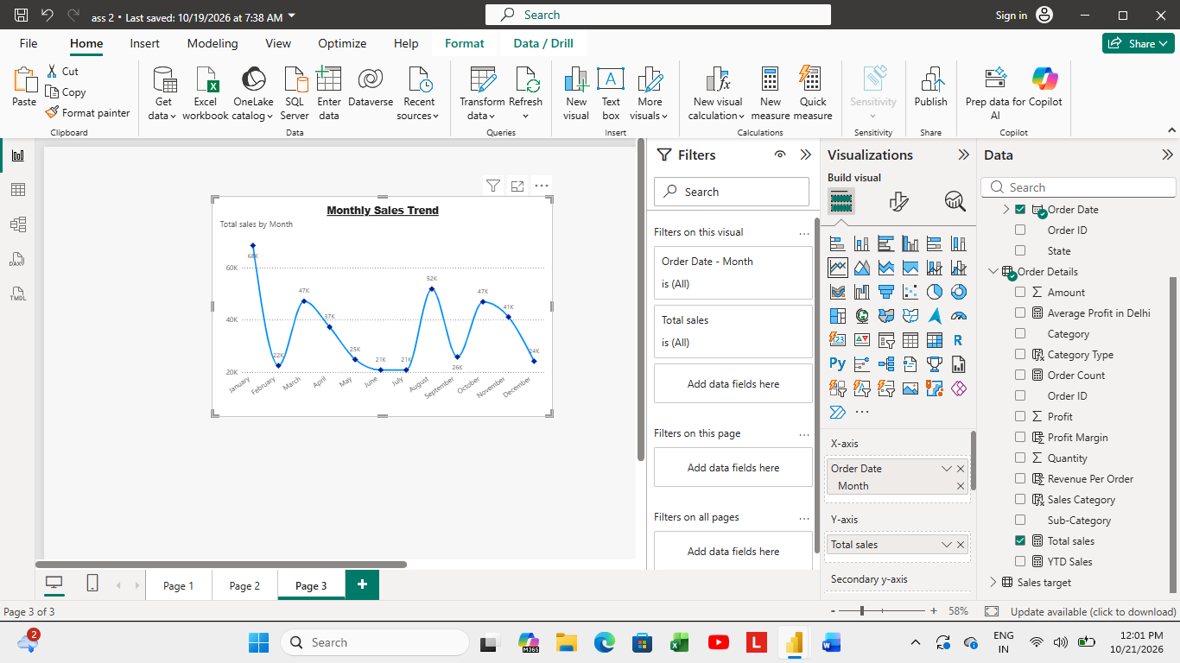
4.Comparison of Profit and Quantity by sub-category: To show the relationship between the profit and quantity used scatter chart. Where I added sum of profit to x-axis and sum of quantity to y-axis, sub-category to legend.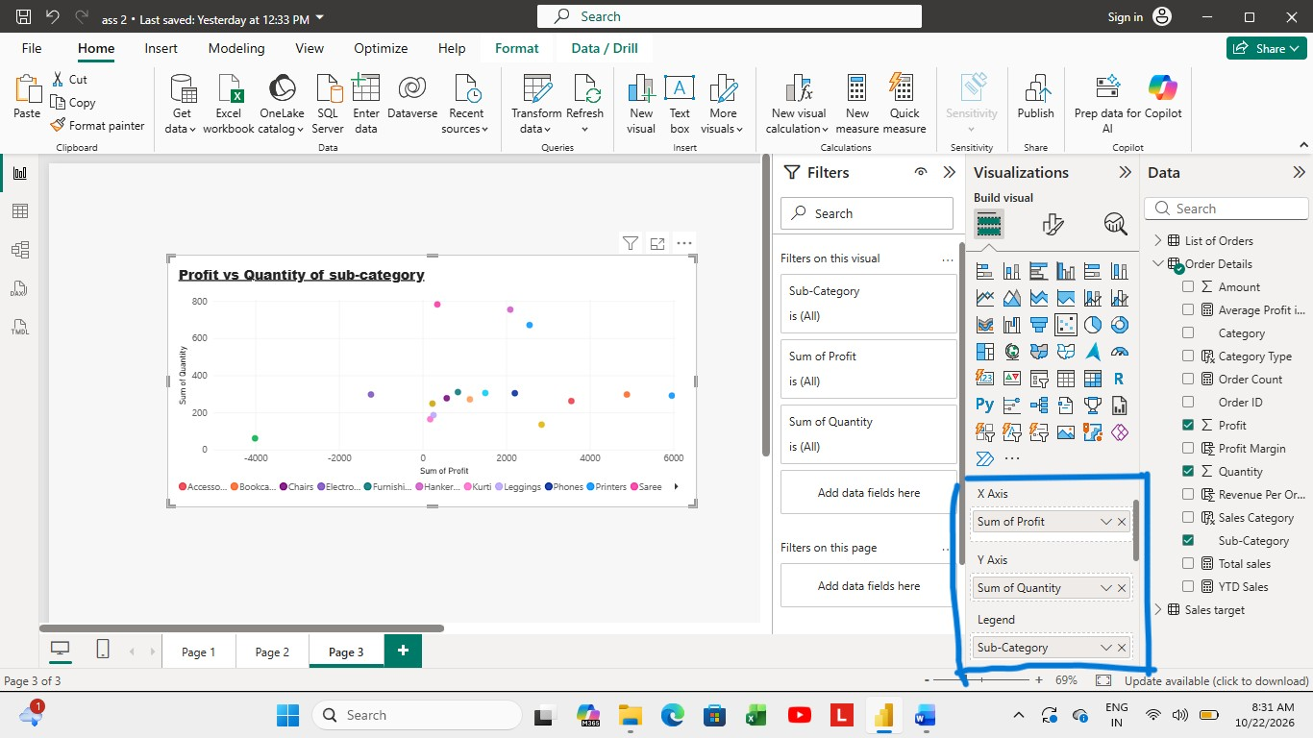
5. Comparison of Total /sales amount and Target: created cards to display the total sales amount alongside the sales target for quick comparison and analysis.
As mentioned in the assignment pdf I used cards to display the minimum target for each segment, here for each segment I used category because I can’t find any segment details in the dataset.
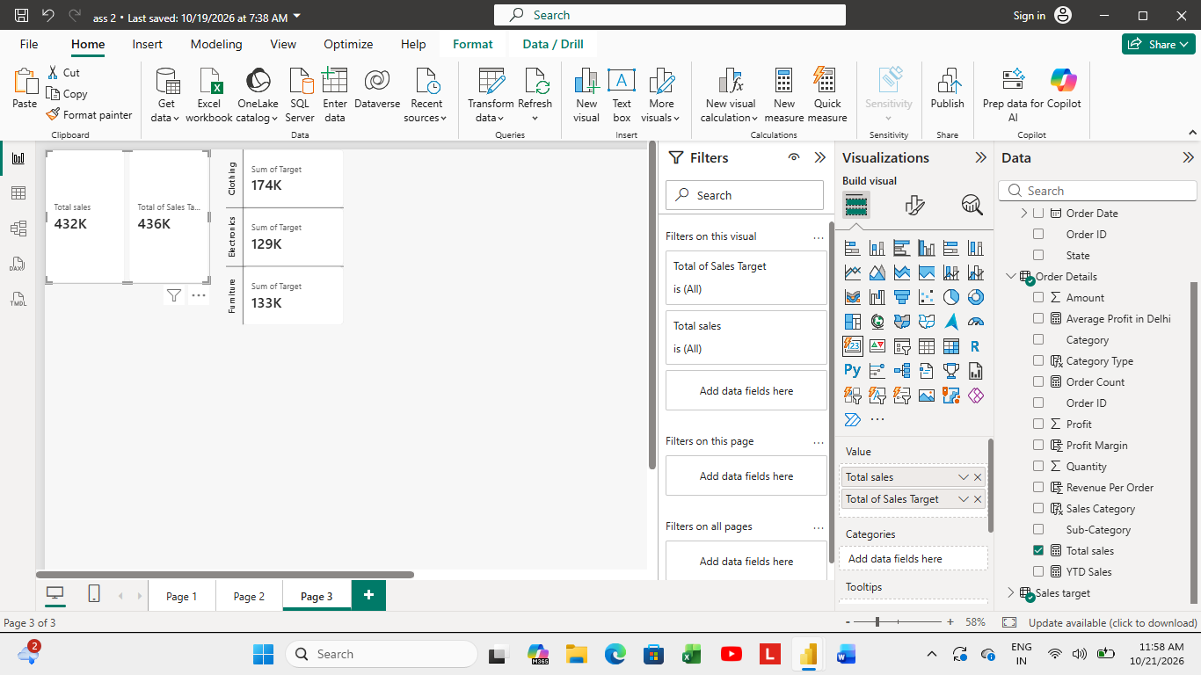
6. Sales Performance Matrix: Built a matrix view to analyze the how actual sales compare to sales target across different categories and months.
Where I added order date (month wise) to row and category, order date (month wise) to column, in values I added total sales and total target measures.
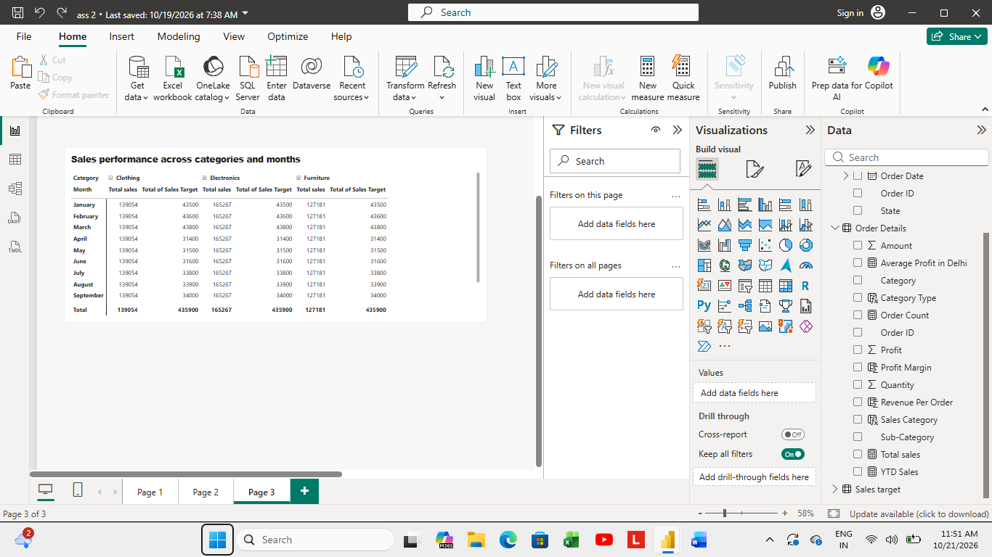
7. Geographic Sales Analysis: To add map chart
Go to fileoption and settingoptionsglobalsecuritygive tick for map and filled map visuals.
To represent regional sales, I added state and city to location and total sales value to bubble size.
Given tittle and increased the bubble size to highlight it.
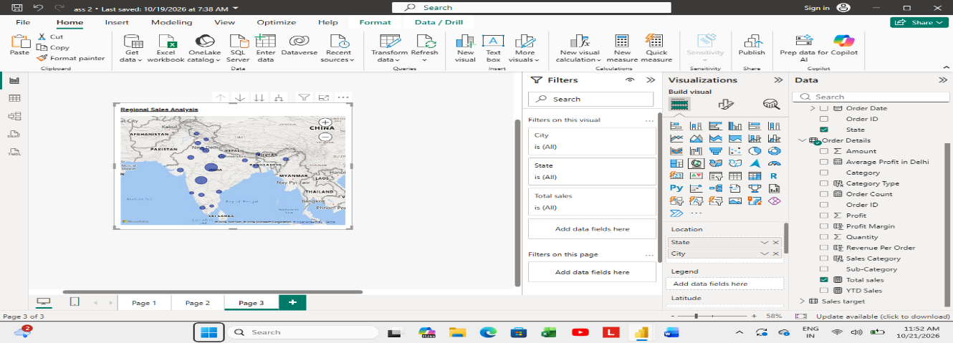
8. Sales Distribution by sub-category: To represent the sales distribution across different sub-categories used Tree Map.
Sub-category to category and total sales to values. This shows how total sales is distributed across sub-categories.
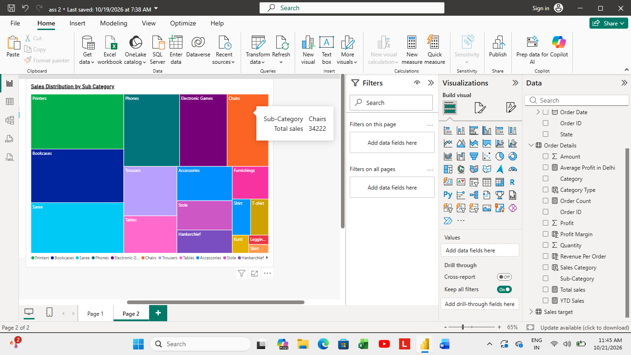
9. Order Count Analysis by State: used funnel chart to visualize the distribution of order counts across different states.
Sales in category and order count in values.
