**6 Weeks Industrial Training Report**

**O**n

**O**NLINE **M**USIC **P**ORTAL

Submitted to the partial fulfilment for the award of the degree of

**B**achelor of **T**echnology

In

**C**omputer **S**cience & **E**ngineering



**Submitted To Submitted By**

Er. Amarjit Kaur Rosy

1818097

B.Tech/CSE/5

**Table of Contents**

|  |  |  |
| --- | --- | --- |
| **Sr.no.** | **Contents** | **Page no.** |
| 1. | Student’s Declaration | 3 |
| 2. | Abstract | 4 |
| 3. | Acknowledgement | 5 |
| 4. | About Institution | 6 |
| 5. | Introduction of Project | 7 |
| 6. | Problem Statement | 9 |
| 7. | Objective | 9 |
| 8. | Existing System & its Limitations | 10 |
| 9. | Proposed System & its advantages | 11 |
| 10. | Hardware & Software Tools | 12 |
| 11. | **Feasibility Study**  a) Economic Study  b) Technical Study  c) Operational Study | 13 |
| 12. | **Technologies Used**   * HTML * CSS * JavaScript * PHP * MySQL | 15 |
| 13. | Data Flow Diagram | 19 |
| 14. | E-R diagram | 21 |
| 15. | Database Structure | 22 |
| 16. | Database Design | 23 |
| 17. | **Project Modules**   * **Home Page** * **About Page** * **Artist** * **Genre**   i) Genre Index  ii) Genre Insert   * **Album**   i) Album Index  ii)Album Insert   * **Song**   i) Song Index  ii) Song Insert   * **Admin** | 25 |
| 18. | Future Scope | 33 |
| 19. | Conclusion | 34 |
| 20. | References | 35 |

**Student’s Declaration**

I **Rosy** hereby declare that I have undertaken six weeks industrial training at “**Webdox Computer Institute”** during a period from June 1, 2019 to July 15, 2019 in partial fulfilment of requirements for the award of the degree of B.Tech in Computer Science and Engineering . The work which is being presented to the Department of Computer Science at Lyallpur Khalsa College Of Engineering , Jalandhar is an authentic record of training work.

**Abstract**

The main aim of developing this **Online Music Portal System** is to provide user friendly tool for music websites. It’s a collection of Mp3 songs of different languages in one place where users can play and listen the songs on our website at free of cost.

This is one type of online music player. Most of the websites now a day’s provide facility to download music files with free of cost makes problem with piracy so this is the best place to stop music piracy over the internet. Here the customer can play selected music files online.

The main advantage is that it is user-friendly, provide us 24x7 hours customer service and decrease the manual efforts and time.

**Acknowledgement**

The satisfaction that accompanies that the successful completion of any task would be incomplete without the mention of people whose ceaseless cooperation made it possible, whose constant guidance and encouragement crown all efforts with success.

I am grateful to my trainer (M.D) Mr. Varun Kumar, (H.O.D) Dr. Pooja Dhand and my project guide (Assistant Professor) Er. Amarjit kaur for their support and encouragement towards me at every stage in successful completion of my project.

I place my gratitude to my parents who always encouraged me to pursue my interest who have led me onto the right path. Many are responsible for the knowledge and experience I have gained during my project and throughout the course.

Finally, I would also like to thank all those who knowingly or unknowingly helped me all throughout my project.

Internal examiner____________

External examiner____________

H.O.D(CSE)________________

**About Institution**

**W**ebdox **C**omputer **I**nstitute is the best IT training institute in Jalandhar, which provides a variety of programs and courses. Webdox is affiliated to MSME (Ministry of Micro, Small & Medium Enterprises) known for the excellence, quality and consistency .

Webdox provides quality training in software development, hardware and networking, multimedia and animation, Web Designing, E-Accounting, Digital literacy, Ethical hacking and short term courses.

**Mission**

WCI aspires to be the best educational institute, which works to build active and creative minds with a sense of better technology understanding. WCI has a readily skilled manpower to help their students in spiritual, technical, physical, emotional, intellectual and moral development.

**Vision**

WCI wants to achieve unparalleled standards of quality IT education in an inexpensive fee structure. WCI is working to create leading It professional of global standards that will contribute towards the technical and economic growth of our country.

**Courses Offered**

* HTML & CSS
* PHP & MySQL
* JAVA
* Adobe Photoshop
* Adobe InDesign
* Adobe Illustrator
* CorelDraw

**Introduction of Project**

**Online Music Portal**

This e-Music web based project stands as the only digital music service 100% that is focused on serving the needs of independent music fans and independent labels. E-Music (on line music site) is among the top digital music services, offering a diverse catalog of over a lot of tracks from established and emerging artists in every genre

E-Music (on line music site) focuses on selling music beyond the commercial mainstream in every genre, including rock, jazz, comedy, hip-hop, blues, classical, country, folk, children's music, electronic, world, reggae and more. Unlike so much of today's commercial Top 40, independent music is simply about great music. Top independent artists include familiar names such as Johnny Cash, Ray Charles, Miles Davis, Bob Marley and Creedence Clearwater Revival, established rule-breakers such as the Pixies, Lucinda Williams and Black Flag, and breaking new artists like Neko Case.

In our E-Music (on line music site) all electronic records will maintained in password protected archives. All records are maintained so we can provide the facility of uploading and downloading services to the restricted person, in which you may be interested.

By integrating information and improving processes, eMusic will help improve enterprise-wide decision support and operational efficiency. Improved efficiency translates into:

* More resources to support the enterprise.
* Improved customer service
* Web-based and more user friendly interfaces to users.

The E-Music (on line music site) is an online shopping, which is base on web technology. The online transactions are playing an important role in the present world of computer, people are busy their challenging jobs. We can say that “Time is Money” in the present scenario. Internet acts as the backbone for all online transaction. Many people in the world using Internet to meet their needs. Many co-operative societies and organizations are in contact with their customers through Internet only. Things which are done manually take a lot of time. To overcome these situations, the concept of E-Music (on line music site) is developed. It describes the modular structure of E-Music (on line music site) application and provides an in-depth of several pieces of module. The modules in the E-Music (on line music site) are:

* Admin module
* User module
* Visitor module

**Admin module**

After logon, admin have administrative privilege. She/He can delete, update item check transaction within time and manage business.

**User module**

User have allot of function in this module. In this module user can download songs, search song, make wish list, give massage to admin, update their profile etc.

**Visitor module**

E-Music leads for number of unique visitors. Not only leading in unique visitors. This amount represents a huge lead that E-Music has over other shopping sites in web site stickiness. This indicates that E-Music has a strong hold over the internet shopping industry.

**Problem Statement**

There were many problems in existing system like to purchase items from shops. It was time consuming, so the user faces many problems.

* Limited customers.
* The use of manpower in the existing system is so high because maintaining the details about all the products, stock, transaction and much other process.
* Quick reports on the current status will be very time consuming and the chances of error will be high.
* Calculation mistake are another problem for the system and have drawback of accuracy of result obtained.

**Objective**

This Project’s objective was to look at online retail from a customer’s point-of-view and determine which of the biggest US-based ecommerce sites was providing the best customer experience.

A secondary aim was to zero in on key trends and identify opportunities for high-impact and

* Customer experience improvements. Product categories must be well thought out, and intuitive.
* There must be effective decision support tools to guide you through the exploration Process.
* The product must be clearly displayed with appropriate visualization tools.
* If customer I have been to the site before, it must remember me and personalize customer’s subsequent experience?
* It is easy to keep track of things customer want to buy.
* customer need to register in order to make a purchase or access certain
* Content.

Its objective is also to satisfy our clients because almost all merchants want to see that their clients are satisfied with their purchases. It is simply good business. On many occasions, after-sales difficulties arise when communication breaks down.

If you are having difficulty communicating with a merchant who is listed on E-music all you have to do is ask us and we will do our best to contact that merchant on your behalf. If your complaint is reasonable, we will attempt to secure a satisfactory resolution for you. We make no warranties of any kind in this regard but we will do our best to achieve a satisfactory outcome for you.

While it may be a good thing to know that E-Music is behind you when you make a purchase from an E-Music -listed merchant, there are some things that you should do yourself to avoid a mishap in the first place.

**Existing System**

Existing system provides facility to listen music online but it has many limitations as :

**Limitations:**

* Viruses can be introduced.
* Low audio quality
* Music piracy has increased to a greater extent. Cheaper or free “duplicate versions” of the original music files are available on the internet for download.
* Security issues due to fake website. e.g. Lose money/phishing scams on a fake website.
* Contains so many ads.

**Proposed System**

The proposed system is a computerized one. This has greater accuracy and efficiency. This takes only limited time for calculation.

The proposed system can be used to maintain efficiently the HR Department schedule of any type of company. In larger organizations employees are large. At that time also the proposed system is useful and helpful. E-Music System is not only become a desire of the company but it become the need of the company.

The system includes two users

* Administra
* tor(HR)
* General User

The user gets into the system using user name and a unique password. Each user has his own accessibility permission to accomplish his task flawlessly.

**Advantages of proposed system:**

* Easy access to the data
* The new system is more users friendly, reliable and flexible.
* Pop-up menus to carry out transactions for a new user, and for other alert messages.
* Timely Report generation.
* Can access/get files 24x7
* Can be used on multiple devices.

**Hardware and Software Tools**

**Software Requirement**

Operating System Window XP/Windows 7

Web Server Apache

Front End HTML, CSS, JavaScript

Back End PHP & MySQL

**Hardware requirement**

Main Processor Core i3

Hard-disk 8 G.B

RAM 512 MB

Keyboard 104 Key

Monitor V.G.A

**Feasibility Study**

A feasibility study is conducted to select the best system that meets performance requirement. This entails an identification description, an evaluation of candidate system and the selection of best system for job. The system required a statement of constraints; the identification of specific system objective and a description of output define performance etc..The key considerations in feasibility analysis are:

* Economic Feasibility
* Technical Feasibility
* Operational Feasibility

**Economical feasibility**

It looks at the financial aspects of the project. It determines whether the management has enough resource and budget to invest in the proposed system and the estimated time for the recovery of cost incurred. It also determines whether it is worthwhile to invest the money in the proposed project. Economic feasibility is determines by the means of cost benefit analysis. The proposed system is economically feasible because the cost involved in purchasing the hardware and the software are within approachable. The personal cost like salaries of employees hired are also nominal because the working in this system need not required a highly qualified professional. The operating-environment costs are marginal. The less time involved also helped in its economical feasibility. It was observed that the organization has already using computers for other purpose, so that there is no additional cost to be incurred for adding this system to its computers.

The backend required for storing other details is also the same database that is oracle8i. The computers in the organization are highly sophisticated and don’t needs extra components to load the software. Hence the organization can implement the new system without any additional expenditure. Hence, it is economically feasible.

**Technical Feasibility**

It is a measure of the practically of a specific technical solution and the availability of technical resources and expertise The proposed system uses jsp as front-end java bean as middle-end and oracle8i as back-end tool.

* Oracle is a popular tool used to design and develop database objects such as table views, indexes.
* The above tools are readily available, easy to work with and widely used for developing commercial application.

**Operational Feasibility**

The system will be used if it is developed well then be resistance for users that undetermined -

* No major training and new skills are required.
* It will help in the time saving and fast processing and dispersal of user request and applications.
* New product will provide all the benefits of present system with better performance.
* Improved information, better management and collection of the reports.
* User support.
* User involvement in the building of present system is sought to keep in mind the user specific requirement and needs.

**Technologies Used**

**HTML**

**HTML** stands for **Hyper Text Markup Language**, which is the most widely used language on Web to develop web pages. **HTML** was created by Berners-Lee in late 1991 but "HTML 2.0" was the first standard HTML specification which was published in 1995. HTML 4.01 was a major version of HTML and it was published in late 1999. Though HTML 4.01 version is widely used but currently we are having HTML-5 version which is an extension to HTML 4.01, and this version was published in 2012.HTML is the standard markup language for Web pages.

* With HTML you can create your own Website.
* HTML is easy to learn
* HTML is the standard markup language for creating Web pages.

**Features of HTML**

* **Web pages development** - HTML is used to create pages which are rendered over the web. Almost every page of web is having html tags in it to render its details in browser.
* **Internet Navigation** - HTML provides tags which are used to navigate from one page to another and is heavily used in internet navigation.
* **Responsive UI** - HTML pages now-a-days works well on all platform, mobile, tabs, desktop or laptops owing to responsive design strategy.
* **Offline support** HTML pages once loaded can be made available offline on the machine without any need of internet.
* **Game development**- HTML5 has native support for rich experience and is now useful in gaming development.

**CSS**

* CSS is a language that describes the style of an HTML document.
* CSS describes how HTML elements should be displayed.
* **CSS** stands for **C**ascading **S**tyle **S**heets
* CSS describes **how HTML elements are to be displayed on screen, paper, or in other media**
* CSS **saves a lot of work**. It can control the layout of multiple web pages all at once
* External stylesheets are stored in **CSS files**
* **CSS saves time** - You can write CSS once and then reuse same sheet in multiple HTML pages. You can define a style for each HTML element and apply it to as many Web pages as you want.
* **Pages load faster** - If you are using CSS, you do not need to write HTML tag attributes every time. Just write one CSS rule of a tag and apply it to all the occurrences of that tag. So less code means faster download times.
* **Easy maintenance** - To make a global change, simply change the style, and all elements in all the web pages will be updated automatically.
* **Superior styles to HTML** - CSS has a much wider array of attributes than HTML, so you can give a far better look to your HTML page in comparison to HTML attributes.
* **Multiple Device Compatibility** - Style sheets allow content to be optimized for more than one type of device. By using the same HTML document, different versions of a website can be presented for handheld devices such as PDAs and cell phones or for printing.
* **Global web standards**- Now HTML attributes are being deprecated and it is being recommended to use CSS. So its a good idea to start using CSS in all the HTML pages to make them compatible to future browsers.

**JavaScript**

* **JavaScript** is a lightweight, interpreted **programming** language. It is designed for creating network-centric applications. It is complimentary to and integrated with Java. **JavaScript** is very easy to implement because it is integrated with HTML. It is open and cross-platform.
* JavaScript is the programming language of HTML and the Web.
* JavaScript is easy to learn.
* JavaScript is the most popular **programming language** in the world and that makes it a programmer’s great choice. Once you learnt JavScript, it helps you developing great front-end as well as back-end software using different JavaScript based frameworks like JQuery, Node.JS etc.
* JavaScript is everywhere, it comes installed on every modern web browser and so to learn JavaScript you really do not need any special environment setup. For example Chrome, Mozilla Firefox , Safari and every browser you know as of today, supports JavaScript.
* JavaScript helps you create really beautiful and crazy fast websites. You can develop your website with a console like look and feel and give your users the best Graphical User Experience.
* JavaScript usage has now extended to mobile app development, desktop app development, and game development. This opens many opportunities for you as JavaScript Programmer.
* Due to high demand, there is tons of job growth and high pay for those who know JavaScript. You can navigate over to different job sites to see what having JavaScript skills look like in the job market.
* Great thing about JavaScript is that you will find tons of frameworks and Libraries already developed which can be used directly in your software development to reduce your time to market.

**PHP**

PHP started out as a small open source project that evolved as more and more people found out how useful it was. **Rasmus Lerdorf** unleashed the first version of PHP way back in 1994.

* PHP is a recursive acronym for “PHP: Hypertext Preprocessor”.
* PHP is a server side scripting language that is embedded in HTML.
* It is integrated with a number of popular databases, including MySQL, PostgreSQL, Oracle and Microsoft SQL Server.
* PHP is forgiving: PHP language tries to be as forgiving as possible.
* PHP syntax is like C language.

**Characteristics of PHP:**

* Simplicity
* Efficiency
* Security
* Flexibility
* Familiarity

**MySQL**

MySQL is a Relational Database Management System (RDBMS). MySQL operates using client/server architecture in which the server runs on the machine containing the database and clients connect to the server over a network. The server operating system is usually a Linux (like a Redhat 9.0 etc.) or Windows XP and others. As with any other client/server application, MySQL is a multi-user database system, meaning several users can access the database simultaneously.

**Features of MySQL:**

* **Speed:** MySQL runs very fast. It supports clustered servers for demanding applications.
* **Ease of use**: MySQL is a high-performance, relatively simple database system. From the beginning, MySQL has typically been configured, monitored and managed from the command line.
* **Cost:** MySQL is available free of cost. MySQL is a “Open Source” database. MySQL is part of LAMP (Linux, Apache, MySQL, PHP / Perl / Python) environment, a fast growing open source enterprise software stack. More and more companies are using LAMP as an alternative to expensive proprietary software stacks because of its lower cost, reliability and documentation.
* **Query Language Support:** MySQL understands standards based SQL (Structured Query Language) .
* **Capability:** Many clients can connect to the server at the same time. clients can use multiple database simultaneously. We can access MySQL using several interfaces such as command-line clients, Web browsers.
* **Connectivity and Security:** MySQL is fully networked, and database can be accessed from anywhere on the Internet, so you can share your data with anyone and anywhere. The connectivity could be achieved with Windows programs by using ODBC drivers. By using the ODBC connector to MySQL, any ODBC-aware client application can connect to MySQL.
* **Portability:** MySQL runs on many varieties of UNIX, as well as on other non-UNIX systems, such as Windows and OS/2. MySQL runs on hardware from home PCs to high-end server. MySQL can be installed on Windows XP, Windows Server 2003, Red Hat Fedora Linux, Debian Linux, and others.

**Data Flow Diagram**

A data flow diagram shows the logical flow of the system. For a system it describes the input (source), output (destination), database (data stores) and procedures (data flows) all in a format that meets the user’s requirement. When analysis prepares the logical system design, they specify the user needs at a level of detail that virtually determines the information flow into an out of the system and the required data resources. The logical design also specifies input forms and screen layouts.

The activities following logical design are the procedure followed in the physical design e.g. producing programs, software, file and a working system. Design specifications instruct the user about what the system should do.

To construct data flow diagram, we use:

* **Arrows:** anarrow identifies data flow, data in motion. It is a pipeline through which information flows.
* **Circle:** circle stands for a process that converts data.
* **Open-ended Box:** It represents data stores.
* **Square:** A square defines a source or destination of the system data.

**Context Level DFD**

User

Administrator

Personal detail

Browse Products.

Check Order Status Online

Get Query Response

Add Products to wish list

Place Orders & Make Payments

Add & update products

Get Queries

Check Orders

Check Payments

Delivery updates

Query Response

**Context level DFD(Admin/user)**

**First Level DFD**

Browse Products.

Create Account

Update Profile

Buy Item

Get Item information

Get Orders Reports

Get Delivery Reports

Add & update products, category.

Delivery updates & Query Response

Get Queries.

Check Orders & Check Payments.

Add Products to Carts.

Place Orders & Make Payments.

ADMIN

CUSTOMER

MEMBER

VISITOR

**First level DFD (Admin/user)**

**Entity Relationship Diagram**

**Submit**

**Request**

Wishlist_Info

Buy

Has

User

Item_Master

Username

Item_code,

rate

User_Info

insert

Sales_master

Reads

##### Browse

Visitor

FeedBack_ Master

vote

Vote_info

Admin

Delete

check

Maintains

**Database Design**

A database is a collection of inter-related data stored with a minimum of redundancy to serve many applications. It minimizes the artificiality embedded in using separate files. The primary objectives are fast response time to enquire, more information at low cost, control of redundancy, clarity and ease of use, accuracy and fast recovery. The organization of data in a database aims to achieve three major objectives, they are data integration, data integrity and data independence. During the design of the database at most care has been taken to keep up the objectives of the database design.

**Database Structure**

This part of the design consist the overall database schema or we can say that tables which consists various types of records. Table of a database consists attributes, entities, tuples for storing and manipulating records.

Some of the tables are follows:

**1. Bank_Detail:**

|  |  |  |
| --- | --- | --- |
| **Field Name** | **Data Type** | **Constraint** |
| Credit_card_no | Number | Primary key |
| Bank_name | Varchar2 |  |

**2. Item_Master:**

|  |  |  |
| --- | --- | --- |
| **Field Name** | **Data Type** | **Constraint** |
| Item_code | Number | Primary key |
| Title | Varchar2 |  |
| Rate | Number |  |
| Item_Description | Varchar2 |  |
| Singer | Varchar2 |  |
| Qty_On_Hand | Number |  |
| Type | Varchar2 |  |
| Release Date | Date |  |

**3. Login_Info:**

|  |  |  |
| --- | --- | --- |
| **Field Name** | **Data Type** | **Constraint** |
| Username | Varchar2 | Primary key |
| Password | Varchar2 |  |
| SecretQuestion | Varchar2 |  |
| Secret Answer | Varchar2 |  |
| Role | Varchar2 | Type of user (admin or user) |

**4. Sales_Mater:**

|  |  |  |
| --- | --- | --- |
| **Field Name** | **Data Type** | **Constraint** |
| Sales_id |  | Primary key |
| Sales_Date | Date |  |
| Item_code | Number | Foreign key |
| Sales_qty | Number |  |
| Rate | Number |  |
| UserName | Varchar2 | Foreign key |

**5. Vote_Info:**

|  |  |  |
| --- | --- | --- |
| **Field Name** | **Data Type** | **Constraint** |
| Item_Code | Number | Foreign key |
| Number_Votes | Number |  |

**6.WhishList_Info:**

|  |  |  |
| --- | --- | --- |
| **Field Name** | **Data Type** | **Constraint** |
| UserName | Varchar2 | Foreign key |
| Item_code | Number | Foreign key |
| Quantity | Number |  |
| Whish_Date | Date |  |

**7. User_Info:**

|  |  |  |  |
| --- | --- | --- | --- |
|  | **Data Type** | **Constraint** | **Description** |
| UserName | Varchar2 | Primary key |  |
| FirstName | Varchar2 |  |  |
| MiddleName | Varchar2 |  |  |
| LastName | Varchar2 |  |  |
| dateOfBirth | Date |  |  |
| email | Varchar2 |  |  |
| AddressLine! | Varchar2 |  |  |
| AddressLine2 | Varchar2 |  |  |
| City | Varchar2 |  |  |
| State | Varchar2 |  |  |
| Craditcard | Varchar2 |  |  |
| Creditcardtype | Varchar2 |  |  |

**8. FeedBack_Mater:**

|  |  |  |  |
| --- | --- | --- | --- |
| **Field Name** | **Data Type** | **Constraint** | **Description** |
| User_Name | Varchar2 | Foreign key | This is a unique & not null column user_info |
| Message | Varchar2 |  | Type of the Order (Member or Visitor ) |
| Msg_Date | Varchar2 |  | Order date & time |

**Project Modules:**

**HOME PAGE**

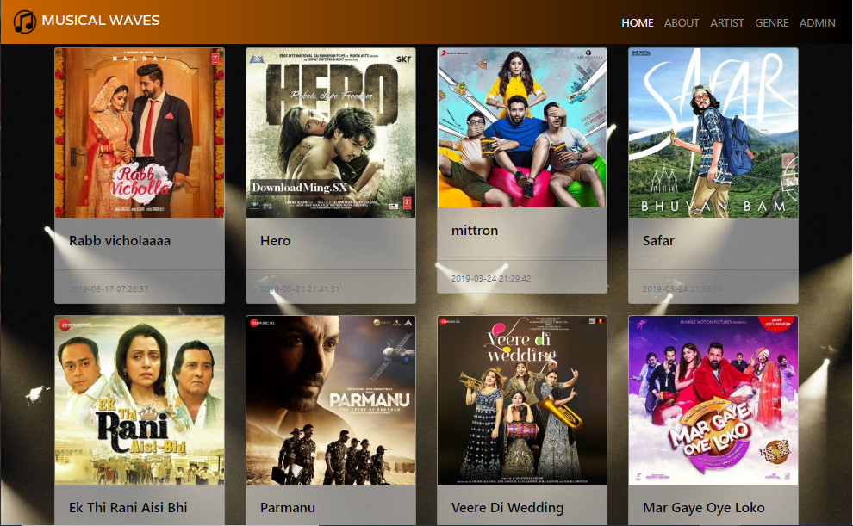

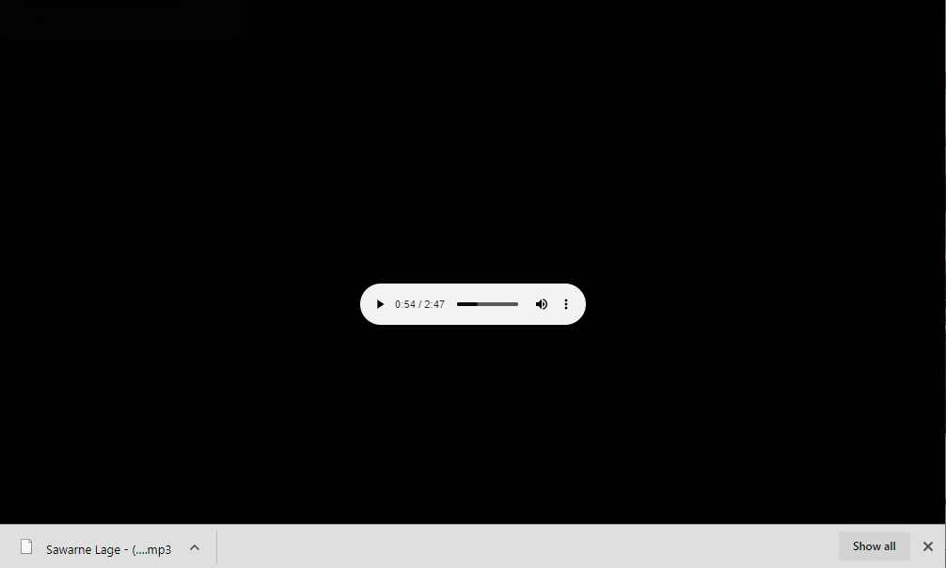

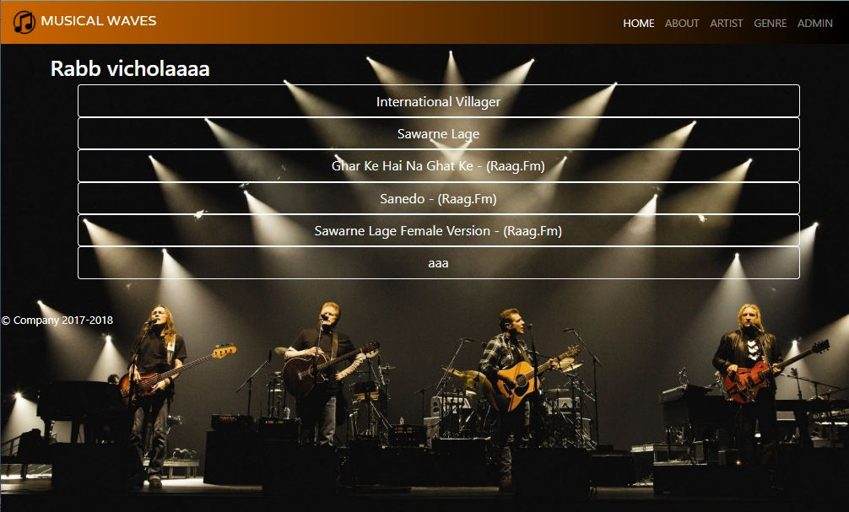**ABOUT PAGE**

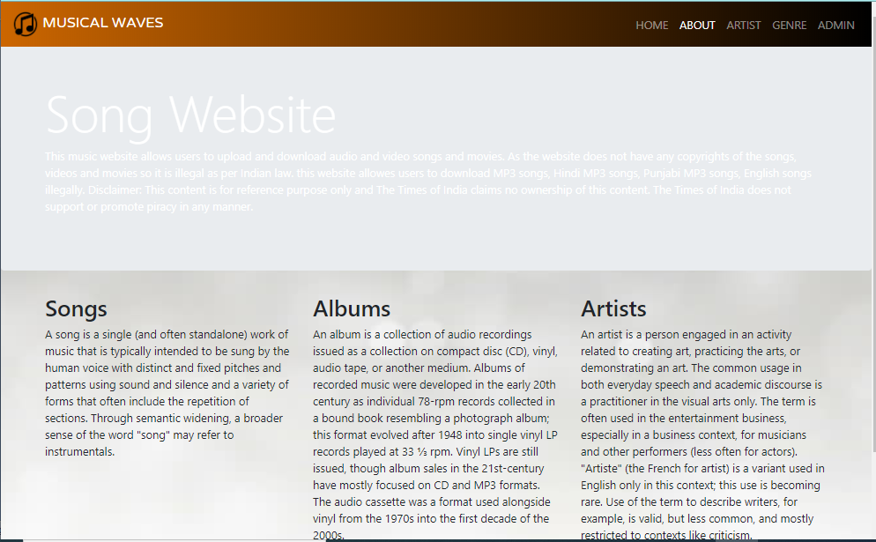

**ARTIST**

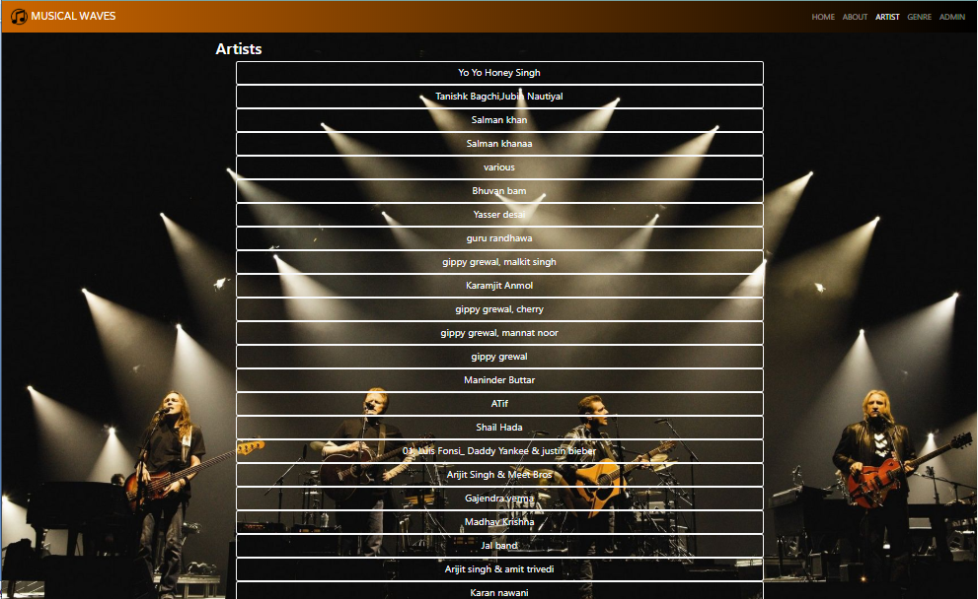

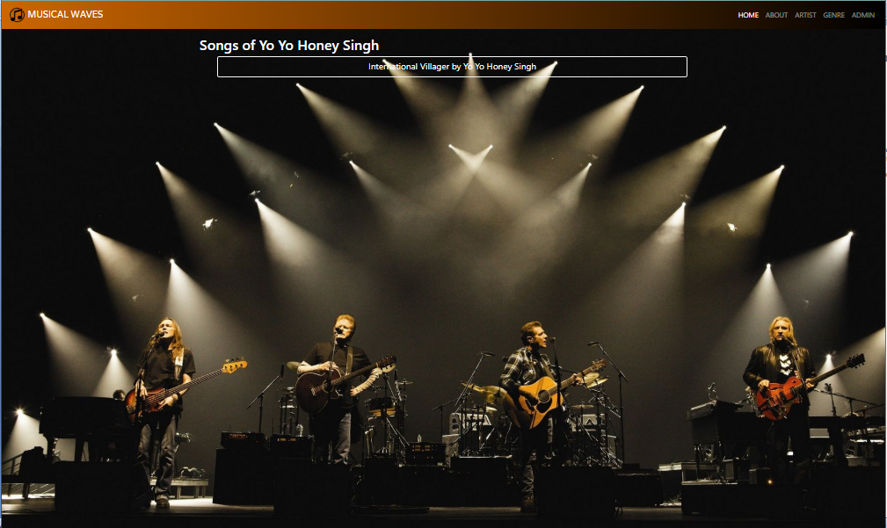

**GENRE**

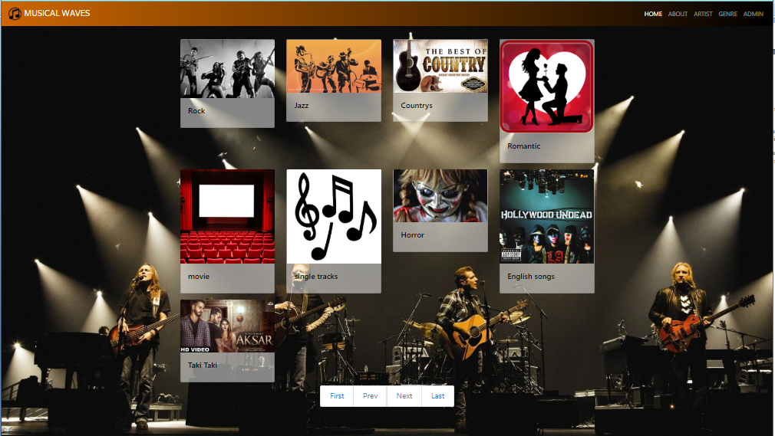

**ADMIN**

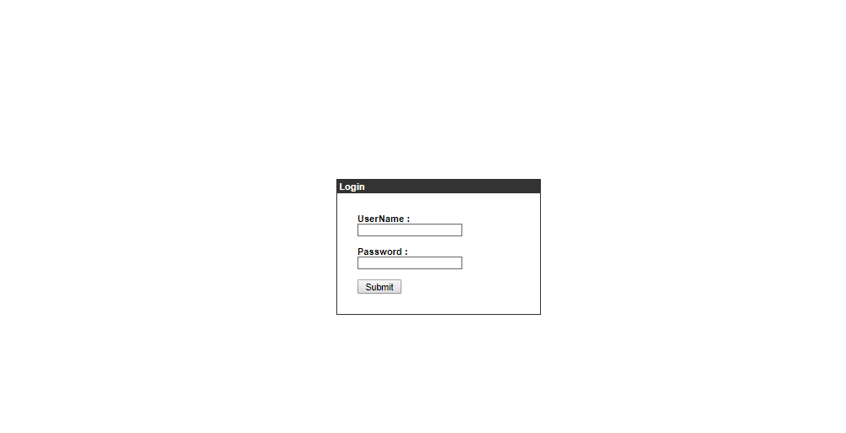

**GENRE INDEX**

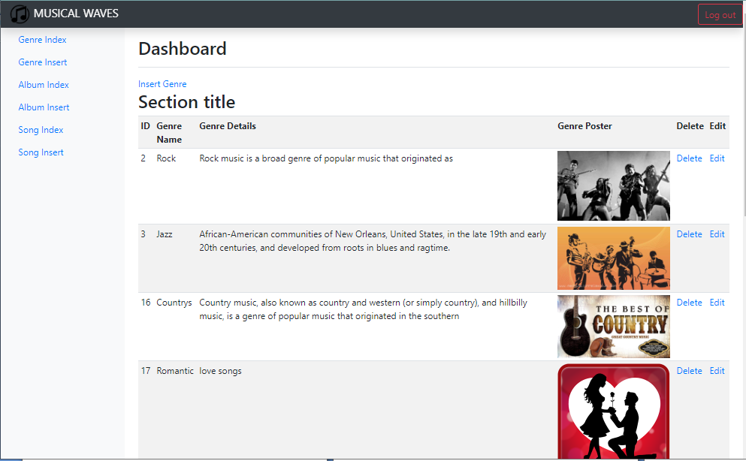

**GENRE INSERT**

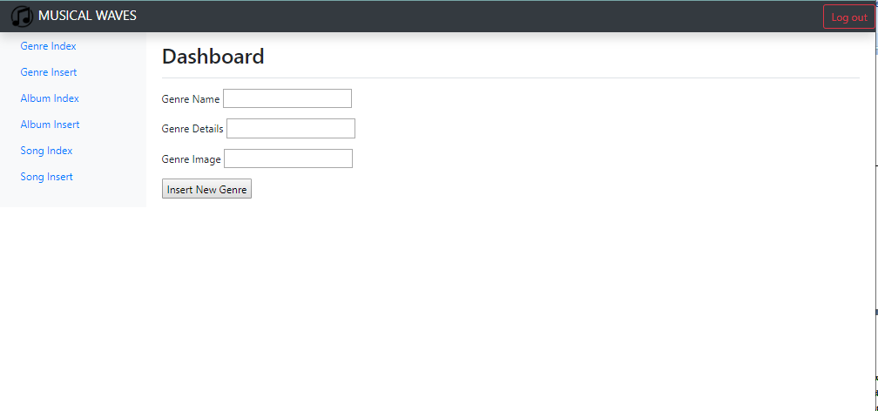

**ALBUM INDEX**

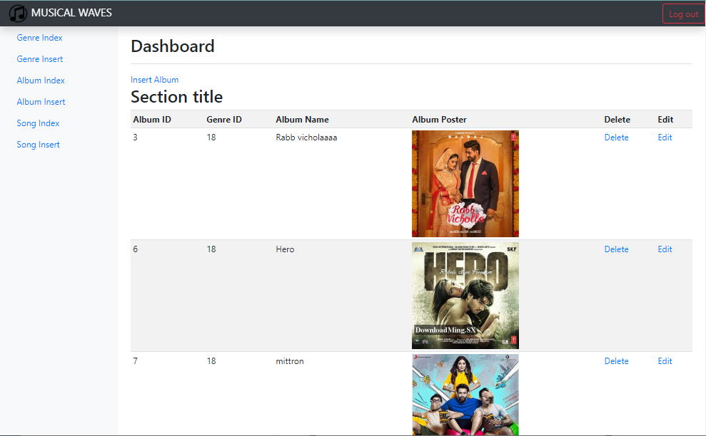

**Album insert**

**ALBUM INSERT**

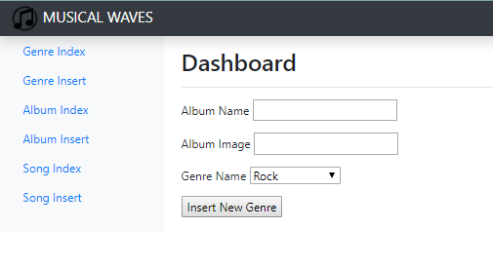

**SONG INDEX**

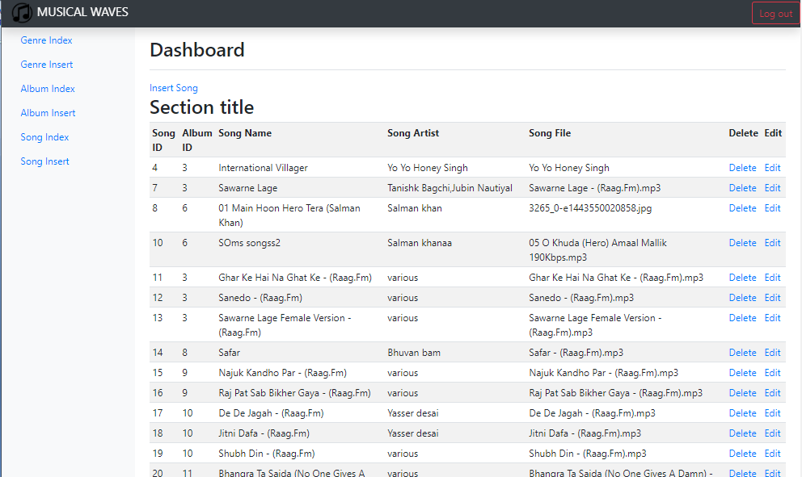

**SONG INSERT**

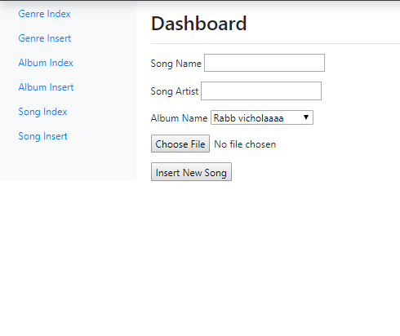

**SONG UPDATE**

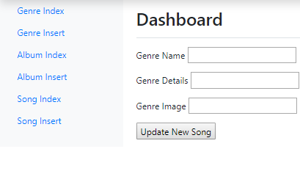

**Future scope**

In future this project can be treated as product according to specification and needs of any organization.

At present days every organization is using web technology for their proper functioning, so this web based project is all in all important from market aspects.

Furthermore if this project will be uploaded, it can be used as music entertainment site and any person can register their self on the site to access different type of music albums.

**Conclusion**

* Proper availability of new songs and videos on the website.
* Ability to listen and download songs.
* Effective use o fdatabase to store songs and videos in bytes.
* Finally a quick and responsive website has been created.

**References**

* <http://java.sun.com/>
* <http://www.coregoogle.com>
* <http://www.unreleashed.com>
* <http://www.wikipedia.com>

**Books**

Core Java – Sun Micro Systems (Vol. 1 & 2)

Core Servlet and JSP by Marty Hall.

Professional Java Server Programming by Subrahmanayam Allamraju & his group.

Complete Reference Oracle 9i.

A Practitioner approach to software engineering –By Pressman

Database System Concepts – By F. Korth

HTML and JavaScript – By Ivan Bayross