**Patching One Node DB System from CLI:**

*Prereq:*

* Database node must be active and running while a patching operation is in progress, whether you are patching the DB system or the database home.
* Patching operations require a minimum of 15 GB of free space in the /u01 directory on the host file system. Use the df -h command on the host to check the available space. If the file system has insufficient space, you can remove old log or trace files to free up space.
* Oracle Clusterware enables servers to communicate with each other so that they can function as a collective unit. The cluster software program must be up and running on the DB system for patching operations to complete. Occasionally you might need to restart the Oracle Clusterware to resolve a patching failure

*Steps:*

1. SSH to the DB System.

ssh -i *<private_key_path>* opc@*<db_system_ip_address>*

1. Log in as opc and then sudo to the root user. Use sudo su - with a hyphen to invoke the root user's profile, which will set the PATH to the dbcli directory (/opt/oracle/dcs/bin).

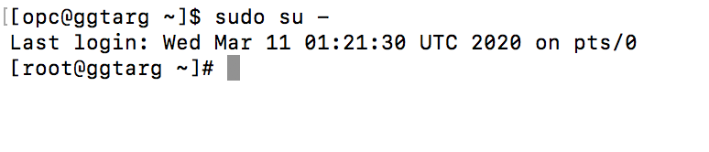

1. Update the CLI by using the [cliadm update-dbcli](https://docs.cloud.oracle.com/en-us/iaas/Content/Database/References/dbacli.htm#dbcli-a) command.

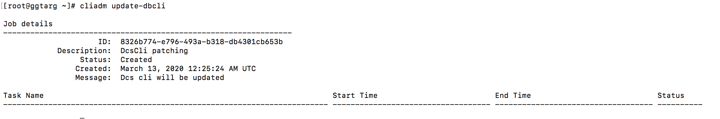

1. Wait for the update job to complete successfully. Check the status of the job by using the [dbcli list-jobs](https://docs.cloud.oracle.com/en-us/iaas/Content/Database/References/dbacli.htm#dbcli4) command.

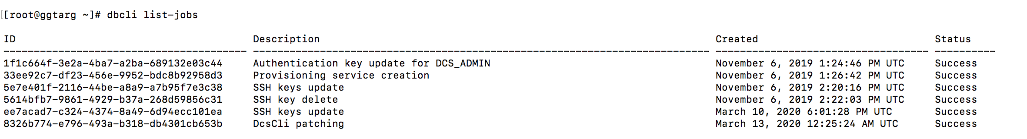

1. Check for installed and available patches. Display the installed patch versions by using the [dbcli describe-component](https://docs.cloud.oracle.com/en-us/iaas/Content/Database/References/dbacli.htm#dbcli43) command. If the Available Version column indicates a version number for a component, you should update the component.

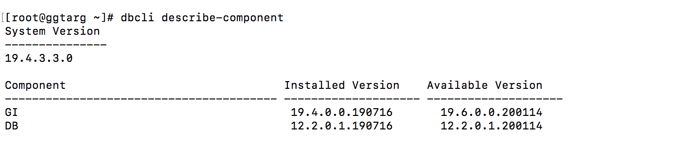

1. Display the latest patch versions available in Object Storage by using the [dbcli describe-latestpatch](https://docs.cloud.oracle.com/en-us/iaas/Content/Database/References/dbacli.htm#dbcli44) command.

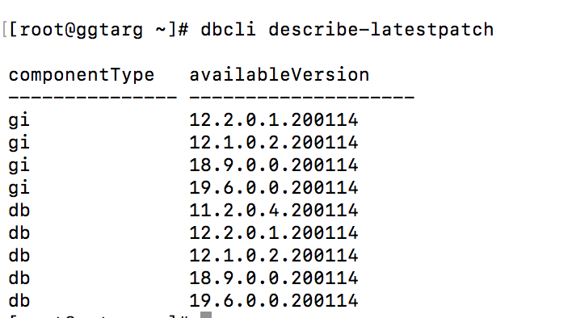

1. Patch the Grid Infrastructure (GI) and storage management kit (OAK) server components. Update the server components by using the [dbcli update-server](https://docs.cloud.oracle.com/en-us/iaas/Content/Database/References/dbacli.htm#dbcli3) command.

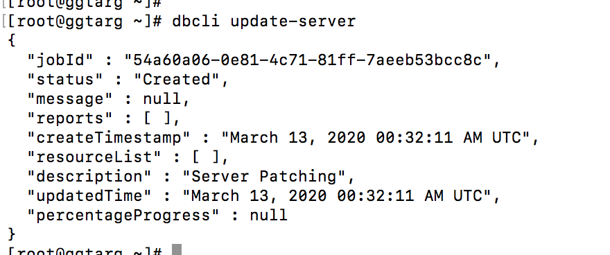

1. Check the job output by using the [dbcli describe-job](https://docs.cloud.oracle.com/en-us/iaas/Content/Database/References/dbacli.htm#dbcli5) command with the job ID.

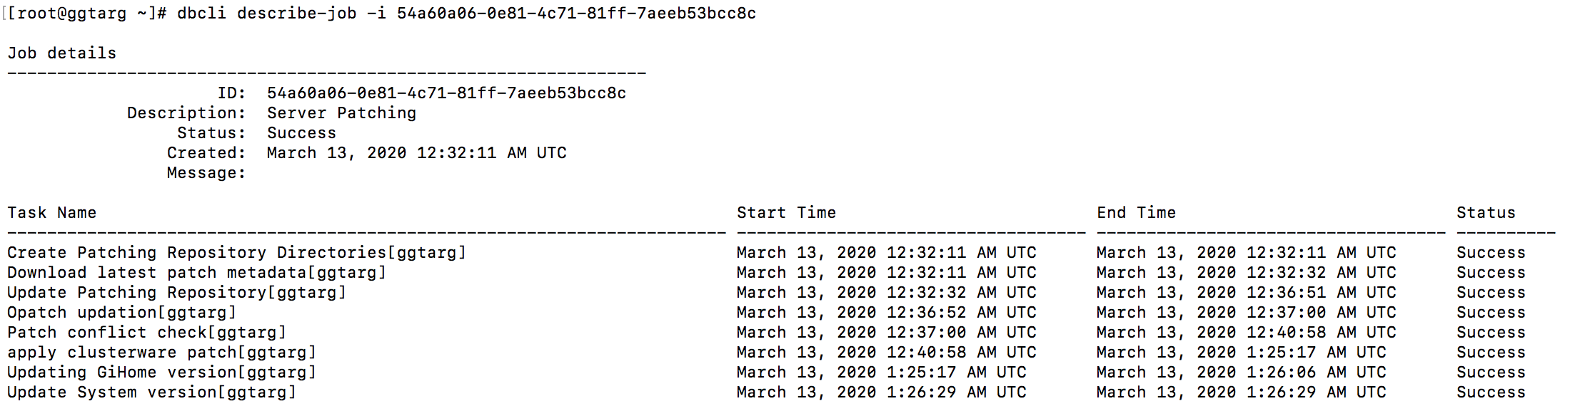

1. Verify that the server components were updated successfully by using the [dbcli describe-component](https://docs.cloud.oracle.com/en-us/iaas/Content/Database/References/dbacli.htm#dbcli43) command. The Available Version column should indicate update-to-date.

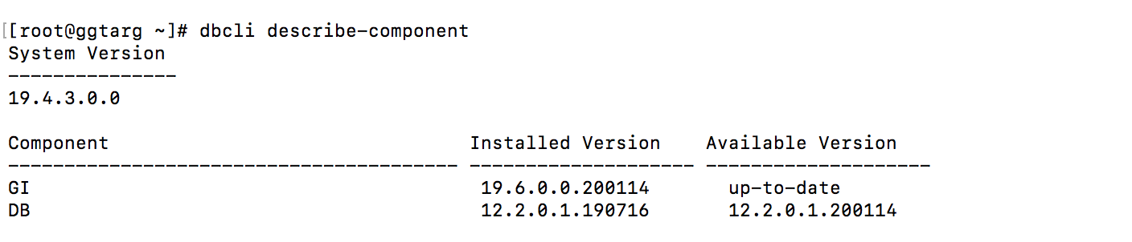

1. Get the ID of the database home by using the [dbcli list-dbhomes](https://docs.cloud.oracle.com/en-us/iaas/Content/Database/References/dbacli.htm#dbcli13) command.



1. Update the database home components by using the [dbcli update-dbhome](https://docs.cloud.oracle.com/en-us/iaas/Content/Database/References/dbacli.htm#updatedbhome) command and providing the ID from the previous step.

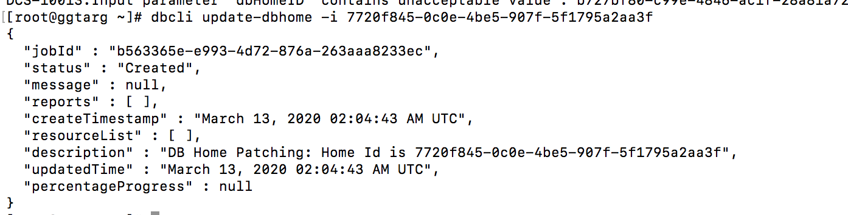

1. Check the job output by using the [dbcli describe-job](https://docs.cloud.oracle.com/en-us/iaas/Content/Database/References/dbacli.htm#dbcli5) command with the job ID.

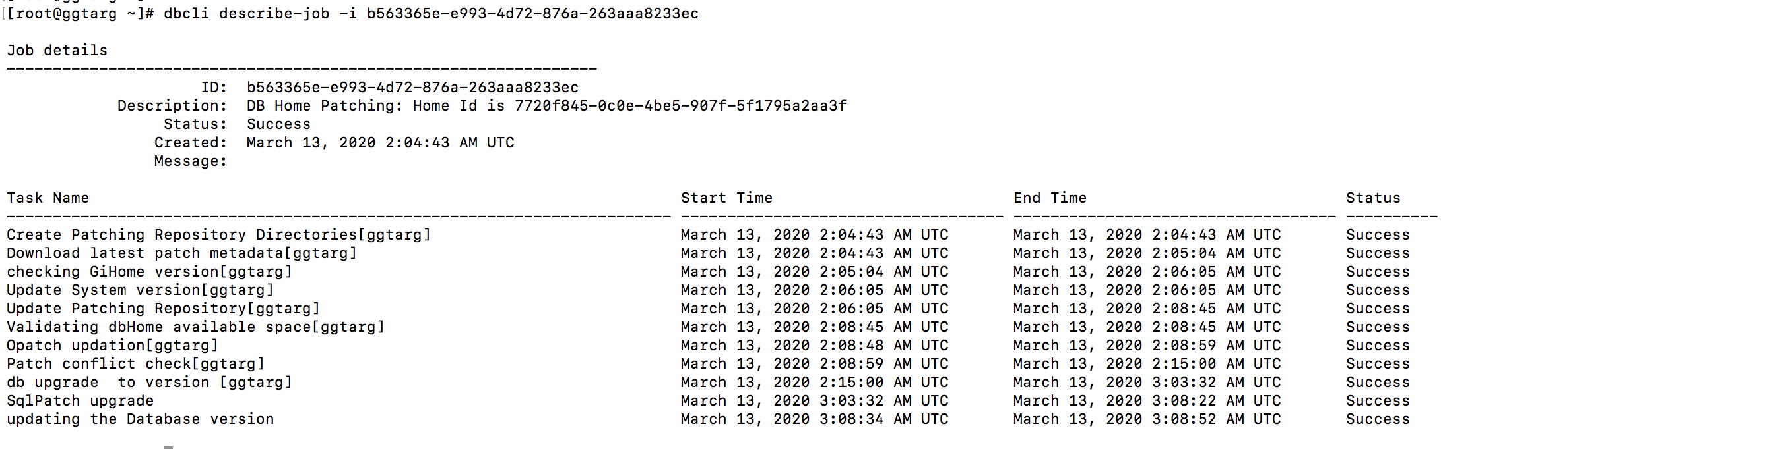

1. Verify that the DB is updated successfully by using the [dbcli describe-component](https://docs.cloud.oracle.com/en-us/iaas/Content/Database/References/dbacli.htm#dbcli43) command. The Available Version column should indicate update-to-date.

