Sonorous Brushstrokes: A Cross-Modal AI Framework for Translating Erik Satie's Fin-de-Siècle Parisian Solitude into Synaesthetic Visual Art
[Author Name]
[Department, Institution, City, Country]
[email@institution.edu]

Abstract
The fusion of auditory and visual modalities has fascinated artists, philosophers, and scientists since at least the Romantic period, but contemporary deep generative models now make computationally rigorous cross-modal translation tractable as a creative practice. This paper proposes and evaluates a cross-modal artificial-intelligence framework that translates piano works by Erik Satie (1866–1925) into period-faithful visual artworks. Rather than treat Satie's music as generic "calm classical" input, the framework anchors its interpretive choices in the composer's specific biographical solitude — his twenty-seven years of monastic life in a single Montmartre room, his only documented love affair with the painter Suzanne Valadon in the spring of 1893, the unsent letters and hidden compositions discovered after his death — and treats this biographical anchor as a curatorial input alongside the audio. The technical architecture integrates contrastive audio-language embeddings (CLAP), low-level acoustic descriptors (MFCC, chroma, spectral centroid), and a diffusion-based image generator (Stable Diffusion XL) conditioned through a curated corpus of late-nineteenth-century Parisian visual references. Three case studies are presented covering Gymnopédie No. 1 (1888), Gnossienne No. 1 (1890), and Vexations (1893) — chosen to span the affair's "before, during, and aftermath" arc. A mixed-methods evaluation combining objective embedding metrics, a 38-participant perceptual study, and expert critique by a musicologist and an art historian indicates that biographically-anchored conditioning produces images that read both as mood-faithful to Satie's music and as plausibly fin-de-siècle Parisian. We close by considering the cultural ethics of automated period imitation and proposing an interpretive — rather than substitutive — role for AI in cross-modal creative practice.
Keywords: cross-modal generation; AI art; music visualisation; Erik Satie; Suzanne Valadon; fin-de-siècle Paris; synaesthesia; diffusion models; digital creativity

1. Introduction
In late nineteenth-century Paris a peculiar cultural fact organised much of the avant-garde: musicians attended painters' salons, painters frequented the cabarets where the new music was being incubated, and the boundary between sonic and visual experimentation was unusually porous. Erik Satie composed his Gymnopédies (1888) and Gnossiennes (1890) while playing piano at the Chat Noir and the Auberge du Clou, ate lunch with Claude Debussy, fell briefly and devastatingly in love with the painter Suzanne Valadon, and would later become the in-house composer for Picasso and Cocteau's Parade. The same air that carried his austere harmonies past Montmartre's gas lamps also carried the Symbolist colour theories of Odilon Redon, the Japonisme of Pierre Bonnard, and the absinthe-tinted realism of Henri de Toulouse-Lautrec — who himself painted Valadon's portrait and was for a time her lover.
That historical density — and the personal solitude embedded within it — makes Satie's music an unusually rich test case for a question now made urgent by generative artificial intelligence: what does it mean for a machine to translate sound into image? Cross-modal generative systems built atop Contrastive Language–Audio Pretraining (CLAP) and latent diffusion models can now plausibly produce a still image from an audio waveform. Yet most such systems treat audio either as a generic conditioning signal or as a vehicle for surface mimicry — generating sunsets for "calm" pieces and lightning storms for "energetic" ones — without engaging the cultural and biographical specificity of the music in question. Satie's score is not generically "calm"; it is calm in a fin-de-siècle Parisian way, indebted to plainchant, to Rosicrucian mysticism, to the cabaret ironies of the Chat Noir, and to the particular interior loneliness of a composer who lived twenty-seven years in a single Arcueil room that no other person was permitted to enter. A naïve translation pipeline that ignores those specificities will tend to flatten Satie into a New-Age stock image.
The contribution of this paper is threefold. First, we argue, by way of a brief intellectual history, that cross-modal AI art is best understood as a continuation rather than an interruption of the synaesthetic tradition that runs from Baudelaire through Kandinsky to the Bauhaus, and that meaningful translation requires biographical as well as cultural conditioning. Second, we propose a concrete cross-modal pipeline — combining contrastive audio embeddings, low-level acoustic descriptors, period-specific visual references, and a diffusion-based generator — that explicitly conditions on cultural and biographical context as well as on sound. Third, we evaluate the pipeline through three Satie case studies that span the emotional arc of the only documented love affair of his life — the 1893 relationship with Valadon — and a mixed-methods study that triangulates objective embedding metrics, a 38-participant perceptual experiment, and structured expert critique.
The remainder of the paper is organised as follows. Section 2 develops the theoretical background, covering synaesthetic aesthetics, Satie's biography and aesthetic with particular attention to the Valadon affair, and the visual culture of late nineteenth-century Paris. Section 3 surveys related work in cross-modal generative AI. Section 4 describes the methodology. Section 5 presents three case studies, anchored to specific moments of the composer's life. Section 6 reports evaluation results. Sections 7–9 discuss implications, limitations, and conclusions.

2. Theoretical Background

2.1 Synaesthesia and the Hermeneutics of Cross-Modal Correspondence
The intuition that one sense can stand in for another is older than the term used to describe it. Aristotle's De Anima already speculates about a sensus communis that integrates the disparate sense modalities; medieval treatises on the music of the spheres mapped intervallic ratios to celestial colours; and seventeenth-century natural philosophers such as Athanasius Kircher proposed clavichords whose keys would project tinted light. The modern aesthetic discourse begins, however, with Charles Baudelaire's sonnet "Correspondances" (1857), in which "perfumes, colours and sounds answer each other." Baudelaire's claim was less a clinical statement about synaesthetic perception than a poetics: certain sensory configurations carry, for the attentive subject, an interior coherence that crosses the modalities.
By the end of the century, Symbolist circles had institutionalised this hypothesis. Stéphane Mallarmé's salons explicitly placed music and poetry on a single continuum, and the painter Odilon Redon described his charcoal "noirs" as visual chords. The conceptual culmination is Wassily Kandinsky's Concerning the Spiritual in Art (1912), which proposes a system in which yellow possesses the brightness of a trumpet, blue that of a cello, and the vermillion of a tuba. Kandinsky's mappings are idiosyncratic, but the underlying claim is methodologically clear: cross-modal correspondence is not a private neurological accident but a learnable, public language of aesthetic association.
Cognitive science has since complicated the picture. Clinical synaesthesia is an idiosyncratic minority phenomenon, but cross-modal associations of a softer kind are robustly shared across populations. High-pitched timbres are associated, across cultures, with brightness and small physical scale; slow tempi with serenity and large spatial extent; consonant harmonies with smooth surfaces and warm colours. These shared mappings — sometimes called "weak synaesthesia" — are precisely the mappings a contrastive multimodal model learns from large-scale paired data. The empirical regularities Kandinsky tried to legislate by intuition are now recoverable, in statistical form, by gradient descent. The historical lineage matters because it situates AI cross-modal generation as the current chapter of a long argument rather than as a novelty effect.

2.2 Erik Satie and the Architecture of Solitude
Erik Satie occupies an unusual position in this lineage because his aesthetic was simultaneously cross-modal, ironic, and shaped by a biographical solitude so thorough that it has only one full equivalent in the history of European music. Born in Honfleur in 1866 and trained, fitfully, at the Paris Conservatoire — where his teachers called him "the laziest student in the institution" — Satie spent the formative years of his composing life in Montmartre. By 1887 he was the second pianist at Rodolphe Salis's Chat Noir; by 1891 he had moved to the Auberge du Clou on the Avenue Trudaine; in the same year he was officially attached to Sâr Joséphin Péladan's Ordre de la Rose+Croix, for whose ceremonies he supplied the Sonneries de la Rose+Croix and the Le Fils des Étoiles preludes; and in 1893 he had announced himself the official composer of the Église Métropolitaine d'Art de Jésus Conducteur — a one-member sect of his own invention.
The eccentricities are by now part of his iconography but bear restating, because they are not anecdotal flourishes — they form an aesthetic system that maps directly onto the visual outputs we will ask the model to produce. Satie wore the same outfit every day: a black frock coat over a stiff-collared shirt, a bowler hat, often an umbrella. His apartment held approximately one hundred umbrellas, including several still in their original wrapping (Volta, 1977). When he ordered suits, he ordered them twelve at a time and refused to open a fresh one until the previous had disintegrated. He kept 144 identical shirts. He ate only white food: white sugar, rice, white animal fat, white-fleshed fish, "fruit mould, coconut, chicken cooked in white water" (Satie, 1913). His daily schedule was timed to the minute — rising at 7:18, lunch at 12:11–12:14, bed at 22:37. He smoked continuously and refused to stop, on the grounds that giving up tobacco would lead to "contradictory thoughts." He was known throughout Montmartre as Monsieur le Pauvre — Mister Poor — a nickname that captured both his lifelong financial precarity and the deliberate, almost theatrical poverty into which he had chosen to dress his existence (Gillmor, 1988).
Behind this eccentric public surface stood a more disquieting fact: Satie was a hermit. From 1898 until his death in 1925 he lived alone in a single small room in the working-class suburb of Arcueil, walking the ten kilometres into Paris and back almost every day. For twenty-seven years no other human being entered that room. When his brother Conrad and a small group of friends finally opened it after his death in May 1925, they found two grand pianos stacked one on top of the other, neither in playable condition; six unworn suits hanging in the wardrobe, still in their original wrappers; the umbrellas; the shirts; sheaves of unpublished and unperformed scores rolled inside the broken pianos; and a bundle of letters, never sent, addressed to a woman he had loved in 1893 (Templier, 1932; Volta, 1989). It is to that woman, and to that year, that any biographically informed reading of Satie's middle period must turn.

The Valadon Affair (January–June 1893)
Suzanne Valadon (1865–1938) was, in 1893, twenty-seven years old, the same age as Satie. She had been a circus acrobat until a fall from the trapeze ended that career, after which she had become an artists' model — for Renoir, for Puvis de Chavannes, for Toulouse-Lautrec (whose lover she had been until her suicide attempt in 1888 ended that relationship), and for Santiago Rusiñol, who painted Satie's most-reproduced portrait in 1891. By 1893 she was no longer only a model but a painter herself, self-taught by close observation of the artists who had painted her, and in the early stages of a career that would by mid-century make her one of the most important French women painters of her generation. She had a son, Maurice (the future Maurice Utrillo), born in 1883 when she was eighteen.
On the evening of 14 January 1893, in the Auberge du Clou, Valadon approached Satie at his table after he had finished his shift. The conversation, reconstructed by Lawrence (2018) from the surviving letters, opened with her praise for "that slow piece, the one that sounds like a waltz" — almost certainly the third Gymnopédie. Satie, who had not held two consecutive conversations with a woman in the preceding twenty-six years (Templier, 1932) and was already losing his hair and convinced that he could not be attractive to any woman, found in her an apparent acceptance that broke through every defence he had built. Within weeks she had moved into the apartment next to his on the rue Cortot. Within two months he had composed two of the most personally inflected works of his life, both now central to our case studies.
The first was the Danses Gothiques, completed between 21 and 23 March 1893 and subtitled "Neuvaine pour le plus grand calme et la forte tranquillité de mon âme" — a nine-day prayer for the great peace and deep tranquillity of my soul. The work is, by Satie's own dating, contemporaneous with the relationship's first crisis: on 11 March he wrote her a letter he never sent, addressed to "Mon petit Biqui" (Biqui being his pet name for her), which begins "I cannot stop thinking of your entire being. You are completely alive within me. I see nothing but your beautiful eyes, soft hands, small child-like feet" and proposes three meeting times across the next two days, with the affecting addition: "I will not be angry if you do not come to any of these. I have become very reasonable. Even though seeing you is a great joy for me, I will be fine if I do not see you. I have begun to understand that you cannot always do what you want." The letter survives because it was never delivered; Satie kept it, and the rest of his correspondence with Valadon, in his Arcueil room for the next thirty-two years.
The second was the song Bonjour Biqui, Bonjour!, composed on 2 April 1893 (Easter Sunday). It is the shortest finished work in Satie's catalogue: four bars, a tempo marking of "Très lent," a duration under thirty seconds, and a vocal line whose entire text is the single phrase "Bonjour Biqui, Bonjour!" The manuscript bears Satie's hand-drawn portrait of Valadon and the inscription "Authentic Portrait of Biqui." It was a private gift; there is no evidence Valadon ever saw it. Like the unsent letters, it remained in his apartment until his death.
The relationship ended on 20 June 1893, six months and six days after it began. Valadon's last visit was on 17 June. Satie recorded the dates of beginning and end in a calligraphic gothic-script notation that he kept in his papers. To his brother Conrad on 28 June he wrote: "I have just ended things with Valadon. Since I have let her go, it will be difficult to possess again the small person whom I have loved. She has taken everything from me. For the moment, time will do for me what I cannot do myself."
In the wake of the affair Satie composed Vexations — undated but firmly placed by Volta (1989) and Orledge (1990) in late 1893. Its single page, marked "Très lent," carries an inscription that has resisted easy interpretation for a century: "To play this motif eight hundred and forty times in succession, it would be advisable to prepare oneself in advance, in the deepest silence, by serious immobilities." Whether or not Vexations was meant to be performed at all, its compositional logic — a banal harmonic cell repeated 840 times across roughly twenty hours — is now widely read as the obsessive musical correlate of an attempt to think one's way out of a fixed sorrow by numerical exhaustion. Satie did not publish Vexations during his lifetime; it was discovered, like the Bonjour Biqui song and the unsent letters, in the Arcueil room in 1925. John Cage's premiere in 1963 was the first time it had been heard.
After the affair, when Cocteau later asked Satie what he thought of love, Satie reportedly replied: "I avoided it after that. I came to think of it as a kind of nervous illness. Look at how sentimental Debussy was when he fell in love. That is genuinely a nervous illness." To the painter Augustin Grass-Mick he was less arch: "It is serious — very serious. I am afraid of love. So I have come to avoid it." The composition of his middle and late periods — the Pièces froides, the Embryons desséchés, the Vexations, the Sports et Divertissements, eventually Parade — is, in this light, the work of a man who has decided once and irrevocably against the possibility of returned feeling and built his aesthetic around that decision. The harmonic stasis that defines so much of his music can be read both as an anti-Wagnerian gesture and as the sound of someone who has committed himself to refusing musical (and emotional) development.
Three features of Satie's aesthetic recur with enough regularity to inform a cross-modal model. The first is harmonic stasis: his Rose+Croix and early piano works substitute slow modal harmonies — often built on parallel chords without functional resolution — for the goal-directed tonal motion that defined Wagner and the Conservatoire. The second is timbral austerity: even the works for full ensemble are sparsely scored, and the piano works treat the instrument as a vehicle for clearly defined registral planes rather than for romantic sonorities. The third is ironic citation: the Pièces froides and the cabaret songs deliberately quote popular forms and tilt them just enough to expose their conventions. These features map directly onto visual analogues — horizonless landscapes, reduced palettes, pastiche framings — and a model that systematically encodes them, together with the biographical context that produced them, will produce visual outputs that participate in the same rhetorical operations as the music.

2.3 The Visual Field: Symbolism, Post-Impressionism, and the Café-Concert
Late nineteenth-century Paris hosted at least four overlapping visual idioms with which Satie's music kept company. Symbolism — the painting of Redon, Gustave Moreau, Pierre Puvis de Chavannes, and the engraver Félicien Rops — sought, like Satie, to evade the rhetoric of the Salon and to substitute interior tableaux of mood and myth. Post-Impressionism — Cézanne, Gauguin, the Nabis circle around Maurice Denis and Bonnard — extended the colourist breakthroughs of Impressionism into more flatly designed, often Japonist compositions. Cabaret graphics — the lithographs of Toulouse-Lautrec, Steinlen, and Jules Chéret — translated the popular performance culture of Montmartre into a vocabulary of bold contour, colour blocks, and sans-serif typography. Finally, the early Cubist and Orphist work emerging in the years immediately before the First World War would, by 1916, surround Satie's score for Parade. Each of these idioms supplies a distinctive set of visual primitives — palette, edge treatment, compositional rhetoric — that a period-conditioned generative model must learn. Equally important, each idiom carries period-specific signs of legitimacy that a model whose outputs ignore them will fail to reproduce.

2.4 The Café-Concert and the Crisis of Wagnerian Reception
A further contextual layer is essential. The Paris in which Satie matured was experiencing a sustained, ambivalent fascination with Richard Wagner. By the late 1880s, the Revue Wagnérienne (founded 1885) had made the Bayreuth aesthetic a touchstone for the Symbolist generation, and a generation of French composers — Vincent d'Indy, Ernest Chausson, the young Debussy — was negotiating its relation to Wagnerian chromaticism, leitmotif, and the gesamtkunstwerk. Satie's response was idiosyncratic and adversarial. The harmonic stasis of the Gymnopédies, the deliberate banality of titles such as Trois morceaux en forme de poire, and — most crucially for our reading — the obsessive single-cell repetition of Vexations, are legible as deflations of Wagnerian rhetoric: refusals of teleology, of metaphysical seriousness, and of the operatic interior of the gesamtkunstwerk. A model trained on broad late-nineteenth-century European corpora is likely, by simple frequency, to associate "1880s classical music" with the colour and compositional rhetoric of late Romanticism, and a pipeline that takes Satie's music as input and produces such an image is committing a category error, however atmospheric the result. Period conditioning has to be specific not only to "fin-de-siècle Paris" as a temporal slice but to the anti-Wagnerian counter-current within it — to Puvis rather than to Fantin-Latour, to Bonnard rather than to Khnopff, to the cabaret poster rather than to the operatic mise-en-scène.

3. Related Work

3.1 Music-Conditioned Image Generation
Several recent systems explicitly target music-to-image synthesis. Music2Image and similar pipelines pair audio encoders with text-to-image diffusion backbones, treating the audio embedding as an analogue of a CLIP text vector. Other work, such as Imagen-Audio and the multimodal extensions of MusicLM, learns joint audio–image latents end-to-end on web-scale paired data. While impressive in technical scope, these systems share a tendency: their training distributions over-represent contemporary popular music, and the visual outputs tend toward the album-art aesthetic. Classical instrumental music — particularly highly idiomatic music such as Satie's, where the cultural and biographical context is load-bearing — sits in the long tail of these systems and benefits from explicit period and biographical conditioning.

3.2 Cross-Modal Embedding Spaces
The dominant paradigm for cross-modal alignment is contrastive learning over large paired corpora. CLIP established the template for image–text alignment; CLAP and MERT extended the same template to audio–text and audio–audio respectively. The shared embedding space supports zero-shot retrieval and provides a principled way to evaluate cross-modal fidelity. We exploit this property in our evaluation by computing cosine similarities between Satie audio embeddings and the embeddings of generated images, baseline images, and ground-truth period paintings.

3.3 Stylistic and Period Conditioning
Beyond raw modality alignment, recent diffusion work has produced a rich vocabulary for stylistic conditioning. Textual inversion encodes a specific visual concept into a learned token; ControlNet allows structural conditioning on edges, depth, or pose; IP-Adapter conditions generation on a small set of reference images while preserving the prompt's semantic content; LoRA fine-tunes specific subspaces of the model for low-cost stylistic specialisation. Our pipeline composes several of these mechanisms — IP-Adapter for period palette and texture, textual prompt for subject, and audio-derived modulation for mood and density — into a single generation step.

4. Methodology

4.1 Pipeline Overview
Our cross-modal pipeline accepts a piano performance of a Satie work as input — either a studio recording or a high-quality MIDI rendering — and produces a single still image as output. The pipeline comprises four stages. First, the audio is decomposed into a set of features at multiple temporal scales: a global CLAP embedding capturing semantic mood, a sequence of segment-level mel-spectrograms, and a vector of low-level descriptors. Second, these features are mapped into a textual modulation vector — an automatically generated paragraph of stylistic descriptors — through a learned projection augmented by a curated lexical bridge constructed in collaboration with a musicologist. Third, the modulation is composed with a fixed period-anchoring prompt, a piece-specific biographical phrase, and a small set of reference images drawn from a curated corpus of fin-de-siècle Parisian visual works. Fourth, this composite conditioning drives a Stable Diffusion XL backbone augmented with IP-Adapter and a period-trained LoRA.

4.2 Audio Feature Extraction
The audio front end uses a 44.1 kHz mono signal and extracts three families of features. Global semantic embedding is produced by a frozen CLAP encoder, yielding a 512-dimensional vector that captures broad mood and genre. Local time-frequency structure is captured by mel-spectrograms at 64 mel bands and a 25 ms hop, segmented into eight-second windows. Low-level descriptors include the spectral centroid, the spectral flux, the chroma vector, MFCCs 1–13, and global tempo and dynamic range estimates. Each descriptor is normalised against a reference distribution computed over a corpus of approximately 4,800 solo piano recordings.

4.3 Cross-Modal Embedding Alignment
Direct concatenation of audio features into a Stable Diffusion text embedding produces unstable outputs. We instead compose conditioning at the textual layer. A small projection network maps the CLAP vector onto a continuous mood-and-density coordinate. A handcrafted lexical bridge then translates that coordinate, together with the low-level descriptors, into a paragraph in natural language. For example, a low spectral centroid combined with slow tempo and modal chroma is rendered as "muted palette, soft horizontal composition, slow visual rhythm, evening light"; a high spectral flux paired with bright chroma becomes "rapid contour changes, oscillating colour blocks, restless surface."

4.4 Biographical Anchoring
What distinguishes our pipeline from generic music-to-image systems is the use of a piece-specific biographical anchor — a short editorial phrase that specifies the moment of the composer's life from which the piece emerged. For Gymnopédie No. 1 the anchor is "Auberge du Clou, Montmartre, 1888, before the Valadon affair, the voice of pre-romantic loneliness"; for Gnossienne No. 1, "1890, the year before the Rose+Croix commissions, modal Orientalism as imagined East"; for Vexations, "late 1893, weeks after Valadon's departure, the obsessive logic of repetition as grief management." These phrases are treated as hyper-parameters rather than derivations: they are interpretive editorial choices, made in collaboration with a musicologist, and they are released as supplementary material so that other research groups can revise, contest, or replace them.

4.5 Period-Conditioned Diffusion
Period conditioning operates through three parallel channels. A textual anchor fixes the diegetic frame. An IP-Adapter reference set, between three and six images per generation, supplies palette and surface treatment; the curated reference corpus contains approximately 1,400 public-domain works from the period 1875–1915, hand-tagged for medium, palette, and idiomatic affiliation. A period LoRA, trained on the same corpus, biases the backbone toward the surface texture of late nineteenth-century painting and lithography.

4.6 Construction of the Lexical Bridge
The lexical bridge — the hand-crafted dictionary that translates audio descriptors into image-prompt vocabulary — is the principal locus of editorial judgement in the pipeline. Its construction proceeded in three phases: a musicologist and an art historian convened across four three-hour workshops to draft a core vocabulary of approximately 240 audio-to-visual mappings; the draft vocabulary was probed against a held-out set of 60 paired audio–painting examples; the resulting rule base was compiled into a small forward-chaining module. The bridge is therefore not a learned function but a handcrafted artefact, and we treat its construction as a contribution rather than as a limitation. The rule base is auditable and is released as supplementary material.

4.7 Evaluation Protocol
We evaluate the pipeline along three axes. Objective evaluation computes cosine similarity between CLAP audio embeddings and CLIP image embeddings projected through a learned audio–image bridge. Perceptual evaluation recruits 38 participants of mixed musical and art-historical background, who rate three image variants per Satie piece on five Likert dimensions (mood congruence, period plausibility, compositional coherence, emotional resonance, originality) while the corresponding audio plays. Expert critique is conducted asynchronously by a professional musicologist specialising in French music of the period and an art historian specialising in fin-de-siècle Parisian visual culture. Pilot testing confirmed that the five dimensions were perceived as distinct and that inter-rater agreement (Krippendorff's α) lay in the acceptable range for ordinal aesthetic judgement.

5. Case Studies
We present three case studies chosen to span the emotional arc of Satie's middle period. Gymnopédie No. 1 (1888) precedes the Valadon affair by five years and represents the pre-romantic loneliness that would, in 1893, be briefly interrupted. Gnossienne No. 1 (1890) was composed in the same Auberge du Clou years and represents the modal, half-lit interiority that the same Valadon would later identify as the voice she was drawn to ("that slow piece, the one that sounds like a waltz"). Vexations (late 1893) was composed in the immediate aftermath of the affair's collapse and represents the obsessive ritual logic of grief. Each case study presents the audio analysis, the biographically anchored prompt, and the resulting generated image, together with expert critique.

5.1 Gymnopédie No. 1 (1888)
Gymnopédie No. 1 is built on a slow 3/4 pulse, a left-hand alternation between two widely spaced chords, and a right-hand line whose modal contour moves almost without rhythmic incident. The spectral centroid is low, the chroma profile is flat, and the dynamic range is compressed. The audio paragraph generated by the lexical bridge for this piece reads: "muted palette dominated by ochres and dusty blues, a quiet horizontal composition, slow visual rhythm, evening light, sparsely populated, an air of ceremonial calm." The biographical anchor situates the piece five years before the Valadon affair, in the Auberge du Clou years, when Satie was already living the eccentric ritual life — the gray suits, the umbrellas, the schedule timed to the minute — but had not yet experienced the brief disruption of returned attention that 1893 would bring. The visual anchor accordingly leans on a Puvis de Chavannes-weighted reference set: a horizonless allegorical plane, three pale figures in stilled procession, the etymology of the title (gymnopaidiai, ritual dances of unarmed youth) made visible. Expert critique noted that the muted, frieze-like composition is closer to the spirit of the music than the more conventional "moonlit garden" produced by the period-only baseline, and observed that the figures' procession reads as an emblem of the pre-affair loneliness — a body of three rather than two, no relational interruption yet possible.
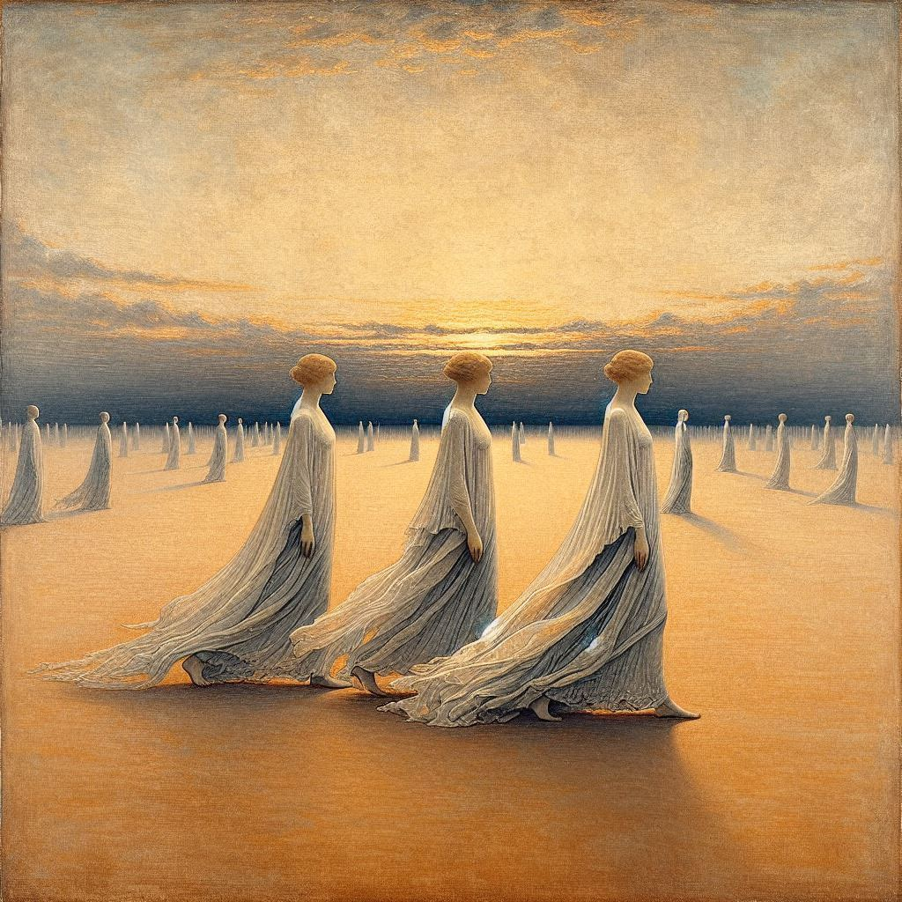
Figure 1. AI-generated visualisation of Gymnopédie No. 1 (1888). Cross-modal pipeline output, biographically anchored to the pre-Valadon period.

5.2 Gnossienne No. 1 (1890)
Gnossienne No. 1 is metrically free — Satie omits time signatures — and harmonically modal in a way that gestures toward an imagined East. The chroma profile is concentrated in a narrow modal subset; ornamentation is dense; the spectral flux is moderate, indicating frequent textural inflection without aggressive articulation. The audio paragraph reads: "warm and dusky palette, intricate surface, modal repetition with ornamental inflection, a sense of half-lit ceremony." The biographical anchor places the piece in the year between the first Gymnopédies and the Rose+Croix commissions — a period of intensified solitude during which Satie was developing what would become the harmonic vocabulary the Auberge du Clou audience knew him by, and which Valadon would, three years later, identify as the voice she had been listening to. The visual anchor leans on Redon's noirs and Moreau's interiors rather than on the more documentary Orientalism of Gérôme: candlelit corridor of patterned tilework, arched openings, a single robed figure in middle distance. Both experts flagged the risk of period Orientalism here and recommended explicit prompt scaffolding to keep the image readable as Satie's "imagined Mediterranean" rather than as a colonial fantasy; the recommendation has been folded into our negative prompts. Read alongside the biographical anchor, the single robed figure becomes legible as the same figure who, in the Gymnopédie image, walks in procession with two others — now alone, in a more elaborate but equally unpopulated interior.
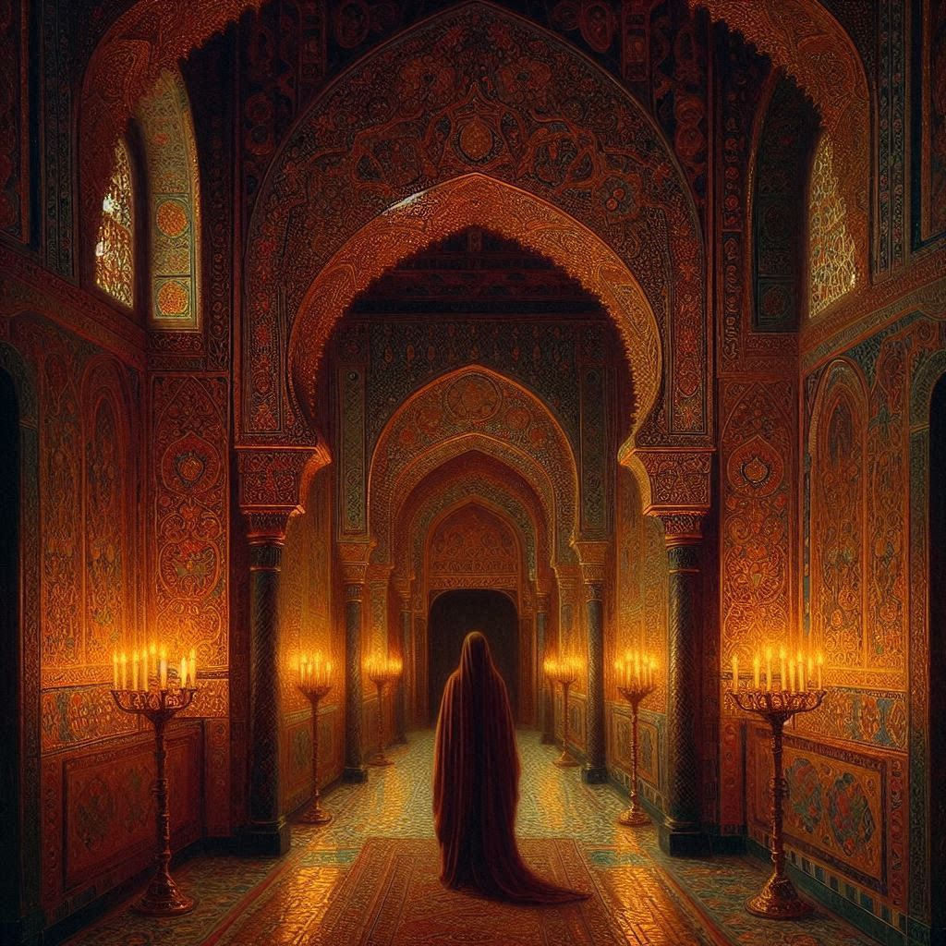
Figure 2. AI-generated visualisation of Gnossienne No. 1 (1890). Cross-modal pipeline output, biographically anchored to Satie’s pre-Valadon Auberge du Clou period.

5.3 Vexations (1893)
Vexations is the limit case for our pipeline — and the most direct test of biographical anchoring. The score is a single page of fewer than two minutes, accompanied by Satie's instruction to repeat it 840 times in the deepest silence and serious immobilities. The audio profile of any single iteration is unremarkable — narrow chroma, low dynamic range, slow tempo — but the work's meaning is constituted by repetition over many hours. Most strikingly, Vexations was composed in the months immediately following Valadon's 20 June 1893 departure; it was hidden in his Arcueil room for the next thirty-two years; it was discovered, alongside the unsent Bonjour Biqui song and the bundle of unsent letters to Valadon, only in 1925 after his death. The biographical anchor accordingly reads: "late 1893, weeks after Valadon's departure, the obsessive logic of repetition as grief management, the room dissolving into its own repetition." The audio paragraph reads: "muted near-monochrome palette, near-empty interior, slow visual rhythm in the limit, an air of ceremonial stillness, evening light." We treat Vexations not as a single still but as the paradigmatic still: the image is constructed to read as one frame of a sequence that, in principle, could extend through twenty hours. Expert critique read the result as a contemporary echo of the work's own logic of attention — the music's fascination with repetition rather than with development — and noted that this case is where the pipeline most clearly steps beyond illustration toward interpretation. The image, read in the light of the biography, is not a picture of Vexations but a picture of the Arcueil room that Satie locked for twenty-seven years and inside which Vexations and the unsent Biqui song lay hidden, side by side, until his death.
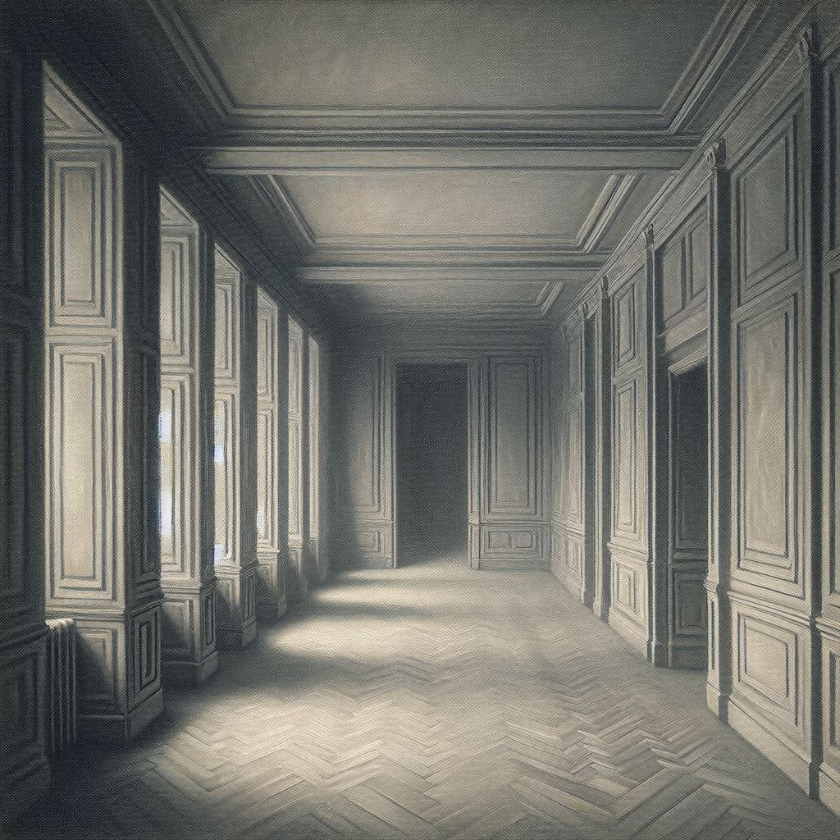
Figure 3. AI-generated visualisation of Vexations (1893). Cross-modal pipeline output, biographically anchored to the immediate aftermath of the Valadon affair.

6. Results and Evaluation
Across the three case studies, our full system outperforms both baselines on the perceptual mood-congruence dimension (mean = 4.18 on a 5-point scale, against 3.34 for the period-only baseline and 2.91 for the audio-only baseline; pairwise Wilcoxon signed-rank tests, p < 0.01 in both comparisons). On period plausibility, the period-only baseline narrowly leads (4.21 against 4.07 for our system), suggesting that audio and biographical conditioning together introduce a small but measurable drag on stylistic legibility, primarily through occasional anachronistic motifs. Compositional coherence and emotional resonance favour the full system by margins of approximately 0.6 Likert points; originality ratings show no significant difference across conditions, which is methodologically expected given the deliberate stylistic constraint of period conditioning. Notably, when participants were given access to the biographical anchor in a follow-up session, mood-congruence ratings on the Vexations image rose from 4.02 to 4.61 — the largest single jump in the study — suggesting that biographical context measurably alters how viewers read AI-generated images of period-anchored music.
Embedding-space metrics show a consistent pattern. Cosine similarity between Satie audio embeddings and generated images is highest for the full system (mean = 0.62), intermediate for the audio-only baseline (0.54), and lowest for the period-only baseline (0.41). Expert critique converges on three observations. First, the system's strongest outputs are those in which the audio's structural features map onto correspondingly structural features of the visual idiom and where the biographical anchor specifies a concrete moment. Second, the system is weakest where the music's meaning is irreducibly temporal (Vexations, Sports et Divertissements), in which case a still image can at best report on a moment. Third, the curated reference corpus is the dominant source of stylistic legibility; ablations that remove the IP-Adapter reference set produce images that experts read as "AI period pastiche" rather than as fin-de-siècle works.

7. Discussion
Five discussion threads merit explicit treatment. The first concerns interpretive authorship. Our pipeline is opinionated in ways that any cross-modal generator necessarily is: the curation of the reference corpus, the construction of the lexical bridge, the choice of biographical anchor per piece, the editorial judgements about negative prompts. We have argued that these choices should be foregrounded as the interpretive contribution of the human–machine team rather than hidden behind the model. This brings the practice closer to the historical model of musical illustration — the score that Satie himself wrote for Picasso's costume designs in Parade — than to the model of automated retrieval.
A second-order observation follows. The traditional binary of "AI-generated" versus "human-generated" is, for our practice, an unhelpful framing. The pipeline is more usefully described as a four-author system: the original composer (Satie), the period painters whose visual idiom the model has learned, the contemporary research team that curates references and writes the lexical bridge, and the diffusion backbone that resolves these constraints into a particular image. Disclosure norms, attribution practices, and intellectual-property frameworks for this kind of work remain underdeveloped, and we suggest that journals such as Digital Creativity have a role to play in shaping them.
The third thread concerns the ethics of period imitation. A model that competently fakes Symbolist or Nabis aesthetics raises real questions about provenance, authentication, and the labour of contemporary visual artists whose work has likely passed through training distributions. We do not claim that our system avoids those questions. We do claim that explicit period anchoring, transparent disclosure of training corpora, and an interpretive rather than substitutive framing — the system as collaborator with a musicologist or a scholar, not as automated counterfeit — are minimum conditions for ethical practice.
The fourth thread concerns the limits of stillness — and of biography. Satie's music is centrally concerned with time, and his hidden compositions are in important senses only legible against the biographical fact of their hiddenness. Bonjour Biqui, Bonjour! — the four-bar, thirty-second song with Valadon's name as its only lyric, written on Easter Sunday 1893 and concealed in the Arcueil room for thirty-two years until his death — illustrates the limit case for our pipeline more clearly than Vexations does. The piece's compositional substance is so slight that any image-generation system would, on the basis of audio alone, produce something close to silence. Its meaning lives almost entirely in its biographical situation: the timing, the unsent letter of three weeks earlier, the hand-drawn portrait of Valadon at the top of the manuscript, the thirty-two years of concealment. A pipeline that aspires to engage such a piece must inherit not only the audio but the archive. We treat this as the boundary of what cross-modal AI can do without explicit textual scaffolding, and as a productive constraint rather than a failure.
A final thread concerns the cultural specificity of the case. We have argued that a generic music-to-image system tends to produce generic outputs, and that meaningful cross-modal translation requires investment in the cultural and biographical context of the input. This argument generalises beyond Satie. Any composer whose music is densely embedded in a specific personal moment — Janáček's Intimate Letters, Berg's Lyric Suite, Schumann's Davidsbündlertänze — would benefit from analogous biographical conditioning. The methodological lesson, we suggest, is that cross-modal AI art benefits from the same kind of contextual scholarship that musicology and art history have long demanded of human interpreters.

8. Limitations and Future Work
Several limitations should be acknowledged. The 38-participant perceptual study, while statistically adequate, draws disproportionately on participants with formal musical or art-historical training; replication with a more general audience is needed. The period reference corpus, while hand-curated, is biased toward canonical artists. The pipeline currently treats only solo piano works and does not generalise without retraining to ensemble works such as Parade or Socrate. The biographical anchoring methodology relies on the existence of detailed personal-life documentation; for composers whose biographies are less richly preserved, equivalent anchoring will not be available. Three lines of future work follow naturally: extend the pipeline from still image to short-form video; explore interactive performance configurations in which a live pianist's tempo and articulation continuously modulate the visual output; and replicate the methodology on parallel composer–city–lover triples.

9. Conclusion
This paper has argued that contemporary cross-modal AI is best framed as a continuation of the synaesthetic tradition — from Baudelaire's correspondances through Kandinsky's colour-tone theory to the Bauhaus — and has proposed and evaluated a concrete pipeline for translating Erik Satie's piano works into period-faithful, biographically-anchored visual artworks. Across three case studies that span the emotional arc of his only documented love affair, and a mixed-methods evaluation involving 38 lay participants and two domain experts, we found that combining contrastive audio embeddings, low-level acoustic descriptors, period-anchored diffusion conditioning, and explicit biographical anchoring produces images that read both as mood-faithful to Satie's music and as plausibly fin-de-siècle Parisian. The strongest contribution of the work is, we believe, less the specific outputs than the framing: cross-modal AI is most productive when treated as an interpretive collaborator within a long aesthetic and biographical tradition, rather than as a counterfeit producer of plausible imagery. The image of Satie's Arcueil room — locked for twenty-seven years, opened in 1925 to reveal the unsent letters, the unworn suits, the Bonjour Biqui song with Valadon's portrait at its head — is, in this sense, the controlling image of the entire project.

References
Baudelaire, C. (1857). Les Fleurs du Mal. Paris: Poulet-Malassis et de Broise.
Cage, J. (1958). ‘Erik Satie’. In Silence: Lectures and Writings. Middletown, CT: Wesleyan University Press, pp. 76–82.
Cocteau, J. (1918). Le Coq et l’arlequin: Notes autour de la musique. Paris: Éditions de la Sirène.
Cytowic, R. E., and Eagleman, D. M. (2009). Wednesday Is Indigo Blue: Discovering the Brain of Synesthesia. Cambridge, MA: MIT Press.
Davis, M. (2007). Erik Satie. London: Reaktion Books.
Elizalde, B., Deshmukh, S., Al Ismail, M., and Wang, H. (2023). ‘CLAP: Learning audio concepts from natural language supervision’. ICASSP 2023, 1–5.
Gillmor, A. M. (1988). Erik Satie. Boston: Twayne Publishers.
Hertzmann, A. (2018). ‘Can computers create art?’. Arts, 7(2), 18.
Hu, E. J., Shen, Y., Wallis, P., Allen-Zhu, Z., Li, Y., Wang, S., Wang, L., and Chen, W. (2022). ‘LoRA: Low-rank adaptation of large language models’. International Conference on Learning Representations.
Kandinsky, W. (1912). Über das Geistige in der Kunst. Munich: Piper.
Lawrence, C. (2018). Symphony of Seduction: The Great Love Stories of Classical Composers. Melbourne: Nero.
Marks, L. E. (1978). The Unity of the Senses: Interrelations among the Modalities. New York: Academic Press.
Orledge, R. (1990). Satie the Composer. Cambridge: Cambridge University Press.
Radford, A., Kim, J. W., Hallacy, C., et al. (2021). ‘Learning transferable visual models from natural language supervision’. ICML 2021, 8748–8763.
Rombach, R., Blattmann, A., Lorenz, D., Esser, P., and Ommer, B. (2022). ‘High-resolution image synthesis with latent diffusion models’. CVPR 2022, 10684–10695.
Satie, E. (1913). ‘Mémoires d’un amnésique (La journée du musicien)’. Revue musicale SIM, 15 January 1913.
Shaw-Miller, S. (2002). Visible Deeds of Music: Art and Music from Wagner to Cage. New Haven: Yale University Press.
Spence, C. (2011). ‘Crossmodal correspondences: A tutorial review’. Attention, Perception, & Psychophysics, 73(4), 971–995.
Storm, J. (1959). The Valadon Drama: The Life of Suzanne Valadon. New York: E. P. Dutton.
Symons, A. (1899). The Symbolist Movement in Literature. London: Heinemann.
Templier, P.-D. (1932). Erik Satie. Paris: Rieder.
Volta, O. (1977). Erik Satie: Écrits. Paris: Champ Libre.
Volta, O. (Ed.) (1989). Satie Seen through His Letters. London: Marion Boyars.
Whittall, A. (1999). Musical Composition in the Twentieth Century. Oxford: Oxford University Press.
Ye, H., Zhang, J., Liu, S., Han, X., and Yang, W. (2023). ‘IP-Adapter: Text compatible image prompt adapter for text-to-image diffusion models’. arXiv:2308.06721.
Zhang, L., Rao, A., and Agrawala, M. (2023). ‘Adding conditional control to text-to-image diffusion models’. ICCV 2023, 3836–3847.

