If the user will enter the wrong number, then it will be asked to re-enter a correct number between 1 and 6.

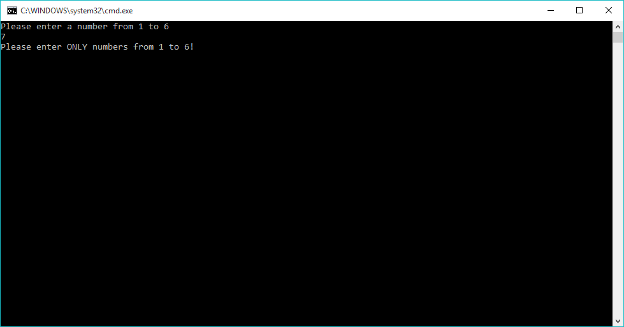

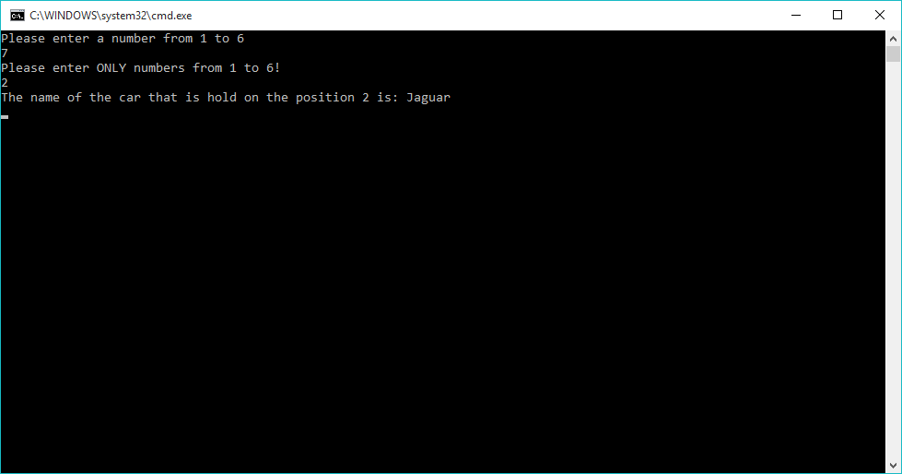If a correct number will be entered, then the program will execute and will display the name of the car stored in that position in the array.

