User enters up to 3 car VIN numbers (a six-digit numeric string), one after another. The program will sort the VIN numbers numerically using 3 types of sorting algorithms. The user can choose from selection, insertion or bubble sorting algorithms.

In case the user will enter a VIN number that will not have the length of 6 digits the console will prompt the user to enter a correct length one.

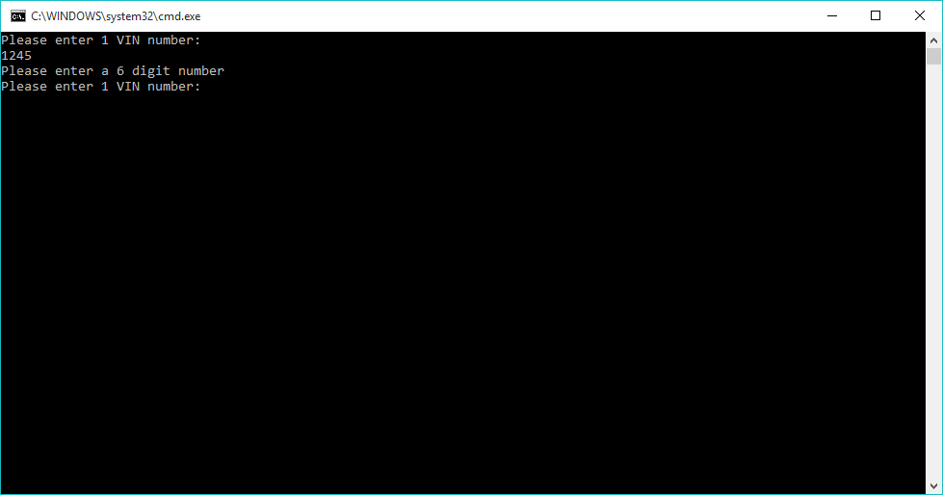

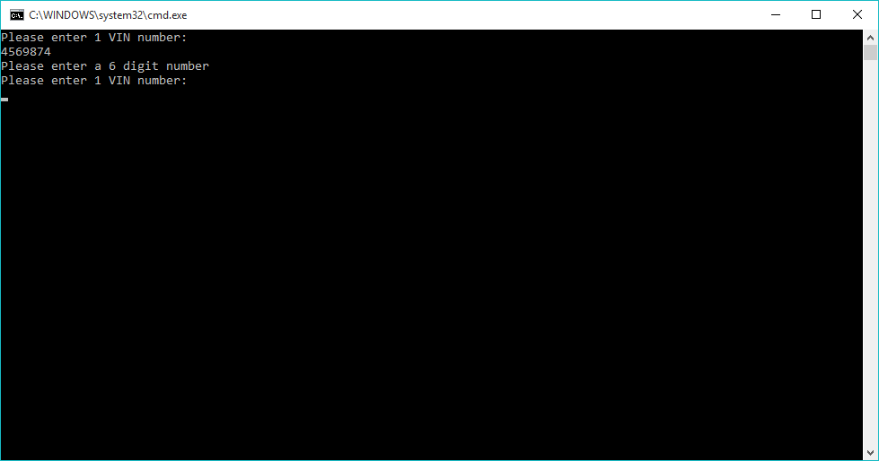

If the user enters the correct length VIN numbers, the program will display the options that the user can chose for sorting.

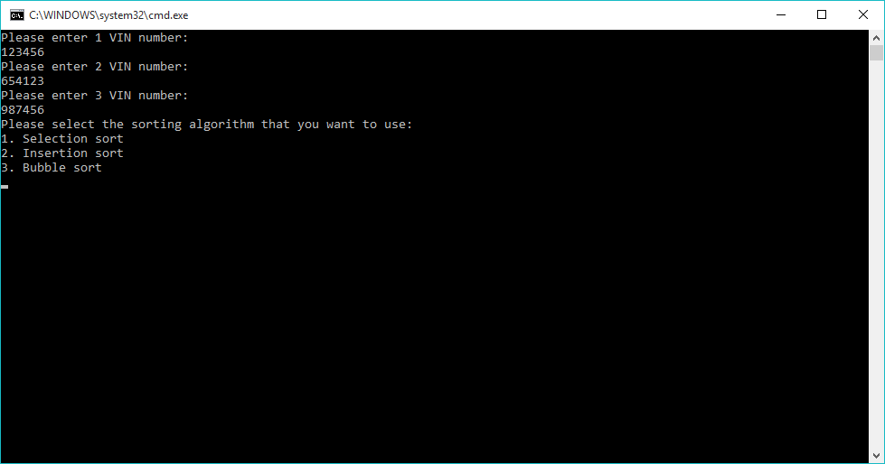

The user can choose the algorithm that will use to sort in ascending order the VIN numbers.

1. Selection sort algorithm

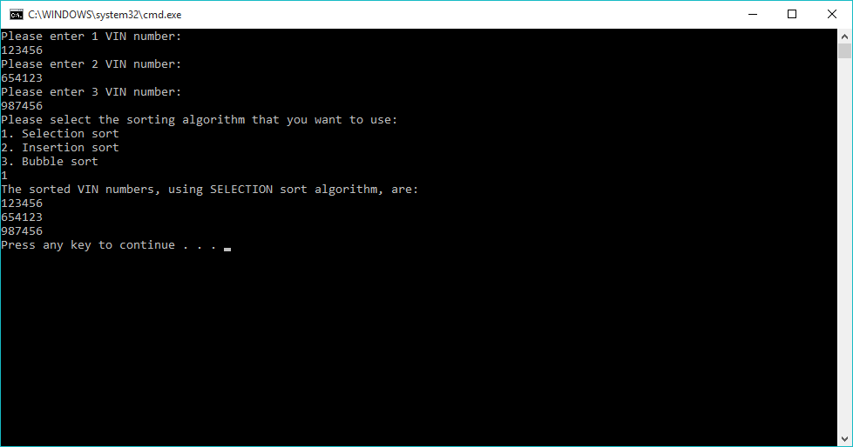

1. Insertion sort algorithm

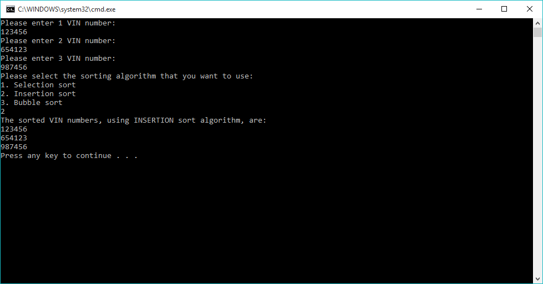

1. 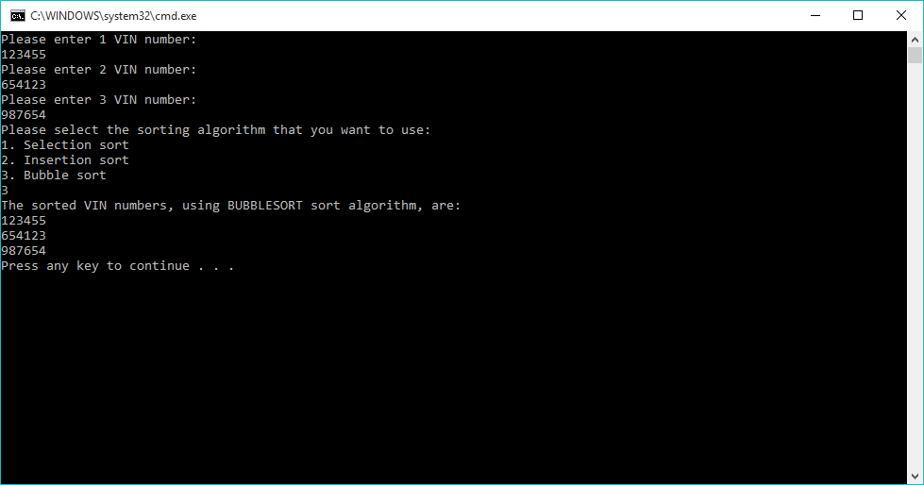Bubble sort algorithm