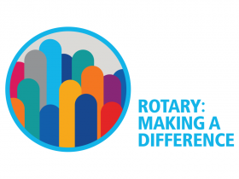

President’s Speech

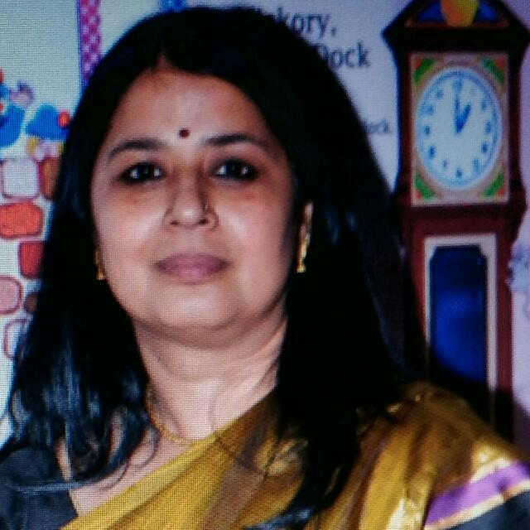

Good evening, welcome to the installation ceremony of the incoming board for the year 2017-18. Today marks a change in the annual cycle, and I want to begin my speech by thanking our out-going president, Rtn Asif Shaikh. Congratulations on an outstanding Rotary year Asif! You and your team have accomplished a great deal and have made the name of our club shine brighter in District 3030. Thank you.

This year is the 101st year of the Rotary Foundation, and for me, my 10th year as a Rotarian. My Rotary journey started in 2008. As a new member I was showered with affection and encouragement, I felt “I belong here”, and this motivated me to take initiative. Through Rotary I have met many people who have gone on to become friends, inspirations, and pillars of support. Being a Rotarian has also given me the chance to serve our community. For this, and for all the people I have met through Rotary, I am truly grateful.

As a Rotarian I have seen what a committed club can do. And this knowledge makes it is a moment of great privilege, pleasure, and honour for me to be installed as President of our club. I accept this opportunity with humility. Ours is a vibrant club, and my aim as president will be to build on the strengths we have, and to create new strengths and positivity as we progress through the year.

“Whatever Rotary may mean to us, to the world it will be known by the results it achieves.” These words by Paul Harris have had a profound impact on me. They remind me that service to society is the founding ideal of Rotary. The incoming board and I envision that this year we will all come together to make a difference in the lives of young children, and we hope that in the future when we look back at this year, that is what Rotary Club of Nasik, Grapecity will be known for.

This year we will take the simplest of actions, actions which when repeated regularly and with love and care will have magnified results.

* Rotary International Focus Area - Wash In Schools - WINS will be our focus this year. With each member of our club getting involved, we propose to reach 100 schools in and around Nasik, thus ensuring hygiene and prevention of disease.
* For the year 2017-18, we will also adopt a school and monitor 1000 students, with a focus on Anemia and adolescent health.
* This Rotary year we will continue to step up our outreach and attract new members to our club. We will focus on mentoring our new members and supporting flexibility to allow Rotarians – young, working, and retired - to make the most of their time, talents, energy, and passion to serve humanity as only Rotarians can.

**As Mother Teresa so beautifully said:-**

**“I can do things you cannot. You can do things I cannot. Together we can do great things. So friends let us join hands and do great things.**

Thank you

Rtn. Alka Singh