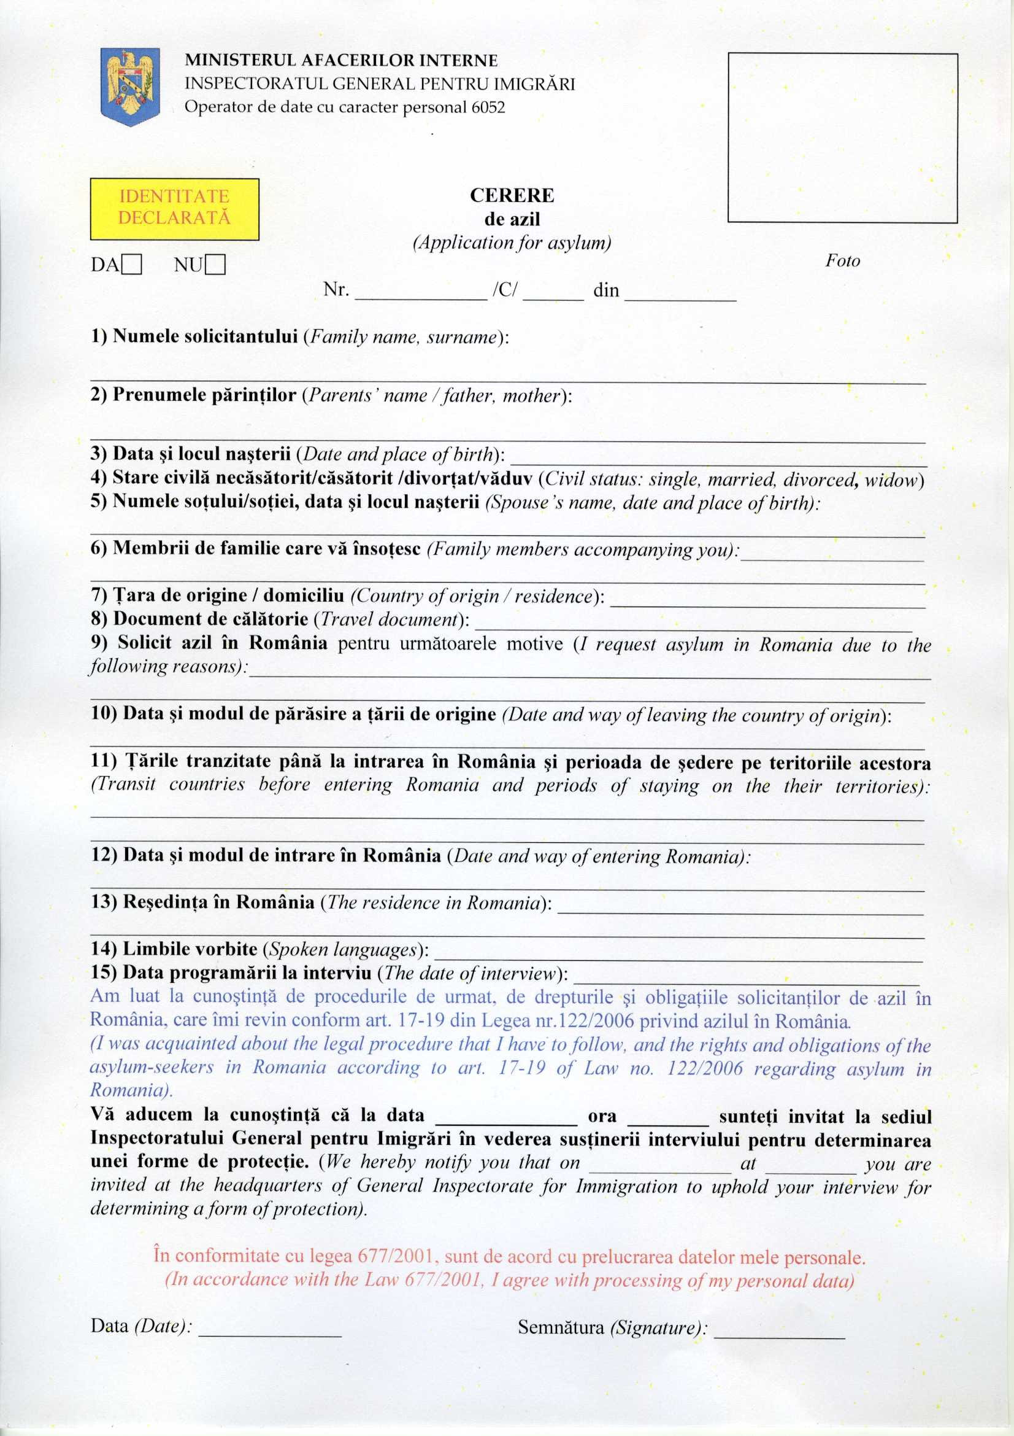

{{spokenLanguages}}

{{city}} {{street}} {{buildingNumber}} {{apartmentNumber}}

{{dateEntering}} {{wayEntering}}

{{transitCountry2}}

{{lastName}}

{{fathersName}} {{mothersName}}

{{dateOfBirth}} {{placeOfBirth}}

{{spouseName}} {{spouseDateOfBirth}} {{spousePlaceOfBirth}}

{{familyMembers}}

{{travelDocument}}

{{transitCountry1}}

{{dateLeaving}} {{wayOfLeaving}}

{{requestReason}}

{{countryOfBirth}}

{{martialStatus}}