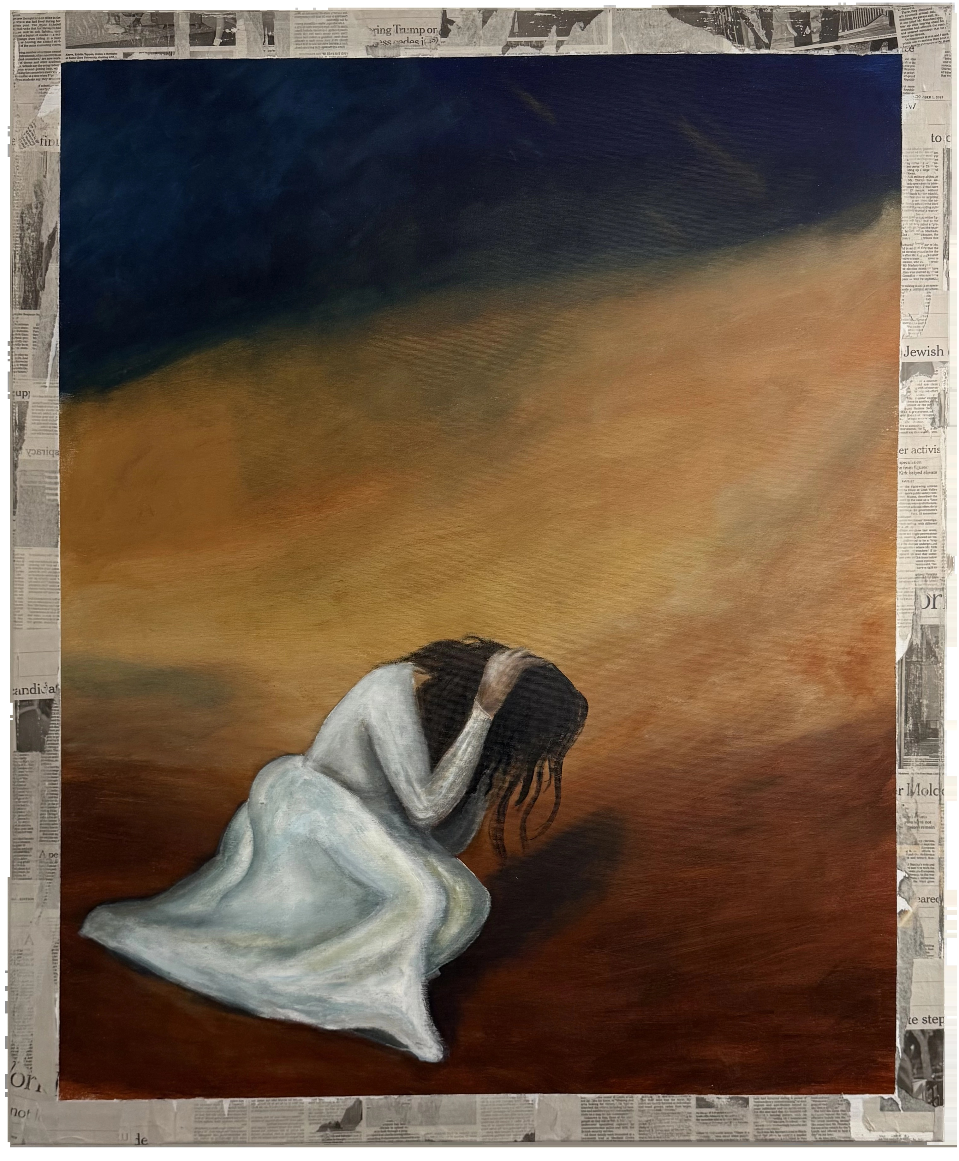

Bride
Mixed media on canvas · 90 × 110 cm
Price: 5,000 ILS

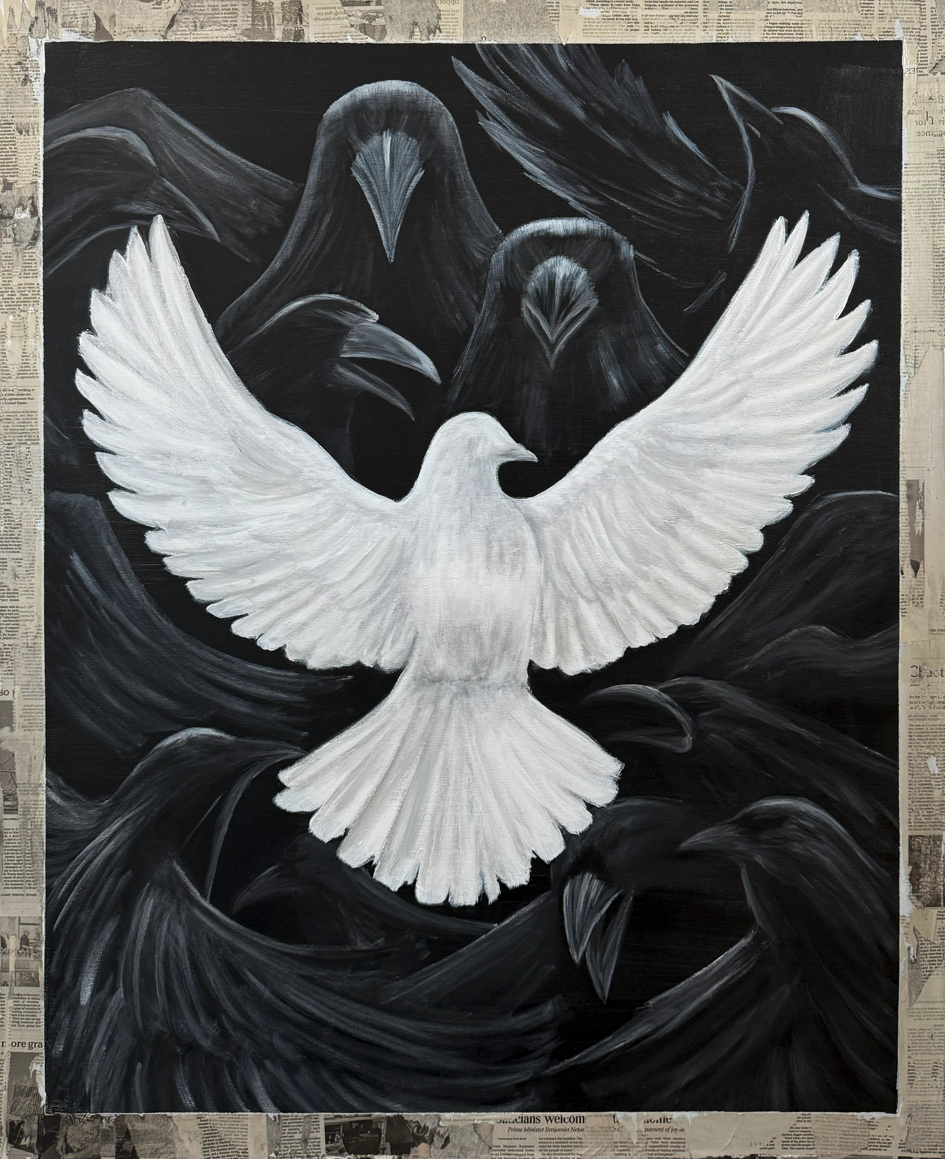

Birds
Mixed media on canvas · 90 × 110 cm
Price: 5,000 ILS

