DEKEL HARARI
Selected Works 2026

Global Art Gallery, Tel Aviv

Prepared exclusively for
Tal Lavon
Miami, FL
The Good Times
Already in Miami — no shipping required

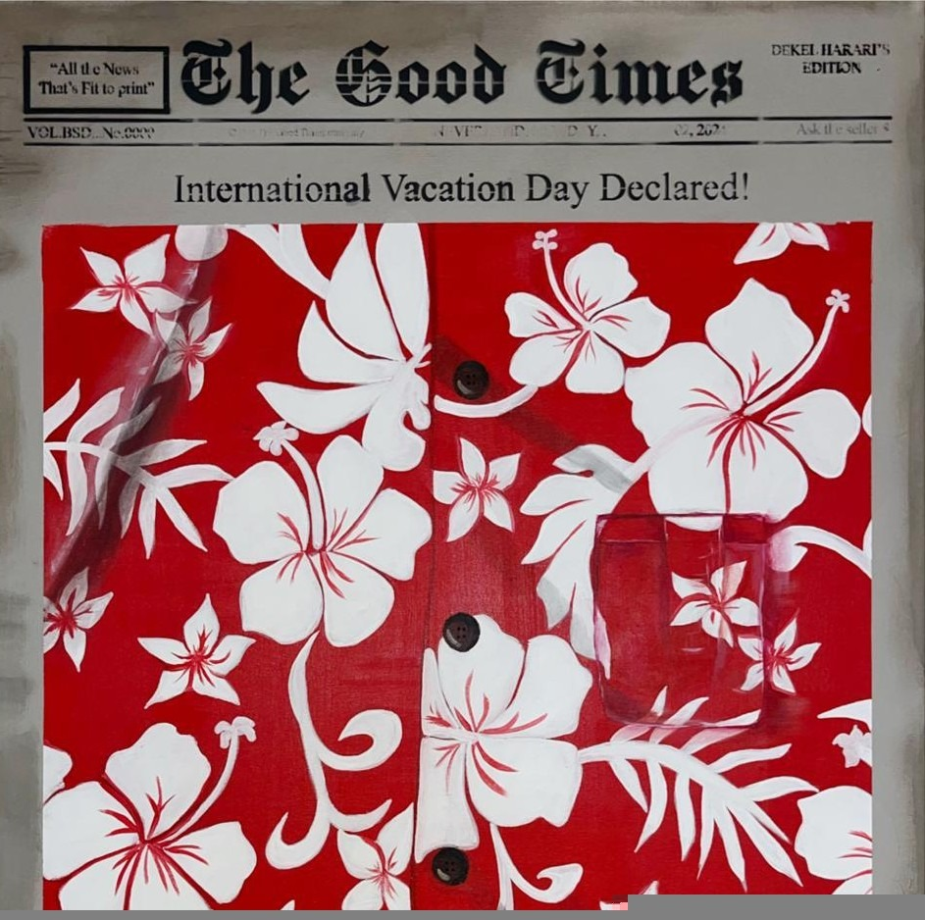  The Good Times 1  Price: 2,000 ILS | 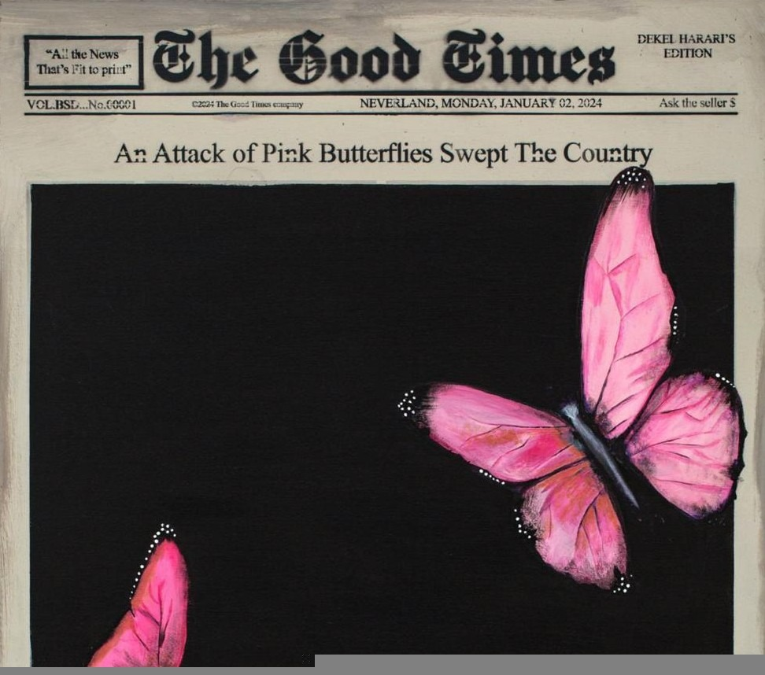  The Good Times 2  Price: 2,000 ILS
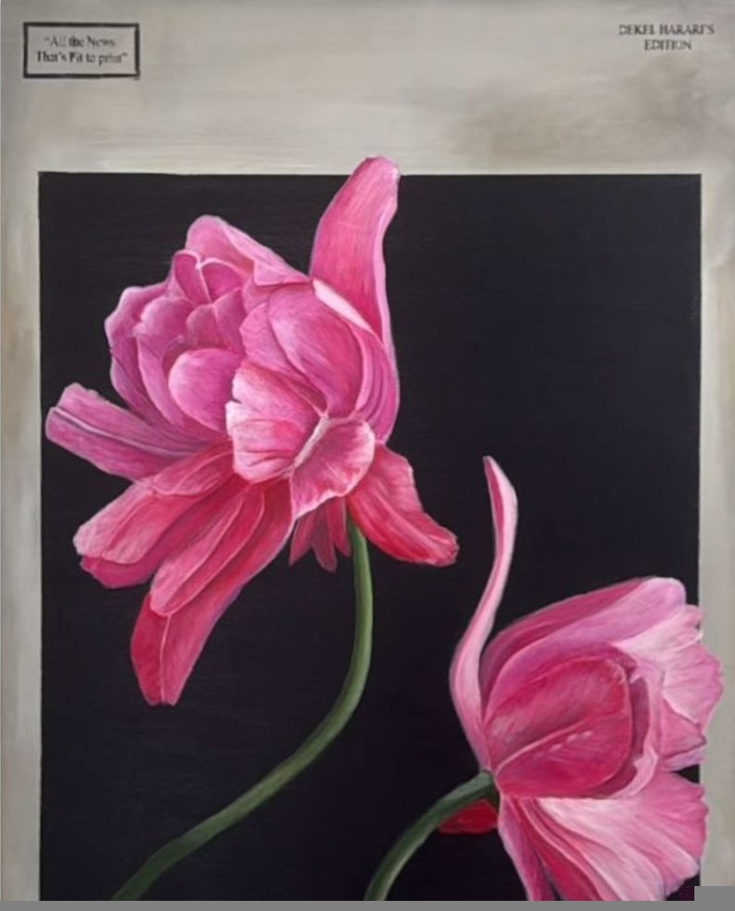  The Good Times 3  Price: 2,000 ILS | 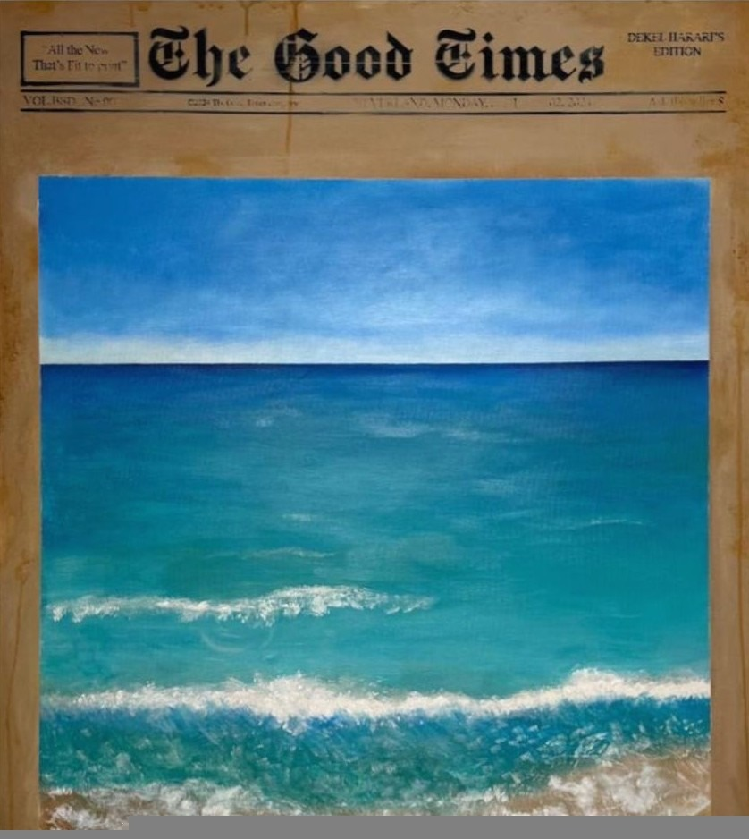  The Good Times 4  Price: 2,000 ILS
Subjects, Removed

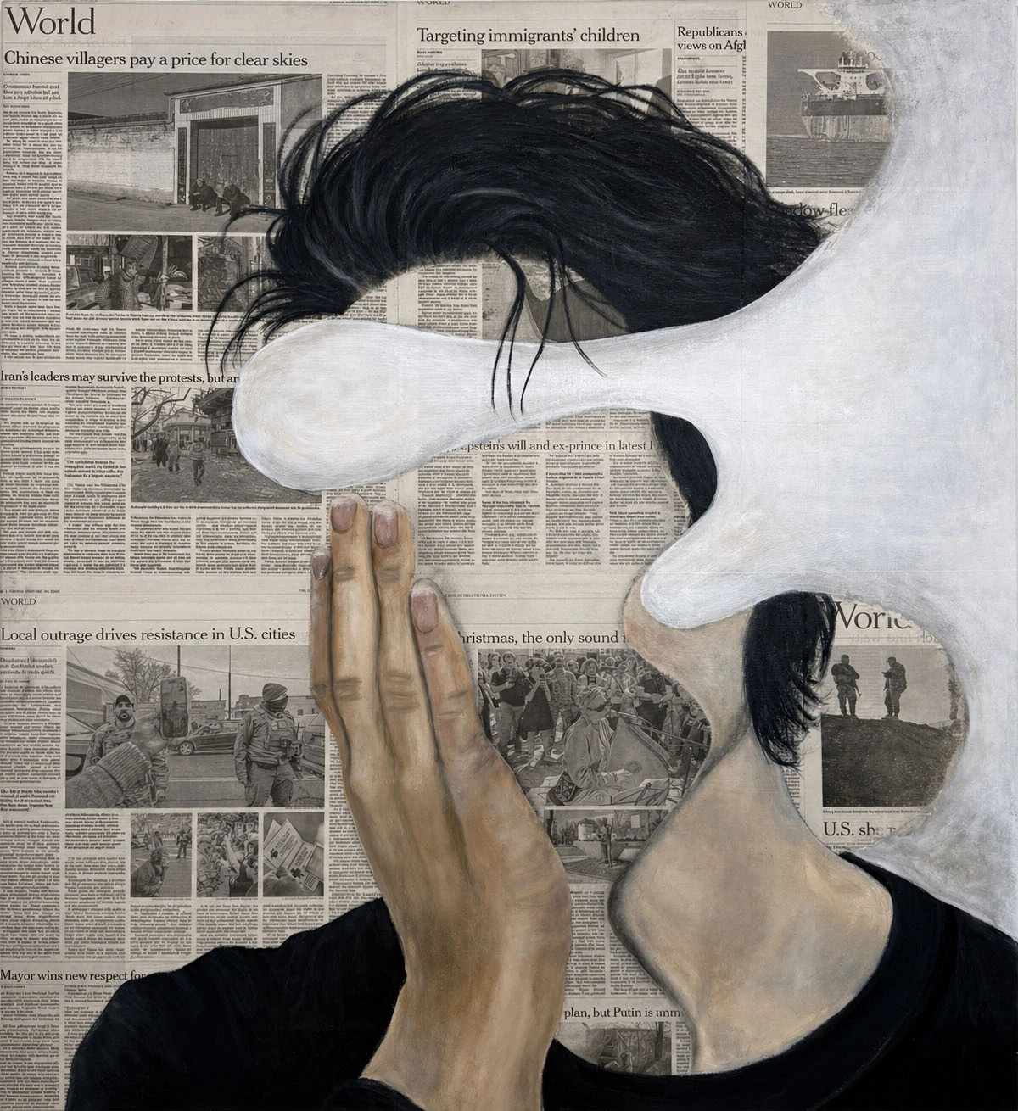  Before Coffee  Mixed media on canvas  90 × 110 cm  Price: 2,500 ILS | 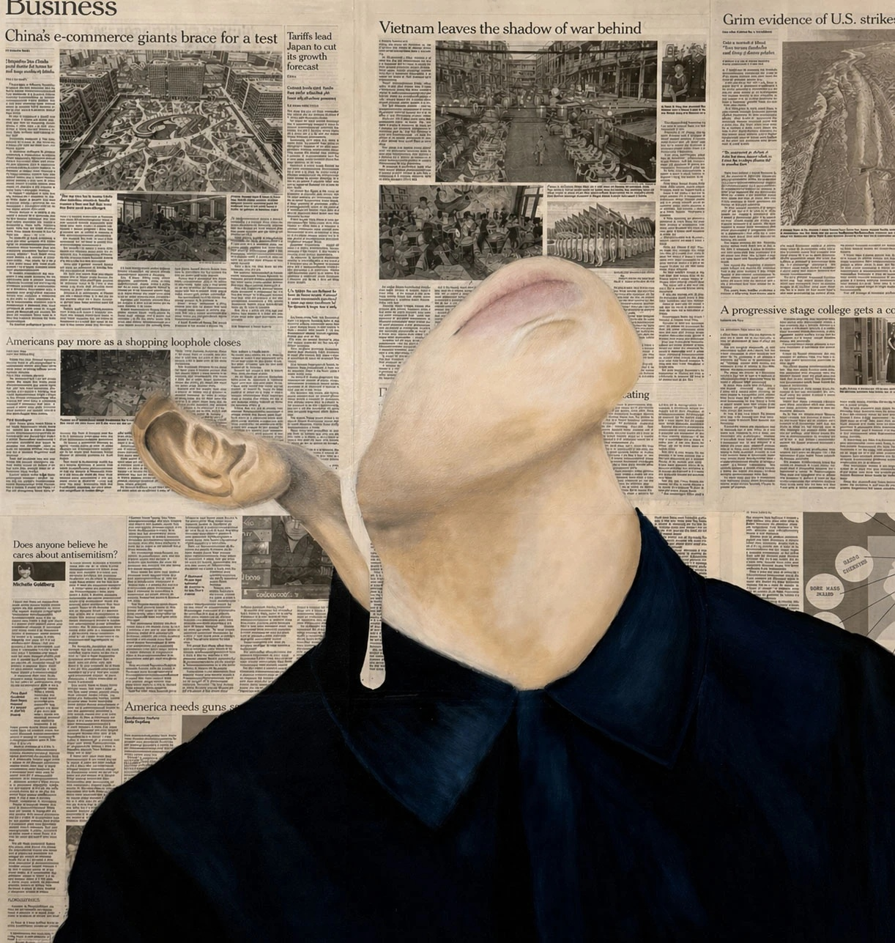  Read More...  Mixed media on canvas  90 × 110 cm  Price: 2,500 ILS

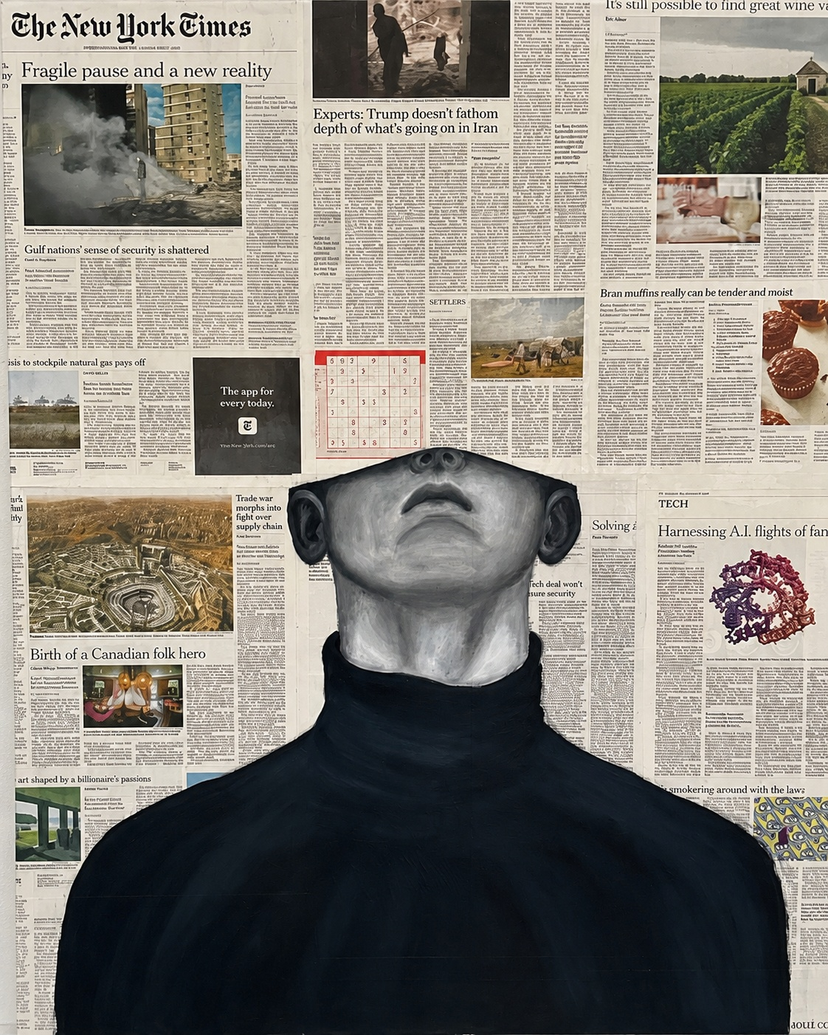  Subscriber  Mixed media on canvas  90 × 110 cm  Price: 2,500 ILS | 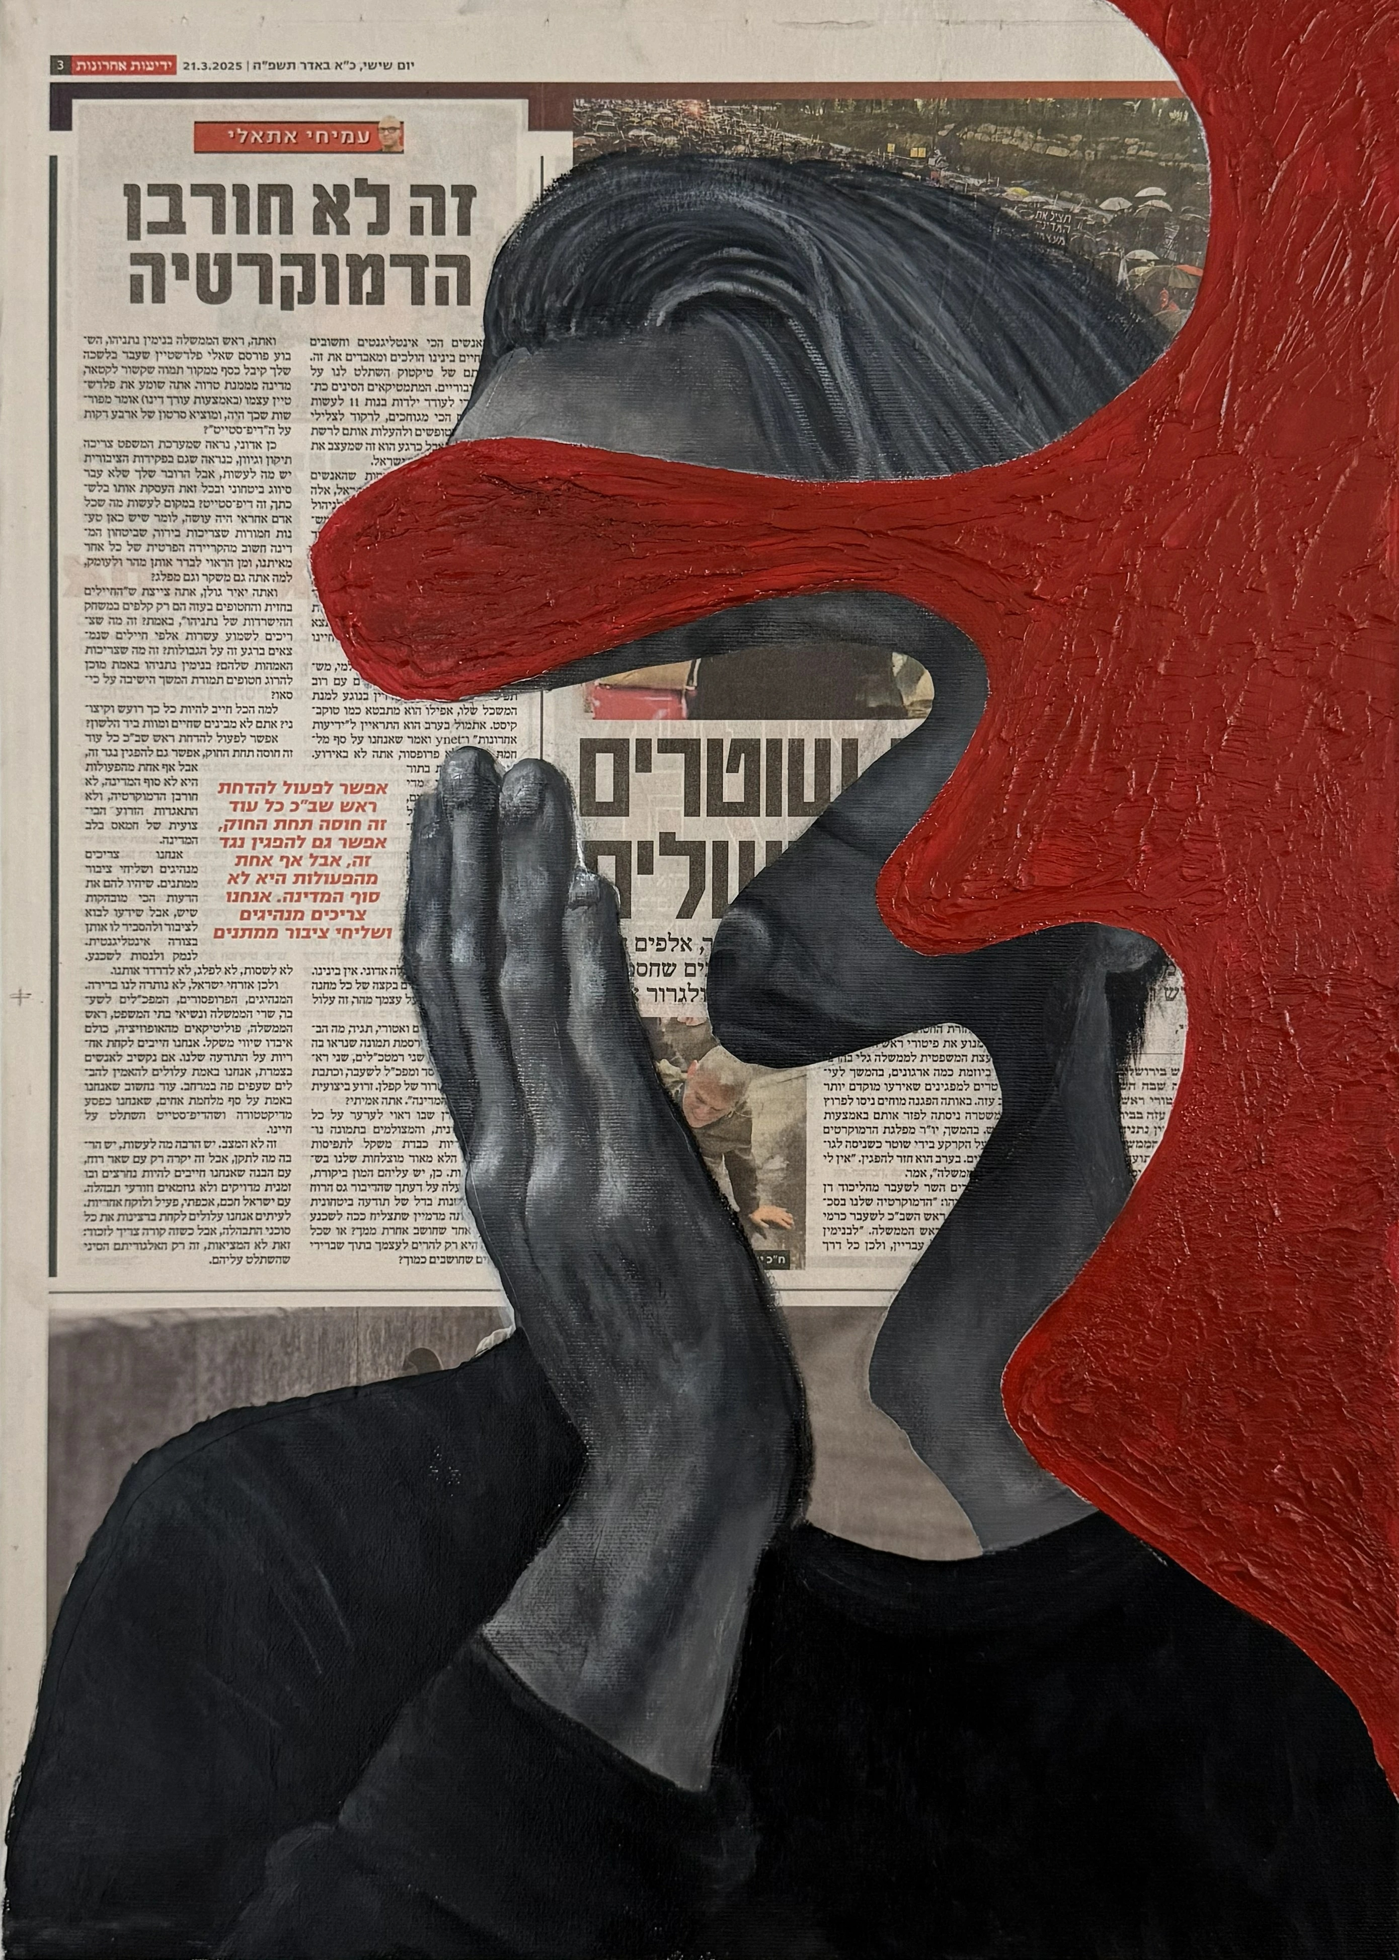  21.03.2025  Mixed media on canvas  35 × 57 cm  Price: 1,000 ILS | 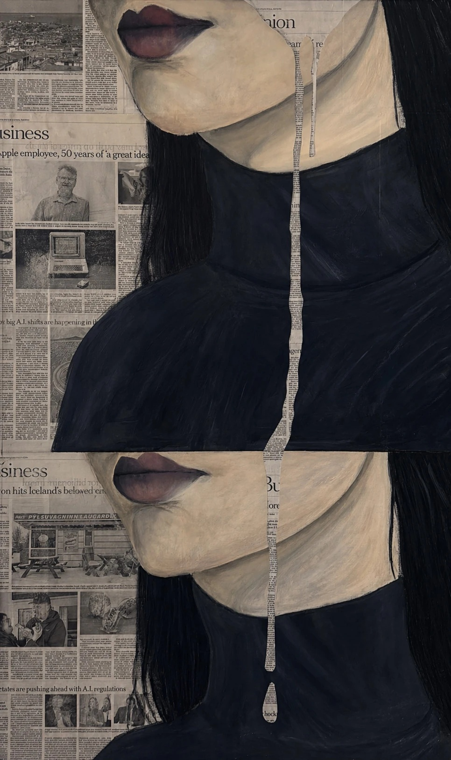  To Be Continued  Mixed media on canvas  120 × 80 cm  Price: 2,500 ILS

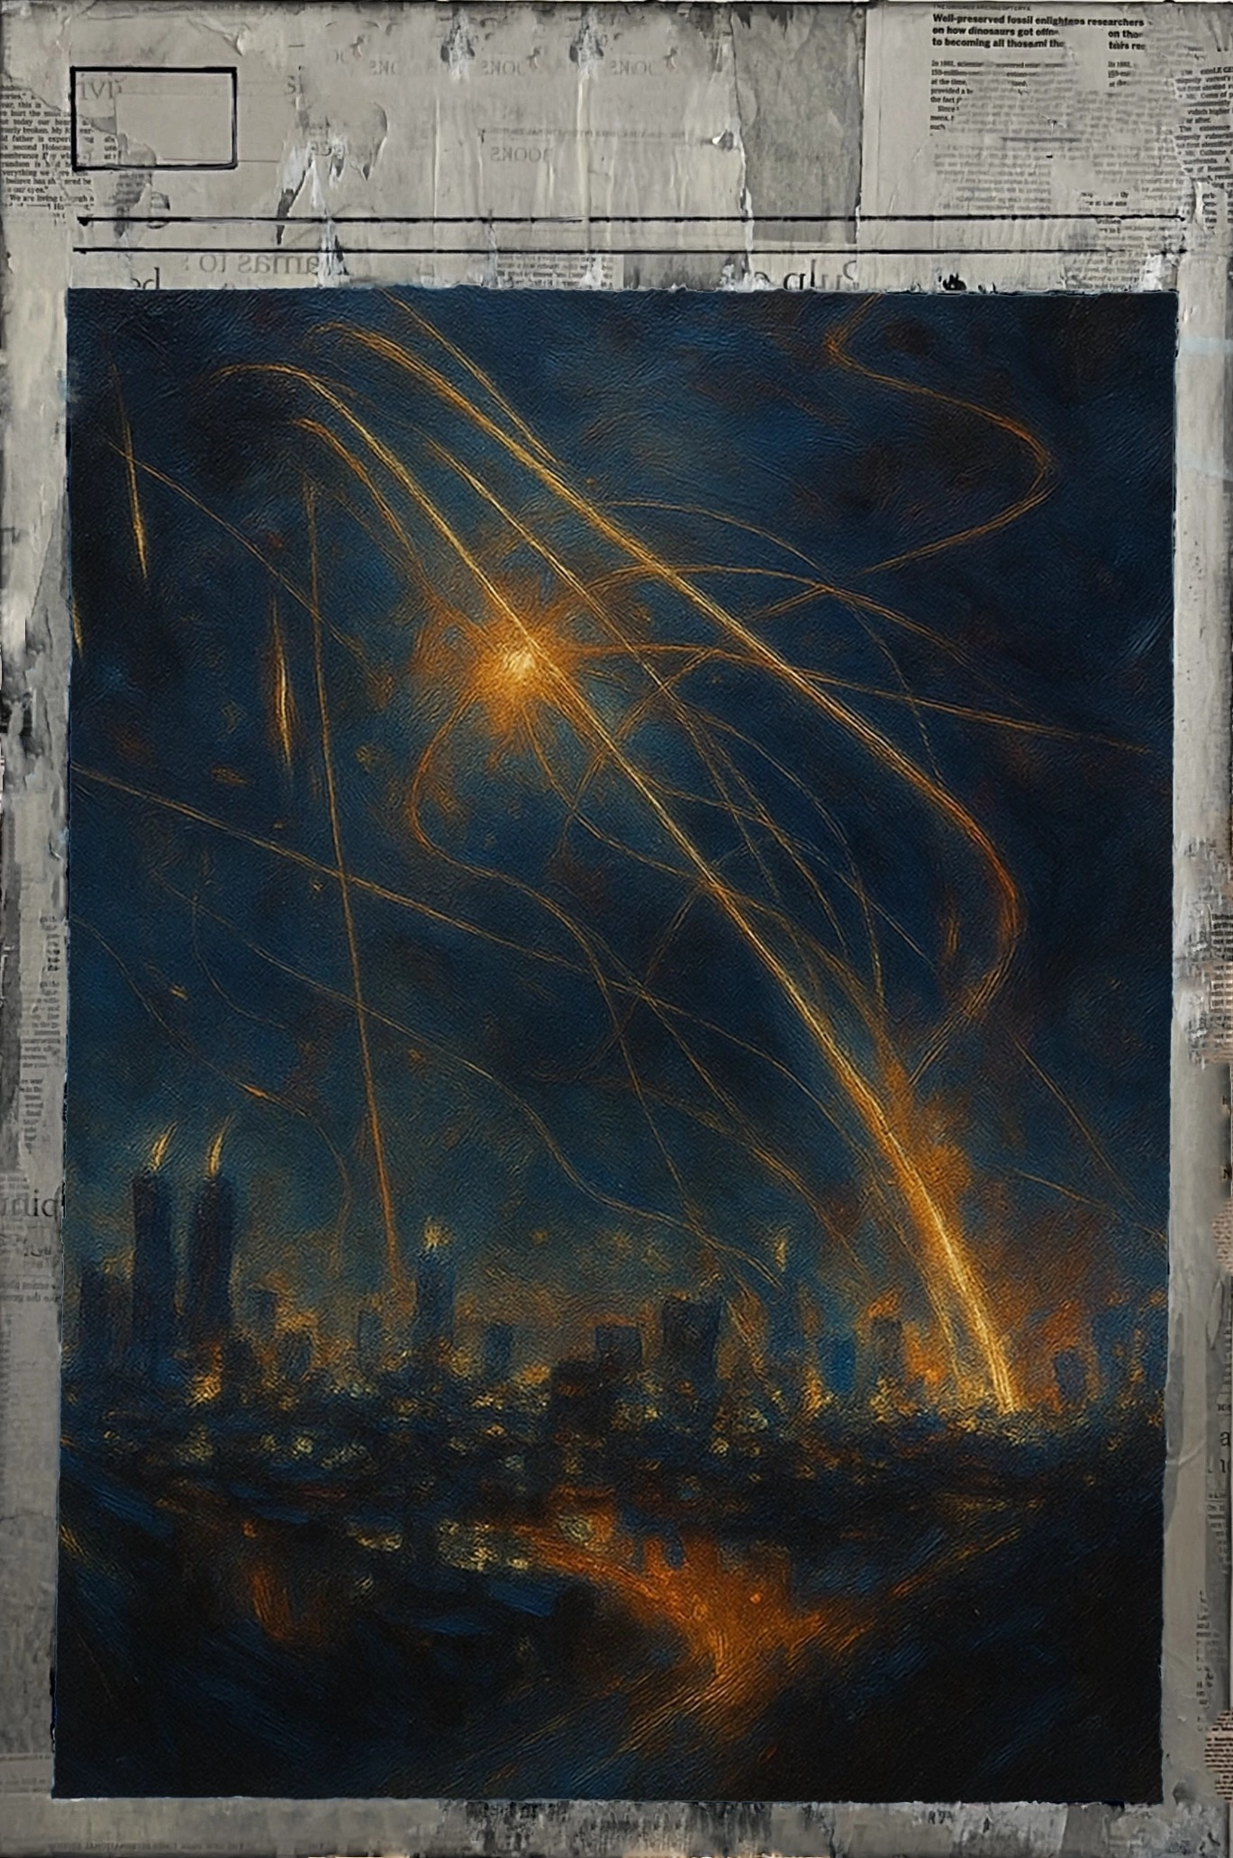  Nightlife  Mixed media on canvas  50 × 75 cm  Price: 1,200 ILS | 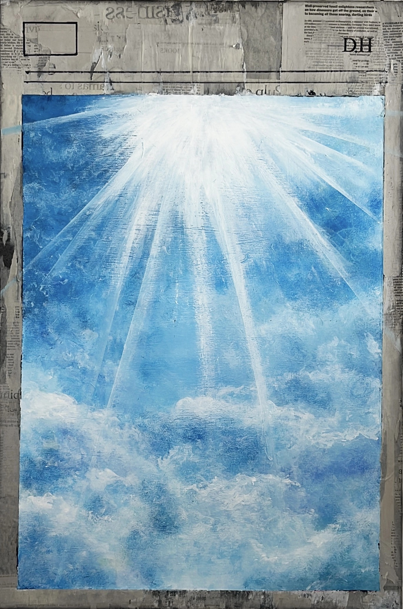  Light Study  Mixed media on canvas  Price: 1,200 ILS
Daily Material

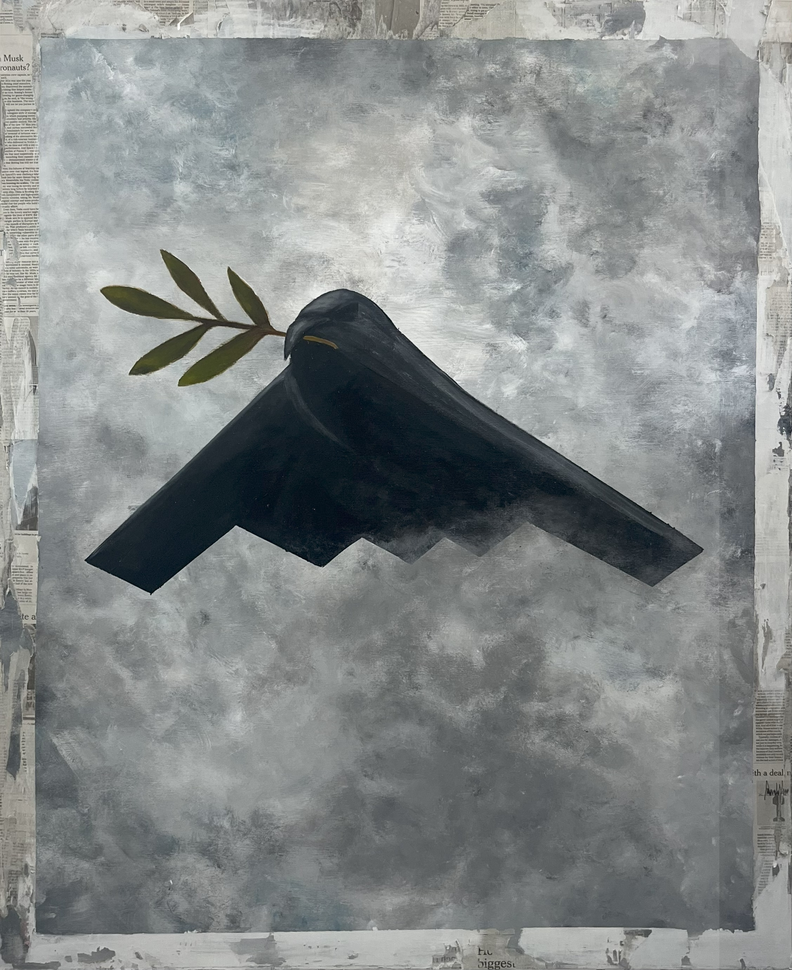  B2  Acrylic on canvas  Price: 2,000 ILS | 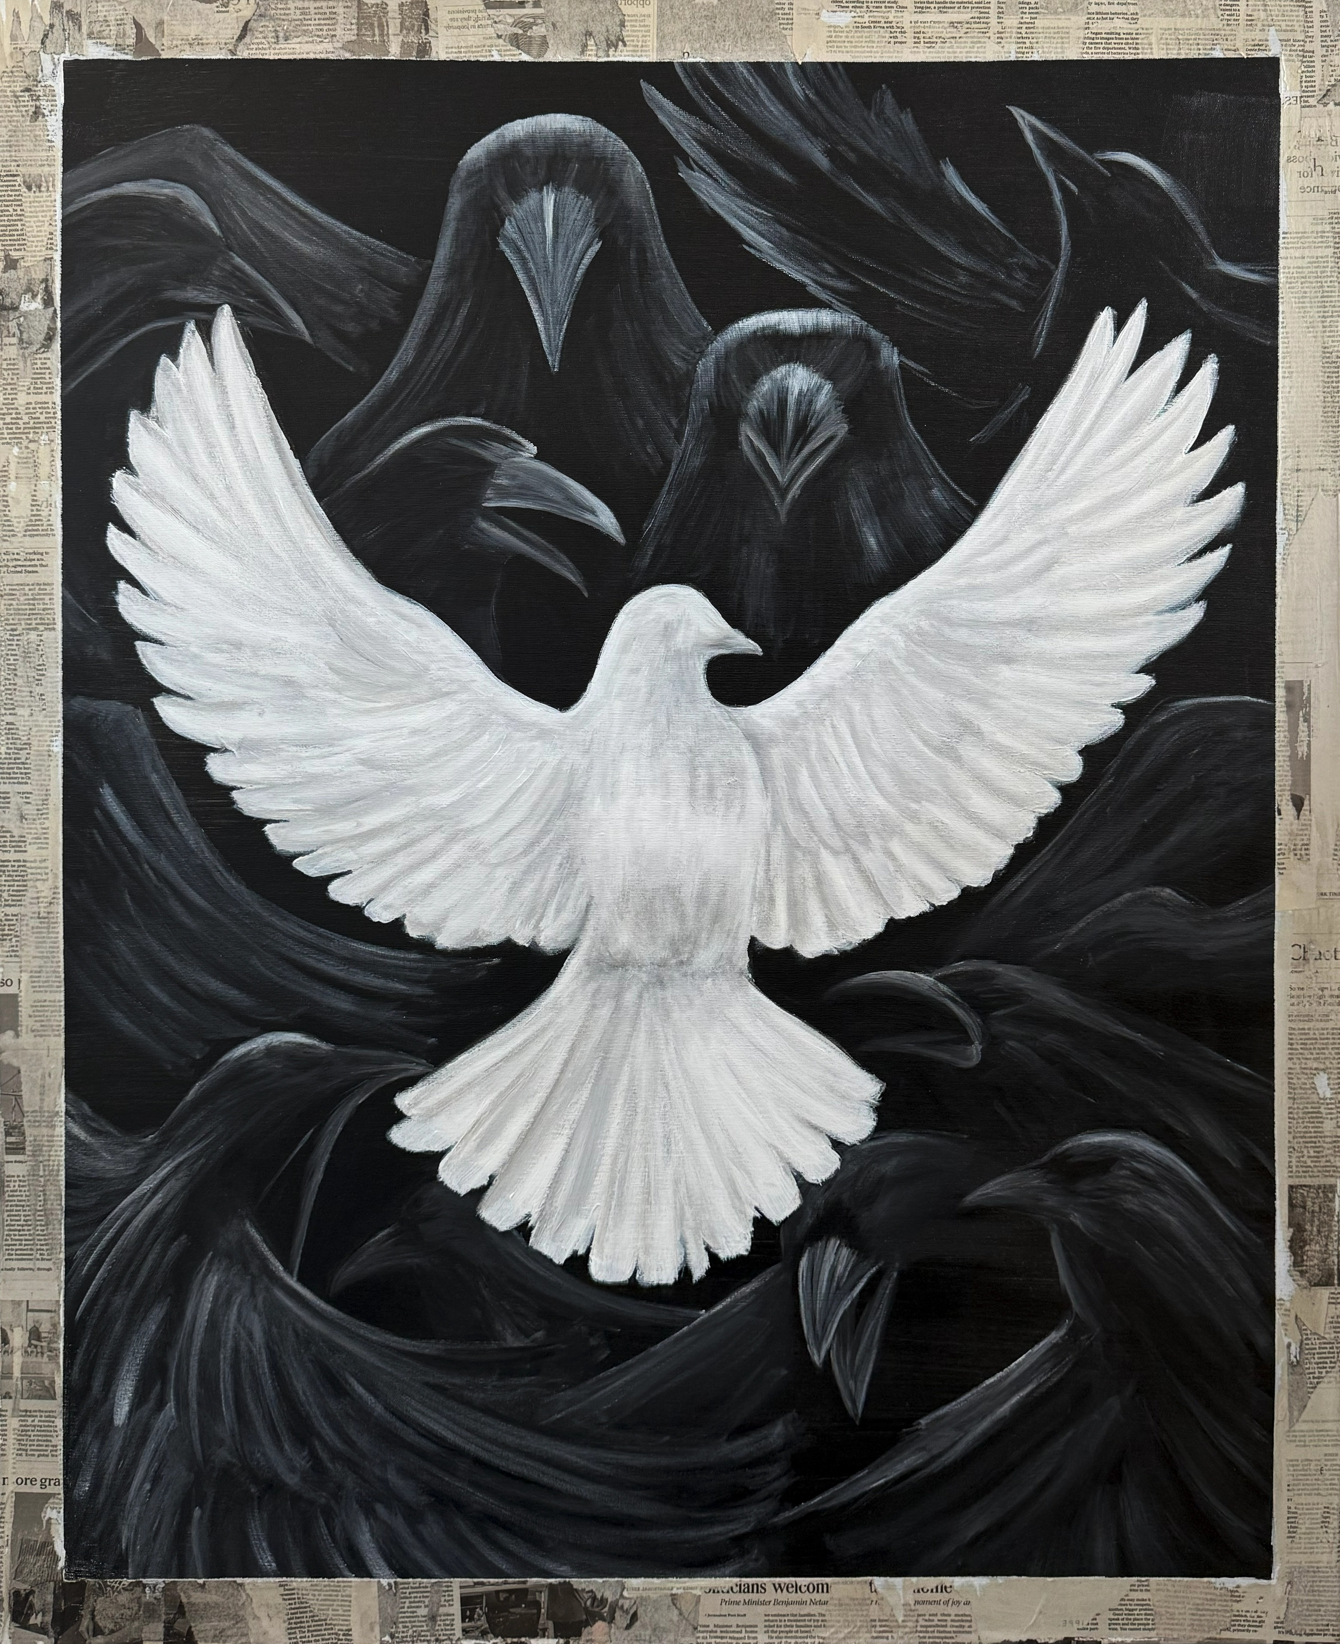  Dove Among Crawls  Mixed media on canvas  Price: 2,000 ILS

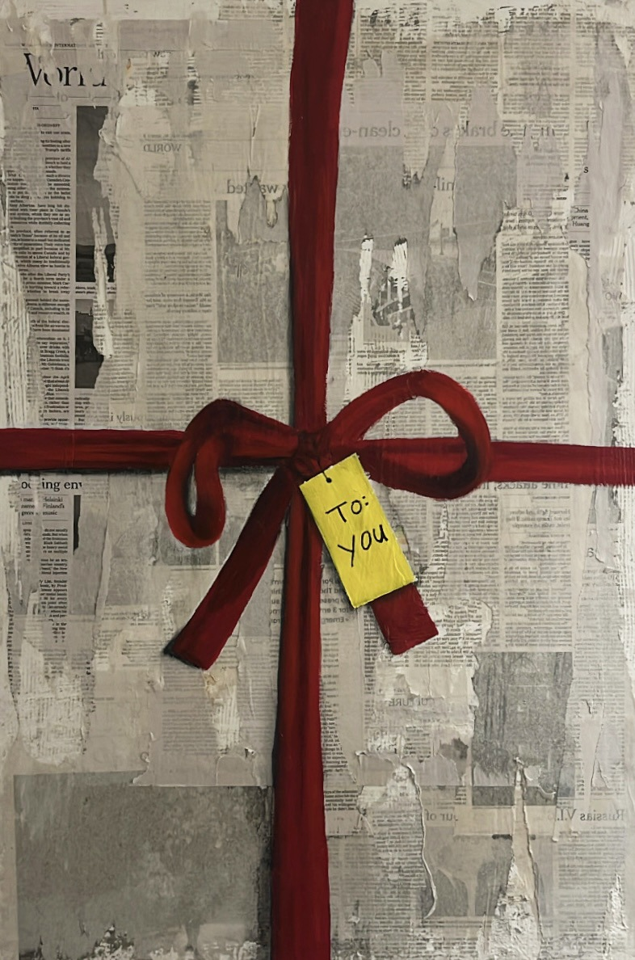  To You  Mixed media on canvas  Price: 1,000 ILS | 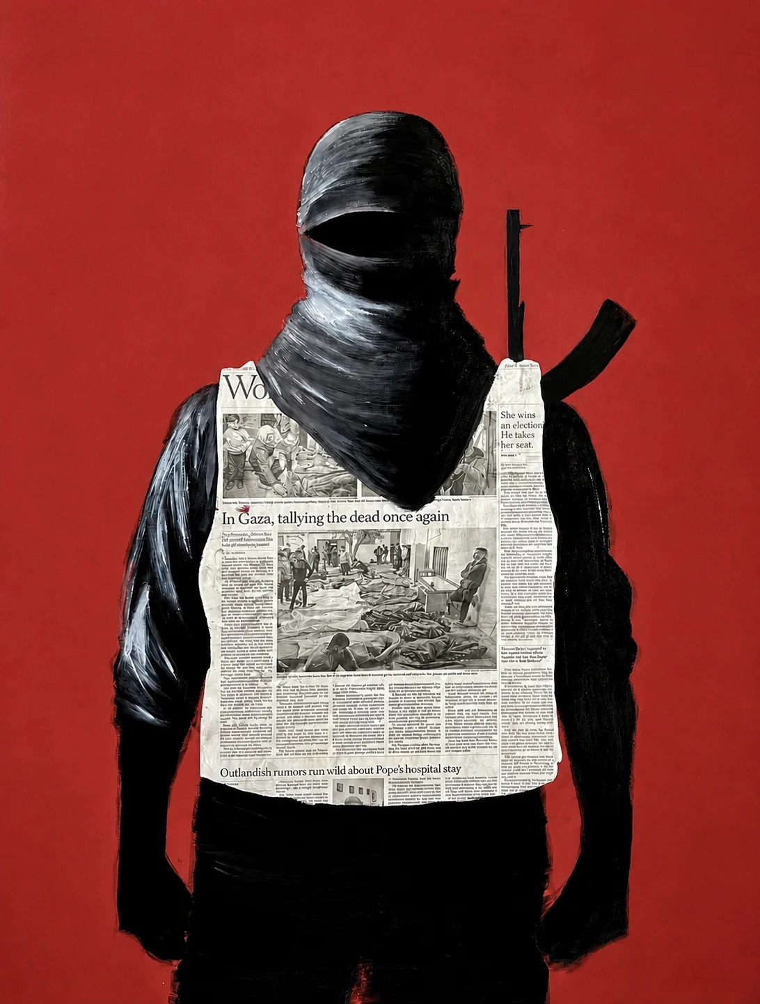  Coverage  Mixed media on canvas  Price: 2,500 ILS
Framed for Display

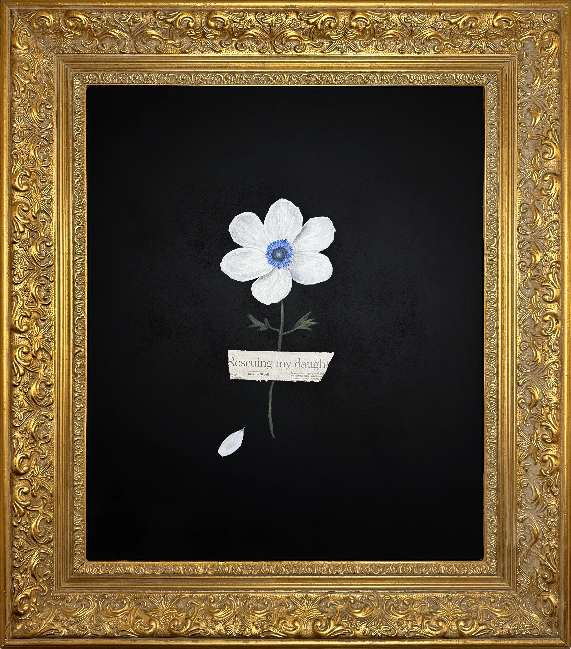  Taped [Anemone]  Mixed media on wood  69 × 81 cm  Price: 3,500 ILS | 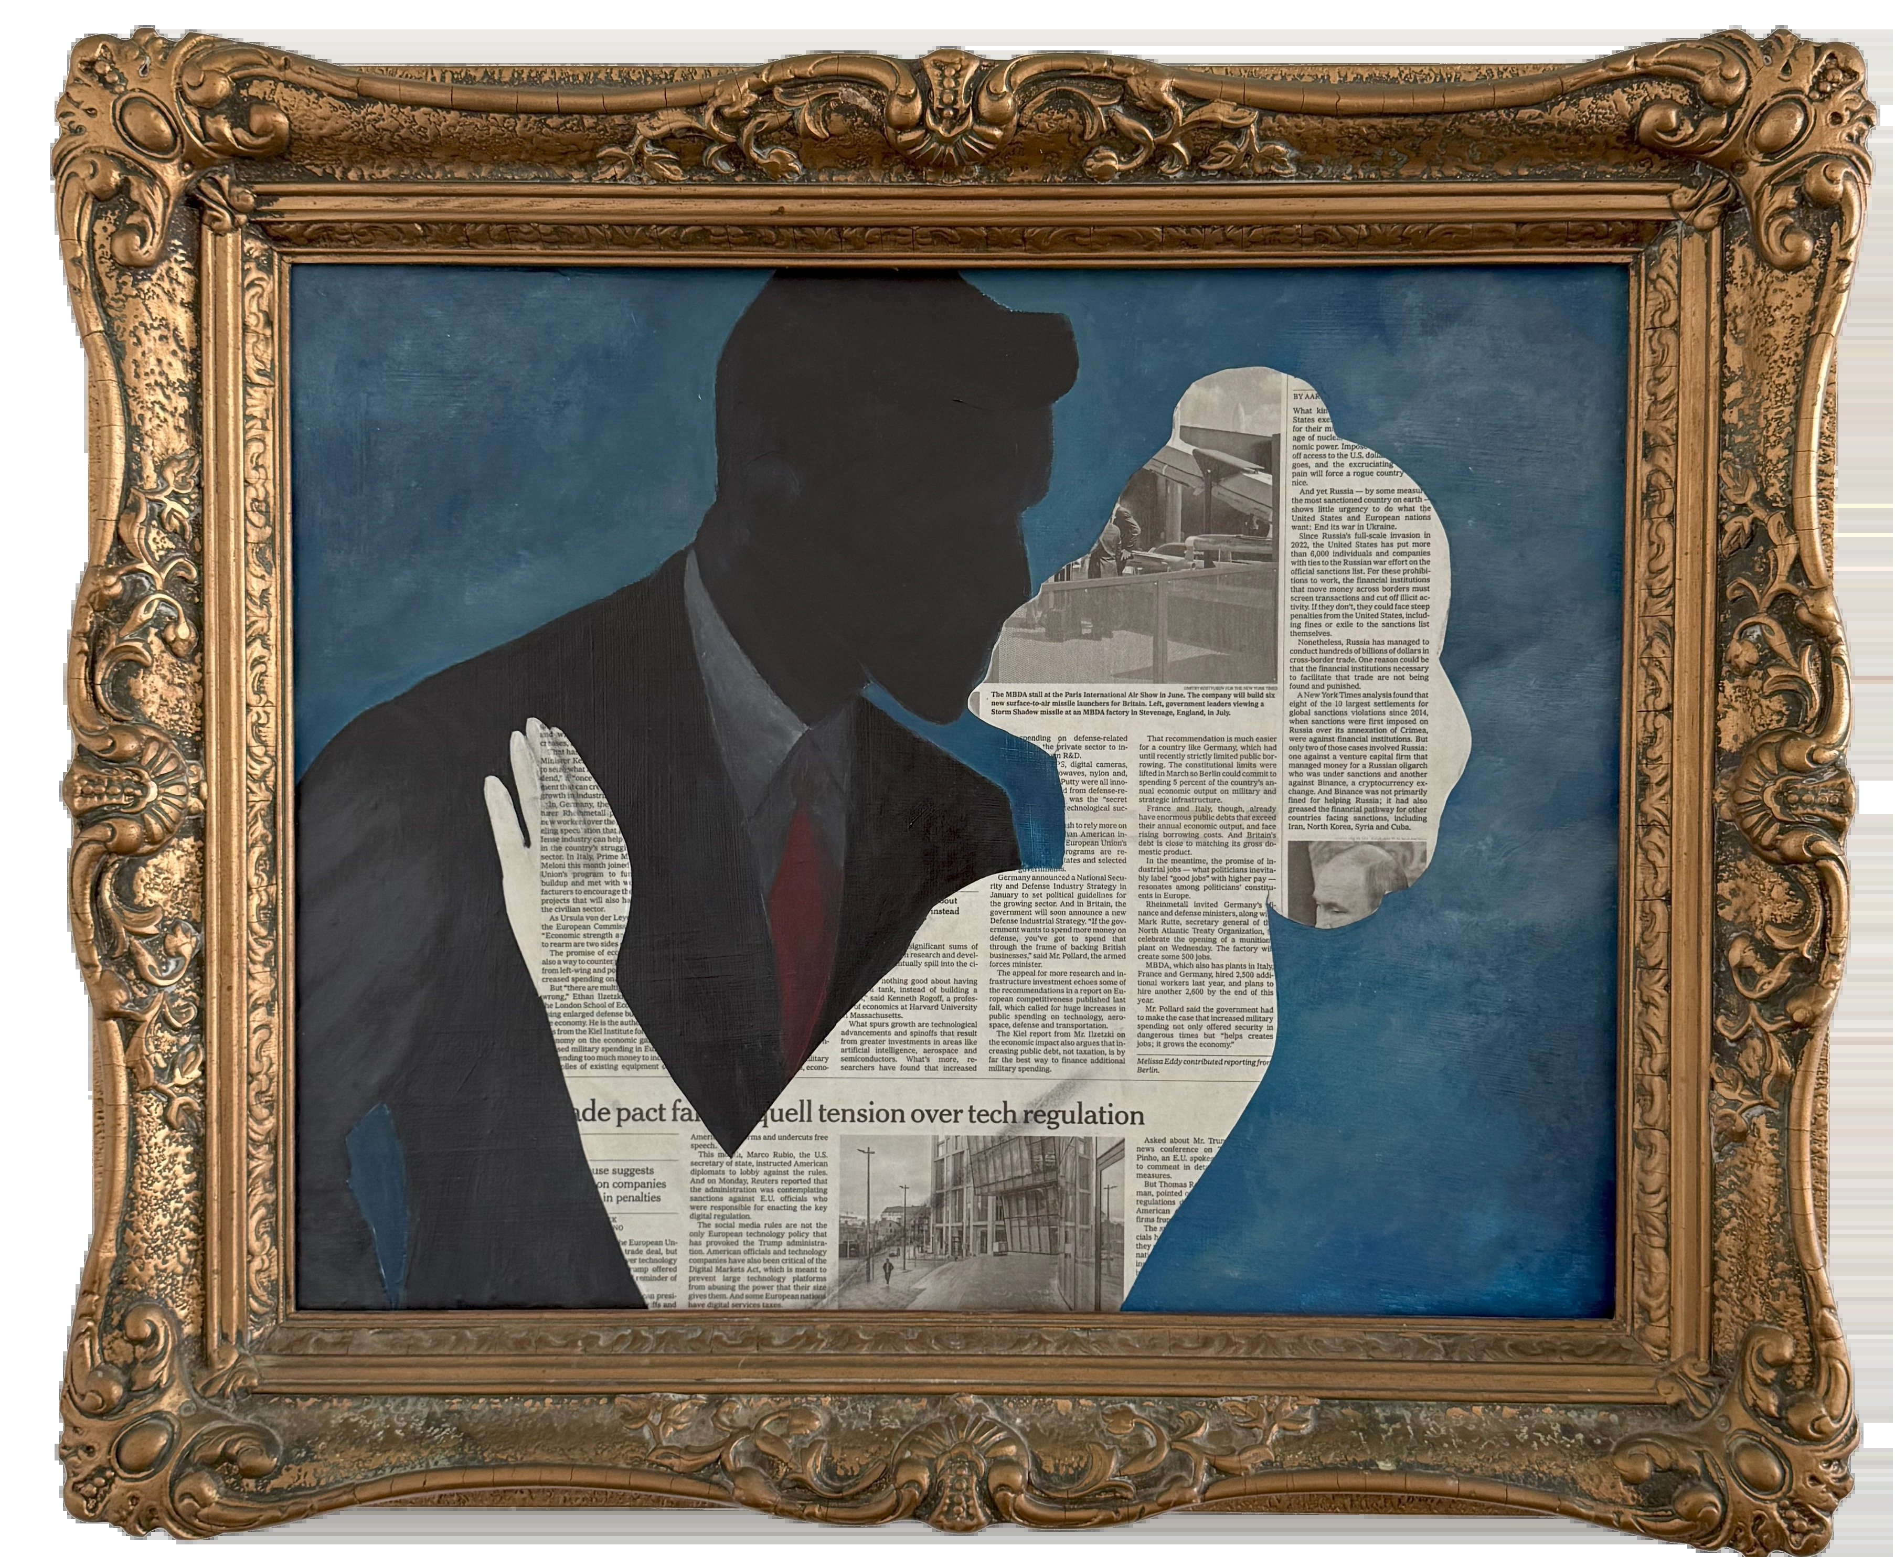  M&A  Mixed media on wood  51 × 61 cm  Price: 1,800 ILS

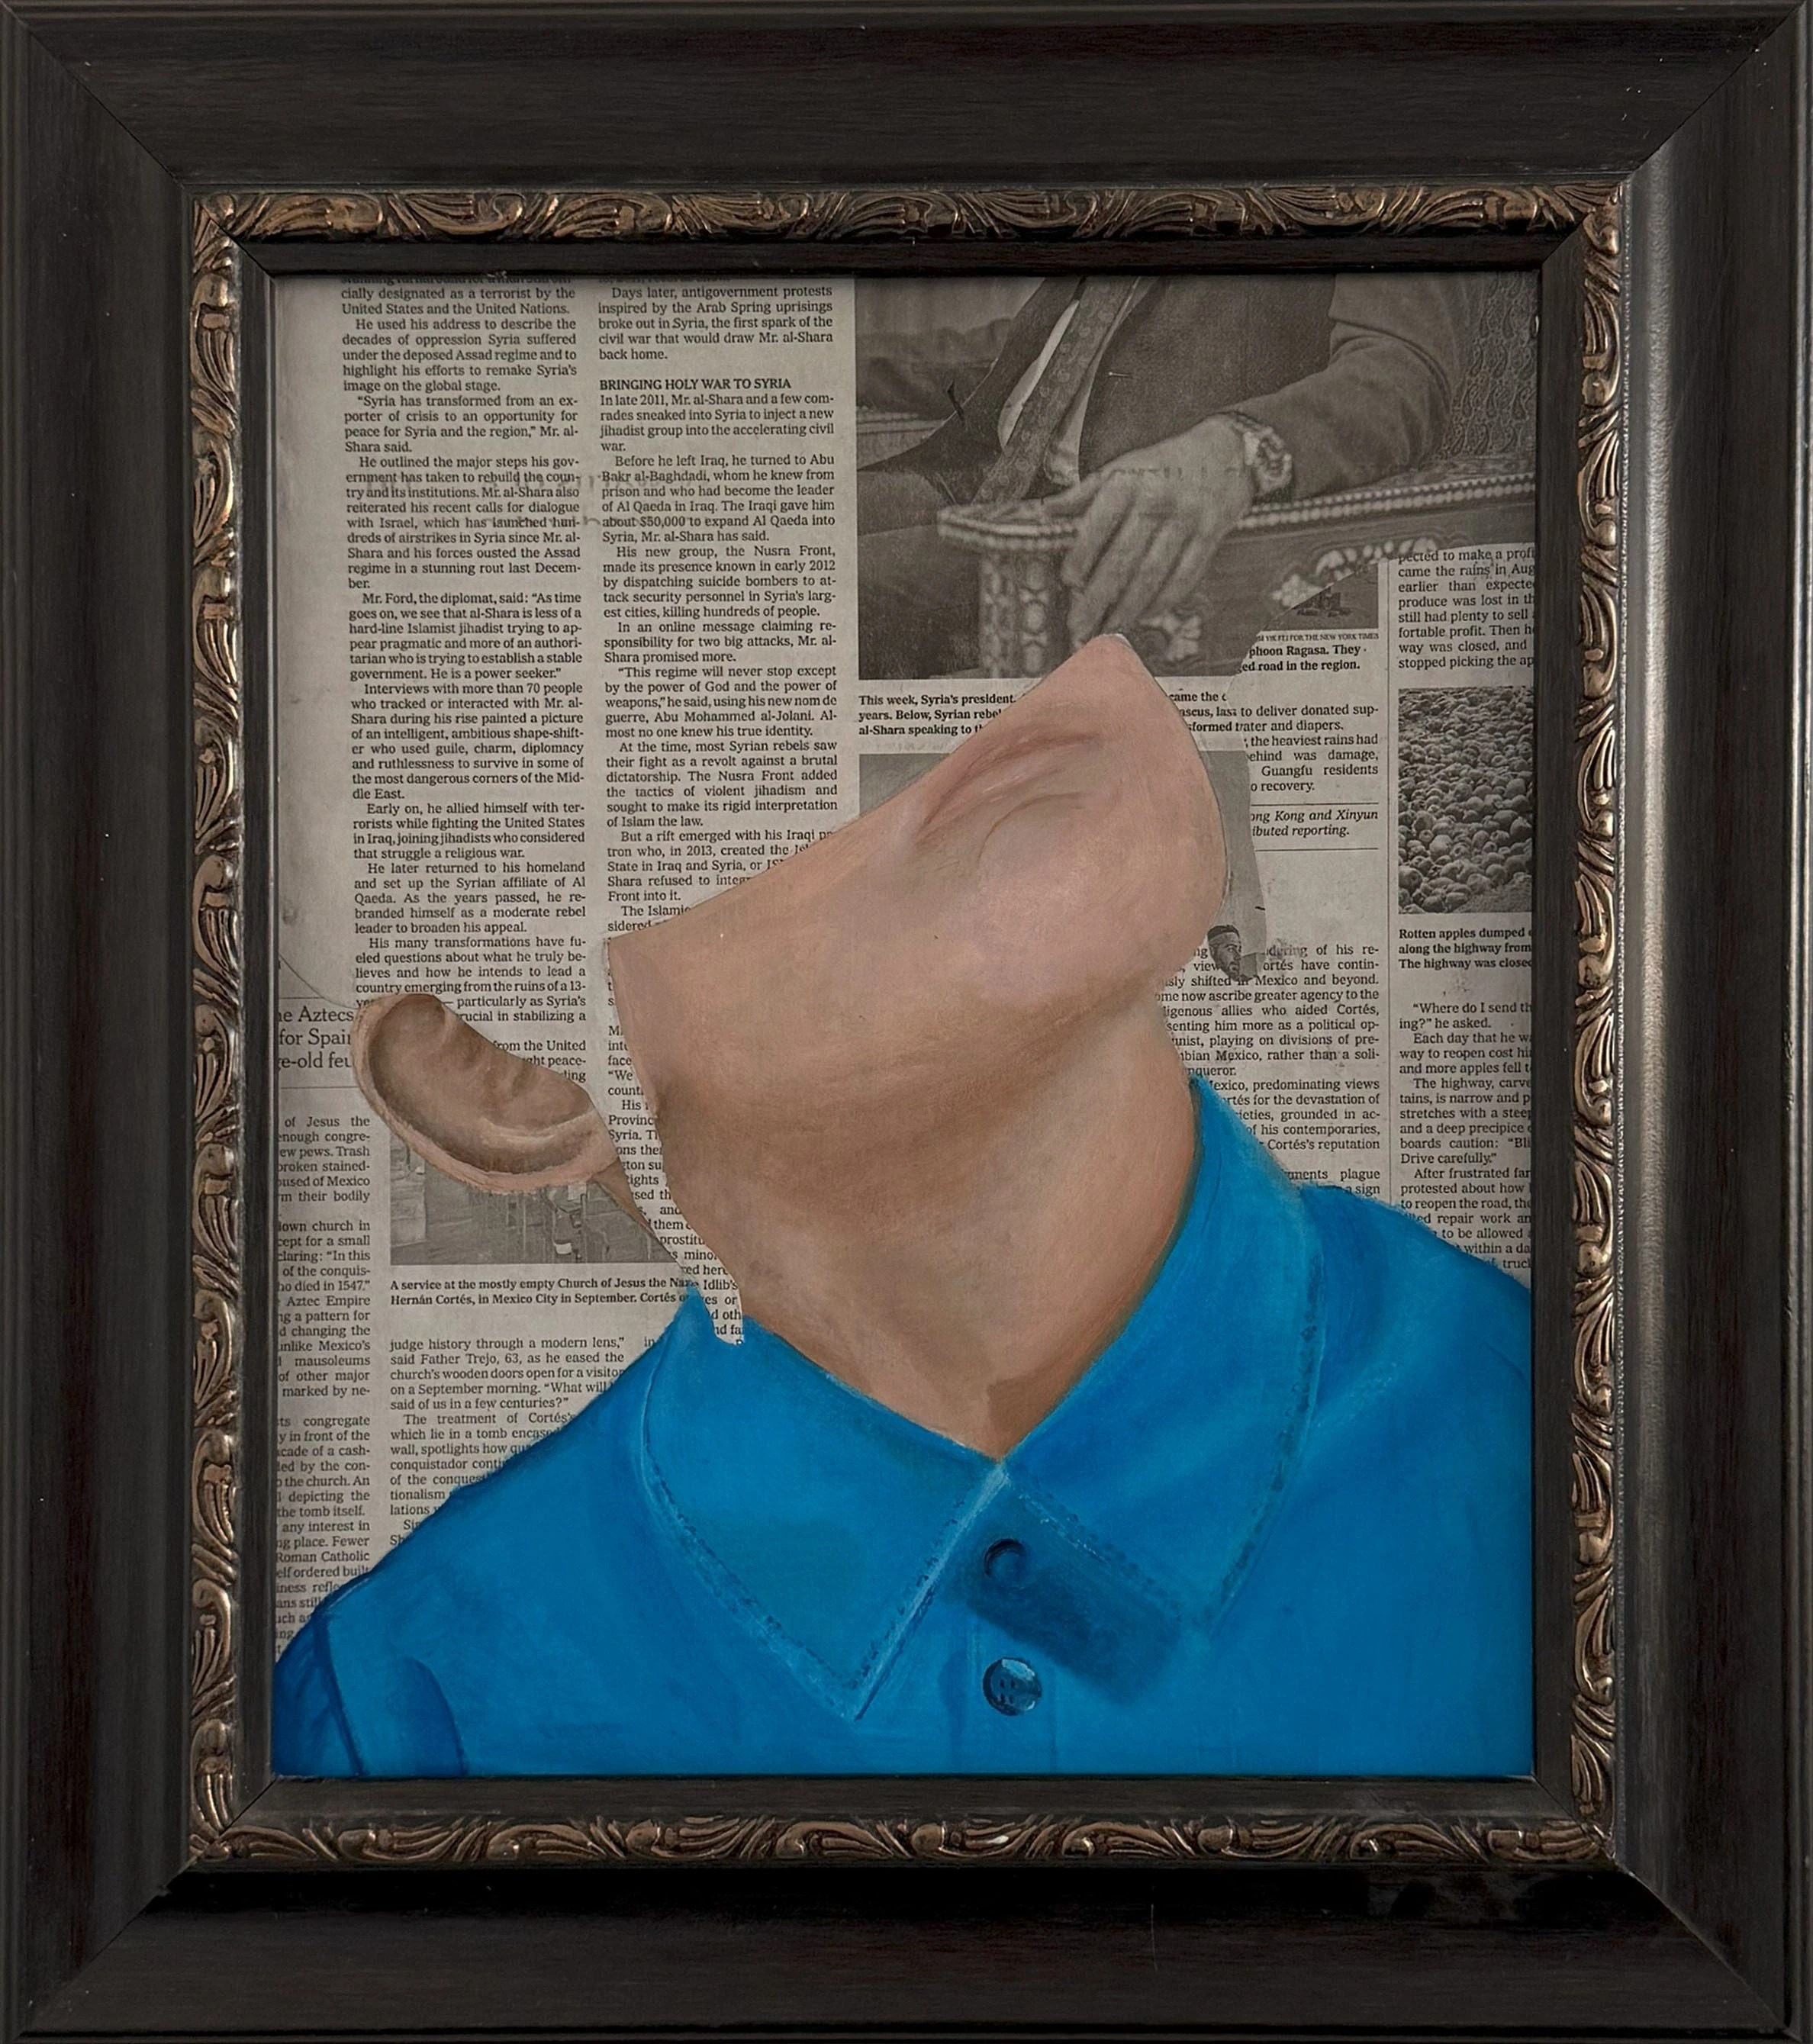
Class
Mixed media on wood
41 × 45 cm
Price: 800 ILS

