|  |  |
| --- | --- |
| Lob - Mail Campaign  Cheap + More feature + Best GUI |  |

1. **Cheap**

Lob.com is very cheap in mailing services - DocuPost, Stamps, easypost, DocuSign, ClickSend, Mailform, PC2Paper, Lob, Click2Mail, PostalMethods, Postmark, DocMail, Hello Market, SendOvernightMail , PostGrid, DocuSend, Switch Mailing Services, Pingen, MySendingBox, ...

(1). Lob - $0.73 for a letter (See <https://www.lob.com/pricing>)

(2). DocuPost - $0.85 (See <https://docupost.com/pricing/>)

(3). PostalMethods - $0.85~1.08 (See <https://www.postalmethods.com/pricing/>)

(4). Click2Mail - $1.45(1 sheet, 2 pages) (See <https://click2mail.com/>)

(5). ClickSend - $2.51 (See <https://www.clicksend.com/en/pricing/en/>)

(6). Mailform - $2.99 (See <https://www.mailform.io/pricing-calculator.html>)

1. **More feature**

Lob.com supports Sending, Reporting, Tracking, Analytics of bulk letters.

Stamps.com doesn't support letter sending, support printing postage label with your printer.

Please have a look once - <https://dashboard.lob.com/>.

1. **Best GUI**

It is very easy to use Lob.com mail service.

Please have a look once - <https://dashboard.lob.com/>.

*So, I recommend Lob!*

# How to launch mail campaign

|  |  |
| --- | --- |
|  | **Time saver:** This guide will walk you through how to launch your campaign from the Lob dashboard, watch this Video: [here](https://help.lob.com/print-and-mail/building-a-mail-strategy/campaign-or-triggered-sends/launch-your-first-campaign). |

**Before you get started**

You’ll need Audience file. You can create Audience file with the following tools:

- get-mail-address.py : Lookup mail address from company name and verify mail address.

- create-audience-cvs.py : Create lob audience file from mail addresses of the Excel file.

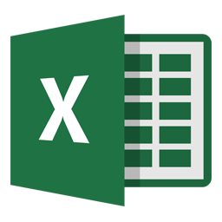

create-audience-cvs.py

**LOB**

Mail Campaign List.xlsx Lob.com audience file.

Please have a look at README.md.

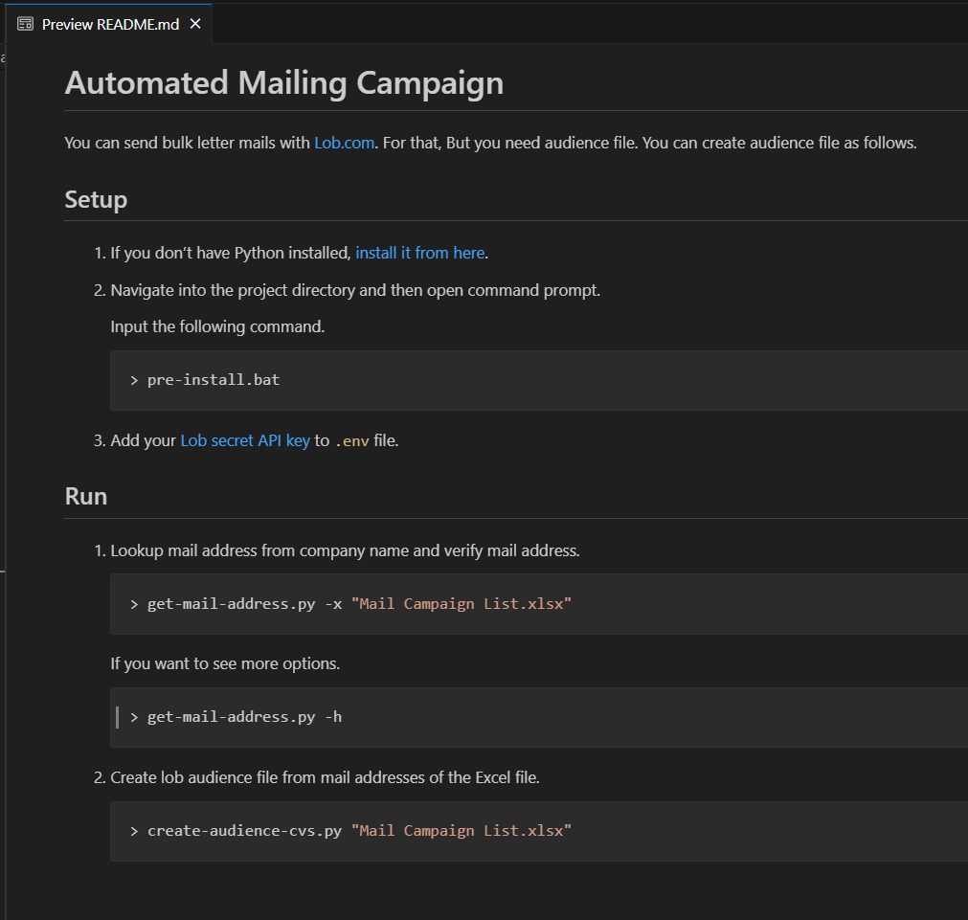

Test results

1. get-mail-address.py : It takes about 30 min for 1200 companies.

2. create-audience-cvs.py : It takes about 5 second for 1200 companies.