## Technologies used:

IDE: PHP-Storm

Environment: Windows 10 x64

Libraries: SQLite3, other built in PHP functions, Postman, Xampp, Apache, PHP 7.3

## Rudimentary UML diagram:

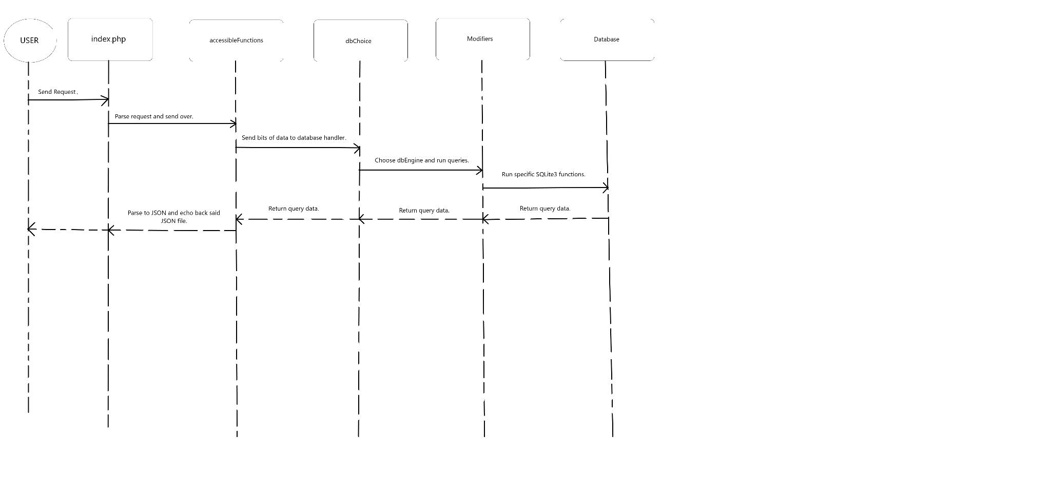

**USER**->(Sends request)->**index.php**->(parse url and send data)->**accessibleFunctions.php**->(send bits needed and verify request type)->**dbChoice.php**->(choose dbEngine required)->**Modifiers.php**->(query database with SQLite3)->**Database.php**->(return result or just execute)->**Modifiers.php**->(return result)->**dbChoice.php**->(return result)->**accessibleFunctions.php**->(encode in JSON format and send back)->**index.php**->(result is back at user in JSON format or the query has simply been executed silently)->**USER**