Part 1 - Static Switching
Static switching is where we manually fill in switch tables matching destination MAC address to the port the packets should go out of. It is similar to how static routing works, except at the MAC layer rather than IP layer. There are serious problems, however. First, it doesn't scale well - for each end host, each switch must have a forwarding path programmed in. Second, it cannot handle dynamic changes - if a host moves from Switch A to Switch B, many, possibly all, switches have to have the forwarding path updated. Third, it's highly error prone.

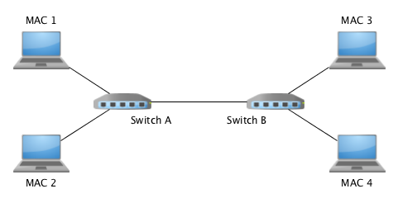

1) TODO, Need to create some data structure (I used essentially a two dimensional array, and record in the data structure the forwarding information for each switch (which port to use to access each of the 4 hosts)
2) TODO, need to take the data in the data structure that created in the first TODO and use it to generate routing policies that you add to the subpolicies list via subpolicies.append() operation.
There are example uses of the append there that you need to change to make use of your data structure (you will probably need some kind of loop to iterate over your data structure).
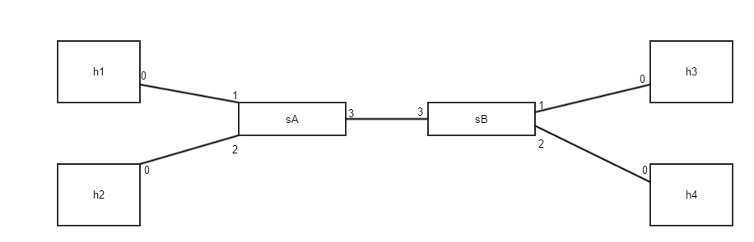
How to run the test

* At the terminal #1) run command
sudo mn -c ; sudo python static-forwarding-topo.py

* Open another terminal #2) run command
./run.sh static-forwarding ( without .py)

*which is the same as manually run command
#cp static-forwarding.py helpers.py ~/pyretic/pyretic/modules; cd ~/pyretic; python pyretic.py -m p0 pyretic.modules.static-forwarding

Part 2 - Learning Switch
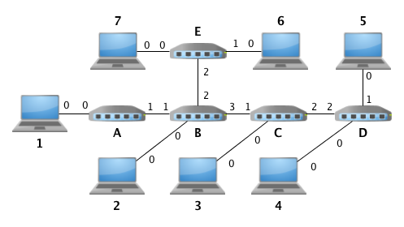

Above is the topology provided for the assignment. There are significantly more switches than in the review, however this allows for more test cases possible. You will be able to use both this topology and the one for the static part of the assignment for testing purposes.

I think there are two things going on:
- the numbers on the diagram are sometimes zero based while the port numbers in the application appear to be 1 based (so (0, 1, 2, 3) in the diagram is actually (1, 2, 3, 4)
- There are some discrepancies -- it seems that the switches have slight differences in how they are connected (look at the "Add links between switches" area in learning-switch-topo.py).
Anyway, from what I can see for switches:

- Switch A to B is correct (port 1 on A is connected to port 1 on B
- Switch B to C is not correct (in the topo, port 2 on B is connected to port 1 on C while the image shows this as 3->1)
- Switch C to D is not correct (in the topo port 2 on C is connected to port 1 on D while the image shows this as 2->2)
- Switch B to E is not correct (in the topo port 3 on B is connected to port 1 on E while the images shows this as 2->2)
For hosts, the host port is always zero, but the source port (from the switch) is always non-zero (2, 3, or 4).
while the port numbers in the diagram appear to have some differences, the general layout appears correct (all the hosts are connected to the switches and all the switches are connected to each other in the layout shown in the image)..
How to run the test

* At the terminal #1) run command
sudo mn -c ; sudo python learning-switch-topo.py

* Open another terminal #2) run command
./run.sh learning-switch ( without .py)

*which is the same as manually run command
#cp learning-switch.py helpers.py ~/pyretic/pyretic/modules; cd ~/pyretic; python pyretic.py -m p0 pyretic.modules.learning-switch

