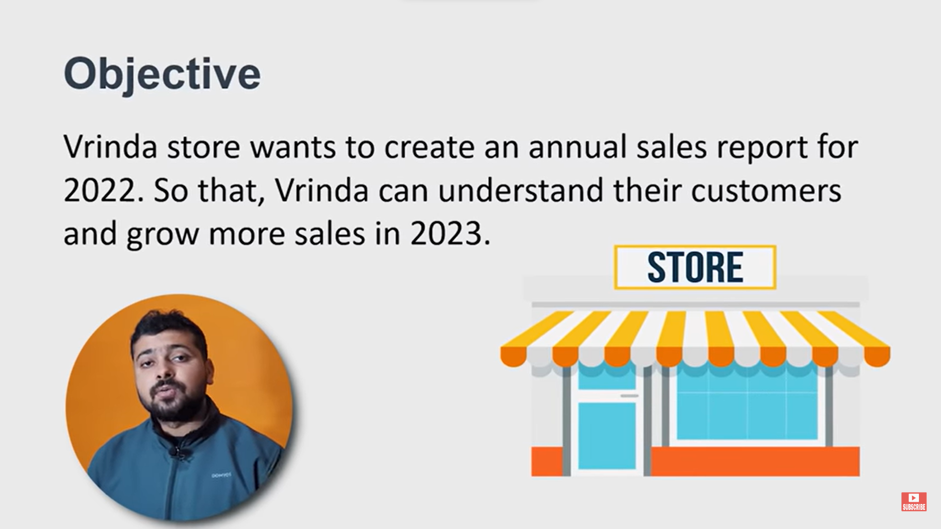

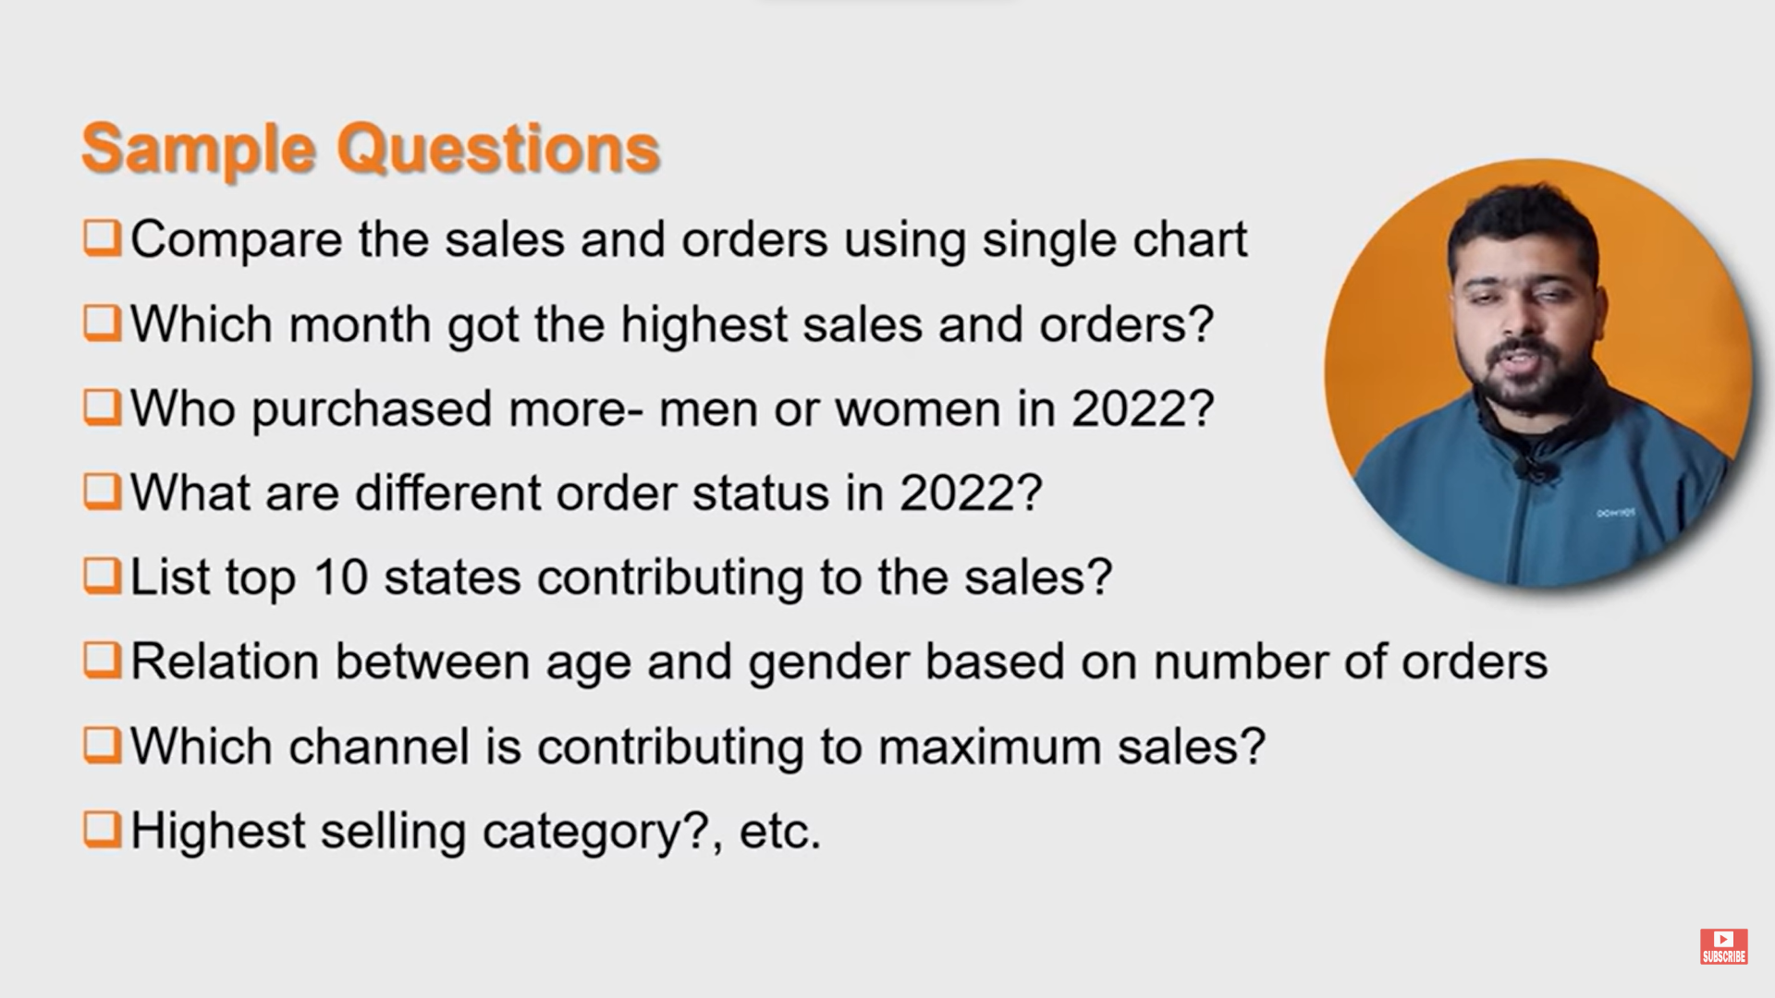

# **DATA Cleaning**

* No blanks/null
* No duplicates
* Data consistency – replace values with unique value

# **DATA Processing**

* Age grouping =IF(E9>=50,"Senior", IF(E9>=30,"Adult","Teenage"))

Paste as values to reduce formula timing

* =TEXT(G2,"mmm")

# **DATA Analysis**

* Create PIVOT table

# **Insights**

