Name: Abdul Rehman Qasim

Roll: 20i-0946

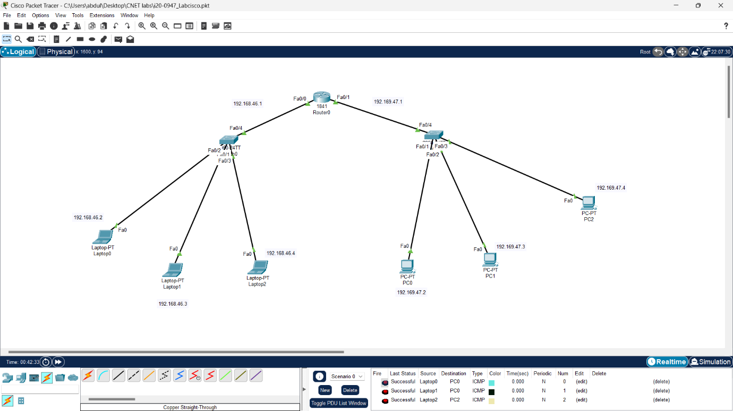

This is the topology overview

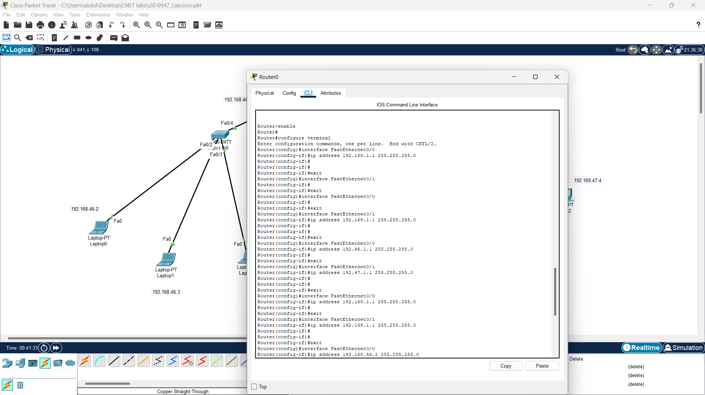

This is the CLI of the router

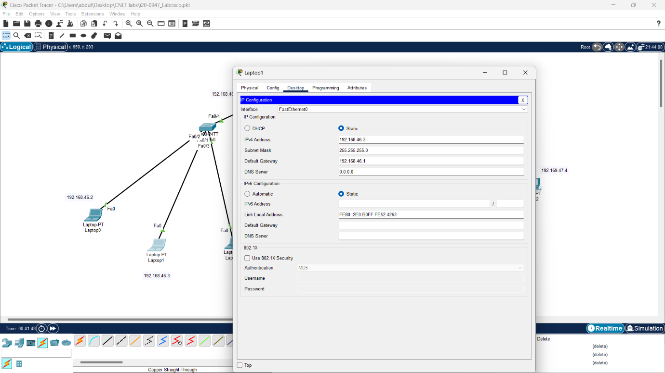

This is the laptop ip configuration setting

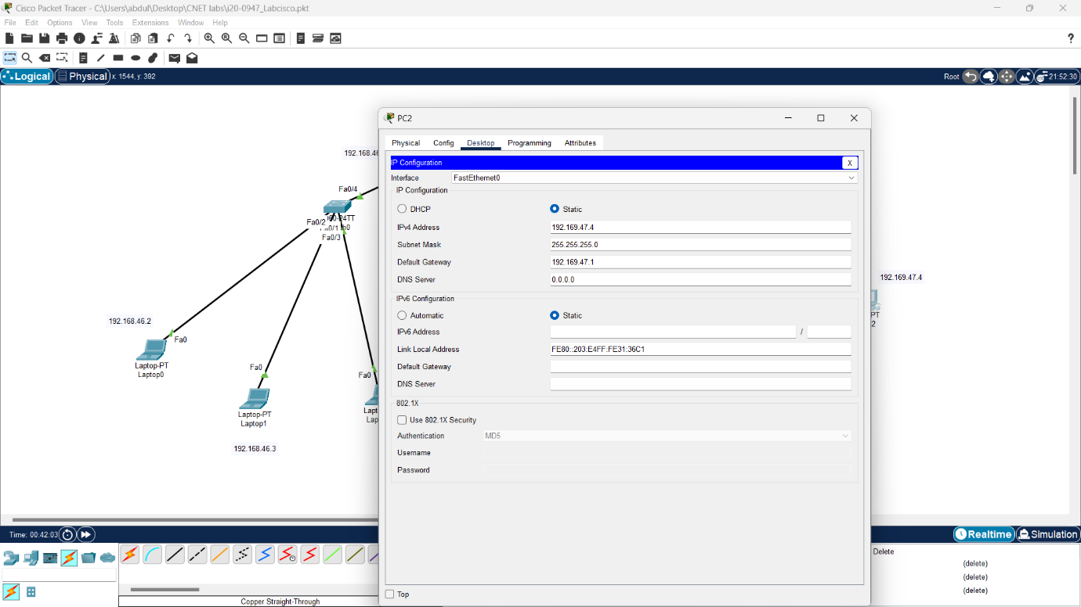

This is the pc ip configuration setting

Note: the first screenshot contains the successful packet transfer evidence