22I-1725

Abdul Sami Qasim

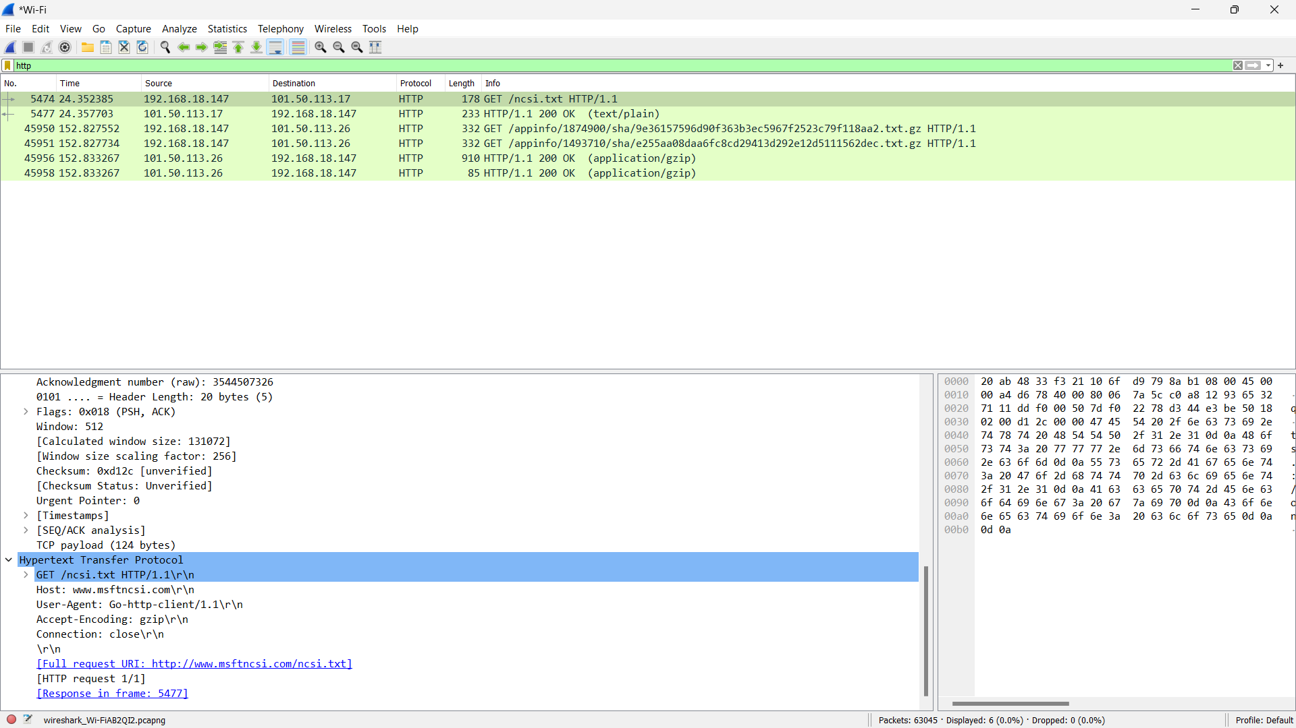

1. 1.1
2. Single language (Chinese)
3. 192.168.18.147 (mine) and 101.50.113.17 (server)
4. 200
5. None
6. 233 bytes
7. A screenshot of a computer

   Description automatically generated
8. 200 OK
9. nothing