Assignment#2

Computer Networks

Ahmad Abdullah

I22-1609

## Question#1

### 1 & 3 .

The IP address of nu.edu.pk is 192.168.0.1 and the IP address of the DNS server is 203.124.44.78

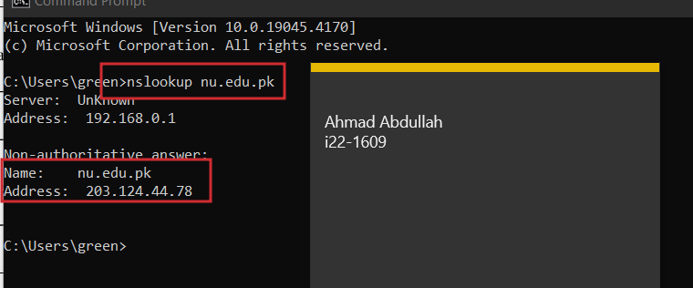

### 2.

The IP address of flex.nu.edu.pk is also 192.168.0.1

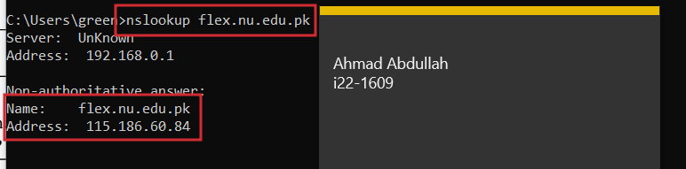

### 4.

The nslookup command in question 1 above comes from a non-authoritative server because generally the first request is done to the non-authoritative server which upon not having the answer sends the request to TLD or a higher server in the hierarchy and the server higher above sends the answer back to the non-authoritative server which sends the response to the client.

### 5.

The command to find the authoritative server is nslookup “-type=NS” nu.edu.pk and the IP of the authoritative server is 192.168.43.1

### 

### 6.

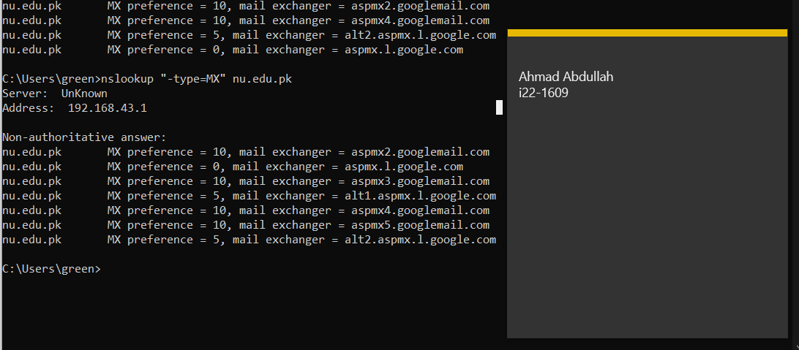

### 7.

Ahmad Abdullah 
i22-1609

### 8.

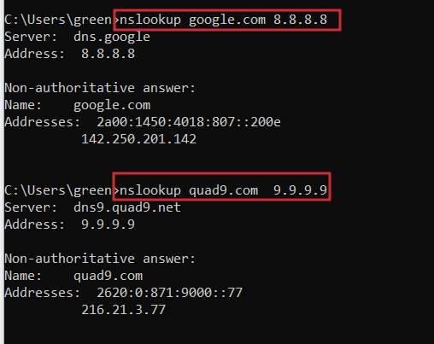

## Question#2

### 1.

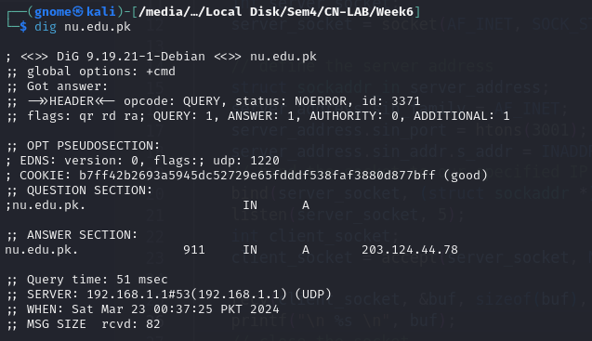

### 2.

### 3.

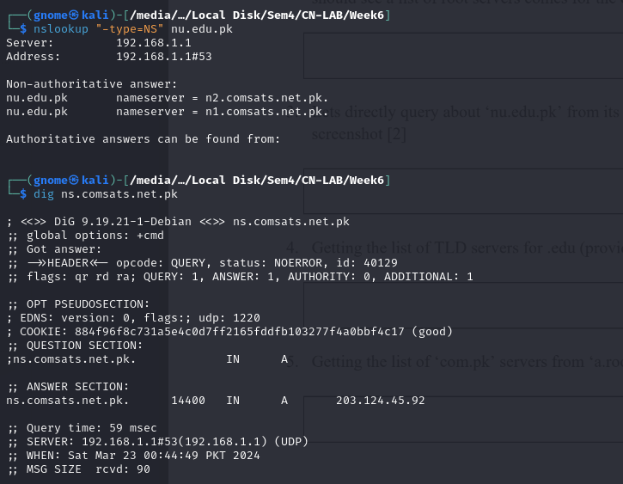

### 4.

### 5.

## Question#3

### 1.

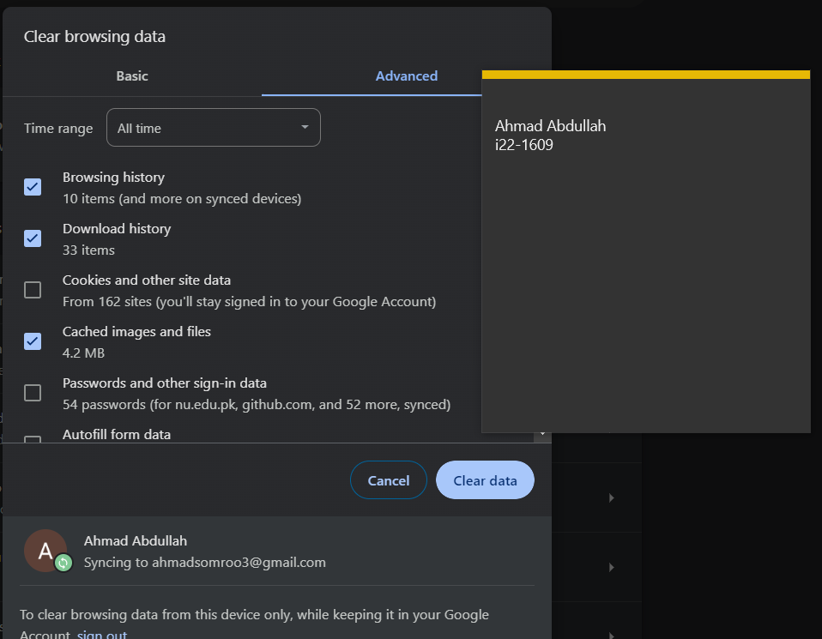

### 2.

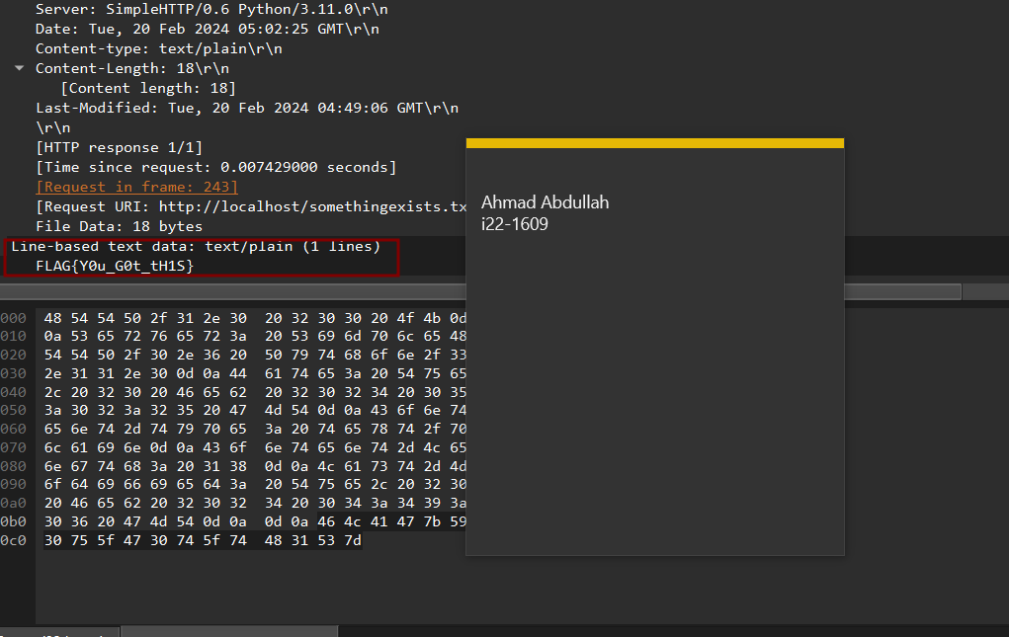

### 3.

There were not any status code for 304 in any sites I visited.

