COAL LAB 3

ABDUL SAMI QASIM
22I-1725
CY-D
Task1:
.model small

.stack 100h

.data
var1 db ?
var2 db ?
.code

main proc
mov ax,@data
mov dx,ax

mov ah,01
int 21h

sub al,30h
mov var1,al

mov ah,01
int 21h

sub al,30h
mov var2,al

add var1,al
add var1,30h
int 21h

mov dl,var1
mov ah,02
int 21h

mov ah,4ch

int 21h

main endp

end main

Output:
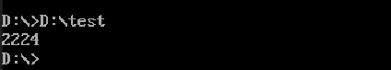

Task2:
.model small

.stack 100h

.data
var1 db ?
var2 db ?
.code

main proc
mov ax,@data
mov dx,ax

mov ah,01
int 21h

sub al,30h
mov var1,al

mov ah,01
int 21h

sub al,30h
mov var2,al

sub var1,al
add var1,30h
int 21h

mov dl,var1
mov ah,02
int 21h

mov ah,4ch

int 21h

main endp

end main

Output:
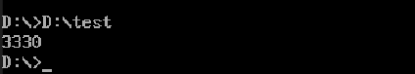

Task3:
.model small

.stack 100h

.data
var1 db ?
var2 db ?
.code

main proc
mov ax,@data
mov dx,ax

mov ah,01
int 21h

sub al,30h
mov var1,al
mov ah,01
int 21h

sub al,30h
mul var1

AAM

mov ch,ah
mov cl,al

mov dl,ch
add dl,30h
mov ah,02
int 21h

mov dl,cl
add dl,30h
mov ah,02
int 21h

mov ah,4ch

int 21h

main endp

end main

Output:
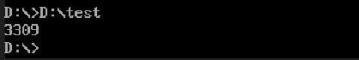

Task4:
.model small
.stack 10h
.data
q db ?
r db ?
.code
Main proc
mov ax,26
mov bl, 5
div bl
mov q, al
mov r, ah
mov dl, q
add dl, 48
mov ah, 2
int 21h
mov dl, r
add dl, 48
mov ah, 2
int 21h
mov ah, 4ch
int 21h
main endp
end main

Output:
