COAL LAB 5
ABDUL SAMI QASIM
22I-1725
CY-D

TASK1:

;code to compare two numbers
.model small
.stack 100h
.data
msg1 db 10,13, "Enter First number: $"
msg2 db 10,13, "Enter Second number: $"
msg3 db 10,13, "Numbers are equal $"
msg4 db 10,13, "Numbers are not equal $"
.code
main proc
mov ax, @data
mov ds, ax
; Display message to enter the first number
mov dx, offset msg1
mov ah, 09h
int 21h
; Read the first number
mov ah, 01h ; Function to read a character from STDIN
int 21h ; Call DOS interrupt
sub al, 30h ; Convert ASCII to numeric value
mov cl, al ; Store the first number
; Display message to enter the second number
mov dx, offset msg2
mov ah, 09h
int 21h
; Read the second number
mov ah, 01h ; Function to read a character from STDIN
int 21h ; Call DOS interrupt
sub al, 30h ; Convert ASCII to numeric value
mov dl, al ; Store the second number
; Compare the two numbers
cmp dl, cl
je equal ; If equal, jump to label1
; If not equal, print the message
mov dx, offset msg4
mov ah, 09h
int 21h
jmp end_prog
equal:
; If equal, print the message
mov dx, offset msg3
mov ah, 09h
int 21h
end_prog:
;end_prog: This is the end of the program. It terminates the program using DOS interrupt 4Ch.
mov ah, 4ch
int 21h
main endp
end main

OUTPUT 1:
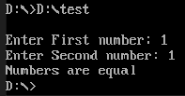

TASK2:

.model small
.stack 100h
.data
array1 db 10 dup(?),0
val1 db 0
.code
main proc
mov ax, @data
mov ds, ax
mov si, 0
mov cx,10
loop1:
mov al,val1
add al,048d
mov array1[si], al
inc val1
inc si
int 21h
loop loop1

mov si, offset array1
mov cx, 10

; loop
l1:
mov dx, [si]
;add dx, 30h
mov ah,2
int 21h
;mov dx, [si+1]
inc si
loop l1

mov ah, 4ch
int 21h
main endp
end main

OUTPUT2:
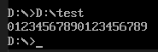

TASK3:
.model small
.stack 100h
.data
array1 db 26 dup(?),0
val1 db 0
.code
main proc
mov ax, @data
mov ds, ax
mov si, 0
mov cx,26
loop1:
mov al,val1
add al,030h
mov array1[si], al
inc val1
inc si
int 21h
loop loop1

mov si, offset array1
mov cx, 26

; loop
l1:
mov dx, [si]
add dx, 31h
mov ah,2
int 21h
;mov dx, [si+1]
inc si
loop l1

mov ah, 4ch
int 21h
main endp
end main

OUTPUT3:
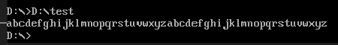

TASK4:

.model small
.stack 100h
.data
array1 db 26 dup(?),0
val1 db 0
.code
main proc
mov ax, @data
mov ds, ax
mov si, 0
mov cx,26
loop1:
mov al,val1
;add al,030h
mov array1[si], al
inc val1
inc si
int 21h
loop loop1

mov si, offset array1
mov cx, 26

; loop
l1:
mov dx, [si]
add dx, 065d
mov ah,2
int 21h
;mov dx, [si+1]
inc si
loop l1

mov ah, 4ch
int 21h
main endp
end main

OUTPUT4:
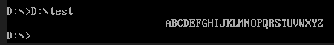

TASK5:

.model small
.stack 100h
.data
prompt db 10, 13, "Enter a number: $"
even_msg db 10, 13, "Input is even. $"
odd_msg db 10, 13, "Input is odd. $"
.code
main proc
mov ax, @data
mov ds, ax

mov dx, offset prompt
mov ah, 09h
int 21h

mov ah, 01h
int 21h

sub al, 30h ; Convert ASCII digit to numeric value

mov ah, 02h
test al, 01b
jz even_l

mov dx, offset odd_msg
mov ah, 09h
int 21h
jmp end_prog

even_l:
mov dx, offset even_msg
mov ah, 09h

end_prog:
int 21h

mov ah, 4ch
int 21h
main endp
end main

OUTPUT5:
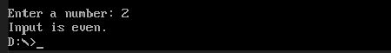

TASK6:
.model small
.stack 100h
.data
array1 db 1, 2, 3, 4, 5, 6
even_char db 'e'
.code
main proc
mov ax, @data
mov ds, ax

mov cx, 6
mov si, 0

loop1:
test byte ptr array1[si], 01b
jnz odd_l

mov byte ptr array1[si], 'e'
jmp next_element

odd_l:
mov byte ptr array1[si], 'o'

next_element:
inc si
loop loop1

; Print the result
mov cx, 6
mov si, offset array1

print_loop:
mov dl, [si]

mov ah, 02h
int 21h

inc si
loop print_loop

mov ah, 4ch
int 21h
main endp
end main

OUTPUT6:
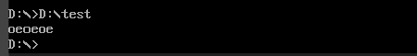

TASK7:

.model small
.stack 100h
.data
array db 1, 2, 3, 4, 5
sum db ?
.code
main proc
mov ax, @data
mov ds, ax

mov cx, 5 ; Number of elements in the array
mov si, offset array ; Point SI to the array
; Clear AX to store the sum

sum_loop:
add ax, [si] ; Add the current element to the sum
inc si ; Move to the next element (2 bytes for each element)

loop sum_loop ; Repeat the loop for the remaining elements

AAM
mov ch,ah
mov cl,al

mov dl,ch
add dl, 48
mov ah,2
int 21h
mov dl,cl
add dl, 48
mov ah, 2
int 21h
main endp
end main

OUTPUT7:
