UNIVERSITY OF IBADAN
DISTANCE LEARNING CENTRE (DLC)
DEPARTMENT OF COMPUTER SCIENCE

Machine Learning Model for Predicting House Rent Prices in Ibadan: A data driven approach for Real Estate Valuation

BY

ROTIMI ISRAEL TAYE
MATRIC NO: E047849

Supervised by

MR. O. A. Abiola

A PROJECT SUBMITTED TO THE DEPARTMENT OF COMPUTER
SCIENCE, UNIVERSITY OF IBADAN, IBADAN, NIGERIA

IN PARTIAL FULFILLMENT OF THE REQUIREMENT FOR THE
AWARD OF BACHELOR OF SCIENCE (B.Sc.) IN COMPUTER
SCIENCE.

CERTIFICATION
This is to certify that the project titled Machine Learning Model for Predicting House Rent Prices in Ibadan: A data driven approach for Real Estate Valuation was completed by Rotimi Israel Taye, with Matriculation Number E047849, in partial fulfillment of the requirements for the Degree of Bachelor of Science (B.Sc) in Computer Science at the University of Ibadan during the 2024-2025 academic year.

…………………………………. ………………………………….
O. A. Abiola (Supervisor) Signature and Date

…………………………………. ………………………………….
Prof. Bolanle Faith Oladejo (HOD) Signature and Date

DEDICATION
I dedicate this project to God Almighty who has seen me through this journey of life for my B.Sc Computer Science. To him be all the glory forever.

ACKNOWLEDGEMENTS
I extend my deepest gratitude to the ever-faithful God, for His graciousness throughout my work on this project. I sincerely appreciate my project supervisor, Mr. O. A. Abiola for his invaluable guidance, helpful suggestions, and valuable corrections throughout this journey. May Almighty God continue to guide him in all his present and future endeavors. I am also grateful to the Head of Department, Prof. Bolanle Oladejo, my Course Facilitator, Prof. Akinola Solomon, and all my lecturers, whose teachings have greatly facilitated my understanding and knowledge during this project. May God strengthen you all.
To my parents, Mr. and Mrs. Rotimi Amoo, your prayers, encouragement, and financial support has been of huge help to me. I pray that you live long in peace to reap the fruits of your labor. Lastly, I thank my Siblings and friends for their constant encouragement and support. God bless you all.

Table of Contents
CERTIFICATION i
DEDICATION ii
ACKNOWLEDGEMENTS iii
LIST OF FIGURES vii
ABSTRACT viii
CHAPTER ONE 1
INTRODUCTION 1
1.0 Background of the Study 1
1.3 Aims and Objectives of the Study 3
Aim of the Study 3
Objectives of the Study 4
1.4 Significance of the Study 4
1.5 Scope of the Study 5
1.6 Limitations of the Study 5
CHAPTER TWO 10
LITERATURE REVIEW 10
2.1 Concept of Housing Rent and Real Estate Valuation 11
2.2 Machine Learning and Predictive Analytics in Real Estate 11
2.3 Linear Regression in Housing Price Prediction 12
2.4 Determinants of House Rent Prices 12
2.5 Data Preprocessing in Machine Learning 13
2.6 Model Evaluation Techniques 14
2.7 Empirical Review of Related Studies 14
2.8 Gaps in Existing Literature 16
2.9 Summary of Literature Review 17
CHAPTER THREE 18
METHODOLOGY 18
3.1 Overview of the Chapter 18
3.2 Overview of Existing Systems 19
3.3 Problems of Existing Systems 19
3.4 Overview of the Proposed System 20
3.4.1 Description of the Proposed System 20
3.4.2 Feasibility Study 21
3.4.3 Requirements Gathering Methods 21
3.4.4 Functional Requirements 21
3.4.5 Non-Functional Requirements 22
3.4.6.1 Hardware Requirements 22
3.4.6.2 Development Tools 22
3.5 System Design 22
3.5.1 Data Collection and Dataset Preparation 22
Dataset Attributes 23
Table 3.1 Dataset Attributes 23
3.5.2 Data Preprocessing 23
3.5.3 Linear Regression Model 24
3.5.4 System Architecture 24
3.5.5 Data Flow Diagram 27
Components of the DFD Level 0 28
Explanation of the DFD Level 0 Flow 28
3.5.6 USE CASE DIAGRAM 30
2. Admin 32
3.5.7 Model Training and Testing 32
3.5.8 Algorithm Design 33
Linear Regression Prediction Algorithm 33
3.5.7 Evaluation Metrics 33
3.6 Chapter Summary 34
CHAPTER FOUR 35
IMPLEMENTATION AND TESTING 35
4.1 Introduction 35
4.2 Implementation 35
4.2.1 Development Tools and Environment 35
Hardware Environment 36
4.2.2 Dataset Implementation 37
4.2.3 Machine Learning Model Implementation 39
4.2.4 System Interface Implementation 42
4.2.4.1 Home Interface 42
4.2.4.2 Manual Prediction Interface 43
4.2.4.3 Prediction Output Interface 44
4.2.4.4 Property Display Interface 45
4.2.4.5 House Comparison Interface 46
4.2.4.6 Prediction History Interface 47
4.2.4.8 Market Analytics Interface 48
4.2.4.9 Dark Mode Interface 49
4.2.4.9 About System Interface 50
CHAPTER FIVE 51
SUMMARY, CONCLUSION AND RECOMMENDATIONS 51
5.1 Overview of the Chapter 51
5.2 Summary of the Study 51
5.3 Summary of Findings 52
5.4 Conclusion 53
5.5 Contributions to Knowledge 54
5.6 Recommendations 54
5.7 Suggestions for Further Research 55
5.8 Chapter Summary 55
REFERENCES 57

LIST OF FIGURES
Figure 3.0 System Architecture 25
Figure 3.1 Data Flow Diagram (DFD) level 0 27
Fig 3.2 DATAFLOW DIAGRAM (DFD) level 1 27
Figure. 3.3 Use case Diagram 30
Figure 3.4 Algorithm Design 33
Figure 4.0 Software and libraries used 37
Figure 4.1 Dataset used in training the model 38
Figure 4.2 Loading the dataset 38
Figure 4.3 Checking for duplicates removal and missing values 39
Figure 4.4 Label encoding 40
Figure 4.5 Feature Scaling 40
Figure 4.6 Model Training 41
Figure 4.7 K-fold cross validation 42
Figure 4.8 Home Interface 43
Figure 4.9 Manual Prediction Interface 44
Figure 4.10 Prediction Output Interface 45
Figure 4.11 Property Gallery Interface 46
Figure 4.12 House Comparison Interface 47
Figure 4.13 Prediction History Interface 48
Figure 4.14 Market Analytics Interface 49
Figure 4.15 Dark Mode Interface 49
Figure 4.16 About System 50

ABSTRACT
House rent estimation remains a challenge due to inconsistent pricing methods, reliance on manual valuation, and the absence of intelligent systems for determining fair rent values. Traditional approaches used by house agents and property owners often result in price variations and inaccurate rent estimations. This study developed a House Rent Prediction System using Linear Regression to estimate annual house rent values based on housing characteristics. The dataset used for the study was obtained from house agents and secondary sources and was preprocessed through data cleaning, encoding, and feature scaling using StandardScaler. The model utilized features such as location, property type, bedroom(s), bathroom(s), house size, lot size, furnishing status, water supply, PHCN availability, and year built. The developed system was implemented using Streamlit and included functionalities such as manual prediction, property visualization, house comparison, prediction history, market analytics, and property carousel display. Model evaluation was carried out using MAE, MSE, RMSE, R² Score, and K-Fold Cross Validation. The results showed that the developed system was effective in predicting house rent values and can support intelligent housing valuation and decision-making.
Keywords: House Rent Prediction, Linear Regression, Machine Learning, Streamlit, Housing Valuation.

CHAPTER ONE

INTRODUCTION

1.0 Background of the Study
Housing is a fundamental necessity, providing individuals with essential shelter and security. However, the housing market is often plagued by issues such as inflated rent prices and a lack of transparency. These issues pose considerable challenges for both landlords and house hunters. Some agents tend to set rent prices at excessively high levels, divorcing them from prevailing market rates and the actual value of the properties. This practice creates a noticeable gap between the true worth of housing units and the amount tenants are obligated to pay. As a result, landlords face difficulties in renting out their properties, as they lack accurate information on the market price. Simultaneously, house hunters encounter challenges in finding housing options that offer genuine value for money amid inflated rent prices.
The real estate market is one of the most dynamic and economically significant sectors in many countries. Housing prices are influenced by a wide range of factors, including location, property size, structural features, and prevailing market conditions. Accurate property valuation is therefore essential for effective decision-making by buyers, sellers, investors, and policy makers. Traditionally, property valuation has depended on manual appraisal methods, expert judgment, and basic comparative analysis. While these approaches have been widely used, they are often time-consuming, inconsistent, and susceptible to human error, particularly when applied to large and complex datasets.
With the rapid growth of digital real estate platforms and increased availability of large-scale property datasets, there is a growing demand for automated and data-driven valuation methods. These modern approaches offer the potential to improve accuracy, consistency, and efficiency in housing price estimation. As a result, predictive modeling techniques based on data analytics and machine learning have gained significant attention within the real estate industry.
Recent advancements in machine learning have provided powerful tools for analyzing large datasets and uncovering patterns that traditional methods may overlook. Among these techniques, Linear Regression remains one of the most widely used statistical models for predicting continuous variables such as housing prices. It provides a strong foundation for modeling the relationship between property prices and multiple independent variables, making it both interpretable and effective as a baseline predictive model.
However, real estate datasets often present several challenges that can negatively impact model performance if not properly addressed. These challenges include missing or incomplete data, differences in feature scales, and the presence of noisy or inconsistent records. Missing values may arise due to incomplete property listings, while varying measurement scales such as property size measured in square meters and prices recorded in different units can distort the learning process of predictive models. Additionally, outliers and data entry errors can introduce noise that reduces prediction accuracy. Consequently, effective data preprocessing is a critical step in developing reliable housing price prediction models.
Data preprocessing techniques such as handling missing values and applying feature scaling help ensure that the dataset is clean, consistent, and suitable for modeling. Proper treatment of missing data prevents loss of valuable information and reduces bias, while feature scaling ensures that all variables contribute appropriately to the model. These preprocessing steps enhance both the stability and predictive performance of the Linear Regression model.
Furthermore, this project outlines using Linear Regression to predict housing prices based on key property features evaluating the performance of predictive models is essential to determine their reliability and generalizability. K-fold cross-validation is a widely adopted evaluation technique that addresses the limitations of a simple train and test split. By partitioning the dataset into multiple subsets and training and testing the model across different combinations, k-fold cross-validation provides a more robust and unbiased estimate of model performance on unseen data. This approach helps to reduce overfitting and increases confidence in the model’s predictive capability.
This project outlines using Linear Regression to predict housing prices based on key property features. It also incorporates essential data preparation steps such as handling missing values, feature scaling, and k-fold cross-validation to ensure a robust and reliable model.
1.2 Problem Statement
Accurately determining the price of residential properties is a major challenge in the real estate industry due to the complex interplay of factors such as location, property size, structural features, economic conditions, and market demand. Traditional methods of property valuation often rely on human expertise, manual analysis, or simple comparison techniques, which may be subjective, inconsistent, and inefficient especially when dealing with large datasets. Additionally, real estate datasets typically contain issues such as missing values, inconsistent data formats, and features measured on different scales, all of which can negatively affect the quality of predictive models.
There is therefore a need for a reliable, data-driven approach that can automatically analyze property features and produce accurate price estimates. Machine learning techniques, particularly Linear Regression, offer a promising solution; however, the effectiveness of such models depends on proper data preprocessing and rigorous evaluation. Without addressing missing values, scaling features appropriately, and validating model performance using techniques like k-fold cross-validation, predictions may lack accuracy and generalizability.

1.3 Aims and Objectives of the Study

Aim of the Study
The aim of this study is to develop an accurate, reliable, and data-driven predictive model for rental housing prices using Linear Regression. This will be achieved by applying essential data preprocessing techniques, including the identification and treatment of missing values, as well as feature scaling to ensure that all numerical variables contribute appropriately to the model. Furthermore, the study seeks to rigorously validate the model’s performance using k-fold cross-validation, providing a robust estimate of its predictive accuracy and generalizability. Ultimately, this research aims to generate meaningful insights into the factors influencing rental prices, thereby supporting informed decision-making for tenants, landlords, property managers, and investors within the rental housing market.

Objectives of the Study
The primary objective of this study is to develop a reliable and data-driven predictive model for estimating rental housing prices using Linear Regression techniques. Accurate rental price prediction is essential for tenants, landlords, property managers, investors, and policy makers to make informed decisions within the rental real estate market. To achieve this aim, the study focuses on the following specific objectives:
- To collect raw data from house agents and couple it with online data from secondary sources like house agent, preprocess and prepare the housing dataset through cleaning, transformation, and feature scaling to ensure data quality and model efficiency.
- To develop a machine learning-based model for predicting house rent using relevant housing features.
- To evaluate the performance and effectiveness of the developed linear regression model using appropriate statistical metrics
These objectives collectively provide a comprehensive and systematic framework for the successful execution of the project. They ensure that the study follows a logical progression, beginning with an in-depth analysis of rental housing data and advancing through essential preprocessing stages such as handling missing values and feature scaling. By incorporating model development and rigorous evaluation using k-fold cross-validation, the objectives emphasize both predictive accuracy and generalizability. Furthermore, the interpretation of model results ensures that the findings are not only technically sound but also meaningful and actionable within the context of the rental real estate market. Overall, the objectives align academic rigor with practical application, demonstrating the effective use of machine learning techniques to address real-world challenges in rental price estimation and support informed decision-making for stakeholders.

1.4 Significance of the Study
This study is significant because it demonstrates how machine learning can be applied to real estate valuation. By developing a predictive model for housing prices, the study provides valuable insights for various stakeholders in the real estate sector.
Firstly, it contributes to a better understanding of how different property features influence market prices, offering useful guidance to buyers, sellers, and investors seeking data-driven decision-making.
Secondly, the study highlights the importance of proper data preprocessing such as handling missing values and applying feature scaling in improving model accuracy and reliability. This serves as an educational resource for data analysts and students learning about practical machine learning workflows.
Additionally, by evaluating the model using k-fold cross-validation, the study provides a reliable assessment of the model’s performance, ensuring that the results are not biased by a single data split. Overall, the study not only enhances predictive modeling in real estate but also reinforces best practices in data preparation and machine learning evaluation.

1.5 Scope of the Study
This study focuses on developing and evaluating a Linear Regression model for predicting rental housing prices using a real estate dataset. The scope is limited to the variables available within the dataset, which may include features such as property size, number of rooms, location indicators, and other relevant attributes.
The study covers key machine learning processes such as data cleaning, handling missing values, feature scaling, model training, and performance evaluation using k-fold cross-validation. Only Linear Regression is used as the predictive technique, although other advanced models are acknowledged but not implemented.

1.6 Limitations of the Study
Despite the contributions and practical relevance of this study, several limitations must be acknowledged to provide a balanced understanding of the findings and to clearly define the scope within which the results should be interpreted. Recognizing these limitations is essential for maintaining academic rigor and for guiding future research in rental housing price prediction.
The project accuracy and reliability of the predictive model developed in this study are highly dependent on the quality, completeness, and representativeness of the dataset obtained. As the dataset is sourced from a secondary platform, the researcher has limited control over how the data was originally collected, processed, and curated. Any inherent biases, inconsistencies, missing values, outdated records, or inaccuracies present in the dataset may directly influence the model’s predictions. For instance, rental prices recorded at a particular time may not accurately reflect current market conditions, especially in rapidly changing rental markets. Consequently, the predictive outcomes of the model may be affected by factors beyond the control of the study.
The dataset used in this research does not adequately represent all geographic regions, rental market segments, or housing types. Rental markets often vary significantly across different cities, neighborhoods, and countries due to differences in economic conditions, population density, infrastructure, and housing demand. If the dataset is concentrated in specific regions or reflects a limited range of rental properties, the generalizability of the findings becomes restricted. As a result, the conclusions drawn from this study may not be directly applicable to all rental markets, particularly those with distinct economic or cultural characteristics.
Another important limitation relates to the scope of features included in the dataset. The study relies primarily on quantitative property-related attributes such as size, number of rooms, and other structural characteristics. While these features play a significant role in determining rental prices, they do not fully capture the complexity of real-world rental valuation. Important qualitative factors such as neighborhood aesthetics, security, and accessibility to public transportation, proximity to schools and workplaces, and overall living conditions are often difficult to quantify. The exclusion of such variables limits the model’s ability to fully represent all determinants of rental prices.
Furthermore, the study does not incorporate broader economic indicators or real-time market conditions that can significantly influence rental prices. Factors such as inflation rates, employment levels, interest rates, housing supply and demand dynamics, and government housing policies play a crucial role in shaping rental markets. Since these external economic variables are not included in the model, the predictions are based solely on historical property features. As a result, the model may not respond effectively to sudden economic changes or market shocks, thereby limiting its applicability in dynamic or rapidly evolving rental environments.
From a methodological perspective, this study focuses exclusively on Linear Regression as the predictive modeling technique. Linear Regression was selected due to its simplicity, interpretability, and suitability as a foundational model for understanding the relationship between rental prices and property features. However, Linear Regression assumes a linear relationship between the dependent variable and independent variables, which may not always hold true in complex real estate markets. Rental prices are often influenced by nonlinear interactions among features, and such relationships may not be fully captured by a linear model. Consequently, the predictive accuracy of the model may be lower than that of more advanced machine learning algorithms.
More sophisticated models such as Random Forest, Gradient Boosting, Support Vector Machines, or Neural Networks have the capacity to model nonlinear patterns and complex feature interactions more effectively. While these techniques could potentially improve predictive performance, they were not considered in this study in order to maintain methodological simplicity and focus. This limitation highlights an opportunity for future research to explore and compare multiple machine learning algorithms in rental price prediction.
Another limitation of the study lies in the evaluation approach. Although k-fold cross-validation is employed to enhance the reliability and robustness of model evaluation, it is still dependent on the quality and distribution of the available data. If the dataset contains imbalanced or clustered observations, cross-validation results may still be biased. Additionally, the study focuses primarily on standard performance metrics, which may not fully capture the practical implications of prediction errors in real-world rental pricing scenarios.
Moreover, the study does not account for temporal changes in rental prices. Rental markets are time-sensitive, and prices can fluctuate due to seasonal trends, economic cycles, or sudden changes in demand. Since the dataset does not explicitly model time-based variations, the predictions may not accurately reflect short-term rental price movements. This temporal limitation restricts the model’s ability to provide dynamic or time-aware rental price forecasts.
1.7 Chapters Layout
This project is organized into five chapters:
- Chapter One introduces the study by presenting the background, problem statement, aim, objectives, scope, and significance of developing a house rent prediction system.
- Chapter Two reviews relevant literature on house rent concepts, machine learning, linear regression, and related predictive studies.
- Chapter Three explains the methodology, including data preprocessing, feature scaling, model development, evaluation, and deployment.
- Chapter Four presents the system implementation and discusses the results obtained from model training and evaluation. It also analyzes the performance of the developed model and demonstrates the functionality of the web-based application
- Chapter Five summarizes the findings of the study and states the overall conclusion drawn from the results. It also provides recommendations for improvement and suggestions for future research.
1.8 Glossary of Terms
1. Algorithm: A step-by-step computational procedure used to perform calculations or solve problems. In this study, linear regression is the algorithm used for prediction.
2. Annual Rent (NGN): The total amount of money paid yearly by a tenant to occupy a residential property, measured in Nigerian Naira.
3. Categorical Variable: A variable that represents categories or groups, such as location or property type, which must be converted into numerical form before model training.
4. Data Preprocessing: The process of cleaning, transforming, and preparing raw data for machine learning to ensure accuracy and reliability.
5. Dataset: A structured collection of data used for analysis and model training.
6. Dependent Variable (Target Variable): The output variable that the model aims to predict. In this project, it is the annual house rent.
7. Feature (Independent Variable): An input variable used to predict the target variable, such as number of bedrooms, house size, or location.
8. Feature Scaling: A preprocessing technique used to standardize the range of numerical features to improve model performance.
9. Linear Regression: A supervised machine learning algorithm used to model the relationship between a dependent variable and one or more independent variables.
10. Machine Learning: A field of artificial intelligence that enables computers to learn patterns from data and make predictions without being explicitly programmed.
11. Mean Absolute Error (MAE): An evaluation metric that measures the average absolute difference between predicted and actual values.
12. Mean Squared Error (MSE): An evaluation metric that measures the average squared difference between predicted and actual values.
13. Model Evaluation: The process of assessing the performance and accuracy of a trained machine learning model using statistical metrics.
14. Model Training: The process of feeding data into an algorithm so it can learn patterns and relationships.
15. R-squared (R²): A statistical measure that indicates how well the independent variables explain the variation in the dependent variable.
16. Streamlit: A Python framework used to build and deploy interactive web-based machine learning applications.
17. Supervised Learning: A type of machine learning where the model is trained using labeled data (input-output pairs).

CHAPTER TWO

LITERATURE REVIEW
- OVERVIEW OF THE CHAPTER
Housing rent in Ibadan is largely determined by a combination of structural, locational, and amenity-related factors, consistent with the hedonic pricing theory which explains that property values are influenced by the characteristics attached to them. Recent studies have shown that variables such as the number of bedrooms, building size, water supply, electricity availability, and neighbourhood quality significantly influence rental values, with location remaining one of the most important determinants of residential rent (Bamiteko & Adebiyi, 2020; Odebode et al., 2024). Furthermore, accessibility to roads, security, environmental quality, and proximity to commercial centres have also been identified as significant factors influencing rental housing prices in urban areas (Olatunji, 2020).
Studies applying hedonic pricing models further reveal that infrastructural development and housing attributes strongly affect rental housing demand and rental price determination in developing cities (Solovev & Pröllochs, 2021). In particular, areas surrounding the University of Ibadan such as Agbowo, Ajibode, and Sango 4experience higher rental demand due to student and staff populations, leading to comparatively higher rents than peripheral areas like Orogun. Recent approaches to rent prediction increasingly apply machine learning models, such as linear regression, to capture complex relationships between housing attributes and rental prices, offering more accurate and data-driven valuation compared to traditional methods.
The chapter examines relevant concepts, theories, empirical studies, preprocessing techniques, machine learning algorithms, and evaluation methods associate works published between 2020 and 2026 in order to ensure that the study aligns with current developments in machine learning and real estate analytics. The chapter also discusses determinants of rental house prices, the role of predictive modeling in property valuation, and the application of Linear Regression in supervised machine learning tasks. Existing studies are critically reviewed to identify research gaps and establish the relevance of the present study. According to Zulkifley et al., (2020), the integration of machine learning into housing valuation systems has significantly improved prediction efficiency and decision-making processes in modern real estate markets.

2.1 Concept of Housing Rent and Real Estate Valuation
Housing remains one of the most important aspects of social and economic development in every society. Residential properties provide accommodation, security, and investment opportunities for individuals and organizations. Rent refers to a certain amount of money paid periodically by the tenant to the landlord in consideration for the occupation and use of the landlord’s property (Onyejiaka et al., 2025). Rental values vary across locations due to several factors such as accessibility, infrastructure, neighborhood quality, and market demand. Real estate valuation is the process of estimating the monetary worth of a property using market trends, physical characteristics, and economic indicators.
Traditional valuation approaches relied heavily on manual assessment methods carried out by professional values. However, these methods are often criticized for subjectivity and inconsistency. Balila and Shabri (2024) explained that machine learning models provide more objective and reliable approaches for property valuation because they are capable of identifying hidden patterns within housing datasets. Sharma et al., (2024) noted that predictive analytics has become increasingly important in real estate markets because of its ability to generate fast and accurate rental estimates. In cities experiencing rapid urbanization such as Ibadan, the demand for intelligent rental valuation systems continues to increase because manual valuation approaches may no longer adequately capture market complexity.

2.2 Machine Learning and Predictive Analytics in Real Estate
Machine learning is a branch of artificial intelligence that enables computer systems to learn patterns from data and make predictions without explicit programming. Machine learning algorithms analyze historical data, identify relationships among variables, and improve prediction accuracy through iterative learning processes. According to Geerts, Vanden Broucke, and De Weerdt (2023), machine learning has transformed modern real estate analytics by enabling automated and scalable property valuation systems. Machine learning techniques are increasingly used in the housing sector for Property valuation, Rental price prediction, Market trend forecasting, Customer preference analysis, Investment risk assessment and the increasing availability of online housing datasets has accelerated the adoption of predictive analytics in the real estate industry.
Chuhan (2024) observed that machine learning models outperform many traditional valuation approaches because they can process large datasets efficiently and capture nonlinear relationships among housing variables. Several machine learning algorithms have been applied to housing prediction problems, including Linear Regression, Random Forest Regression, Support Vector Regression, Artificial Neural Networks, Decision Trees, XGBoost. Among these algorithms, Linear Regression remains highly important because of its interpretability and simplicity (Pai & Wang, 2020).

2.3 Linear Regression in Housing Price Prediction
Linear Regression is one of the most widely used supervised learning algorithms for predicting continuous numerical values such as rental prices and property values. The algorithm establishes a linear relationship between a dependent variable and one or more independent variables.
The Linear Regression equation is represented as:
y = β0 + β1x1 + β2x2 + ... + βnxn + ε
Where:
- y represents the predicted rental price
- β0 represents the intercept
- β1...βn represent coefficients
- x1...xn represent independent variables
- ε represents the error term
Linear Regression predicts housing prices by analyzing relationships between rental values and housing attributes such as number of bedrooms, location, building condition, accessibility, and available amenities. According to Balila and Shabri (2024), Linear Regression remains an effective baseline algorithm for housing prediction because it produces interpretable results and requires relatively low computational resources.
Although advanced ensemble models such as XGBoost may achieve slightly higher prediction accuracy, Linear Regression remains valuable because stakeholders can easily understand the contribution of each feature to rental price prediction (Sharma et al., 2024).

2.4 Determinants of House Rent Prices
Several studies have identified structural, locational, environmental, and economic variables as major determinants of rental house prices. One of the strongest determinants of housing rent is location. Properties located close to educational institutions, transportation systems, healthcare facilities, and business districts often command higher rental prices because of increased accessibility and convenience. According to Tomal (2020), neighborhood quality significantly affects rental values because tenants generally prefer safe and environmentally friendly areas. Similarly, Sharma et al., (2024) found that infrastructure quality, road accessibility, electricity supply, and water availability positively influence housing demand and rental prices.
Structural characteristics also play important roles in determining rental values. Features such as number of bedrooms, number of bathrooms, property size, power supply availability, furnishing status, and water supply availability have direct impacts on rental prices (Bamiteko & Adebiyi, 2020). Environmental conditions such as flood risk, noise pollution, and waste disposal systems also influence housing valuation and rental attractiveness in urban residential markets (Olatunji, 2020). In rapidly growing urban environments like Ibadan, population growth and increasing housing demand contribute significantly to fluctuations in rental prices. Therefore, predictive systems capable of analyzing these variables are important for effective property valuation and rental forecasting (Solovev & Pröllochs, 2021).

2.5 Data Preprocessing in Machine Learning
Data preprocessing is one of the most critical stages in machine learning because raw datasets often contain missing values, inconsistencies, duplicate records, and outliers. Proper preprocessing improves model reliability and prediction accuracy. According to Chuhan (2024), preprocessing techniques significantly influence the performance of machine learning algorithms in housing prediction tasks. Major preprocessing techniques include: Data cleaning, Handling missing values, Feature scaling, Encoding categorical variables and Outlier detection.
Missing values occur when some observations within the dataset are incomplete. Numerical missing values are often replaced using mean or median imputation, while categorical missing values are replaced using mode imputation.
Feature scaling standardizes numerical variables into comparable ranges. This prevents variables with larger values from dominating smaller variables during model training. Standardization is represented mathematically as:
z = (x - μ) / σ
Encoding techniques such as Label Encoding and One-Hot Encoding are used to convert categorical variables into numerical representations suitable for machine learning algorithms.
Outliers are abnormal observations significantly different from the majority of records. Outlier detection methods such as Boxplots and Interquartile Range analysis help improve model robustness by removing extreme values capable of distorting predictions.

2.6 Model Evaluation Techniques
Model evaluation is necessary to determine how effectively a machine learning model performs on unseen data. Reliable evaluation techniques help assess prediction accuracy, generalizability, and robustness. One widely used evaluation approach is k-fold cross-validation. In this technique, the dataset is divided into k subsets. The model is trained using k-1 subsets and validated using the remaining subset. This process repeats until every subset has been used for validation once. According to Yagmur, Kayakus, and Terzioglu (2022), cross-validation reduces overfitting and provides more reliable performance estimates than simple train-test splitting. Common evaluation metrics include:
Mean Absolute Error (MAE):
$MAE=1/n\sum_{i=1}^{n}{|yi-ŷi|}$ --------- Equation 2.1
Mean Squared Error (MSE):

$MSE=1/n\sum_{i=1}^{n}{\left(yi-ŷi\right)}$ --------- Equation 2.2
Root Mean Squared Error (RMSE):
$RMSE=\sqrt{(1/n)\sum{{\left(yi-ŷi\right)}^{2}}}$--------- Equation 2.3
$Coe$fficient of Determination (R²):
$R² =1-\frac{{\sum{\left(yi-ŷi\right)}}^{2}}{{\sum{\left(yi-Ӯi\right)}}^{2}}$ --------- Equation 2.4
These evaluation metrics help determine the accuracy and reliability of predictive models in housing rent prediction.

2.7 Empirical Review of Related Studies
Several recent studies have demonstrated the effectiveness of machine learning techniques in housing price prediction. Pai and Wang (2020) applied machine learning models to real estate prediction using transaction datasets and found that predictive analytics improved property valuation accuracy significantly. Zulkifley et al., (2020) conducted a survey of machine learning models for housing prediction and emphasized the importance of preprocessing techniques such as normalization, feature engineering, and cross-validation. Tomal (2020) investigated rental housing determinants in Poland and found that neighborhood quality, accessibility, and structural characteristics strongly influence rental prices.
Li, Mei, and Wang (2020) examined spatial dependence in housing price analysis and concluded that geospatial variables significantly improve predictive performance. Yagmur et al., (2022) compared different machine learning techniques for housing prediction and observed that ensemble models generally achieve higher prediction accuracy, although Linear Regression remains highly interpretable. Geerts et al., (2023) reviewed methods and data types used in house price prediction systems and highlighted the growing relevance of machine learning in modern real estate analytics. Sharma et al., (2024) developed an XGBoost-based housing prediction model and reported strong predictive performance compared to traditional statistical methods.
Balila and Shabri (2024) compared multiple machine learning algorithms for property price prediction and concluded that while advanced algorithms provide higher accuracy, Linear Regression remains computationally efficient and easier to interpret. Predicting real estate prices is continuously advancing toward more accurate and reliable predictions using more and more sophisticated machine learning methods. Pai et al., (2020) explored the use of machine learning techniques for predicting real estate transaction prices, employing models such as Least Squares Support Vector Regression (LSSVR), Classification and Regression Trees (CART), General Regression Neural Networks (GRNN), and Back propagation Neural Networks (BPNN). Their research, utilizing transaction data from Taichung, Taiwan, found that attribute selection significantly improved model performance. In particular, LSSVR outperformed the other models in terms of prediction accuracy, highlighting the effectiveness of support vector-based models for real estate price predict house prices, comparing it with the traditional hedonic pricing model.
Their results showed that XGBoost significantly outperformed the hedonic model, demonstrating its better predictive accuracy, regularization for over fitting, and ability to handle sparse data forecasting. Similarly, Zaki et al., (2022) applied XGBoost, a powerful gradient boosting algorithm, to predict house prices, comparing it with the traditional hedonic pricing model. Their results showed that XGBoost significantly outperformed the hedonic model, demonstrating its better predictive accuracy, regularization for over fitting, and ability to handle sparse data.
In recent years, there has been a growing trend in utilizing more advanced algorithms for rent prediction. Ming et al., (2020) explored rent prices in Chengdu, China using the Extreme Gradient Boosting (XGBoost) algorithm. Oluyele et al. (2024) developed a machine learning-based rental price prediction model using housing attributes such as location, property characteristics, and neighborhood features. Their findings demonstrated that machine learning techniques can effectively estimate rental values and support decision-making in the housing sector. Hu and Tang (2023) proposed a geographically weighted ensemble learning model for residential rent prediction and observed that incorporating spatial information significantly improved prediction performance across different urban locations. Chen et al. (2024) applied machine learning algorithms to rental valuation and found that property size, location, building characteristics, and neighborhood conditions were among the most influential determinants of rental prices.
Cao et al., (2024) investigated rental price prediction using machine learning techniques and reported that data-driven models provide reliable estimates of rental values when relevant housing characteristics are properly represented in the dataset. Oluyele et al., (2024) emphasized that housing attributes such as location, number of rooms, accessibility to infrastructure, and environmental quality have substantial effects on rental prices within urban housing markets. Trinkaus and Kauermann (2023) evaluated the effectiveness of machine learning algorithms for rental valuation and concluded that modern predictive models can outperform traditional approaches when sufficient housing data are available. Zong and Song (2023) developed a machine learning-based house rent prediction model and demonstrated that predictive algorithms are capable of identifying complex relationships between housing features and rental values.
Wu et al., (2021) conducted a study on the determinants of the market value of residential properties in Ibadan metropolis, Nigeria. The findings revealed that the major determinant factors influencing the rental value of residential buildings in the study area are the number of toilets, the existence of a burglar alarm, and the condition of the buildings. Additionally, the type of building and the number of toilets were identified as major determinant factors influencing capital value.
A traditional numeric value prediction method given a set of inputs is Ordinary Least Squares regression (OLS). This method of prediction relies upon a linear relationship between input variables or features, and an output variable predicted by these linear relationships.

2.8 Gaps in Existing Literature
Despite significant advancements in machine learning-based property valuation systems, several gaps remain in existing literature. First, many studies focus primarily on property sales price prediction rather than rental house valuation (Solovev & Pröllochs, 2021). Second, most existing studies rely heavily on datasets obtained from developed countries and may not accurately reflect Nigerian housing market conditions (Olatunji, 2020). Third, limited studies specifically address rental house prediction in Ibadan despite the city’s growing population and housing demand. Fourth, many advanced machine learning models emphasize prediction accuracy without considering interpretability, which is important for transparency in real estate decision-making. Finally, some studies neglect preprocessing techniques such as missing value treatment, feature scaling, and outlier handling despite their importance in predictive modeling. This study addresses these gaps by developing an interpretable Linear Regression-based rental prediction system using comprehensive preprocessing and evaluation techniques.

2.9 Summary of Literature Review
This chapter reviewed literature related to housing rent prediction, real estate valuation, machine learning techniques, preprocessing methods, and model evaluation approaches. The review established that housing rent is influenced by structural, environmental, economic, and locational factors.
The chapter also demonstrated that machine learning techniques provide efficient and reliable alternatives to traditional property valuation methods. Linear Regression was identified as a suitable predictive algorithm because of its simplicity, interpretability, and effectiveness in numerical prediction tasks. Empirical studies conducted between 2020 and 2026 confirmed the growing importance of predictive analytics in real estate markets. However, identified gaps in previous studies justify the need for the present study, particularly within the context of rental house prediction in Ibadan using robust preprocessing and evaluation techniques.

CHAPTER THREE

METHODOLOGY

3.1 Overview of the Chapter
This chapter presents the methodology adopted for the design and implementation of the House Rent Prediction System using Linear Regression. The methodology provides a structured framework that guided the processes involved in data acquisition, preprocessing, model development, training, testing, deployment, and evaluation of the developed prediction system.
The study adopted a machine learning approach to estimate house rent values using housing attributes collected from both primary and secondary sources. The methodology ensures that the developed system is capable of producing accurate rent predictions while supporting users in housing valuation and decision-making.
The chapter further explains the techniques, tools, and procedures employed in implementing the system, including data collection methods, feature engineering, system architecture, model validation procedures, system design, and evaluation methods.
The methodology adopted consists of the following stages:
i. Collection of housing data from house agents and online datasets.
ii. Data cleaning and preprocessing.
iii. Feature transformation and scaling.
iv. Development of the Linear Regression model.
v. Model training and testing.
vi. Cross-validation using K-Fold technique.
vii. Development of the prediction interface using Streamlit.
viii. Evaluation of prediction performance.
The methodology was selected to ensure reliability, accuracy, scalability, and transparency in house rent estimation.

3.2 Overview of Existing Systems
House rent information within Nigeria is commonly obtained through physical house agents, online advertisements, social media listings, real estate websites, and direct communication with landlords. These methods primarily provide property listing services without intelligent mechanisms for rent estimation.
Most existing property platforms display rental values based on information supplied by landlords or agents. Consequently, pricing often varies considerably because of differences in location, negotiation practices, agency fees, inflation, housing conditions, and market demand.
Existing housing systems usually provide property information without automated prediction capability. Users are therefore required to manually compare prices before making decisions.
Most existing systems fail to perform rent estimation using housing characteristics such as Location, Property Type, Furnishing Status, Water Supply, PHCN Availability, Number of Bedroom(s), Number of Bathroom(s), House Size, Lot Size, Year Built.
Although some international platforms apply artificial intelligence and machine learning techniques for housing valuation, most of these systems were developed for foreign housing markets and do not adequately represent local housing environments.
As a result, there is a need for an intelligent and localized prediction system capable of estimating house rent prices automatically.

3.3 Problems of Existing Systems
The existing methods of determining house rent prices present several limitations and challenges. These include:
- Lack of Accurate Rent Prediction: Most property platforms do not provide intelligent systems capable of predicting house rent prices based on housing features. Users therefore rely on manual estimations and agent pricing.
- Inconsistency in Pricing: Different agents may assign different prices to similar properties within the same location, resulting in price inconsistency and unfair valuation.
- Time Consumption: House seekers spend considerable time comparing house prices across multiple locations before making decisions.
- Human Bias and Manipulation: Manual pricing methods are susceptible to bias, manipulation, and exploitation by agents or landlords.
- Absence of Data-Driven Decision Making: Most existing systems do not utilize historical housing data and machine learning techniques for accurate pricing analysis and prediction.
- Limited Transparency: Users are unable to determine whether a house rent is reasonable because there is no automated valuation mechanism.
These limitations create the need for an intelligent house rent prediction system capable of estimating rent prices accurately using machine learning techniques.

3.4 Overview of the Proposed System

3.4.1 Description of the Proposed System
The proposed system is a machine learning-based house rent prediction system developed using the Linear Regression algorithm and deployed through Streamlit. The system predicts house rent prices based on important housing attributes obtained from real estate agents and physical house agents, property websites, social media advertisements, and word-of-mouth communication housing datasets.
The developed application provides an interactive environment where users can browse available houses and property information, view house images and descriptions, select properties for instant prediction, enter housing details manually, compare properties, view prediction history, access market analytics information. The prediction process is based on the following housing features location, property type, bedroom(s), bathroom(s), furnishing status, water supply, PHCN availability, house size, lot size, year built. The Linear Regression model processes these variables and estimates the expected annual rent value. The system was designed to improve transparency and support intelligent housing valuation.

3.4.2 Feasibility Study
A feasibility study was conducted to determine whether the proposed system can be successfully implemented.
- Technical Feasibility: The system is technically feasible because Python provides powerful machine learning libraries like Scikit-learn, Pandas, NumPy, Joblib, Streamlit, Matplotlib and PIL. These tools support efficient data preprocessing, model training, and evaluation.
- Economic Feasibility: The project is economically feasible because the software tools used are open-source and freely available. No expensive hardware or software licenses are required.
- Operational Feasibility: The proposed system is user-friendly and can be operated easily by users with minimal technical knowledge.
- Schedule Feasibility: The system can be developed within the academic project timeline because the Linear Regression algorithm is computationally efficient and easy to implement.

3.4.3 Requirements Gathering Methods
The requirements for the proposed system were gathered using both primary and secondary data collection methods.
- Primary Data Collection: Primary data were collected from house agents and property managers. Information gathered includes: House rent prices, Property types, Housing features, Location details
- Secondary Data Collection: Secondary data were obtained from Kaggle housing datasets and online real estate platforms. These datasets provided additional records necessary for training the machine learning model.
- Literature Review: Relevant journals, research papers, and articles on house rent prediction and machine learning were reviewed to identify suitable methodologies and algorithms.

3.4.4 Functional Requirements
The functional requirements describe the major operations the system must perform.
The system should be able to accept housing details from users when they input it, display available properties display house images and descriptions which is one of the features, predict rent values, store prediction records in the prediction history which can be viewed in the user interface in a table format, compare properties like two different properties together to be able to choose one, display market analytics and generate prediction outputs.

3.4.5 Non-Functional Requirements
The non-functional requirements describe the quality attributes of the system.
- Accuracy: The system should produce accurate rent predictions.
- Reliability: The prediction system should function consistently without failure.
- Performance: The system should generate predictions within a short time.
- Scalability: The system should support larger datasets in the future.
- Usability: The interface should be easy to understand and use.
- Security: The dataset and prediction outputs should be protected from unauthorized access.

3.4.6.1 Hardware Requirements
Building this application requires a minimum requirement of Intel Corei3 Processor, 4GB RAM, 500 GB Hard Disk and Internet connectivity. I will recommend Intel Core i5 Processor or higher, 8 GB RAM, SSD Storage for a hitch free work.

3.4.6.2 Development Tools
The development tools are Python Programming Language, Jupyter Notebook / VS Code, Python IDLE, Streamlit and the libraries Used are Pandas, NumPy, Scikit-learn, Joblib, Streamlit, Matplotlib, PIL and for operating system windows 10/11, and Linux or macOS could be used. In my own case I used windows 10 pro.

3.5 System Design

Data Collection and Dataset Preparation
The dataset used in this study was obtained from two major sources raw housing data collected from house agents and online housing datasets downloaded. The combined dataset contains important housing features relevant to rent prediction. The datasets were merged to form a unified housing dataset for training and testing.

Dataset Attributes
The dataset includes the following features:
Feature | Description
Location | House location
Property Type | Category of property
Bedroom(s) | Number of bedrooms
Bathroom(s) | Number of bathrooms
House Size | House size in square meters
Lot Size | Total land area
Year Built | Construction year
Furnishing | Furnishing status
Water Supply | Water availability
PHCN Availability | Electricity condition
Rent | Target variable
Bedrooms | Number of bedrooms
Bathrooms | Number of bathrooms
Property Type | The property type whether mini-flat, self-contain, flat, Duplex, room
Location | Area where the property is located
Water supply | The availability of water in the environment
Power supply | The availability of electricity in the environment
Year built | The year the house was built
Size | Size of the house in square meter
Furnishing Status | Furnished or unfurnished
Rent | Target variable in Naira

Table 3.1 Dataset Attributes

3.5.2 Data Preprocessing
Data preprocessing was carried out to improve dataset quality and model performance.
The preprocessing stages include:
  - Data Cleaning: Missing values, duplicate records, and inconsistent entries were removed from the dataset.
  - Data Transformation: Categorical variables such as location and furnishing status were converted into numerical values using encoding techniques.
  - Feature Scaling: Feature scaling was performed using StandardScaler to normalize numerical values and improve model efficiency.

3.5.3 Linear Regression Model
Linear Regression was selected because it is effective for predicting continuous numerical values such as house rent prices. The Linear Regression model establishes a relationship between independent variables and the target variable. The Linear Regression equation is given as:
y = β0 ​+ β1​x1 ​+ β2​x2​ + ⋯ + βn​xn ​+ ε
Where:
- y = predicted rental price
- β0​ = intercept (constant term)
- β1​,β2​,…,βn​ = regression coefficients
- x1​,x2​,…,xn​ = independent variables/features
- ε = error term
The model was trained using the prepared housing dataset.

System Architecture
The architecture of the proposed system consists of Data input, Data Preprocessing Layer, Model Training Layer, Model Evaluation Layer and Price Prediction Layer components.
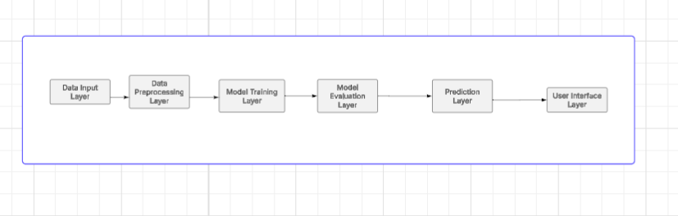
Figure 3.0 System Architecture
Explanation on system Architecture
The system architecture shown above illustrates the workflow of the proposed house rent prediction system using Linear Regression. It describes the sequential processes involved in transforming raw housing data into an accurate rent price prediction. The architecture consists of five major components, namely: Data Input, Data Preprocessing, Model Training, Model Evaluation, and Price Prediction Output.
1. Data Input Layer
This is the first stage of the system where housing data are collected and entered into the system. The input data may come from house agents, property managers, and online datasets. The dataset contains important housing features that influence rent prices.
The quality and quantity of the input data significantly affect the performance of the prediction model.
2. Data Preprocessing Layer
After data collection, the dataset undergoes preprocessing to improve data quality and prepare it for machine learning operations. Raw datasets usually contain missing values, duplicate records, inconsistent entries, and categorical data that cannot be directly processed by machine learning algorithms.
The preprocessing stage involves data cleaning, handling missing values, removing duplicate records, encoding categorical variables, feature scaling and normalization. Feature scaling is particularly important because it ensures that numerical values are standardized, thereby improving model efficiency and prediction accuracy.
3. Model Training Layer
In this stage, the cleaned and processed dataset is used to train the Linear Regression model. The algorithm learns the relationship between the independent variables (housing features) and the dependent variable (house rent price).
The dataset is usually training dataset (used for learning) and testing dataset (used for validation)
During training, the model calculates regression coefficients that help it establish the best-fit line for predicting rent prices.
The Linear Regression model attempts to minimize prediction errors and improve accuracy through statistical learning techniques.
4. Model Evaluation Layer
After training, the model performance is evaluated using testing data and statistical evaluation metrics. This stage determines how well the model can predict unseen house rent values.
The evaluation metrics include Mean Absolute Error (MAE), Mean Squared Error (MSE), Root Mean Squared Error (RMSE), R² Score (Coefficient of Determination). A good model is expected to produce low error values, high prediction accuracy, and strong correlation between actual and predicted rent prices. This stage helps verify the effectiveness and reliability of the developed system.
5. Prediction Layer
This is the final stage of the system where the trained model generates predicted house rent prices based on user input features.
6. User Interface Layer
The Streamlit interface provides interaction between users and the prediction engine. When a user enters housing details the system processes the information through the trained Linear Regression model and outputs the estimated rent value. The prediction output assists house seekers in budgeting, landlords in property valuation, and real estate agents in market analysis. The output improves transparency and supports data driven decision making in the housing sector.

Data Flow Diagram
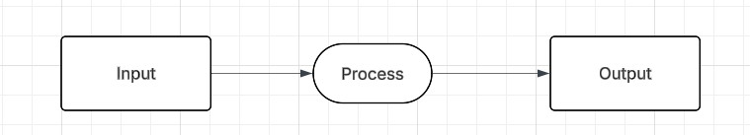

Figure 3.1 Data Flow Diagram (DFD) level 0

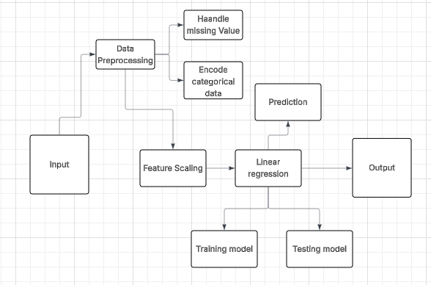

Figure 3.2 DATAFLOW DIAGRAM (DFD) level 1
Explanations on Data Flow Diagram (DFD)
DFD Level 0 (Context Diagram)
The Level 0 Data Flow Diagram, also known as the Context Diagram, provides a high-level overview of the house rent prediction system. It illustrates the interaction between the user and the system without showing the internal processing details.
In this level, the entire machine learning system is represented as a single process. The user provides housing information such as the number of bedrooms, bathrooms, location, parking space, and house size as input into the system. The system processes the information using the Linear Regression model and returns the predicted house rent price as output.

Components of the DFD Level 0
  - Input: The input represents the housing data entered into the system by the user. These include the Number of bedrooms, Number of bathrooms, Parking spaces, Location, House size and Furnishing status.
  - Process: The process represents the machine learning operations carried out within the system. At this level, all operations such as preprocessing, model training, testing, and prediction are combined into a single process.
  - Output: The output represents the predicted house rent price generated by the system after processing the user’s housing data.

Explanation of the DFD Level 0 Flow
The user enters housing details into the system as input. The system processes the data using the trained Linear Regression model and produces the estimated rent value as output. The Level 0 DFD therefore provides a simplified overview of how data move between the user and the prediction system.
DFD Level 1
The Level 1 Data Flow Diagram provides a more detailed representation of the internal operations of the house rent prediction system. Unlike the Level 0 DFD, which treats the system as a single process, the Level 1 DFD breaks the system into multiple sub processes that describe how data are transformed step-by-step.
The Level 1 DFD consists of the following major processes:
- Data Input: This process involves collecting housing data from users, house agents, and secondary sources datasets. The data contain important housing attributes such as: Bedrooms, Bathrooms, Property type, House location, House size, Furnishing status, and Electricity supply.
These features serve as the independent variables for the prediction model.
- Data Preprocessing: The collected data are passed through preprocessing operations to improve dataset quality and prepare them for machine learning tasks.
The preprocessing stage includes:
- Handling Missing Values: Incomplete records and missing values are identified and corrected to prevent inaccuracies in the prediction process.
- Encoding Categorical Data: Categorical variables such as location and furnishing status are converted into numerical values because machine learning algorithms require numerical input data. This stage ensures that the dataset is clean, structured, and suitable for model training.
- Feature Scaling: After preprocessing, feature scaling is applied to normalize numerical variables. This ensures that variables with larger values do not dominate smaller variables during training. Feature scaling improves Prediction accuracy, Model efficiency, Faster model convergence and StandardScaler is commonly used for this purpose.
- Linear Regression Model: The processed dataset is then supplied to the Linear Regression algorithm. The algorithm establishes a relationship between housing features and rent prices. The model attempts to determine the best-fit line that minimizes prediction errors and accurately predicts house rent prices.
- Training Model: The training process involves teaching the Linear Regression algorithm using historical housing data. During training the model learns: the patterns in the dataset, regression coefficients are calculated and relationships between variables are established. Typically 80% of the dataset is used for training.
- Testing Model: After training, the remaining dataset is used for testing. The testing phase evaluates the model accuracy, prediction capability, generalization performance. This stage ensures that the model performs effectively on unseen data. Usually 20% of the dataset is used for testing.
- Prediction: Once the model has been trained and tested successfully, it performs prediction. When users enter housing details, the system processes the information and estimates the likely house rent price using the trained Linear Regression model.
- Output: The final output of the system is the predicted house rent price and the output assists house seekers in budgeting, Landlords in rent valuation, Real estate agents in market analysis, Researchers in housing price studies.

3.5.6 USE CASE DIAGRAM
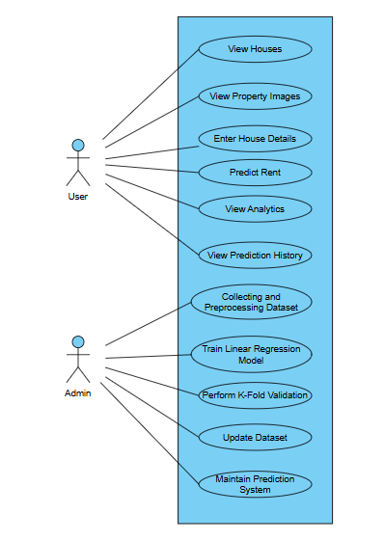
Figure. 3.3 Use case Diagram
Explanations on Use Case Diagram
The Use Case Diagram illustrates the interactions between the users of the House Rent Prediction System and the various functionalities provided by the system. The diagram identifies two major actors involved in the operation of the system namely: User and Admin.
1. User
The user represents end-users such as house seekers, tenants, landlords, property managers, and real estate stakeholders who interact with the prediction system.
The user can perform the following functions:
  - View Houses: This functionality allows users to browse available houses displayed within the system interface. The displayed properties contain relevant information such as property type, location, and housing descriptions. This feature assists users in exploring available housing options before making decisions.
  - View Property Images: The system allows users to view images associated with different houses. The image display feature improves visualization and enables users to examine property appearance before prediction. The image module enhances user interaction and provides better understanding of available properties.
  - Enter House Details: The user enters housing information required for rent prediction. The input features include location, property Type, bedroom(s), bathroom(s), house Size, lot Size, furnishing Status, water Supply, PHCN Availability, year built. These features serve as independent variables for the prediction model.
  - Predict Rent: After entering housing details, the system processes the information using the trained Linear Regression model and generates the estimated annual house rent value. This functionality assists users in housing valuation, budget planning, rent comparison, property assessment
  - View Analytics: The analytics functionality enables users to access housing statistics and market information generated by the system. The analytics module provides average rent information, housing statistics, and market insights. This assists users in understanding rental patterns and housing trends.
  - View Prediction History: The prediction history module stores previous predictions generated by the system. Users can revisit earlier prediction results for future reference and comparison.

2. Admin
The admin actor represents the system administrator or developer responsible for maintaining and improving the machine learning backend of the prediction system.
Unlike end-users, the admin does not interact with the public interface for rent prediction but manages the internal machine learning processes.
The admin performs the following operations:
  - Collecting and Preprocessing Dataset: The admin collects housing records from house agents and online datasets. After collection, preprocessing activities are carried out including data cleaning, missing value handling, and duplicate removal, encoding categorical variables, feature scaling. This ensures that the dataset is suitable for machine learning operations.
  - Train Linear Regression Model: The administrator trains the Linear Regression algorithm using the prepared dataset. During training, relationships between housing features and rent values are learned by the model. The trained model is subsequently saved for prediction purposes.
  - Perform K-Fold Validation: The administrator performs K-Fold Cross Validation to evaluate the performance and reliability of the prediction model. The validation process helps to improve model reliability, reduce overfitting, measure generalization performance, and improve prediction consistency. Five-fold validation was adopted in this study.
  - Update Dataset: The administrator updates the housing dataset whenever new housing records become available. Updating the dataset ensures that the prediction system remains relevant and reflects current housing market conditions.
  - Maintain Prediction System: The administrator is responsible for maintaining the overall prediction system. Maintenance activities include updating model files, monitoring prediction performance, improving system functionality and managing deployment components. This ensures continuous and efficient operation of the developed system.

3.5.7 Model Training and Testing
The dataset was divided into training and testing sets.
- 80% of the dataset was used for training.
- 20% was used for testing.
The model learned relationships between housing features and rent prices during training. The testing phase was used to evaluate prediction accuracy.

3.5.8 Algorithm Design

Linear Regression Prediction Algorithm

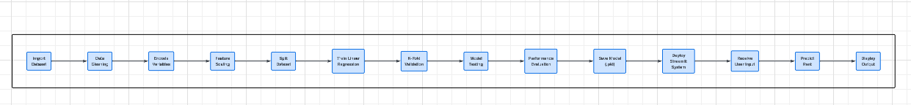

Figure 3.4 Algorithm design

Import Dataset, Data Cleaning, Handle Missing Values, Encode Categorical Variables, Perform, Feature Scaling, Split Dataset into Training and Testing Sets, Train Linear Regression Model, Perform K-Fold Cross Validation, Test Model Performance, Evaluate Model Performance, Save, Model Files (.pkl), Deploy Streamlit Application, Accept User Input, Preprocess User Input, Predict House Rent, Display Prediction Output and Store Prediction History

3.5.7 Evaluation Metrics
The performance of the developed model was evaluated using statistical metrics.
- Mean Absolute Error (MAE):
$MAE=1/n\sum_{i=1}^{n}{|yi-ŷi|}$ --------- Equation 3.1
- Mean Squared Error (MSE):

$MSE=1/n\sum_{i=1}^{n}{\left(yi-ŷi\right)}$ --------- Equation 3.2
- Root Mean Squared Error (RMSE):
$RMSE=\sqrt{(1/n)\sum{{\left(yi-ŷi\right)}^{2}}}$--------- Equation 3.3
- $Coe$fficient of Determination (R²):
$R² =1-\frac{{\sum{\left(yi-ŷi\right)}}^{2}}{{\sum{\left(yi-Ӯi\right)}}^{2}}$ --------- Equation 3.4
These metrics were used to determine the effectiveness and predictive accuracy of the developed model.

3.6 Chapter Summary
This chapter presented the methodology adopted for the development of the House Rent Prediction System using Linear Regression. The chapter discussed the existing housing systems and their limitations, as well as the proposed intelligent prediction system developed to address the identified problems.
The chapter further explained the procedures involved in data collection from house agents and secondary sources, data preprocessing, feature transformation, feature scaling, model development, training, testing, and validation using K-Fold Cross Validation. In addition, the system architecture, Data Flow Diagrams (DFD), Use Case Diagram, algorithm design, and implementation modules of the developed Streamlit application were presented.
Finally, evaluation metrics such as Mean Absolute Error (MAE), Mean Squared Error (MSE), Root Mean Squared Error (RMSE), and Coefficient of Determination (R²) were discussed for assessing the performance and effectiveness of the developed house rent prediction model.

CHAPTER FOUR

IMPLEMENTATION AND TESTING

4.1 Introduction
This chapter presents the implementation and testing of the House Rent Prediction System developed for predicting annual house rent values using Linear Regression. The implementation stage transformed the methodology and design presented in Chapter Three into a functional predictive application capable of estimating house rent prices using housing attributes.
The developed system integrates machine learning techniques with a user-friendly Streamlit interface to provide an interactive environment for rent estimation. The implementation process involved dataset preparation, preprocessing, model development, deployment, and interface design.
The developed application supports:
- Manual rent prediction using housing inputs
- Property browsing through house images and descriptions
- House comparison functionalities
- Market analytics visualization
- Prediction history tracking
- Theme customization using dark mode
The implementation also incorporated K-Fold Cross Validation to improve model reliability and prediction consistency.

4.2 Implementation

4.2.1 Development Tools and Environment
The implementation of the House Rent Prediction System required suitable hardware like Computer and software resources like Jupyter, python and it libraries to support the operations of the machine learning model using Linear regression, data preprocessing(which involves data cleaning, removing duplicates, checking for missing values), visualizations and deployment using streamlit for the interface .

Hardware Environment
The following hardware resources were used:
- Development Computer is Intel Core i5 Processor, 8GB RAM, 465GB Storage.
The workstation generally supported all that was needed to be done in building the model which some of the processing are model training, preprocessing operations, and Streamlit deployment.
- Testing Device
The developed application was tested on Windows laptop environment also on Mobile browser environment. This ensured compatibility across devices which means it can be used across all devices android or any other mobile device.
Software Tools and Technologies
Some of the libraries used are shown in Figure 4.0. The software tools and technologies used in the implementation of this project are:
  - Python Programming Language: Python which is one of the easiest programming language served as the primary development language because of its support for machine learning and data analytics.
  - Jupyter Notebook: Jupyter Notebook was used virtual for writing the python codes due to it’s simplicity during Data cleaning, Dataset exploration, Model development, Validation experiments.
  - Visual Studio Code (VS Code): VS Code was used for application development and Streamlit integration.
  - Streamlit: Streamlit was used for frontend implementation and deployment. It enabled rapid development of: User interface components, Sidebar navigation, Property cards, Analytics views, Theme customization.
  - Scikit-learn: Scikit-learn was used for: Linear Regression implementation, Feature scaling, Train-test splitting, K-Fold validation, Evaluation metrics
  - Pandas: Pandas supported dataset loading, cleaning, transformation, data manipulation
  - NumPy: NumPy enabled numerical computations and matrix operations.
  - Joblib: Joblib was used to save trained files such as rent_model.pkl, scaler.pkl, feature_order.pkl. These files were integrated into the Streamlit application.
  - Matplotlib: Matplotlib generated visual analytics and rent charts.
  - PIL (Python Imaging Library): PIL was used for image handling within the property display section.

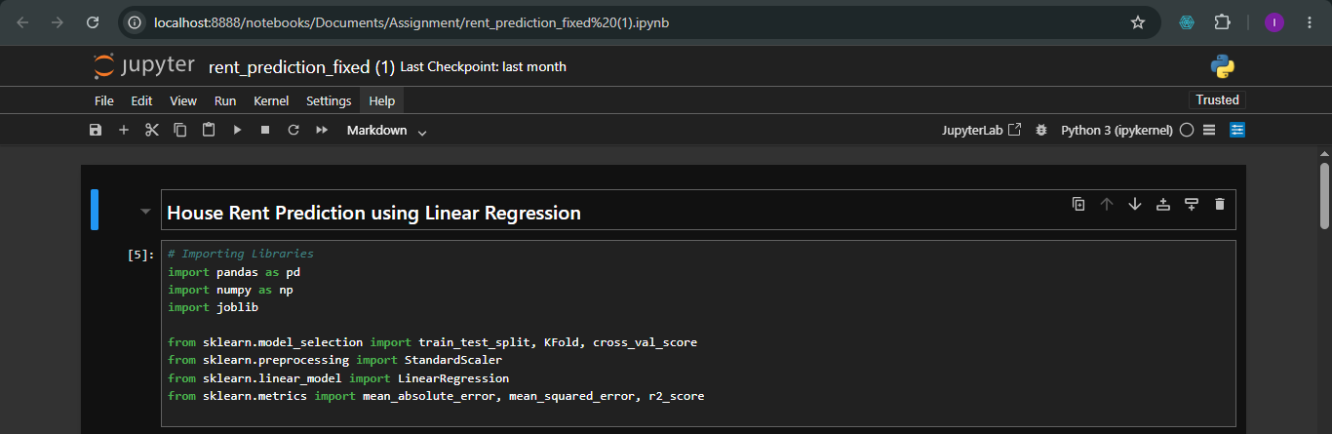
Figure. 4.0 Software and libraries used

4.2.2 Dataset Implementation
The dataset used in this project was obtained from two sources:
- Housing information collected from house agents within Ibadan.
- Secondary housing datasets obtained from newspaper and social media.
The datasets were merged to improve coverage and diversity. The resulting dataset contained attributes including: Location, Property Type, Bedroom(s), Bathroom(s), House Size, Lot Size, Furnishing, Water Supply, PHCN availability, Year built, Rent and can be viewed in Figure 4.1.
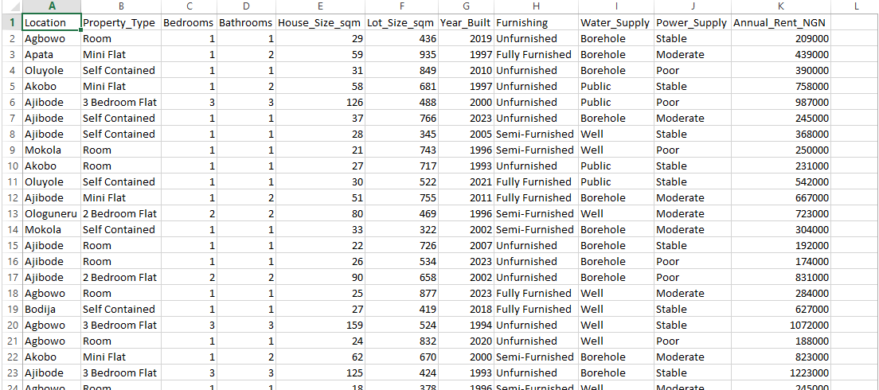
Figure 4.1 Dataset used in training the model
The dataset was loaded into the jupyter notebook and the dataset was subjected to duplicate removal, checking for missing values, data transformation and scaling which can be viewed below in Figure 4.2. and Figure 4.3.
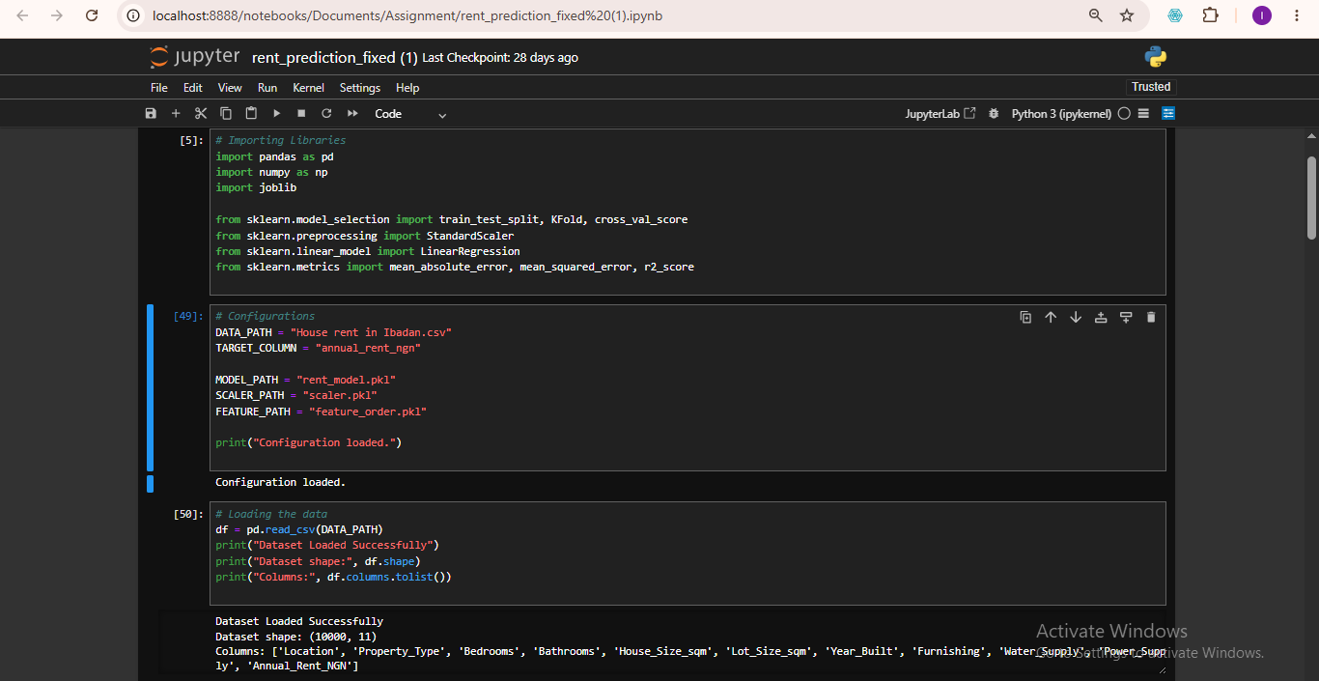
Fig. 4.2 Loading the dataset
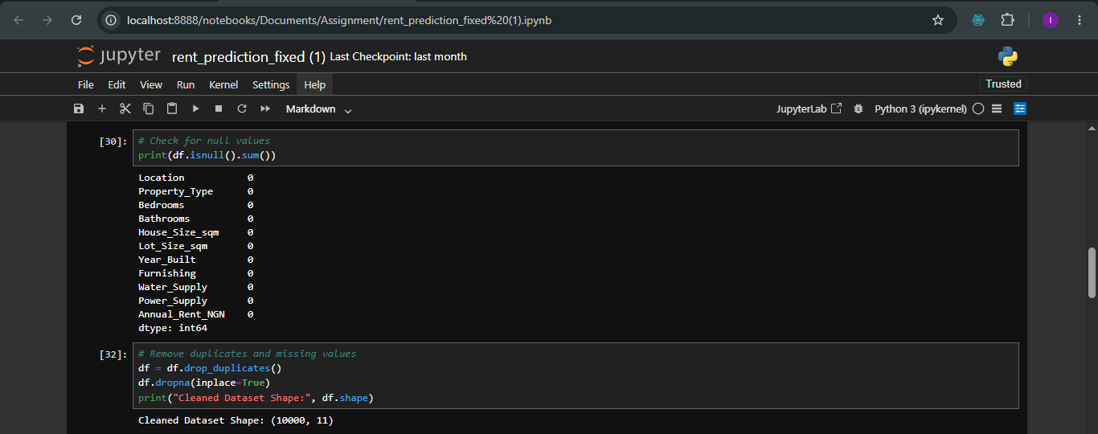
Fig .4.3 Checking for duplicates removal and missing values

4.2.3 Machine Learning Model Implementation
The machine learning model implementation discusses the data encoding which label encoding was been used, followed the stages below. Feature scaling was also done using StandardScaler, model training using Linear regression and K-fold validation was also used which was performed using 5 fold validation. The following has been discussed below:
- Data Encoding
Categorical variables cannot be processed directly by Linear Regression. Therefore label Encoding was applied to variables including location, property type, furnishing, water Supply, PHCN Availability. This transformed categorical attributes into numerical representations. The Label encoding was done and can be viewed in Figure 4.4 below.

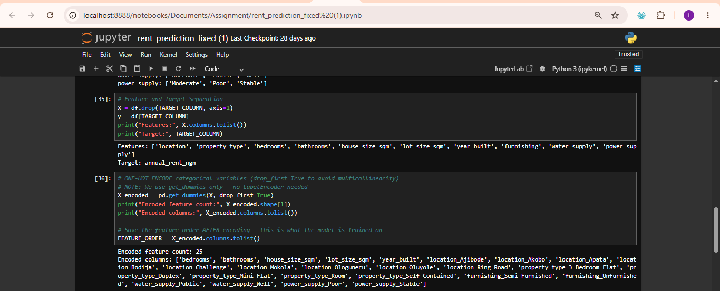
Fig. 4.4 Label encoding
- Feature Scaling
Feature scaling was performed using StandardScaler and can be viewed in Figure 4.5. Scaling ensured that larger numerical values did not dominate smaller variables during training. The scaler was exported as scaler.pkl for deployment.
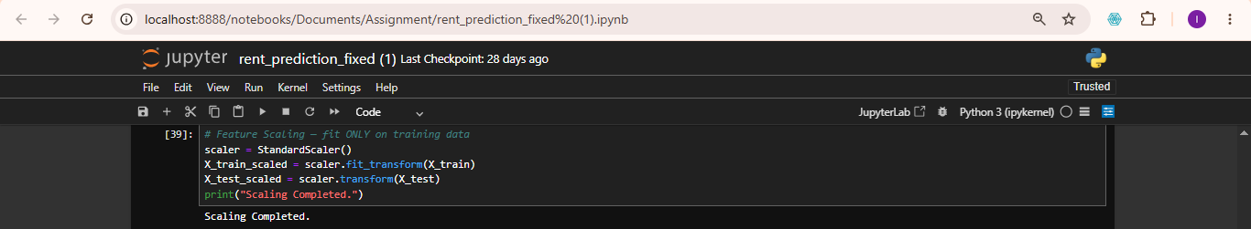
Fig. 4.5 Feature Scaling
- Model Training
Linear Regression can be viewed in Figure 4.6 was selected because house rent prediction involves continuous numerical values. Training operations was done by splitting the data into a ratio of 80% for training set and 20% testing set, feature extraction, coefficient learning, prediction fitting. Dataset partitioning are:
Training set = 80%
Testing set = 20%
The trained model was exported as rent_model.pkl
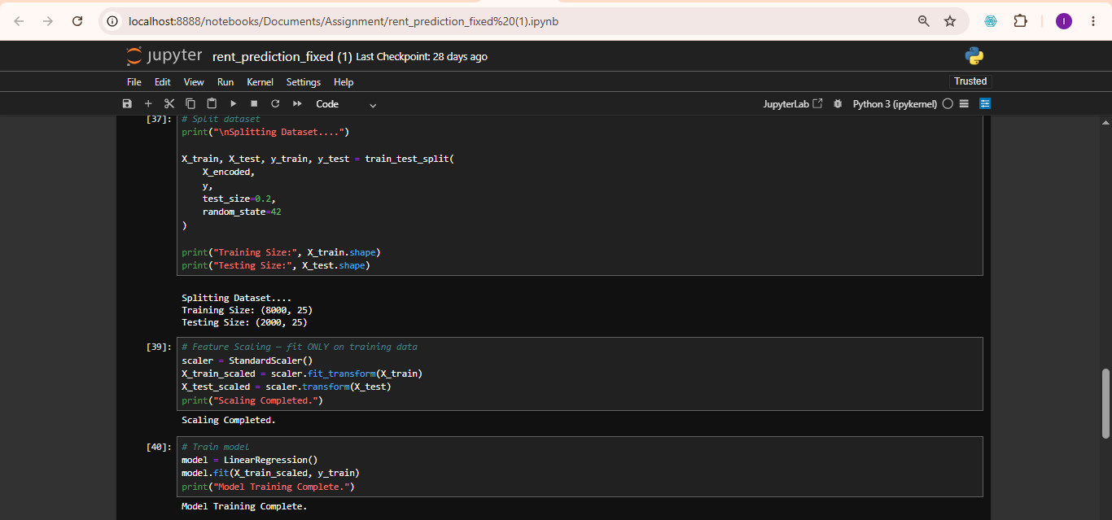
Fig 4.6 Model Training
- K-Fold Cross Validation
To improve reliability, K-Fold validation was performed. The data was splitted into five subset and four subsets out of the five was used for training while the other one subset was used in validation and repeated until the folds participated. The approach improved generalization and reduced overfitting. The procedures involved splitting dataset into five subsets, training using four subsets, validating using one subset and repeating until all folds participated as discussed in Figure 4.7

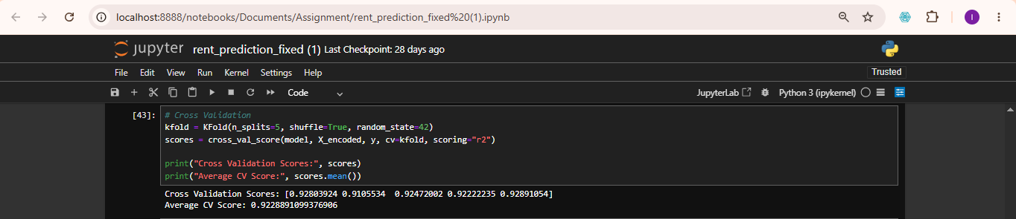
Fig. 4.7 K-fold cross validation

4.2.4 System Interface Implementation
The developed application was deployed using Streamlit and organized into multiple modules.

Home Interface
The home page serves as the entry point of the application and shown below in Figure 4.8. The interface provides the application title which gives us information about the name of the application which is called House rent prediction system, navigation menu which shows you how you navigate through the application which also make it easy for users to navigate through the application, quick access tools and theme customization which is the ability of the application to change theme from the light mode to the dark mode which makes it suitable for some developers and users.

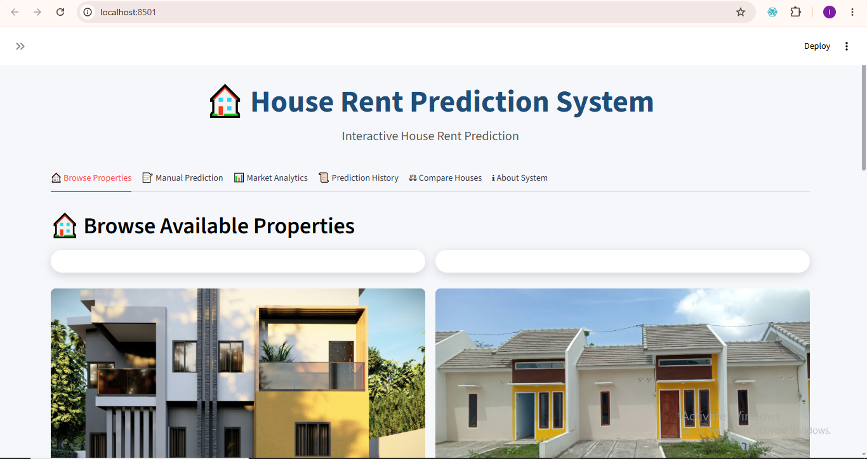
Figure 4.8 Home Interface

Manual Prediction Interface
The prediction interface enables users to manually enter housing details and the prediction inputs include location meaning where the house to be predicted is located, property type which is different kinds of house either single room, duplex or flat, number of bedroom(s), number of bathroom(s), size of the house, lot size, furnishing status of the house whether fully furnished, semi-furnished or unfurnished, mode of water supply, PHCN availability, the year the house was built. After entering the information, users select the prediction button to generate estimated rent. Figure 4.9 shows the image of the manual prediction interface.
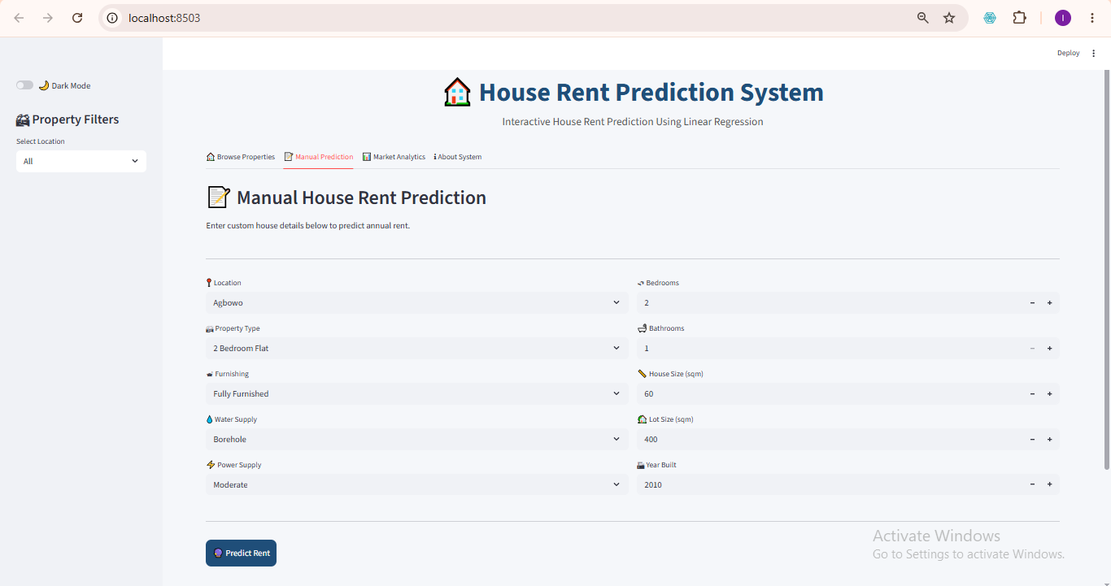
Figure 4.9 Manual Prediction Interface

4.2.4.3 Prediction Output Interface
The prediction module processes user information and returns the estimated annual rent value. Output example of the estimated annual rent is in Naira since it for Nigeria precisely Ibadan people or those who will like to migrate down to Ibadan as shown in Figure 4.10.
Output Value: ₦ xxx,xxx
The result of this prediction assists those who are seeking for house called Tenant(s), Landlords who are owners of the house(s) and Real estate practitioners who basically use this as business.
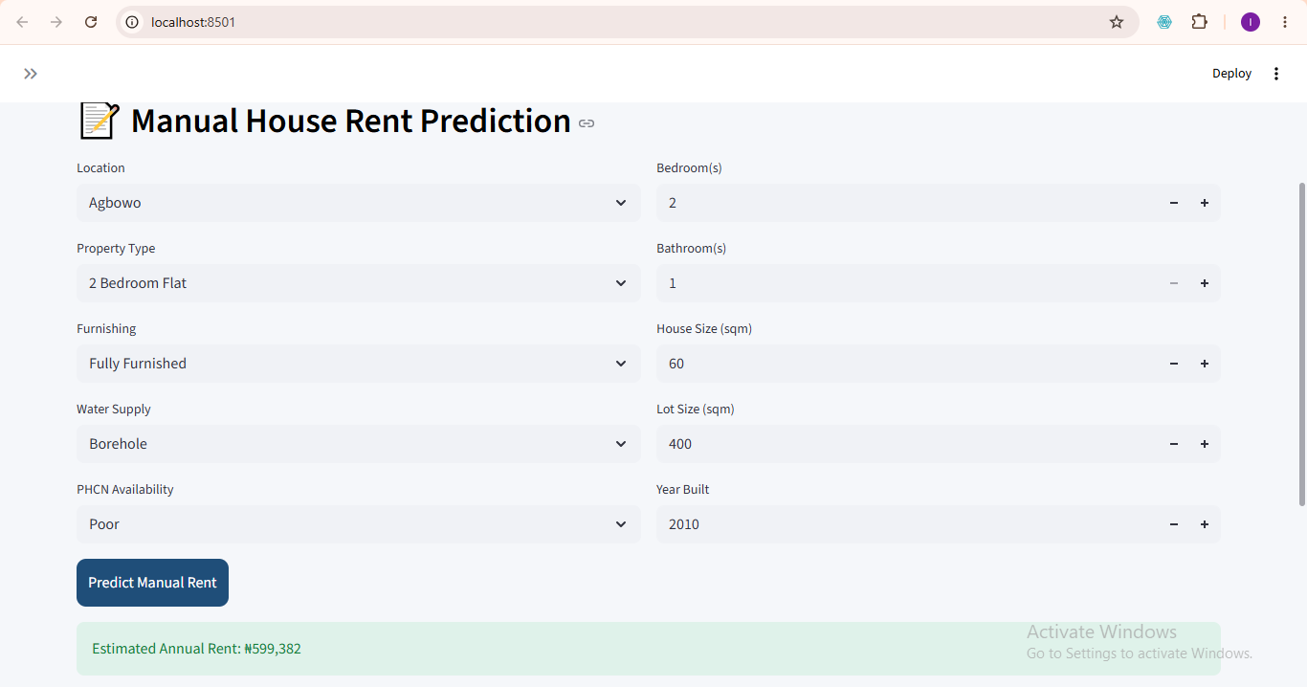
Figure 4.10 Prediction Output Interface

Property Display Interface
The developed system includes a property browsing section. Properties are displayed using image cards. Each card contains house image, description and housing information. Users may select properties directly for prediction as shown in Figure 4.11.

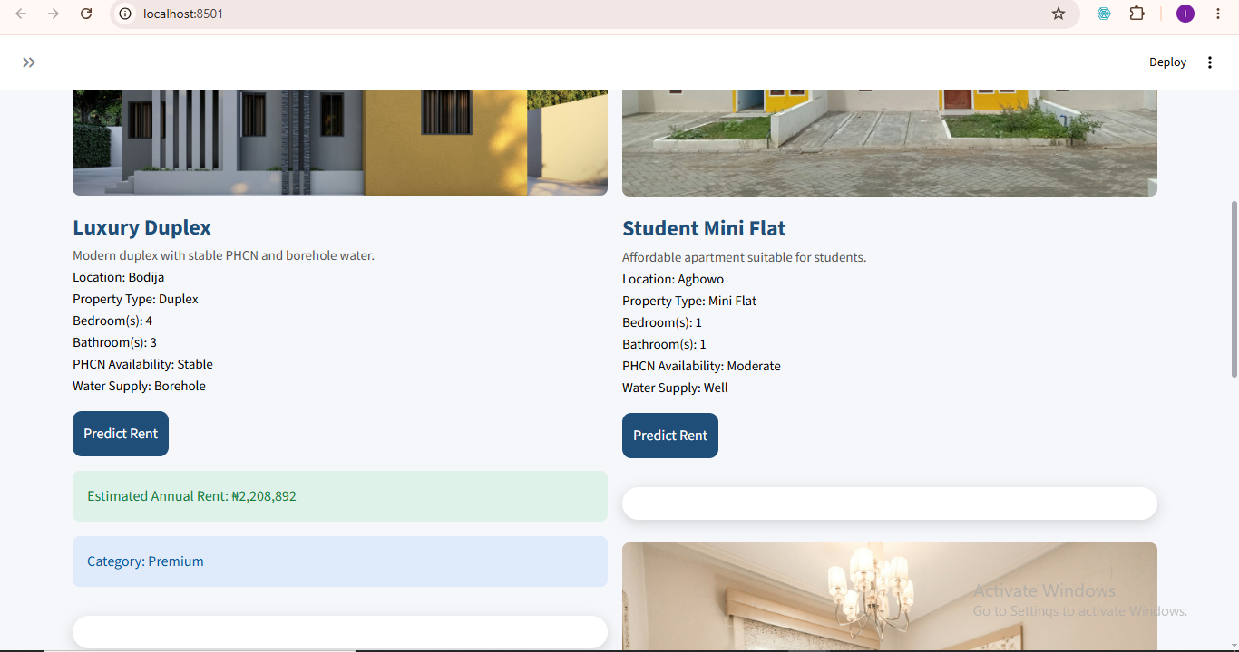
Figure 4.11 Property Gallery Interface

House Comparison Interface
This house comparison interface allow users to compare two different houses, then click on the compare button after selecting the two houses to be compare and evaluate rent values. The comparison interface assists users in cost evaluation, property selection and housing decisions. This feature is a major section which users will like to use since it will help them in decision making as shown below in Figure 4.12.
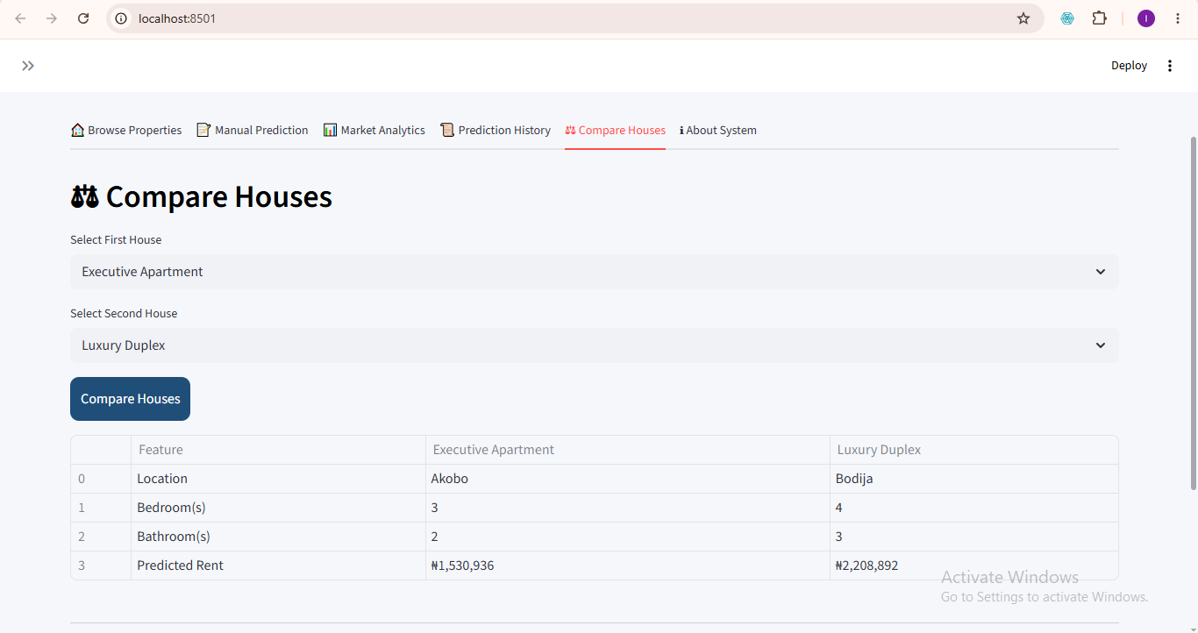
Figure 4.12 House Comparison Interface

Prediction History Interface
Prediction history stores previously generated outputs of the prediction done in the anywhere in the interface meaning all the pages which are the browse house property where you can predict by predicting the houses seeing the picture and details, also the manual prediction interface where you can enter the details of your choice and predict as many time as possible, the house comparison interface is also not left out. This module enables users to revisit earlier predictions done. Stored information includes House details, prediction values, and time records as shown in Figure 4.13 below.
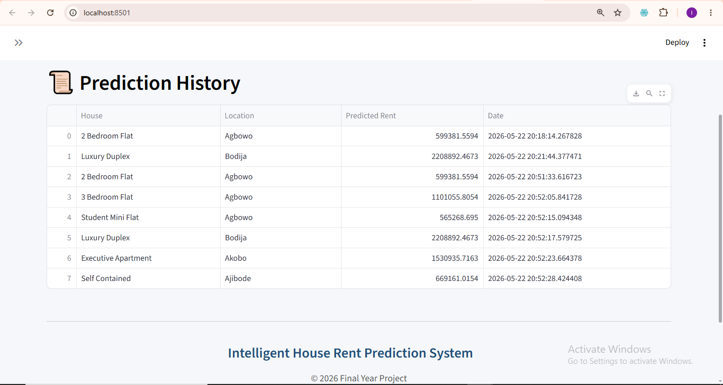
Figure 4.13 Prediction History Interface

4.2.4.8 Market Analytics Interface
The analytics module provides visualization of housing information. Displays information like average rent values, housing distribution and statistical summaries. This module improves market understanding. This same module displays the accuracy of the model which is 92% which is been displayed by R² and the Root Mean Square Error (RMSE) alongside with the Mean Average Error(MAE) as shown in Figure 4.14 below.
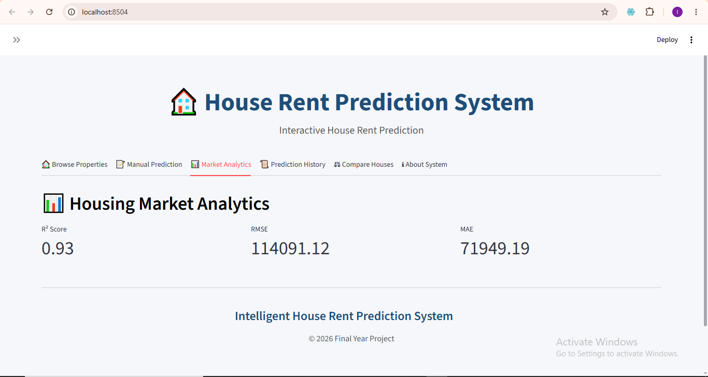
Figure 4.14 Market Analytics Interface

4.2.4.9 Dark Mode Interface
The dark mode interface allows users especially those who do not like the white mode to switch, mostly developers also like to use the dark mode. The dark mode applies to all tabs in the interface. The toggle do this is in the sidebar, once it is clicked on the dark mode is activated and the whole background changes to dark mode. This can be viewed in Figure 4.15 below.
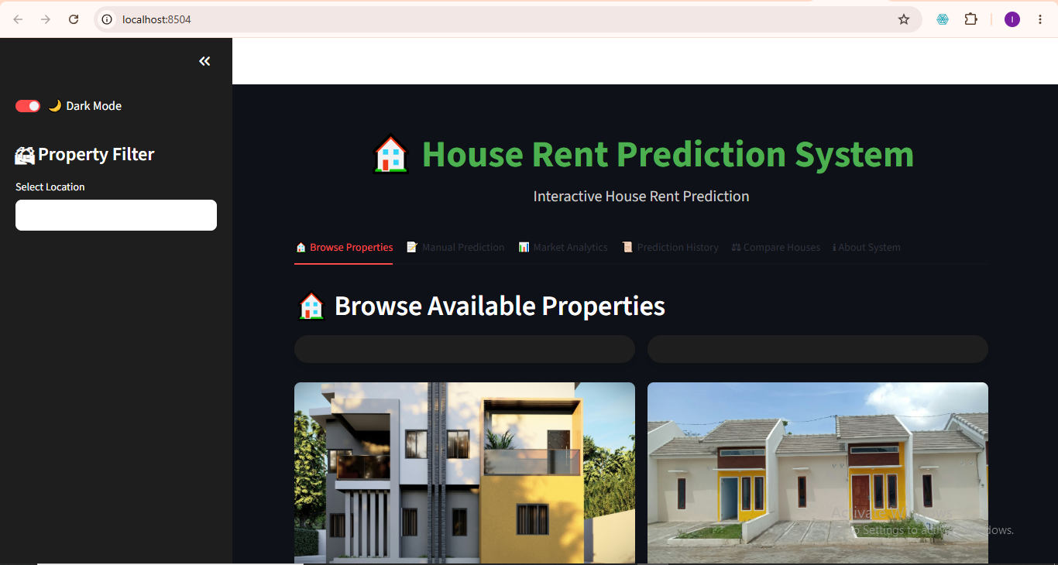
Figure 4.15 Dark Mode Interface

4.2.4.9 About System Interface
The About System Interface as displayed in Figure 4.16 talks about the system tells us about the system which is a machine learning-based model application developed for predicting house rent prices using Linear Regression. And features include Property Gallery, Manual Prediction, Housing Analytics, Prediction History, House Comparison, Dark Mode Toggle. Also technologies used are Python, Streamlit, Pandas, Scikit-learn

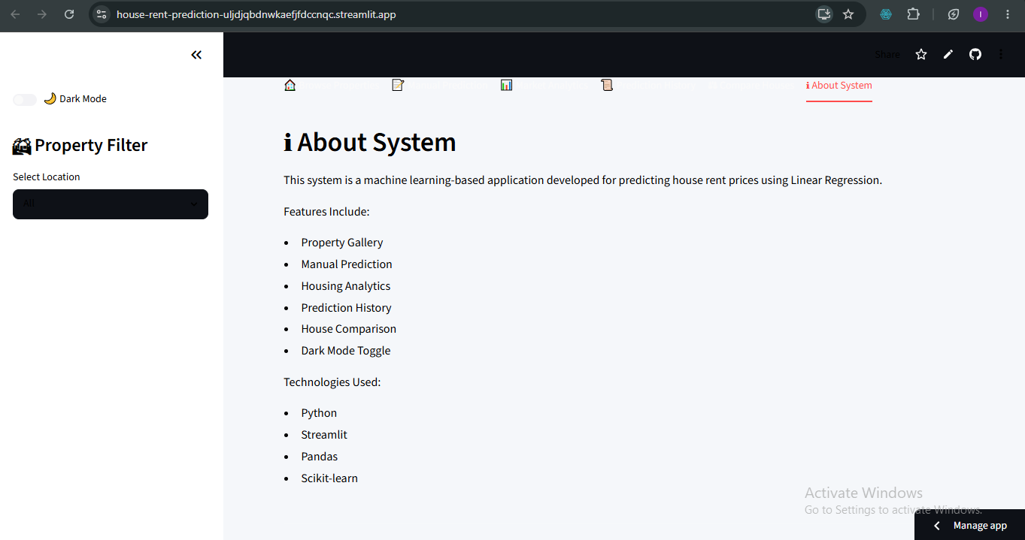
Figure 4.16 About System

CHAPTER FIVE

SUMMARY, CONCLUSION AND RECOMMENDATIONS

5.1 Overview of the Chapter
This chapter presents the summary, conclusion, and recommendations of the study on the development of a House Rent Prediction System using Linear Regression. The chapter highlights the major activities carried out during the research, discusses the findings obtained from the implementation and evaluation stages, and provides recommendations for future improvements.
The study focused on developing an intelligent prediction system capable of estimating house rent values using relevant housing characteristics. The developed application integrated machine learning techniques with a user-friendly Streamlit interface to provide a practical solution for house rent estimation and housing analysis.4

5.2 Summary of the Study
The increasing inconsistency in house rent pricing, especially within developing urban environments, has created challenges for house seekers, landlords, and real estate practitioners. Traditional methods of rent determination rely heavily on house agents, manual valuation, and subjective judgment, which often result in inaccurate and inconsistent pricing.
To address these challenges, this study developed a machine learning-based House Rent Prediction System using Linear Regression.
The study began with data acquisition from two major sources:
- Housing information collected from house agents.
- Secondary housing datasets obtained from news and social media.
The collected datasets were combined and prepared for model development through preprocessing operations such as removal of duplicate records, handling missing values, data transformation, One-Hot Encoding of categorical variables and Feature scaling using StandardScaler
The developed model utilized housing variables including location, property Type, bedroom(s), bathroom(s), House Size, Lot Size, Furnishing Status, Water Supply, PHCN Availability and Year Built. The Linear Regression algorithm was selected because it is suitable for predicting continuous numerical values such as house rent.
The developed system was deployed using Streamlit and implemented with several modules including manual prediction module, Property browsing module, House image display section, Property carousel display, Prediction history module, House comparison module, Market analytics section and Dark mode customization. Model evaluation was carried out using Mean Absolute Error (MAE), Mean Squared Error (MSE), Root Mean Squared Error (RMSE) and Coefficient of Determination (R²). Additionally, K-Fold Cross Validation was incorporated to improve model reliability and minimize overfitting. Testing results showed that the developed application successfully generated house rent predictions and supported interactive housing exploration.

5.3 Summary of Findings
The implementation and testing stages produced several important findings.
  - Successful Development of Prediction Model: The Linear Regression model was successfully trained and integrated into the developed application. The model established relationships between housing characteristics and rent values and generated predictions effectively.
  - Effective Data Preprocessing Improved Model Performance: The preprocessing stage significantly improved data quality. Operations such as duplicate removal, feature transformation, encoding and scaling contributed positively to prediction performance.
  - Streamlit Improved System Usability: The deployment of the prediction model through Streamlit improved user interaction. The developed interface enabled users to perform rent prediction without technical knowledge.
  - Housing Visualization Improved User Experience: The inclusion of house images, property descriptions improved visual interaction and system usability.
  - K-Fold Validation Improved Reliability: K-Fold Cross Validation improved prediction consistency and reduced the possibility of model overfitting. The validation process enhanced confidence in the developed model.
  - Market Analytics Improved Decision-Making: The analytics module enabled users to study housing information and observe rent trends. This improved data-driven decision-making.

5.4 Conclusion
This study successfully developed a House Rent Prediction System using Linear Regression for estimating annual house rent values based on housing characteristics. The developed system addressed the limitations of existing rent estimation methods by introducing an intelligent and automated prediction mechanism. The system utilized housing information such as Location, Property Type, Bedroom(s), Bathroom(s), House Size, Lot Size, Furnishing Status, Water Supply, PHCN Availability, Year Built to estimate rent values. The developed application combined machine learning prediction with an interactive Streamlit interface provides users with a practical platform for housing exploration and rent estimation. The implementation also incorporated additional functionalities including property visualization, house comparison, prediction history tracking, market analytics, and dark mode customization.
The study objectives were successfully achieved:
Objective One
To collect raw housing data and combine those with online datasets while performing preprocessing and preparation operations.
This objective was achieved through dataset acquisition, cleaning, encoding, and scaling procedures.
Objective Two
To develop a machine learning model for predicting house rent.
This objective was achieved through the implementation of Linear Regression Model and K-fold validation was done to validate the model.

Objective Three
To evaluate model effectiveness using statistical metrics.
This objective was achieved using MAE, MSE, RMSE, R² Score, and K-Fold Cross Validation. Overall, the developed system demonstrated the ability to support intelligent house rent estimation and improve transparency within the housing sector.

5.5 Contributions to Knowledge
The study contributed to knowledge in the following ways:
- Development of a localized house rent prediction model suitable for housing environments.
- Integration of machine learning prediction with an interactive web interface.
- Combination of agent-collected housing information with secondary datasets.
- Introduction of visual property exploration using house images.
- Implementation of comparison and analytics functionalities for housing decision support.
- Application of K-Fold Cross Validation to improve reliability.
The developed system therefore contributes to research relating to machine learning applications in housing valuation.

5.6 Recommendations
Although the developed system achieved its objectives, several improvements may be considered in future studies.
  - Adoption of Advanced Machine Learning Algorithms
Future work may compare Linear Regression with algorithms such as Random Forest, XGBoost, Gradient Boosting, and Artificial Neural Networks to improve prediction accuracy.
  - Expansion of Dataset Size
Future studies should collect larger housing datasets from multiple cities to improve model generalization.
  - Integration of Real-Time Property Platforms
The system may be connected to online housing platforms to support automatic updates.
  - Geographic Information System (GIS) Integration
Future implementations may include map-based property visualization.
  - Inclusion of Additional Housing Variables.
Future studies may include variables such as Security level, Road accessibility, Parking availability, Distance to commercial centers, Environmental quality to improve model performance.

5.7 Suggestions for Further Research
Future researchers may extend this work by:
- Developing hybrid prediction systems.
- Comparing multiple machine learning algorithms.
- Investigating deep learning approaches for rent prediction.
- Implementing real-time housing analytics systems.
- Developing nationwide rent prediction frameworks.

5.8 Chapter Summary
This chapter presented the summary, findings, conclusion, and recommendations of the study.
The study successfully developed a House Rent Prediction System using Linear Regression and deployed it through Streamlit. The system integrated machine learning prediction with property visualization, analytics, and interactive functionalities.
The evaluation and testing stages demonstrated that the developed system can support intelligent rent estimation and improve housing decision-making processes.

REFERENCES

Balila, A. E., & Shabri, A. B. (2024). (n.d.). Comparative analysis of machine learning algorithms for predicting Dubai property prices. Frontiers in Applied Mathematics and Statistics,, 10, 1–15. https://doi.org/10.3389/fams.2024.1327376.
Bamiteko, O. D., & Adebiyi, O. O. (2020). Determinant of housing price in Lagos residential market: Role of intermediaries. Journal of Finance and Economics, 8(6), 237–243. https://doi.org/10.12691/jfe-8-6-1 .
Cao, S., Liao, W., & Huang, J. (2024). Research on renting price prediction based on machine learning. . Proceedings of the 5th Management Science Informatization and Economic Innovation Development Conference., https://doi.org/10.4108/eai.8-12-2023.2344718.
Chen, W., Farag, S., Butt, U., & Al-Khateeb, H. . (2024). Leveraging machine learning for sophisticated rental value predictions: A case study from Munich, Germany. Applied Sciences, 14(20), 9528. https://doi.org/10.3390/app14209528.

Chuhan, N. (2024). House price prediction based on different models of machine learning. Applied and Computational Engineering, 54(1), 112–120. https://doi.org/10.54254/2755-2721/54/20241334.
Geerts, M., vanden Broucke, S., & De Weerdt, J. (2023). A Survey of Methods and Input Data Types for House Price Prediction. ISPRS International Journal of GeoInformation, 12(5), NA. https://link-gale.
Hu, G., & Tang, Y. (2023). GERPM: A geographically weighted stacking ensemble learning-based urban residential rents prediction model. Mathematics, 11(14), 3160. https://doi.org/10.3390/math11143160.
Li, D. K., Mei, C. L., & Wang, N. (2020). Tests for spatial dependence and heterogeneity in spatial autoregressive varying coefficient models with application to housing price analysis. Regional Science and Urban Economics, 83, 103470. https://doi.org/10.
Ming Y, Zhang J, Qi J et al. (2020). Prediction and Analysis of Chengdu Housing Rent Based on XGBoost Algorithm. Proceedings of the 2020 3rd International Conference on Big Data Technologies, 1-5.[DOI].
Odebode, A. A., Oladimeji, D. E., & Ogunbayo, O. T. . (2024). An examination of the influence of housing attributes on residential property rental value in South-western Nigeria using the hedonic pricing model. . International Journal of Real Estate Studies.
Olatunji, A. I. (2020 ). Characterising real estate value as co-determinant of housing choice optimality in Nigeria. Journal of African Real Estate Research, 5(2), 106–132. https://doi.org/10.15641/jarer.v5i2.861.
Oluyele, S., Akingbade, J., Akinode, V., & Idoghor, R. (2024). Prediction of urban house rental prices in Lagos, Nigeria: A machine learning approach. ABUAD Journal of Engineering Research and Development, 7(2), 216–228.

Onyejiaka, J. C., Onyima, C. N., & Okafor, J. I. (2025). Examination of factors that lead to rent default on selected residential properties in Awka, Anambra State. International Journal of Real Estate,, 1(1), 65–79.
Pai, P. F., & Wang, W. C. (2020). Using machine learning models and actual transaction data for predicting real estate prices. Applied Sciences, 10(17), 5832. https://doi.org/10.3390/app10175832.
Sharma, H., Harsora, H., & Ogunleye, B. (2024). An optimal house price prediction algorithm: XGBoost. . Analytics, 3(1), 30–45. https://doi.org/10.3390/analytics3010003.
Solovev, K., & Pröllochs, N. (2021). Integrating floor plans into hedonic models for rent price appraisal. arXiv. https://arxiv.org/abs/2102.08162.
Tomal, M. (2020). Housing rent and its determinants in Cracow, Poland. . Geographia Polonica, 93(3), 317–333. https://doi.org/10.7163/GPol.0173.
Trinkaus, O., & Kauermann, G. (2023). Can machine learning algorithms deliver superior models for rental guides? . AStA Wirtschafts- und Sozialstatistisches Archiv, 17, 305–330.
Wu B, Wang L, Lv SX et al. (2021). Effective crude oil price forecasting using new text-based and big-data-driven model. Measurement, 168: 108468.[DOI].
Yagmur, A., Kayakus, M., & Terzioglu, M. (2022). House price prediction modeling using machine learning techniques: A comparative study. . Aestimum, 81, 39–56. https://doi.org/10.36253/aestim-13153.
Zaki, J., Nayyar, A., Dalal, S., & Ali, Z. H. (2022). House price prediction using hedonic pricing model and machine learning techniques. Concurrency and Computation: Practice and Experience . 34(27).
Zong, H., & Song, J. (2023). Research on the prediction model of house rent based on machine learning. . Proceedings of the International Conference on Big Data Blockchain and Economy Management., https://doi.org/10.4108/eai.19-5-2023.2334250.

Zulkifley, N. H., Rahman, S. A., Ubaidullah, N. H., & Ibrahim, I. (2020). House price prediction using a machine learning model: A survey of literature. . International Journal of Modern Education and Computer Science,, 12(6), 34–43. https://doi.org/10.5815/.

