ABSTRACT
House rent estimation remains a challenge due to inconsistent pricing methods, reliance on manual valuation, and the absence of intelligent systems for determining fair rent values. Traditional approaches used by house agents and property owners often result in price variations and inaccurate rent estimations. This study developed a House Rent Prediction System using Linear Regression to estimate annual house rent values based on housing characteristics. The dataset used for the study was obtained from house agents and secondary sources and was preprocessed through data cleaning, encoding, and feature scaling using StandardScaler. The model utilized features such as location, property type, bedroom(s), bathroom(s), house size, lot size, furnishing status, water supply, PHCN availability, and year built. The developed system was implemented using Streamlit and included functionalities such as manual prediction, property visualization, house comparison, prediction history, market analytics, and property carousel display. Model evaluation was carried out using MAE, MSE, RMSE, R² Score, and K-Fold Cross Validation. The results showed that the developed system was effective in predicting house rent values and can support intelligent housing valuation and decision-making.
Keywords: House Rent Prediction, Linear Regression, Machine Learning, Streamlit, Housing Valuation.

1.0 Introduction
Housing is a fundamental necessity, providing individuals with essential shelter and security. However, the housing market is often plagued by issues such as inflated rent prices and a lack of transparency. These issues pose considerable challenges for both landlords and house hunters. Some agents tend to set rent prices at excessively high levels, divorcing them from prevailing market rates and the actual value of the properties. This practice creates a noticeable gap between the true worth of housing units and the amount tenants are obligated to pay. As a result, landlords face difficulties in renting out their properties, as they lack accurate information on the market price. Simultaneously, house hunters encounter challenges in finding housing options that offer genuine value for money amid inflated rent prices.
The real estate market is one of the most dynamic and economically significant sectors in many countries. Housing prices are influenced by a wide range of factors, including location, property size, structural features, and prevailing market conditions. Accurate property valuation is therefore essential for effective decision-making by buyers, sellers, investors, and policy makers. Traditionally, property valuation has depended on manual appraisal methods, expert judgment, and basic comparative analysis. While these approaches have been widely used, they are often time-consuming, inconsistent, and susceptible to human error, particularly when applied to large and complex datasets.
This project outlines using stack ensemble to predict housing prices based on key property features. It also incorporates essential data preparation steps such as handling missing values, feature scaling, and k-fold cross-validation to ensure a robust and reliable model.
Accurately determining the price of residential properties is a major challenge in the real estate industry due to the complex interplay of factors such as location, property size, structural features, economic conditions, and market demand. Traditional methods of property valuation often rely on human expertise, manual analysis, or simple comparison techniques, which may be subjective, inconsistent, and inefficient especially when dealing with large datasets.
The aim of this study is to develop an accurate, reliable, and data-driven predictive model for rental housing prices using Linear Regression. The primary objective of this study is to develop a reliable and data-driven predictive model for estimating rental housing prices using Linear Regression techniques are to perform data preprocessing and feature engineering. To develop a stack ensemble machine learning-based model for predicting house rent using relevant housing features. To evaluate the performance and effectiveness of the developed linear stack ensemble model using appropriate statistical metrics.
This study is significant because it demonstrates how machine learning can be applied to real estate valuation. By developing a predictive model for housing prices, the study provides valuable insights for various stakeholders in the real estate sector. This study focuses on developing and evaluating a Linear Regression model for predicting rental housing prices using a real estate dataset. The scope is limited to the variables available within the dataset, which may include features such as property size, number of rooms, location indicators, and other relevant attributes.
The study covers key machine learning processes such as data cleaning, handling missing values, feature scaling, model training, and performance evaluation using k-fold cross-validation. Stack ensemble which include Random Forest, Gradient Boost, Linear Regression and Ridge Regression for the Meta model was used as the predictive technique, although other advanced models are acknowledged but not implemented.
Despite the contributions and practical relevance of this study, several limitations must be acknowledged to provide a balanced understanding of the findings and to clearly define the scope within which the results should be interpreted. Recognizing these limitations is essential for maintaining academic rigor and for guiding future research in rental housing price prediction. The project accuracy and reliability of the predictive model developed in this study are highly dependent on the quality, completeness, and representativeness of the dataset obtained. As the dataset is sourced from a secondary platform, the researcher has limited control over how the data was originally collected, processed, and curated. Another important limitation relates to the scope of features included in the dataset. The study relies primarily on quantitative property-related attributes such as size, number of rooms, and other structural characteristics.

2.0 Literature Review
Several recent studies have demonstrated the effectiveness of machine learning techniques in housing price prediction. Pai and Wang (2020) applied machine learning models to real estate prediction using transaction datasets and found that predictive analytics improved property valuation accuracy significantly. Zulkifley et al., (2020) conducted a survey of machine learning models for housing prediction and emphasized the importance of preprocessing techniques such as normalization, feature engineering, and cross-validation. Tomal (2020) investigated rental housing determinants in Poland and found that neighborhood quality, accessibility, and structural characteristics strongly influence rental prices.
Li, Mei, and Wang (2020) examined spatial dependence in housing price analysis and concluded that geospatial variables significantly improve predictive performance. Yagmur et al., (2022) compared different machine learning techniques for housing prediction and observed that ensemble models generally achieve higher prediction accuracy, although Linear Regression remains highly interpretable. Geerts et al., (2023) reviewed methods and data types used in house price prediction systems and highlighted the growing relevance of machine learning in modern real estate analytics. Sharma et al., (2024) developed an XGBoost-based housing prediction model and reported strong predictive performance compared to traditional statistical methods.
Balila and Shabri (2024) compared multiple machine learning algorithms for property price prediction and concluded that while advanced algorithms provide higher accuracy, Linear Regression remains computationally efficient and easier to interpret. Predicting real estate prices is continuously advancing toward more accurate and reliable predictions using more and more sophisticated machine learning methods. Pai et al., (2020) explored the use of machine learning techniques for predicting real estate transaction prices, employing models such as Least Squares Support Vector Regression (LSSVR), Classification and Regression Trees (CART), General Regression Neural Networks (GRNN), and Back propagation Neural Networks (BPNN). Their research, utilizing transaction data from Taichung, Taiwan, found that attribute selection significantly improved model performance. In particular, LSSVR outperformed the other models in terms of prediction accuracy, highlighting the effectiveness of support vector-based models for real estate price predict house prices, comparing it with the traditional hedonic pricing model.
Their results showed that XGBoost significantly outperformed the hedonic model, demonstrating its better predictive accuracy, regularization for over fitting, and ability to handle sparse data forecasting. Similarly, Zaki et al., (2022) applied XGBoost, a powerful gradient boosting algorithm, to predict house prices, comparing it with the traditional hedonic pricing model. Their results showed that XGBoost significantly outperformed the hedonic model, demonstrating its better predictive accuracy, regularization for over fitting, and ability to handle sparse data.
In recent years, there has been a growing trend in utilizing more advanced algorithms for rent prediction. Ming et al., (2020) explored rent prices in Chengdu, China using the Extreme Gradient Boosting (XGBoost) algorithm. Oluyele et al. (2024) developed a machine learning-based rental price prediction model using housing attributes such as location, property characteristics, and neighborhood features. Their findings demonstrated that machine learning techniques can effectively estimate rental values and support decision-making in the housing sector. Hu and Tang (2023) proposed a geographically weighted ensemble learning model for residential rent prediction and observed that incorporating spatial information significantly improved prediction performance across different urban locations. Chen et al. (2024) applied machine learning algorithms to rental valuation and found that property size, location, building characteristics, and neighborhood conditions were among the most influential determinants of rental prices.
Cao et al., (2024) investigated rental price prediction using machine learning techniques and reported that data-driven models provide reliable estimates of rental values when relevant housing characteristics are properly represented in the dataset. Oluyele et al., (2024) emphasized that housing attributes such as location, number of rooms, accessibility to infrastructure, and environmental quality have substantial effects on rental prices within urban housing markets. Trinkaus and Kauermann (2023) evaluated the effectiveness of machine learning algorithms for rental valuation and concluded that modern predictive models can outperform traditional approaches when sufficient housing data are available. Zong and Song (2023) developed a machine learning-based house rent prediction model and demonstrated that predictive algorithms are capable of identifying complex relationships between housing features and rental values.
Wu et al., (2021) conducted a study on the determinants of the market value of residential properties in Ibadan metropolis, Nigeria. The findings revealed that the major determinant factors influencing the rental value of residential buildings in the study area are the number of toilets, the existence of a burglar alarm, and the condition of the buildings. Additionally, the type of building and the number of toilets were identified as major determinant factors influencing capital value. A traditional numeric value prediction method given a set of inputs is Ordinary Least Squares regression (OLS). This method of prediction relies upon a linear relationship between input variables or features, and an output variable predicted by these linear relationships.
Despite significant advancements in machine learning based property valuation systems, several gaps remain in existing literature. Many studies focus primarily on property sales price prediction rather than rental house valuation (Solovev & Pröllochs, 2021). Most existing studies rely heavily on datasets obtained from developed countries and may not accurately reflect Nigerian housing market conditions (Olatunji, 2020). Limited studies specifically address rental house prediction in Ibadan despite the city’s growing population and housing demand. Also, many advanced machine learning models emphasize prediction accuracy without considering interpretability, which is important for transparency in real estate decision-making. Finally, some studies neglect preprocessing techniques such as missing value treatment, feature scaling, and outlier handling despite their importance in predictive modeling. This study addresses these gaps by developing an interpretable stack ensemble machine learning based model for rental prediction system using comprehensive preprocessing and evaluation techniques.

3.0 Methodology

System Architecture
The architecture of the system consists of Data input, Data Preprocessing Layer, Model Training Layer, Model Evaluation Layer and Price Prediction Layer components. The system architecture shown above illustrates the workflow of the proposed house rent prediction system using Linear Regression. It describes the sequential processes involved in transforming raw housing data into an accurate rent price prediction. The architecture consists of five major components, namely: Data Input, Data Preprocessing, Model Training, Model Evaluation, and Price Prediction Output.
3.1 Data Flow Diagram (DFD)
DFD Level 0 (Context Diagram)
The Level 0 Data Flow Diagram, also known as the Context Diagram, provides a high-level overview of the house rent prediction system. It illustrates the interaction between the user and the system without showing the internal processing details. The Level 0 DFD therefore provides a simplified overview of how data move between the user and the prediction system.
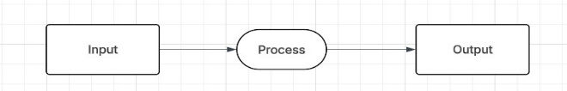
Figure. 3.2 DFD level 0
DFD Level 1
The Level 1 Data Flow Diagram provides a more detailed representation of the internal operations of the house rent prediction system. Unlike the Level 0 DFD, which treats the system as a single process, the Level 1 DFD breaks the system into multiple sub processes that describe how data are transformed step-by-step.
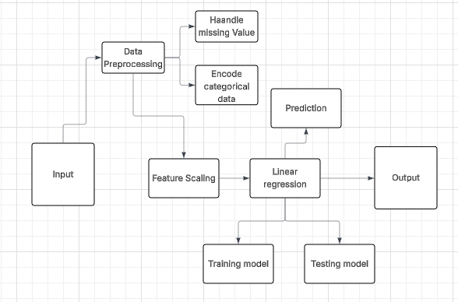
Figure. 3.3 DFD Level 1

3.2 Model Training and Testing
The dataset was divided into training and testing sets which is 80% of the dataset was used for training and 20% was used for testing the model. The model learned relationships between housing features and rent prices during training. The testing phase was used to evaluate prediction accuracy.

3.4 Algorithm Design
Stack ensemble (using Gradient boost, Random Forest, Linear regression, and Ridge regression for the metal model) was used in the prediction Algorithm

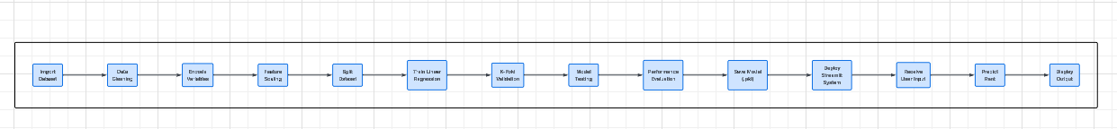

Figure 3.5 Algorithm design

Import Dataset, Data Cleaning, Handle Missing Values, Encode Categorical Variables, Perform, Feature Scaling, Split Dataset into Training and Testing Sets, Train Linear Regression Model, Perform K-Fold Cross Validation, Test Model Performance, Evaluate Model Performance, Save, Model Files (.pkl), Deploy Streamlit Application, Accept User Input, Preprocess User Input, Predict House Rent, Display Prediction Output and Store Prediction History
Finally, evaluation metrics such as Mean Absolute Error (MAE), Mean Squared Error (MSE), Root Mean Squared Error (RMSE), and Coefficient of Determination (R²) were discussed for assessing the performance and effectiveness of the developed house rent prediction model.

4.0 Result Discussion
This chapter presents the implementation and testing of the House Rent Prediction System developed for predicting annual house rent values using Stack Ensemble using Gradient Boost, Random Forest, Linear Regression and Ridge Regression for the metal model. The implementation stage transformed the methodology and design presented in Chapter Three into a functional predictive application capable of estimating house rent prices using housing attributes.
The developed system integrates machine learning techniques which is stack ensemble using gradient boost, linear regression, random forest and ridge regression for metal model with a user-friendly Streamlit interface to provide an interactive environment for rent estimation. The implementation process involved dataset preparation, preprocessing, model development, deployment, and interface design.
The developed application supports Manual rent prediction using housing inputs, Property browsing through house images and descriptions, House comparison functionalities, Market analytics visualization, Prediction history tracking and Theme customization using dark mode. The implementation also incorporated K-Fold Cross Validation to improve model reliability and prediction consistency.

4.2 Implementation

4.2.1 Development Tools and Environment
The implementation of the House Rent Prediction System required suitable hardware like Computer and software resources like Jupyter, python and it libraries to support the operations of the machine learning model using Linear regression, data preprocessing(which involves data cleaning, removing duplicates, checking for missing values), visualizations and deployment using streamlit for the interface .

Hardware Environment
The following hardware resources were used:
- Development Computer is Intel Core i5 Processor, 8GB RAM, 465GB Storage.
The workstation generally supported all that was needed to be done in building the model which some of the processing are model training, preprocessing operations, and Streamlit deployment.
- Testing Device
The developed application was tested on Windows laptop environment also on Mobile browser environment. This ensured compatibility across devices which means it can be used across all devices android or any other mobile device.
Software Tools and Technologies
Some of the libraries used are shown in Figure 4.0. The software tools and technologies used in the implementation of this project are Python Programming Language, Jupyter Notebook, Visual Studio Code (VS Code), Streamlit: Scikit-learn, Pandas, NumPy, Joblib, Matplotlib, PIL (Python Imaging Library).
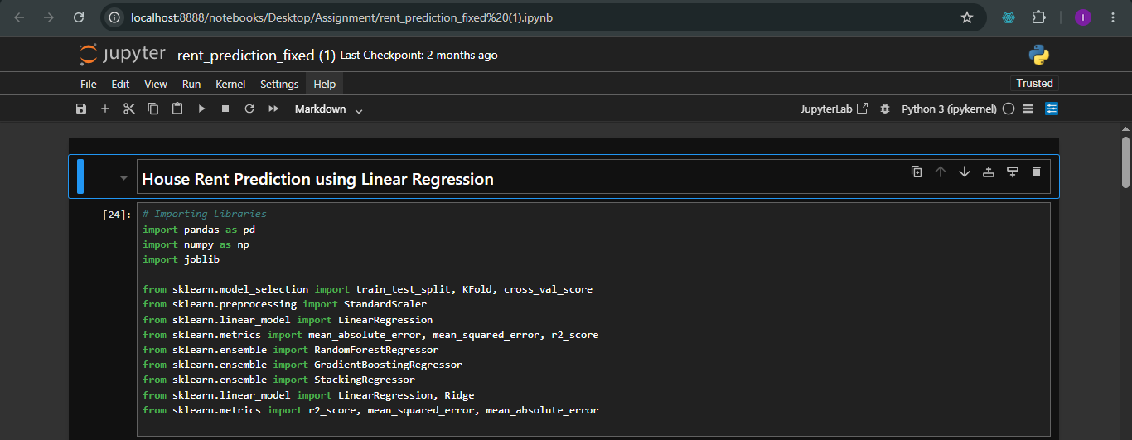
Figure. 4.0 Software and libraries used

Dataset Implementation
The dataset used in this project was obtained from two sources which are house agents within Ibadan and secondary housing datasets obtained from newspaper and social media.
The datasets were merged to improve coverage and diversity and can be viewed in Figure 4.1.
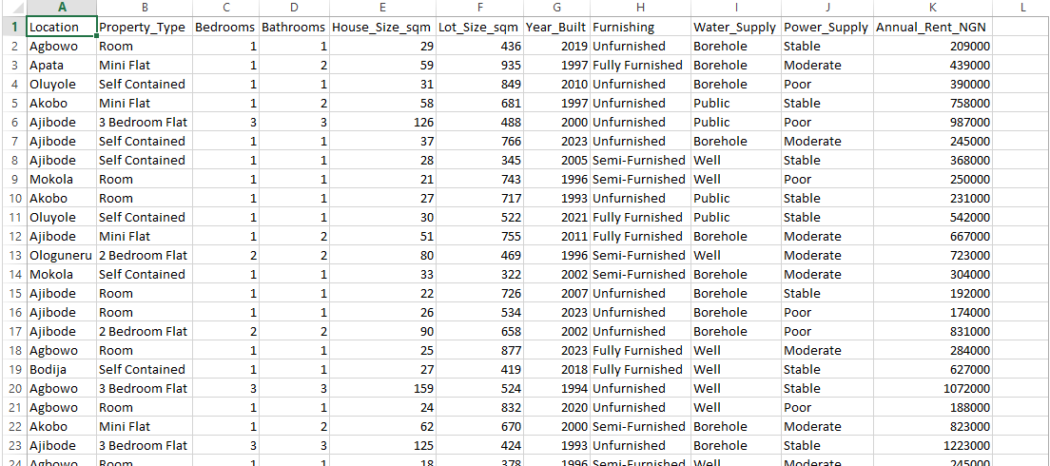
Figure 4.1 Dataset used in training the model
The dataset was loaded into the jupyter notebook and the dataset was subjected to duplicate removal, checking for missing values, data transformation and scaling which can be viewed below in Figure 4.2. and Figure 4.3.
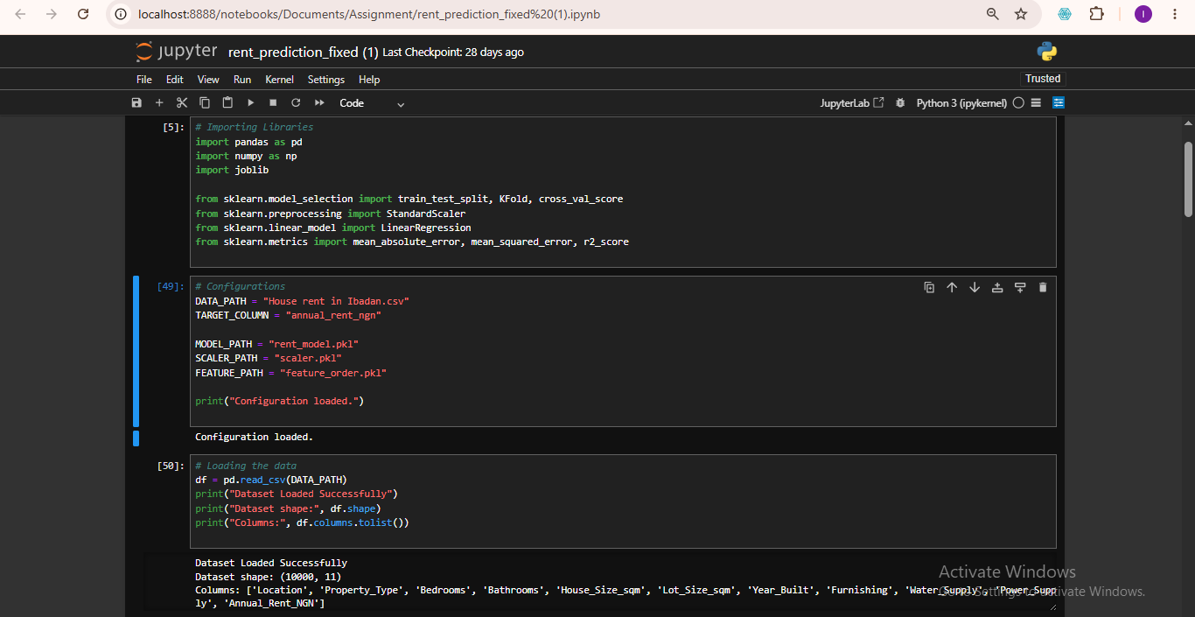
Fig. 4.2 Loading the dataset
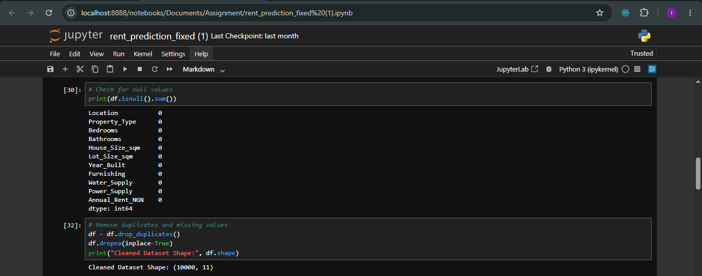
Fig .4.3 Checking for duplicates removal and missing values

4.2.3 Machine Learning Model Implementation
The machine learning model implementation discusses the data encoding which label encoding was been used, followed the stages below. Feature scaling was also done using StandardScaler, model training using Linear regression and K-fold validation was also used which was performed using 5 fold validation. The following has been discussed below:
- Data Encoding
Categorical variables cannot be processed directly by Linear Regression. Therefore label Encoding was applied to variables including location, property type, furnishing, water Supply, PHCN Availability. This transformed categorical attributes into numerical representations. The Label encoding was done and can be viewed in Figure 4.4 below.

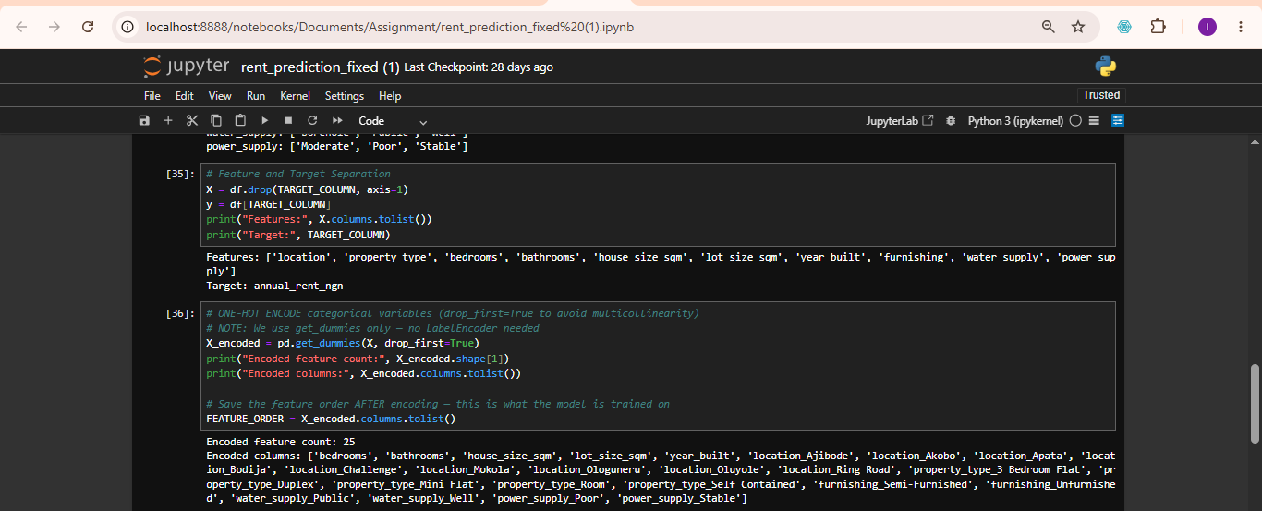
Fig. 4.4 Label encoding
- Feature Scaling
Feature scaling was performed using StandardScaler and can be viewed in Figure 4.5. Scaling ensured that larger numerical values did not dominate smaller variables during training. The scaler was exported as scaler.pkl for deployment.
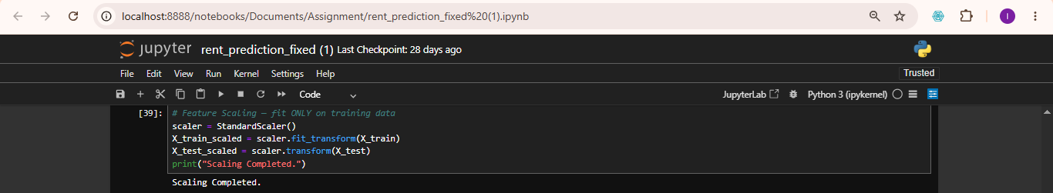
Fig. 4.5 Feature Scaling
- Model Training
Random Forest, Gradient boost, linear regression and ridge regression for the metal model was used for model training and can be viewed in Figure 4.6 was selected because house rent prediction involves continuous numerical values. Training operations was done by splitting the data into a ratio of 80% for training set and 20% testing set, feature extraction, coefficient learning, prediction fitting. Dataset partitioning are:
The trained model was exported as rent_model.pkl
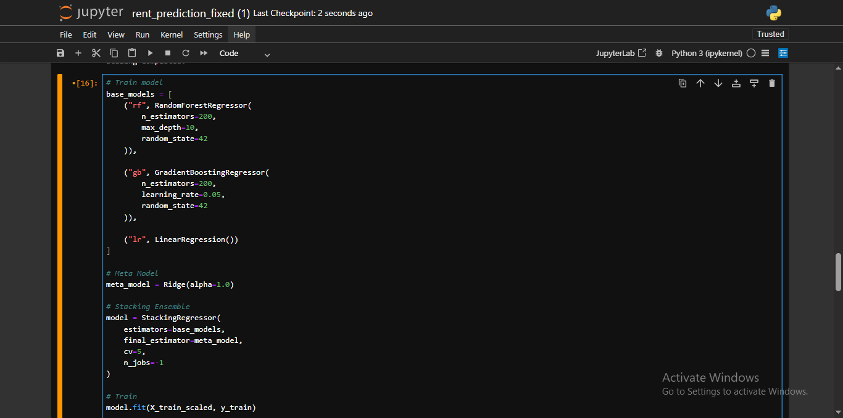
Fig 4.6 Model Training
- K-Fold Cross Validation
To improve reliability, K-Fold validation was performed. The data was splitted into five subset and four subsets out of the five was used for training while the other one subset was used in validation and repeated until the folds participated. The approach improved generalization and reduced overfitting. The procedures involved splitting dataset into five subsets, training using four subsets, validating using one subset and repeating until all folds participated as discussed in Figure 4.7

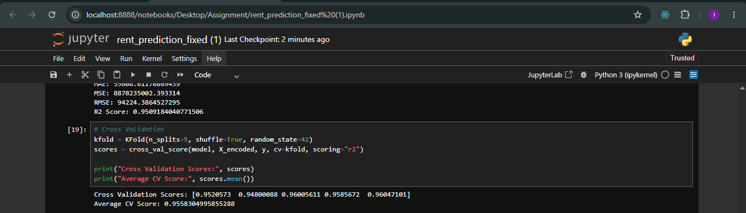
Fig. 4.7 K-fold cross validation

4.2.4 System Interface Implementation
The developed application was deployed using Streamlit and organized into multiple modules.

Home Interface
The home page serves as the entry point of the application and shown below in Figure 4.8. The interface provides the application title which gives us information about the name of the application which is called House rent prediction system, navigation menu which shows you how you navigate through the application which also make it easy for users to navigate through the application, quick access tools and theme customization which is the ability of the application to change theme from the light mode to the dark mode which makes it suitable for some developers and users.

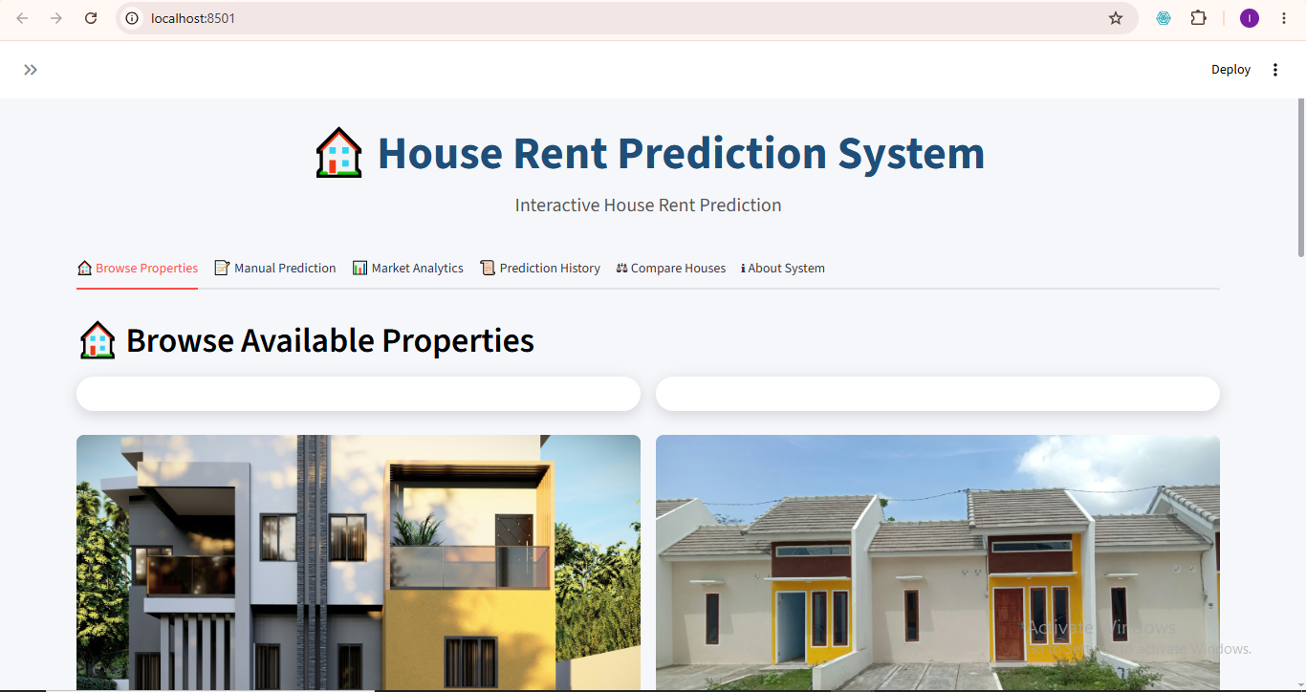
Figure 4.8 Home Interface

Manual Prediction Interface
The prediction interface enables users to manually enter housing details and the prediction inputs include location meaning where the house to be predicted is located, property type which is different kinds of house either single room, duplex or flat, number of bedroom(s), number of bathroom(s), size of the house, lot size, furnishing status of the house whether fully furnished, semi-furnished or unfurnished, mode of water supply, PHCN availability, the year the house was built. After entering the information, users select the prediction button to generate estimated rent. Figure 4.9 shows the image of the manual prediction interface.
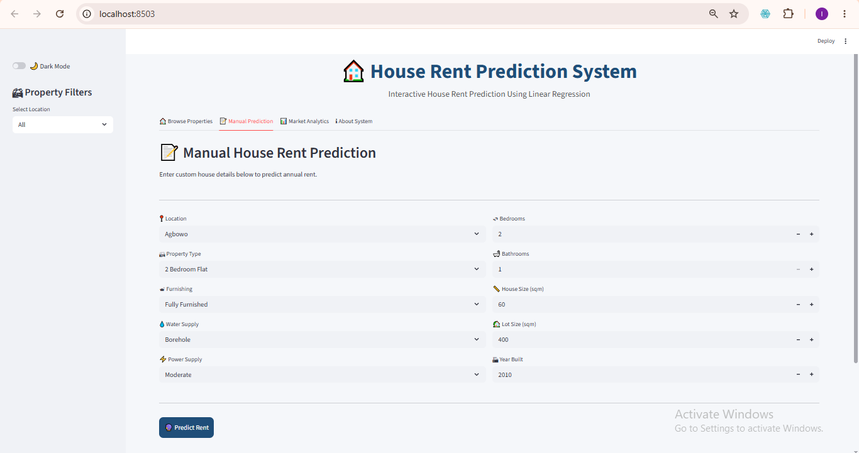
Figure 4.9 Manual Prediction Interface

4.2.4.3 Prediction Output Interface
The prediction module processes user information and returns the estimated annual rent value. Output example of the estimated annual rent is in Naira since it for Nigeria precisely Ibadan people or those who will like to migrate down to Ibadan as shown in Figure 4.10.
Output Value: ₦ xxx,xxx
The result of this prediction assists those who are seeking for house called Tenant(s), Landlords who are owners of the house(s) and Real estate practitioners who basically use this as business.
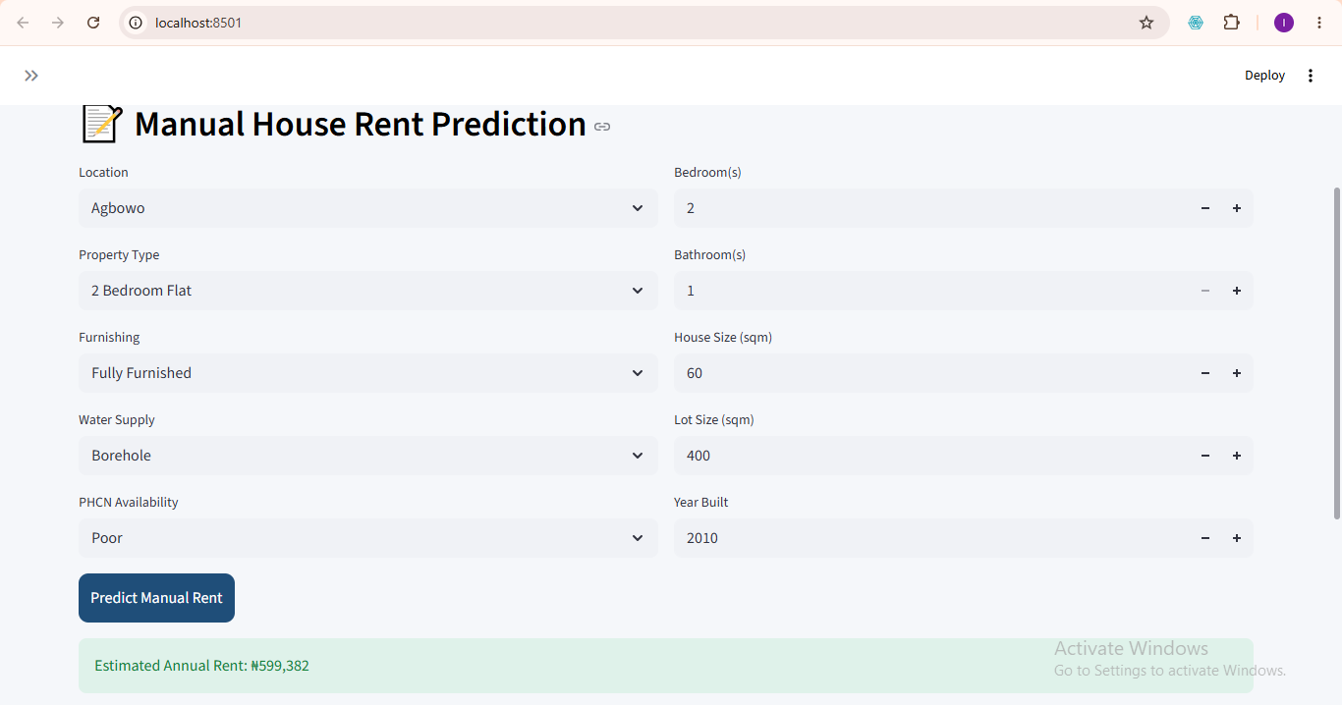
Figure 4.10 Prediction Output Interface

Property Display Interface
The developed system includes a property browsing section. Properties are displayed using image cards. Each card contains house image, description and housing information. Users may select properties directly for prediction as shown in Figure 4.11.
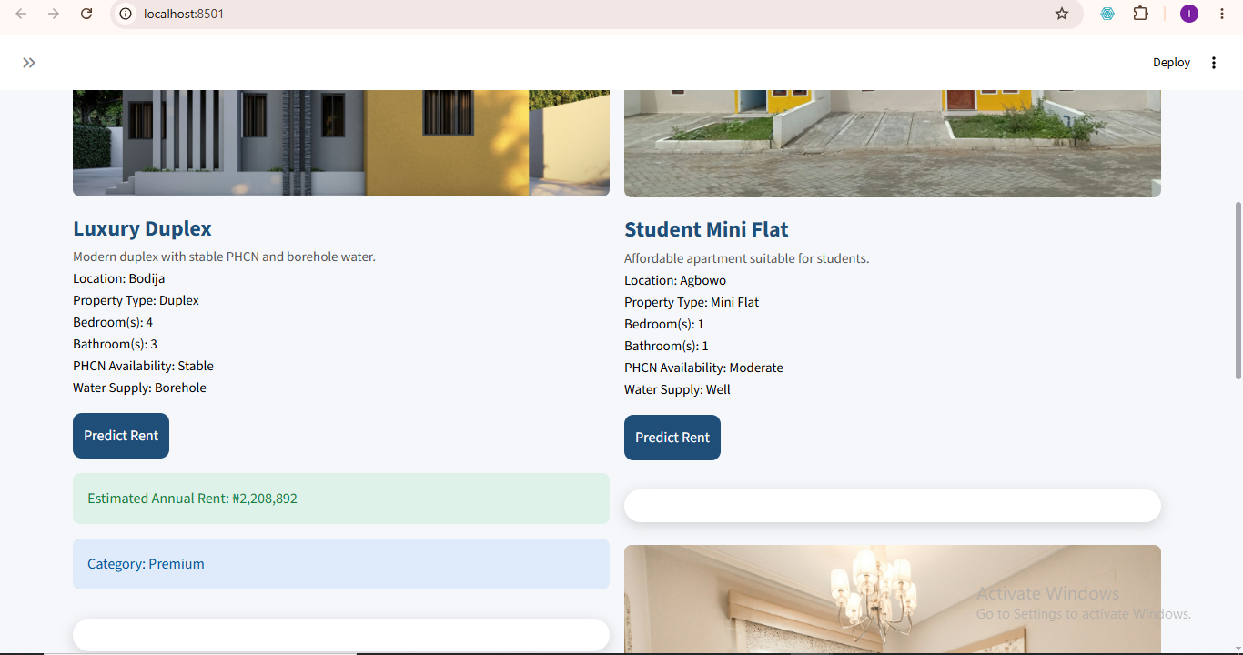
Figure 4.11 Property Gallery Interface

House Comparison Interface
This house comparison interface allow users to compare two different houses, then click on the compare button after selecting the two houses to be compare and evaluate rent values. The comparison interface assists users in cost evaluation, property selection and housing decisions. This feature is a major section which users will like to use since it will help them in decision making as shown below in Figure 4.12.
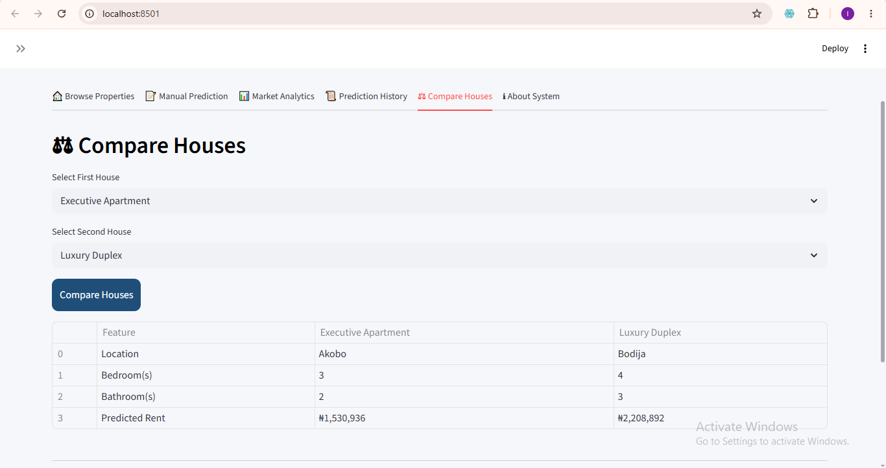
Figure 4.12 House Comparison interface

Prediction History Interface
Prediction history stores previously generated outputs of the prediction done in the anywhere in the interface meaning all the pages which are the browse house property where you can predict by predicting the houses seeing the picture and details, also the manual prediction interface where you can enter the details of your choice and predict as many time as possible, the house comparison interface is also not left out. This module enables users to revisit earlier predictions done. Stored information includes House details, prediction values, and time records as shown in Figure 4.13 below.
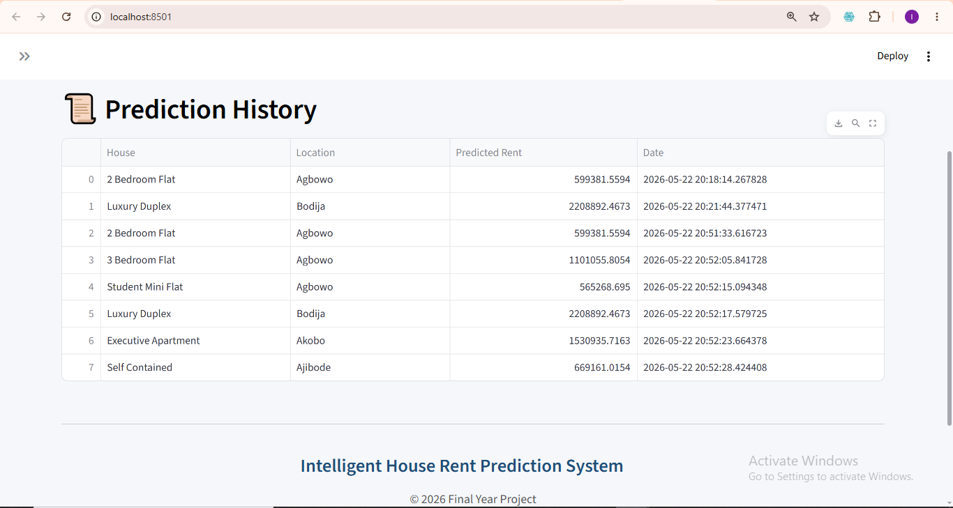
Figure 4.13 Prediction History Interface

4.2.4.8 Market Analytics Interface
The analytics module provides visualization of housing information. Displays information like average rent values, housing distribution and statistical summaries. This module improves market understanding. This same module displays the accuracy of the model which is 95% which is been displayed by R² and the Root Mean Square Error (RMSE) alongside with the Mean Average Error(MAE) as shown in Figure 4.14 below.
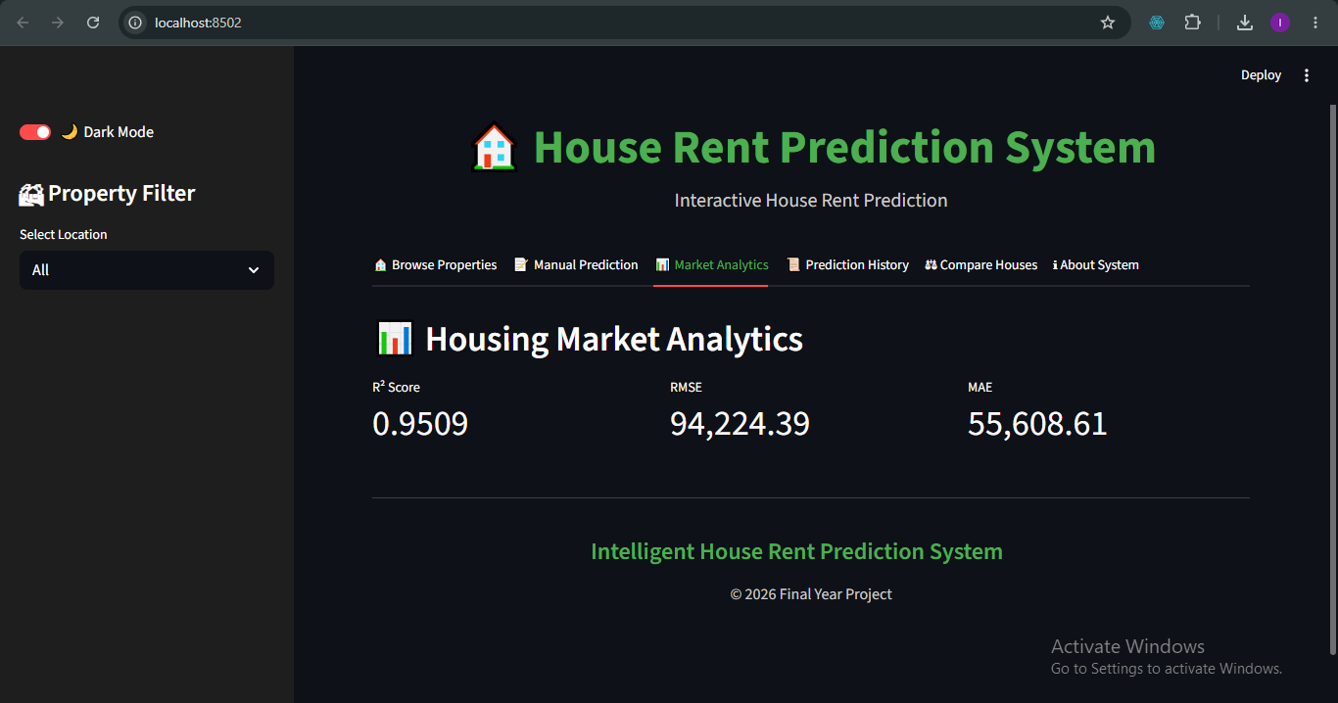
Figure 4.14 Market Analytics Interface

4.2.4.9 Dark Mode Interface
The dark mode interface allows users especially those who do not like the white mode to switch, mostly developers also like to use the dark mode. The dark mode applies to all tabs in the interface. The toggle do this is in the sidebar, once it is clicked on the dark mode is activated and the whole background changes to dark mode. This can be viewed in Figure 4.15 below.
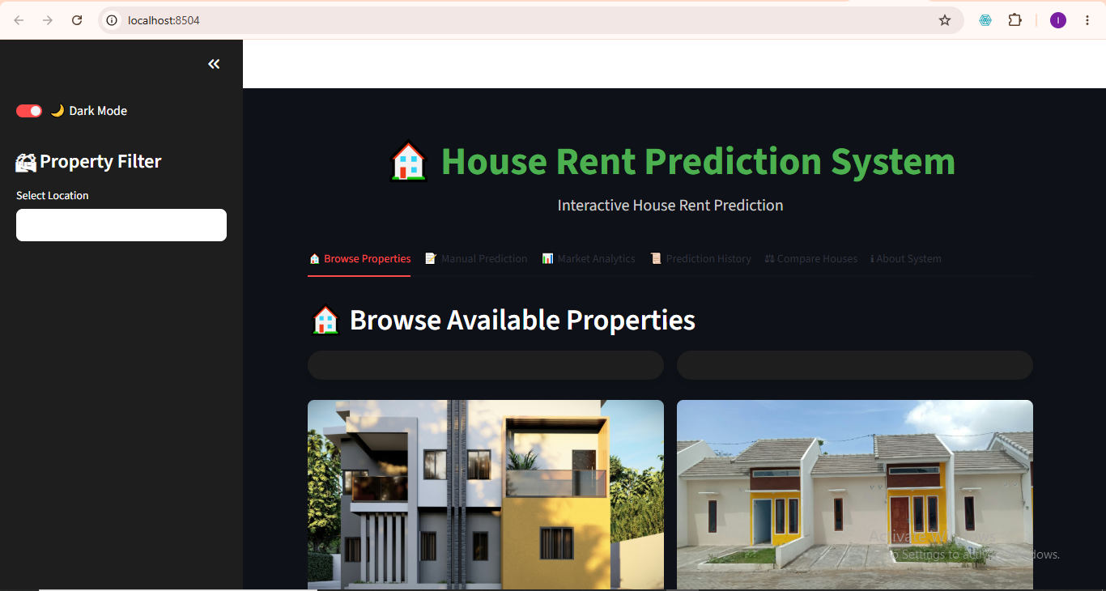
Figure 4.15 Dark Mode Interface

4.2.4.9 About System Interface
The About System Interface as displayed in Figure 4.16 talks about the system tells us about the system which is a machine learning-based model application developed for predicting house rent prices using Linear Regression. And features include Property Gallery, Manual Prediction, Housing Analytics, Prediction History, House Comparison, and Dark Mode Toggle. Also technologies used are Python, Streamlit, Pandas, Scikit-learn

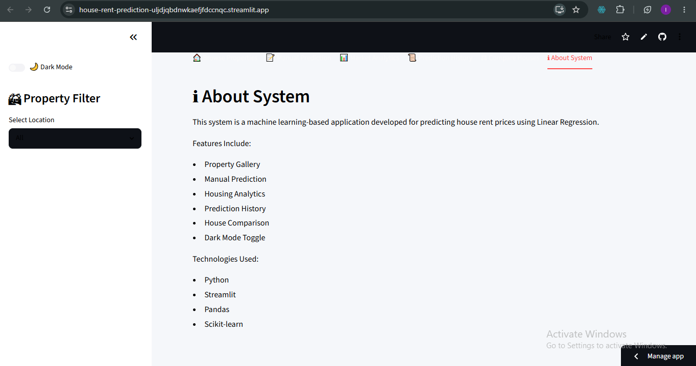
Figure 4.16 About System

5.1 Summary
The increasing inconsistency in house rent pricing, especially within developing urban environments, has created challenges for house seekers, landlords, and real estate practitioners. Traditional methods of rent determination rely heavily on house agents, manual valuation, and subjective judgment, which often result in inaccurate and inconsistent pricing.
To address these challenges, this study developed a machine learning-based House Rent Prediction System using Linear Regression.
The study began with data acquisition from two major sources:
- Housing information collected from house agents.
- Secondary housing datasets obtained from news and social media.
The collected datasets were combined and prepared for model development through preprocessing operations such as removal of duplicate records, handling missing values, data transformation, One-Hot Encoding of categorical variables and Feature scaling using StandardScaler
The developed model utilized housing variables including location, property Type, bedroom(s), bathroom(s), House Size, Lot Size, Furnishing Status, Water Supply, PHCN Availability and Year Built. The Linear Regression algorithm was selected because it is suitable for predicting continuous numerical values such as house rent.
The developed system was deployed using Streamlit and implemented with several modules including manual prediction module, Property browsing module, House image display section, Property carousel display, Prediction history module, House comparison module, Market analytics section and Dark mode customization. Model evaluation was carried out using Mean Absolute Error (MAE), Mean Squared Error (MSE), Root Mean Squared Error (RMSE) and Coefficient of Determination (R²). Additionally, K-Fold Cross Validation was incorporated to improve model reliability and minimize overfitting. Testing results showed that the developed application successfully generated house rent predictions and supported interactive housing exploration.

5.3 Summary of Findings
The implementation and testing stages produced several important findings.
  - Successful Development of Prediction Model: The Linear Regression model was successfully trained and integrated into the developed application. The model established relationships between housing characteristics and rent values and generated predictions effectively.
  - Effective Data Preprocessing Improved Model Performance: The preprocessing stage significantly improved data quality. Operations such as duplicate removal, feature transformation, encoding and scaling contributed positively to prediction performance.
  - Streamlit Improved System Usability: The deployment of the prediction model through Streamlit improved user interaction. The developed interface enabled users to perform rent prediction without technical knowledge.
  - Housing Visualization Improved User Experience: The inclusion of house images, property descriptions improved visual interaction and system usability.
  - K-Fold Validation Improved Reliability: K-Fold Cross Validation improved prediction consistency and reduced the possibility of model overfitting. The validation process enhanced confidence in the developed model.
  - Market Analytics Improved Decision-Making: The analytics module enabled users to study housing information and observe rent trends. This improved data-driven decision-making.

5.4 Conclusion
This study successfully developed a House Rent Prediction System using Linear Regression for estimating annual house rent values based on housing characteristics. The developed system addressed the limitations of existing rent estimation methods by introducing an intelligent and automated prediction mechanism. The system utilized housing information such as Location, Property Type, Bedroom(s), Bathroom(s), House Size, Lot Size, Furnishing Status, Water Supply, PHCN Availability, Year Built to estimate rent values. The developed application combined machine learning prediction with an interactive Streamlit interface provides users with a practical platform for housing exploration and rent estimation. The implementation also incorporated additional functionalities including property visualization, house comparison, prediction history tracking, market analytics, and dark mode customization.

5.6 Recommendations
Although the developed system achieved its objectives, several improvements may be considered in future studies.
  - Adoption of Advanced Machine Learning Algorithms
Future work may compare Linear Regression with algorithms such as Random Forest, XGBoost, Gradient Boosting, and Artificial Neural Networks to improve prediction accuracy.
  - Expansion of Dataset Size
Future studies should collect larger housing datasets from multiple cities to improve model generalization.
  - Integration of Real-Time Property Platforms
The system may be connected to online housing platforms to support automatic updates.
  - Geographic Information System (GIS) Integration
Future implementations may include map-based property visualization.
  - Inclusion of Additional Housing Variables.
Future studies may include variables such as Security level, Road accessibility, Parking availability, Distance to commercial centers, Environmental quality to improve model performance.
REFERENCES
Olatunji, A. I. (2020 ). Characterising real estate value as co-determinant of housing choice optimality in Nigeria. Journal of African Real Estate Research, 5(2), 106–132. https://doi.org/10.15641/jarer.v5i2.861.
Solovev, K., & Pröllochs, N. (2021). Integrating floor plans into hedonic models for rent price appraisal. arXiv. https://arxiv.org/abs/2102.08162.
Wu B, Wang L, Lv SX et al. (2021). Effective crude oil price forecasting using new text-based and big-data-driven model. Measurement, 168: 108468.[DOI].
Zong, H., & Song, J. (2023). Research on the prediction model of house rent based on machine learning. . Proceedings of the International Conference on Big Data Blockchain and Economy Management., https://doi.org/10.4108/eai.19-5-2023.2334250.

Trinkaus, O., & Kauermann, G. (2023). Can machine learning algorithms deliver superior models for rental guides? . AStA Wirtschafts- und Sozialstatistisches Archiv, 17, 305–330.
Cao, S., Liao, W., & Huang, J. (2024). Research on renting price prediction based on machine learning. . Proceedings of the 5th Management Science Informatization and Economic Innovation Development Conference., https://doi.org/10.4108/eai.8-12-2023.2344718.
Chen, W., Farag, S., Butt, U., & Al-Khateeb, H. . (2024). Leveraging machine learning for sophisticated rental value predictions: A case study from Munich, Germany. Applied Sciences, 14(20), 9528. https://doi.org/10.3390/app14209528.
Hu, G., & Tang, Y. (2023). GERPM: A geographically weighted stacking ensemble learning-based urban residential rents prediction model. Mathematics, 11(14), 3160. https://doi.org/10.3390/math11143160.
Oluyele, S., Akingbade, J., Akinode, V., & Idoghor, R. (2024). Prediction of urban house rental prices in Lagos, Nigeria: A machine learning approach. ABUAD Journal of Engineering Research and Development, 7(2), 216–228.
Ming Y, Zhang J, Qi J et al. (2020). Prediction and Analysis of Chengdu Housing Rent Based on XGBoost Algorithm. Proceedings of the 2020 3rd International Conference on Big Data Technologies, 1-5.[DOI].
Zaki, J., Nayyar, A., Dalal, S., & Ali, Z. H. (2022). House price prediction using hedonic pricing model and machine learning techniques. Concurrency and Computation: Practice and Experience . 34(27).
Pai, P. F., & Wang, W. C. (2020). Using machine learning models and actual transaction data for predicting real estate prices. Applied Sciences, 10(17), 5832. https://doi.org/10.3390/app10175832.
Balila, A. E., & Shabri, A. B. (2024). (n.d.). Comparative analysis of machine learning algorithms for predicting Dubai property prices. Frontiers in Applied Mathematics and Statistics,, 10, 1–15. https://doi.org/10.3389/fams.2024.1327376.
Sharma, H., Harsora, H., & Ogunleye, B. (2024). An optimal house price prediction algorithm: XGBoost. . Analytics, 3(1), 30–45. https://doi.org/10.3390/analytics3010003.

Geerts, M., vanden Broucke, S., & De Weerdt, J. (2023). A Survey of Methods and Input Data Types for House Price Prediction. ISPRS International Journal of GeoInformation, 12(5), NA. https://link-gale.
Yagmur, A., Kayakus, M., & Terzioglu, M. (2022). House price prediction modeling using machine learning techniques: A comparative study. . Aestimum, 81, 39–56. https://doi.org/10.36253/aestim-13153.
Li, D. K., Mei, C. L., & Wang, N. (2020). Tests for spatial dependence and heterogeneity in spatial autoregressive varying coefficient models with application to housing price analysis. Regional Science and Urban Economics, 83, 103470. https://doi.org/10.
Tomal, M. (2020). Housing rent and its determinants in Cracow, Poland. . Geographia Polonica, 93(3), 317–333. https://doi.org/10.7163/GPol.0173.
Pai, P. F., & Wang, W. C. (2020). Using machine learning models and actual transaction data for predicting real estate prices. Applied Sciences, 10(17), 5832. https://doi.org/10.3390/app10175832.
Zulkifley, N. H., Rahman, S. A., Ubaidullah, N. H., & Ibrahim, I. (2020). House price prediction using a machine learning model: A survey of literature. . International Journal of Modern Education and Computer Science,, 12(6), 34–43. https://doi.org/10.5815/.

