HTML Form (Index.html)

This file creates a simple login form.

<form action="login.php" method="POST">
<label for="username">Username:</label>
<input type="text" id="username" name="username" required>

<label for="password">Password:</label>
<input type="password" id="password" name="password" required>

<button type="submit">Login</button>
</form>

<form>: Collects the username and password.

method="POST": Sends data securely.

required: Ensures fields aren’t empty.

action="login.php": Sends the form data to the server-side PHP script for processing.

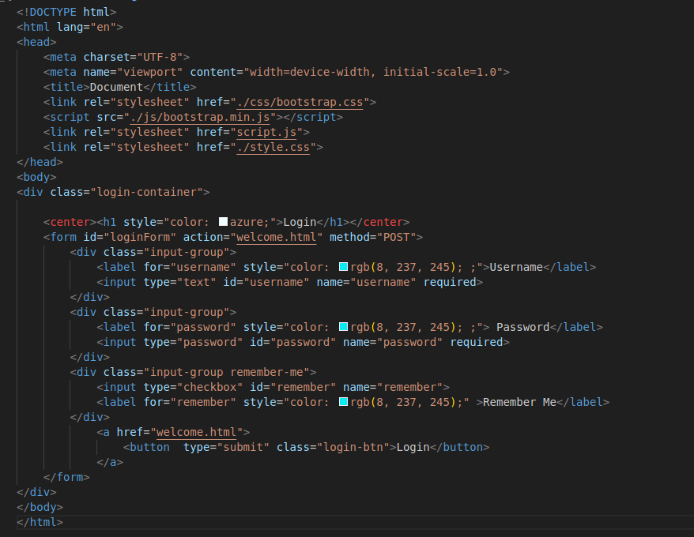

Database Connection (db_connect.php)

This file connects to the MySQL database.

<?php
$servername = "localhost";
$username = "root";
$password = "";
$dbname = "secure_login";

$conn = new mysqli($servername, $username, $password, $dbname);

if ($conn->connect_error) {
die("Connection failed: " . $conn->connect_error);
}
?>

$conn = new mysqli(): Creates a connection to MySQL.

Error handling: If the connection fails, it stops with an error message.

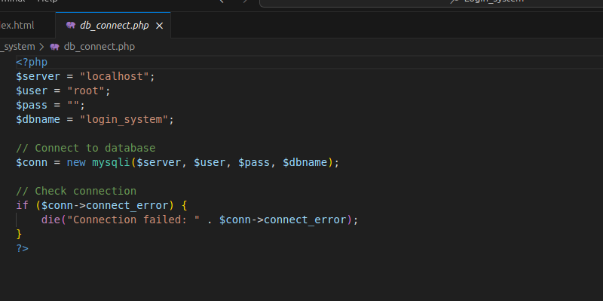

Login Logic (login.php)

Handles form submissions, authenticates users, and starts a session.

<?php
session_start();
include 'db_connect.php';

if ($_SERVER['REQUEST_METHOD'] === 'POST') {
$username = $_POST['username'];
$password = $_POST['password'];

session_start(): Starts a session to track logged-in users.

include 'db_connect.php': Imports the database connection file.

$_SERVER['REQUEST_METHOD']: Ensures the form was submitted with POST.

---

SQL Query & SQL Injection Prevention

$stmt = $conn->prepare("SELECT id, password FROM users WHERE username = ?");
$stmt->bind_param("s", $username);
$stmt->execute();
$result = $stmt->get_result();

Prepared statement ($stmt): Protects against SQL injection.

bind_param(): Safely binds user input to the query.

$stmt->execute(): Runs the query securely.

$stmt->get_result(): Gets the result of the query.

Password Verification

if ($stmt->num_rows > 0) {
$stmt -> bind_result($hashed_password);
$stmt -> fetch();

if (password_verify($password, $hashed_password)) {
$_SESSION['username'] = $username'];
setcookie(“users”, $username, time() +3600, “/”. “”,true);
header(“Location: dashboard.php”);
exit();

} else {
echo "Invalid Password.";
}
} else {
echo "User not found!";
}

$stmt -> close();
$conn-> close();

$stmt->num_rows > 0 : Checks if a user was found.

password_verify(): Compares the entered password with the hashed password from the database.

Session variables ($_SESSION): Store user data after successful login.

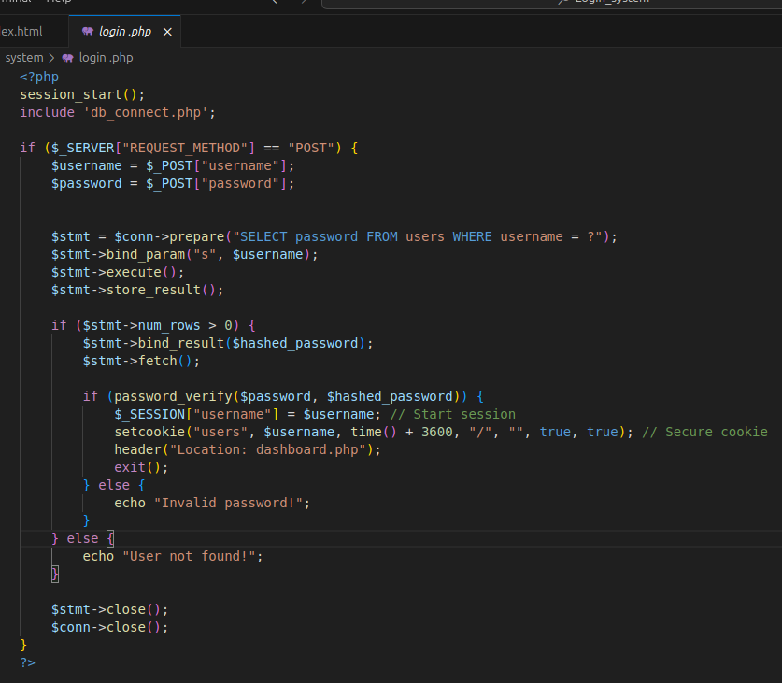

SQL Injection Prevention Feature

Without prepared statements, attackers could inject malicious SQL.
Example of a vulnerable query:

$query = "SELECT * FROM users WHERE username = '$username' AND password = '$password'";

If someone enters this as a username:

' OR '1'='1

It would turn into:

SELECT * FROM users WHERE username = '' OR '1'='1' AND password = ''

Result: They’d log in without valid credentials!
Solution: Use prepared statements as shown above.

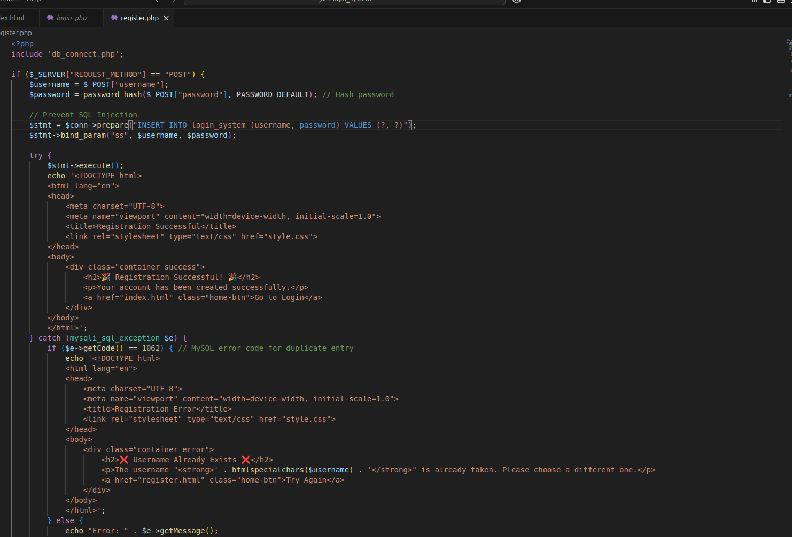

-

Final System Flow

- User submits the form → (Username & password sent to login.php)
- PHP handles the request → (Connects to the database)
- SQL query with prepared statements → (Fetches user data)
- Password verification → (Compares entered password with hashed version)
  - If password matches → Proceed to session management
  - If password does not match → Show login error
- Session management → (Creates session & sets secure cookies)
- Login success or failure
  - If success → Redirect to dashboard
  - If failure → Show error message

