MERIDIAN TECHNOLOGIES
Investor Day — March 11, 2026 | Positioning Memo | Confidential

Meridian is the agentic work platform enterprises trust — and we are declaring that identity today.

EXECUTIVE SUMMARY
Meridian Technologies enters Investor Day as a financially sound, cash-rich company — $463M in liquidity, no debt, 17% FCF margins — at a genuine strategic inflection point. Project management as a software category is commoditizing. AI agents are becoming the primary interface through which knowledge work gets done. Every major competitor has picked a side. Today, Meridian picks its side: we are declaring ourselves the agentic work platform for regulated enterprises — combining the Helio agent framework with the governance infrastructure (FedRAMP, HIPAA, role-based agent permissions, audit trails, model-neutral architecture) that AI-native upstarts cannot replicate and that our four major competitors have not yet built for regulated industries. This is not a pivot; it is an acceleration of the direction the company has been moving since the Helio acquisition in November 2025. The declaration changes our pricing model, our hiring mix, and our M&A pipeline — and it gives investors, employees, and customers a single sentence they can hold us to for the next three years.
THE POSITION WHAT WE ARE DECLARING

"Meridian is the agentic work platform regulated enterprises trust — projects are how we started; governed agents are how work gets done in the next decade."

WHY THE STRATEGIC LOGIC IN THREE POINTS
1. The moat only matters here. Enterprise customers are urgently asking for agent governance — auditability, role-based agent permissions, model selection, data residency. 18 of 22 enterprise advisory board sessions raised this unprompted. No major competitor has built it for regulated industries. If we declare Option A (PM with AI features), this governance infrastructure is table stakes — not a differentiator. Option B is the only path where the moat is worth what we paid to build it.
2. The competitive landscape has sorted. Asana and Monday have moved to bundled agentic pricing, competing on breadth at no incremental cost. Smartsheet is governance-forward but explicitly anti-agentic — a slow-growth, acquisition-rumored peer. Atlassian is the only credible agentic competitor in the premium tier, but they are developer/IT-shaped and thin in regulated industries. The white space — premium agentic platform for regulated enterprise — has one occupant today. That occupant should be Meridian.
3. We have the assets and the window. $506M in liquidity. The Helio agent framework, ahead of schedule. 44% Copilot attach rate on Q4 enterprise renewals. FedRAMP Moderate, HIPAA certified. Every quarter we delay this declaration, Atlassian deepens its enterprise install base and the model labs build more native governance. The window is 18–24 months. We are declaring now.
COMPETITIVE LANDSCAPE WHERE EACH COMPETITOR SITS
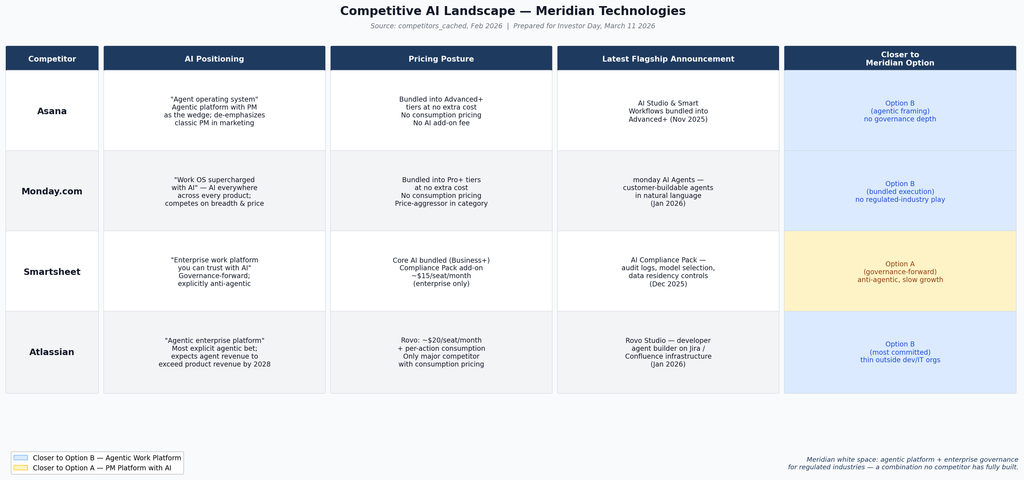
Figure 1. AI competitive landscape across positioning, pricing, flagship announcement, and Meridian option alignment. Source: competitors_cached, Feb 2026.
POSITIONING MATRIX PM-CENTRIC VS. AGENTIC / BUNDLED VS. PREMIUM
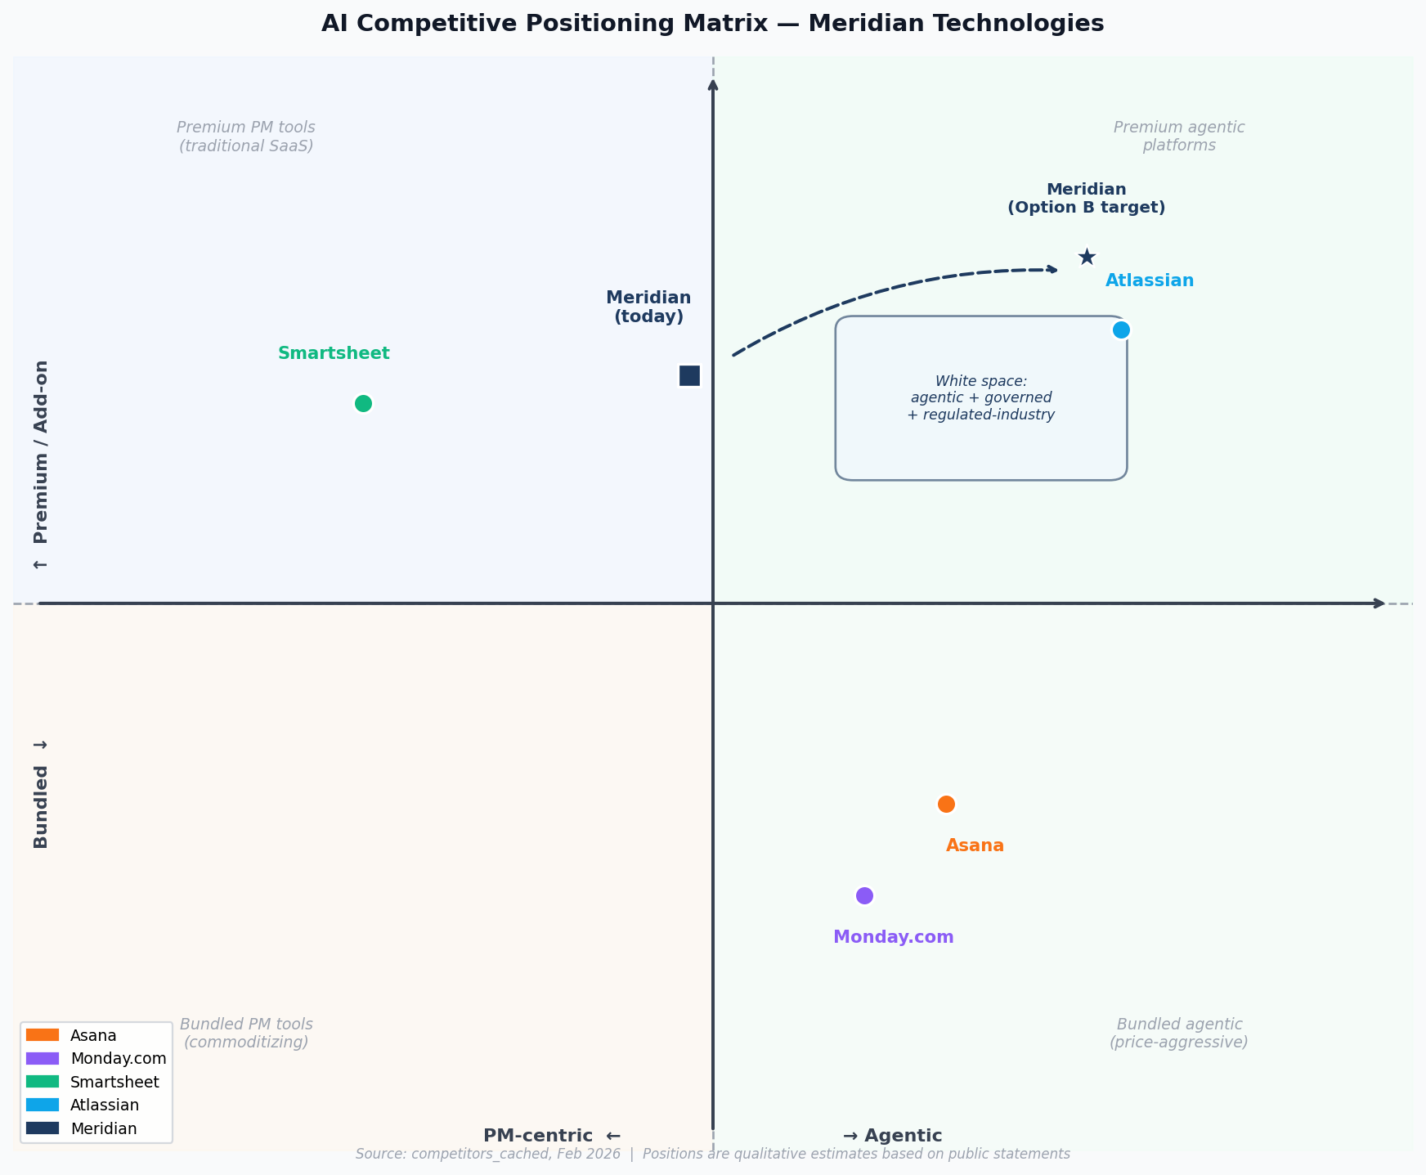
Figure 2. Qualitative positioning of Meridian and four competitors. Dashed arrow shows the Option B strategic move declared at Investor Day. Source: competitors_cached, Feb 2026.
THREE RISKS WHAT WE ARE WATCHING — AND HOW WE ARE MANAGING THEM
Risk 1 — Model labs commoditize governance. Anthropic or OpenAI ships enterprise agent governance good enough for regulated industries by late 2026, collapsing our differentiation. Mitigation: we are building at the workflow and vertical compliance layer — FedRAMP High, GxP, pharma audit — which model labs are unlikely to pursue. We will monitor CISO conversations in our enterprise base for early signal. If we hear it in Q3 or Q4 2026, we have two quarters to adjust.
Risk 2 — Consumption pricing stalls in mid-market. Mid-market customers (47% of ARR, NRR 102%) are already pushing back on $40/seat Copilot. Announcing consumption pricing at Investor Day could accelerate churn before agentic revenue ramps. Mitigation: we will bundle Copilot into mid-market standard tier in Q2 2026 to stop the renewal headwind, and position consumption pricing as enterprise-only in year one. $506M in liquidity absorbs the 12-18 month revenue air gap if ramp is slower than modeled.
Risk 3 — Helio retention cliff in 2026. The Helio team's first major compensation event hits in 2026. If 8-12 of the 28 engineers depart, the agent-builder roadmap is exposed. Mitigation: CPO has identified the 12 highest-risk Helio engineers; the People team is executing targeted retention packages in Q1 2026. We will report Helio headcount on each earnings call through 2027 as a voluntary disclosure.
THREE COMMITMENTS WHAT INVESTORS CAN HOLD US TO

Commitment 1 — Copilot attach rate above 50% on enterprise renewals by Q4 2026. We hit 44% in Q4 2025, our first quarter of GA. 50% by year-end is the proof point that enterprise customers are buying the agentic platform, not just renewing the PM tool. We will report this metric publicly every quarter.
Commitment 2 — Announce consumption pricing model by Q3 2026. The shift from per-seat-only to per-seat-plus-consumption for agent features is the structural pricing move that validates the agentic platform thesis. We commit to announcing the model, the rollout timeline, and initial consumption economics no later than Q3 2026.
Commitment 3 — $25M+ in AI Copilot ARR by year-end 2026. From $3.5M at the end of 2025 to $25M+ by end of 2026 — a 7× increase driven by enterprise attach rate expansion and initial mid-market uptake post-bundling. This is the earliest financial signal that the agentic positioning is translating into revenue, not just narrative.

Catherine Park, President & CEO | Investor Day, March 11 2026 | Confidential — Do Not Distribute

