MERIDIAN TECHNOLOGIES
Board of Directors — Annual Strategic Review | May 2026

Meridian is financially sound and strategically at a crossroads — enterprise is working, the AI window is closing, and this board needs to align on what we are before March 11.

Good morning. My first year as your CEO has given me a clear picture of where this company stands. I want to spend five minutes on three things I need the board to understand, and then I have one ask. Everything else in the materials supports this frame.
ISSUE 1 THE AI WINDOW IS CLOSING — AND OUR BUILD PLAN MAY NOT BE ENOUGH
AI Copilot reached GA in September with 710 paying seats and a 44% enterprise attach rate — ahead of our internal target. That is the good news. The bad news: Asana bundled AI into its standard tier in October, Monday is now larger than us by ARR, Atlassian announced agentic Jira in January, and ClearAI Work just raised at a $1B+ valuation. Every quarter we are not a credible AI platform, competitors are embedding switching costs in our mid-market accounts.
- AI Copilot: 710 paying seats / $3.5M ARR at year-end — less than 1% of total ARR (meridian_kpis_2024.csv)
- 8 of 12 roadmap items slipped or were deferred in 2025; engineering capacity is the binding constraint (meridian_product_roadmap_2025.md)
- Mid-market NRR compressed from 115% → 102% since 2022; Asana pricing pressure now "steady state" (meridian_kpis_2024.csv, Q3 earnings call)
- "Roadmap thrash" cited by 31% of engineering in the employee survey; three AI pivots in 18 months (meridian_employee_survey_2025.md)
ISSUE 2 GROWTH DECELERATION IS STRUCTURAL, NOT CYCLICAL
Full-year growth: 28% (2022) → 19% (2023) → 16% (2024) → 11% (2025) → guided 10–14% (2026). This is not a bad quarter. The chart below shows why: enterprise is the only segment growing strongly. SMB has declined 50% from its peak and is still accelerating downward. Mid-market — 47% of our ARR — grew +15% in 2025 but its NRR is 102% and falling. If mid-market follows SMB, we have a serious problem. If Copilot stabilizes mid-market, we have a path.
- Enterprise ARR: $74M (Q4 2022) → $167M (Q4 2025), +126% over three years; NRR 125%
- SMB ARR: $105M (Q4 2022) → $52M (Q4 2025), -50%; gross logo churn 22% annually
- Sales efficiency (magic number): 1.20 (Q1 2024) → 0.92 (Q4 2025) (meridian_kpis_2024.csv)
- 2026 guidance midpoint implies ~12% growth; Street consensus was 15% (Q4 2025 earnings call)
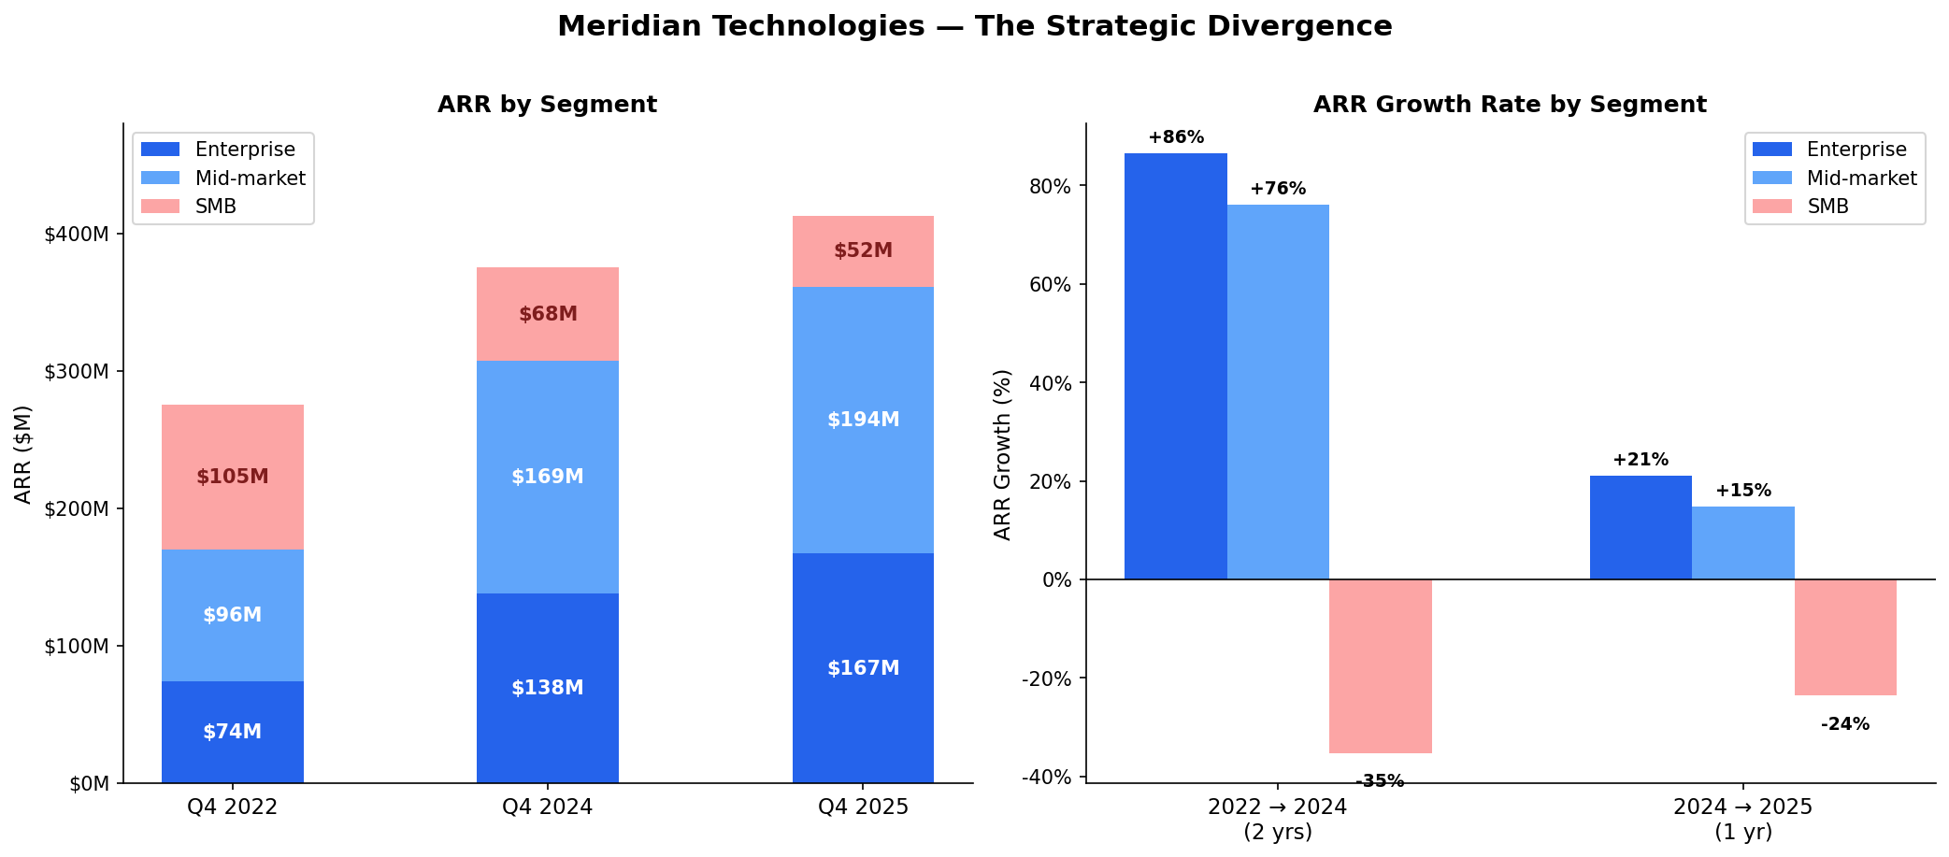
Figure 1. ARR by segment (Q4 2022–2025) and segment growth rates. Source: meridian_financials_2022_2025.csv, meridian_segments_overview.md.
ISSUE 3 TALENT FRAGILITY AT THE WORST POSSIBLE MOMENT
We are attempting our most complex transformation ever — segment reorg, Helio integration, AI roadmap pivot, and a pricing model change — simultaneously. The engineering team executing this is underpaid relative to AI-native startups and showing early attrition signals. If we lose 15–25 senior engineers in H1 2026, the roadmap slips further. If the Helio team unwinds at their 2026 compensation cliff, our agent-builder roadmap is exposed.
- 27% of senior engineers cited pay falling behind AI-native benchmarks (meridian_employee_survey_2025.md)
- People team recommends emergency comp refresh in Q1 2026 or risk losing 15–25 key engineers
- Helio retention agreements vest through 2028 — 2026 cash cliff is the first test (meridian_product_roadmap_2025.md)
- "We don't know what we are anymore" — 19% of all employees, 28% of sales (meridian_employee_survey_2025.md)

MY ONE ASK OF THIS BOARD
Before we leave today, I need the board aligned on one question: Is Meridian an enterprise project management platform with AI features, or an agentic work platform with project management as one surface?
These are not the same company. They have different R&D priorities, different sales motions, different pricing models, and different addressable markets. I have a strong view — I will share it at Investor Day on March 11. But I need the board's alignment before I make that declaration publicly. That conversation is the purpose of today's meeting.

Catherine Park, President & CEO | May 2026 | Confidential

