
University of Frontier Technology
Department of Educational Technology and Engineering(EdTE)
Faculty of Digital Transformation and Engineering
Session: 2022-2023

Lab Report NO 1
Course Title: Digital Content Design and Development Sessional
Course Code: ET 306 Section: G2

Lab Experiment Name: Design, Development, and Deployment of a Personal Portfolio Website

Student Details

Name |  | ID
1. | Omor Faruk | 2202026

Lab Date : 30th OCTOBER,2025
Submission Date : 2ND NOVEMVER,2025
Course Teacher’s Name : Md. Naimul Pathan

Lab Report Status
Marks: ………………………………… Signature:.....................
Comments:.............................................. Date:..............................

1.Summary:
This experiment involves designing, developing, and deploying a responsive personal portfolio website for Omor Faruk — a Competitive Programmer and Educational Technology student. The portfolio highlights academic background, technical expertise, and projects using modern web technologies. The completed website was hosted using GitHub Pages for public access and version control.

2. OBJECTIVES / AIM
- To design a responsive, visually appealing portfolio website using HTML, CSS, and JavaScript.
- To present academic information, skills, achievements, and projects in a professional layout.
- To implement interactive features and animations for an enhanced user experience.
- To deploy the completed website using GitHub Pages for online accessibility.
- To understand the process of using Git and GitHub for version control and web hosting.

3. PROCEDURE / ANALYSIS / DESIGN

Method:
- Requirement Analysis:
  - Determined key sections: Header, About, Skills, Experience, Achievements, Projects, and Contact.
- Design Stage:
  - Created layout wireframe and color theme
  - Selected Montserrat for headings and Roboto for body text.
  - Planned animations (fade-ins, hover effects, and smooth scrolling).

- Development Process (Flowchart):
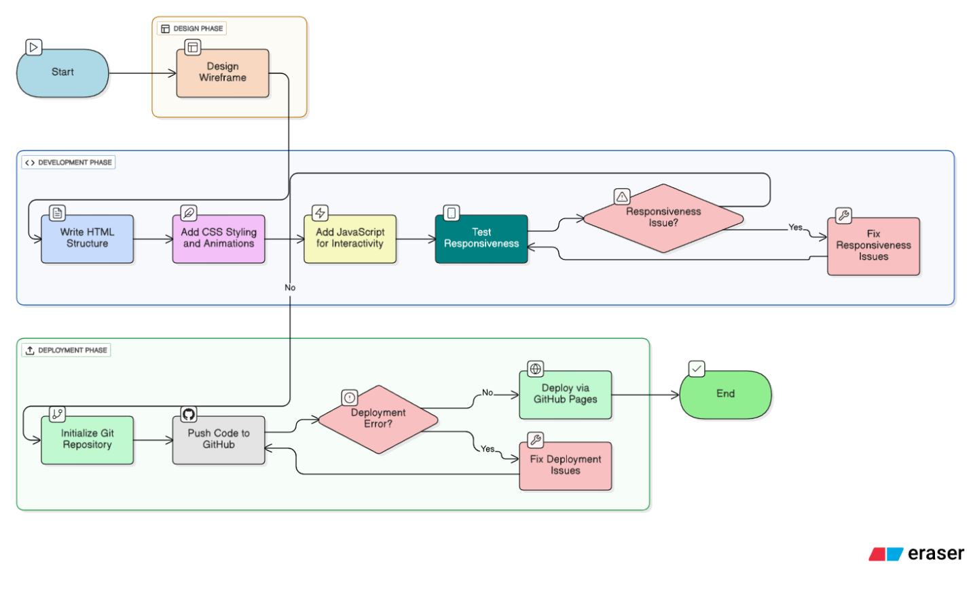

- Tools & Technologies Used:
  - HTML5, CSS3, JavaScript
  - Git and GitHub (for version control and deployment)
  - Code Editor: VS Code

4. IMPLEMENTATION
Overview:
The website was built as a single-page application with a responsive layout and smooth animations. After local testing, it was deployed to GitHub Pages for public access and continuous version management.
Implementation Details:
- Frontend Development:
  - HTML structure created with semantic tags for accessibility.
  - CSS used for design (glassmorphism, hover transitions, gradient backgrounds).
  - JavaScript enabled smooth scrolling, form validation, and typing animations.
- GitHub Deployment Steps:
    - Initialized a local Git repository.
    - Committed all project files.
    - Pushed to a GitHub repository named portfolio.
    - Enabled GitHub Pages in repository settings to host the website.
    - Final URL: Omor Faruk — Portfolio
- Version Control:
Used Git to manage project versions and updates efficiently.

5. TEST RESULT / OUTPUT
Testing Conducted:
Test Type | Description | Result
Local Browser Test | Verified design, layout, and animation locally | Passed
Responsive Test | Checked on mobile, tablet, and desktop devices | Passed
Form Validation | Tested error messages for empty fields | Passed
Navigation | Verified smooth scroll and section alignment | Passed
GitHub Pages Hosting | Ensured correct online deployment | Passed
Link Verification | Checked all internal/external links | Passed

Website Output Screenshot:
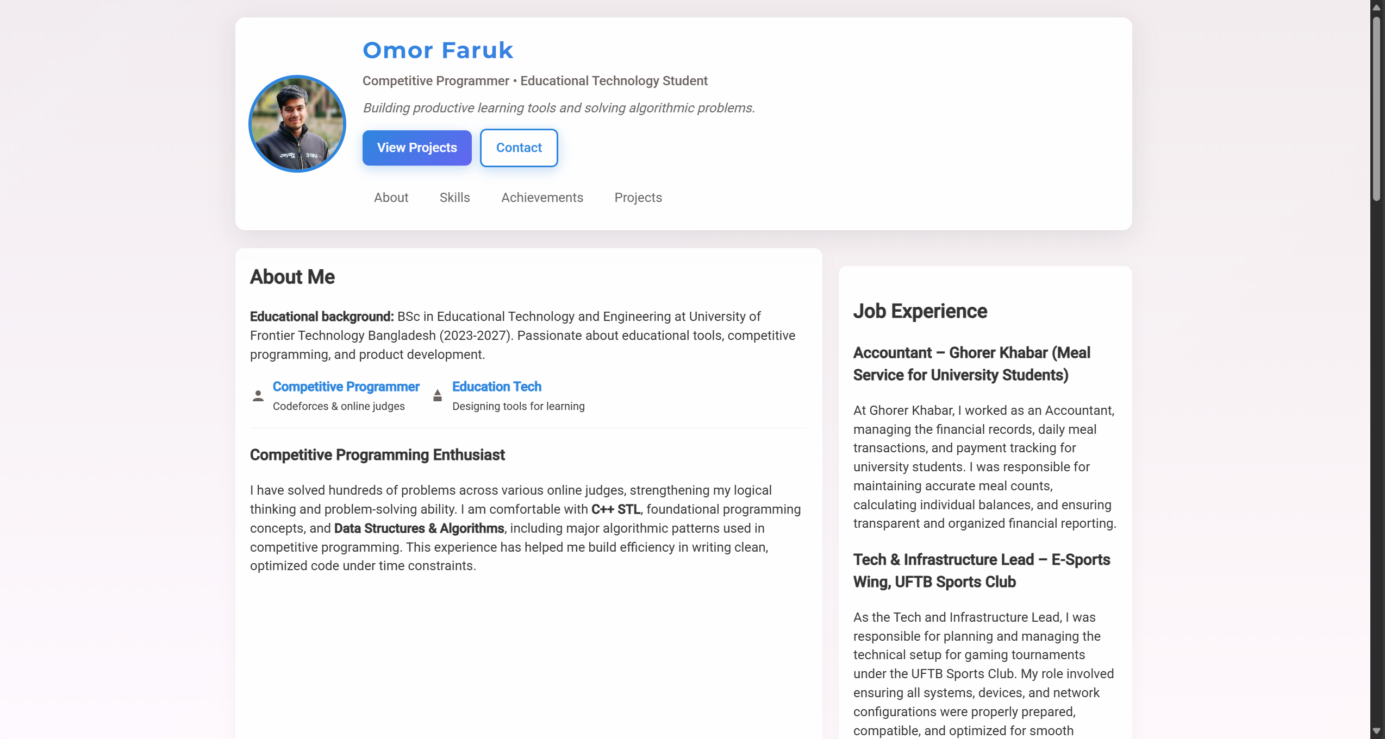
Website successfully loaded via GitHub Pages with all animations and links functional.
- Accessible across browsers (Chrome, Firefox, Edge, mobile Safari).
Program Bugs:
- Minor animation timing delay during first scroll — later optimized with CSS easing.

6. ANALYSIS AND DISCUSSION
- Result Analysis:
The deployed portfolio accurately presents the student’s achievements and skills. Hosting through GitHub Pages ensured easy access and free version-controlled deployment.
- What Went Well:
Smooth integration of animations and successful GitHub deployment.
- Trouble Spots:
Initial alignment issues on mobile view and image scaling during responsive testing.
- Most Difficult Part:
Configuring animations to load efficiently without increasing page load time.
- What I Liked:
Seeing the site live online and accessible through a custom URL.
- What I Learned:
  - How to deploy static websites using GitHub Pages.
  - Basics of Git commands for pushing, committing, and hosting.
  - The importance of responsive design testing.
- Mapping of Objectives:
Objective | Achieved | Description
Create responsive portfolio | ✅ | Works across all screen sizes
Add interactivity & animations | ✅ | Scroll and hover effects implemented
Deploy using GitHub Pages | ✅ | Successfully hosted online
Showcase personal details | ✅ | Projects and achievements clearly displayed

7. SUMMARY
This experiment successfully demonstrated the complete process of creating and deploying a personal portfolio website. It combined front-end web development skills with GitHub-based hosting. The portfolio serves as a professional digital identity and a technical exercise in modern web design, responsiveness, and cloud deployment.

