Tool Design

The GUI of the map editor will be made using Microsoft Blend, and the final user interface will be like bellow:

Menu bar

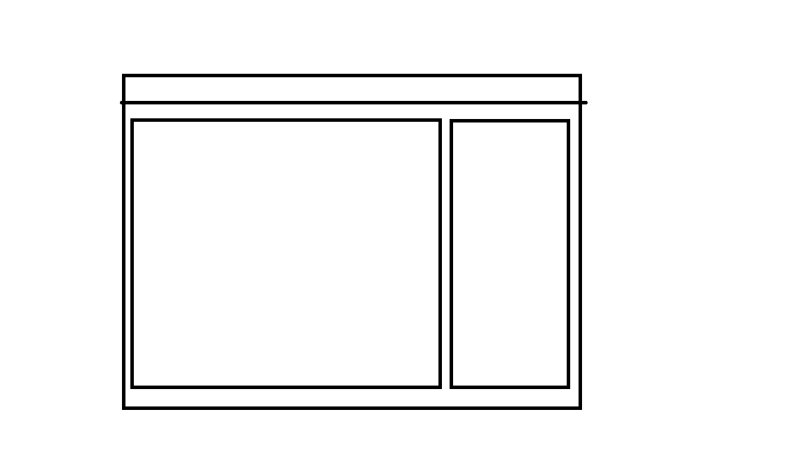

Map Interface

Tools bar

Basically the map editor contains 3 sections distinct: menu bar, tools bar and map interface window.

Menu bar

Open existed map file

Create new map file

Save current map file

Map editor options

Tools bar

Button to load sprites

Button to resize sprite

Button to define a selected sprite’s properties

Button to delete selected sprite

List view of loaded sprites

Button to go back in history manipulation

Button to restore history manipulation

Map Interface

Support zoom of window

Support drag and drop sprites

Support copy and paste of sprite in map

Support navigation in map

Support drawing geometric form