RCS Liferay Twitter Portlet

Installation Guide

Document Revisions
Date | Revision | By
2015/03/16 | 1 | Ron Wesenbeek

Table of Contents
RCS Liferay Twitter Portlet 1
Installation Guide 1
Document Revisions 2
General Description 4
Installation 5
Configuration 6
Configure the RCS Twitter settings 6
Configure the RCS Twitter scheduler 8
Configure the Display Tweets portlet 9

General Description

Twitter is one of the most used applications to share your activities with the rest of the world.
This portlet makes it very easy to put your twitter feeds on a page and style them to your needs.

Installation and configuration is simple and provides powerful features such as storing tweets in your local database and style them just like you are used to in Liferay.

This application consists of three portlets. Two portlets that will be displayed in the Control Panel, for configuration purposes. And another portlet that will display the tweets in any page we want.

Installation
Deploy the RCS Twitter portlet into your portal. There are several ways to accomplish this. Here is one.
- Log in as an admin user and go to Control Panel.
- Click on Apps → App Manager → Install.
- Click on File Upoad, then Browse and search for the RCS twitter war file.

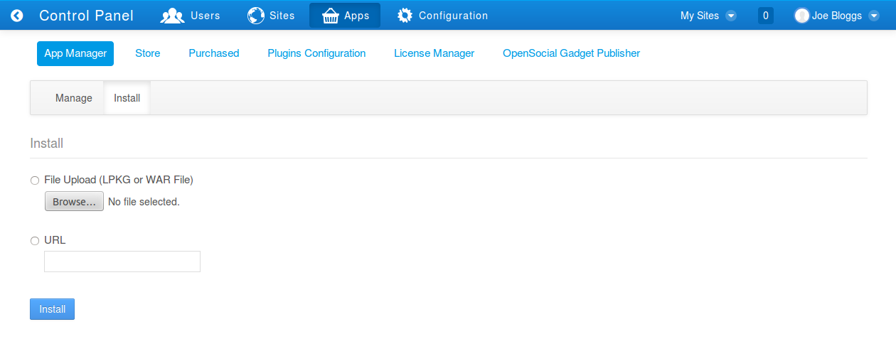Fig 1: App Manager

Once the war is selected, click on the Install button.

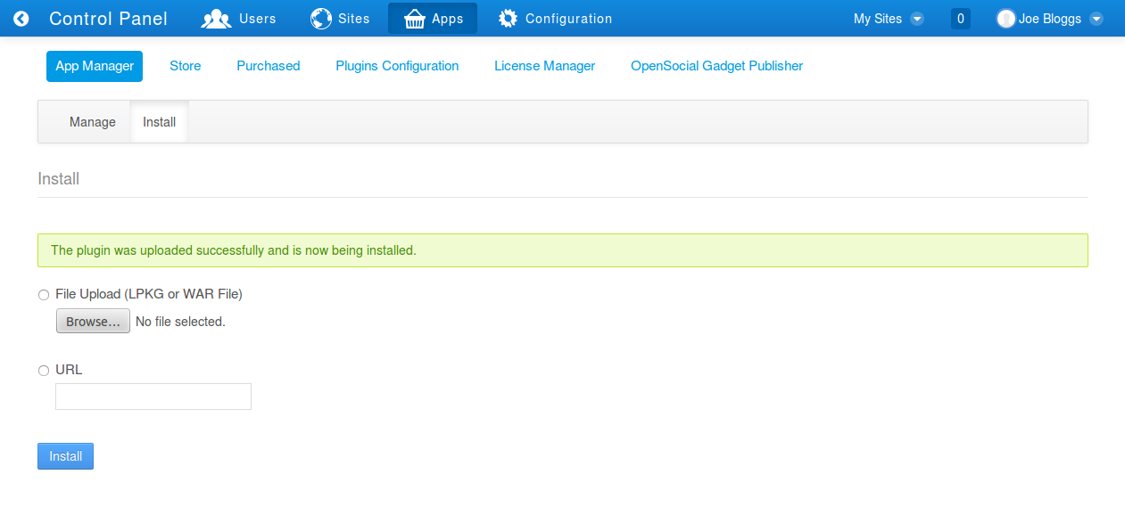Fig 2: Upload a new WAR file.

Once the portlet is installed you can start configuring it.

Configuration

Configure the RCS Twitter settings

In the Control Panel, click on Sites (on the dockbar), and then click on the site name below

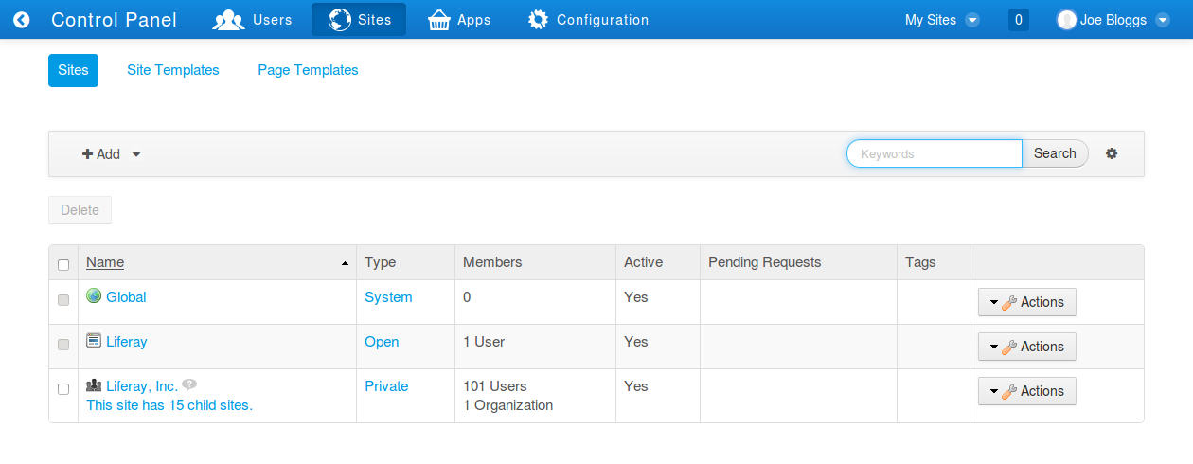
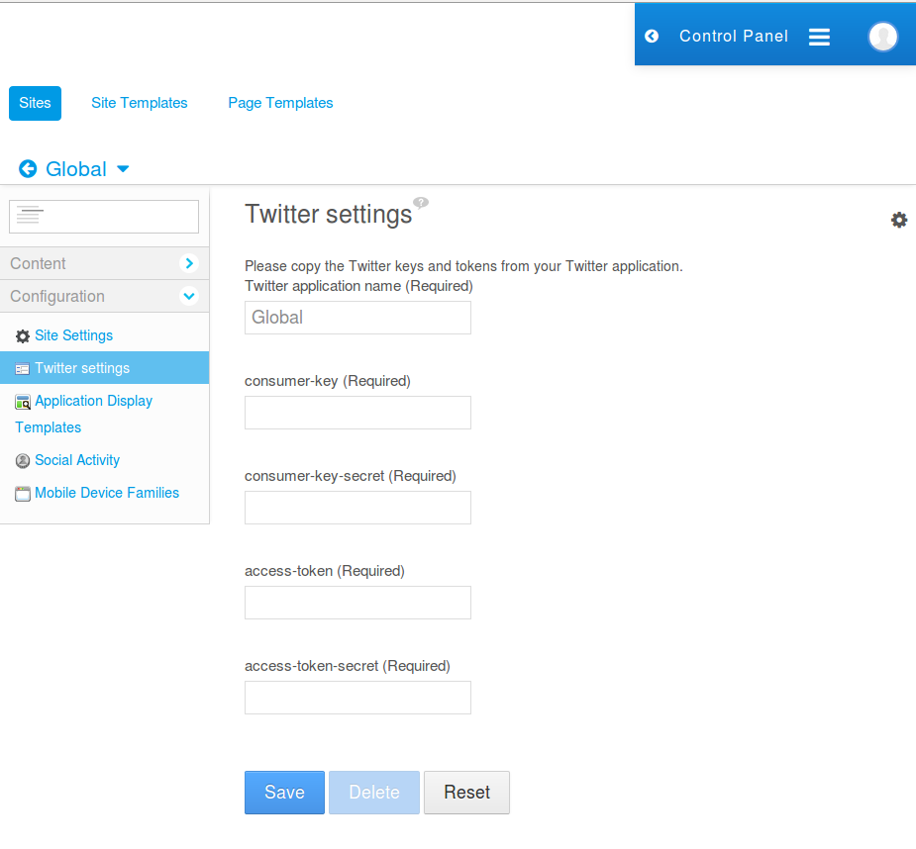

Go to https://apps.twitter.com/ and log in with your twitter account.

Copy and paste the keys and secrets to your portlet settings.
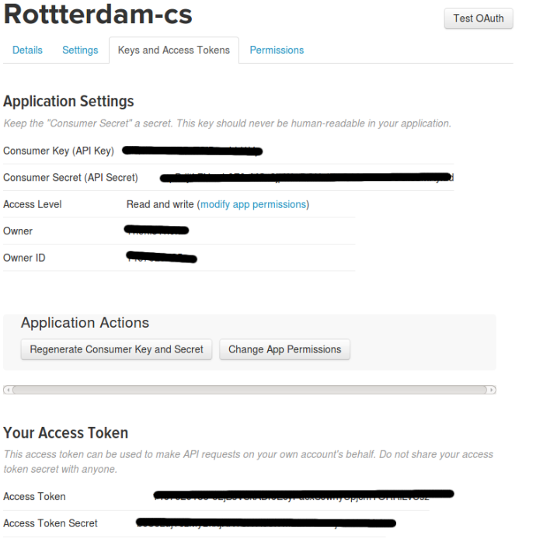

Configure the RCS Twitter scheduler
By default the scheduler is getting tweets every five minutes and stores them in your database.
You can change this with the Scheduler settings portlet: go to Configuration panel – Configuration – Scheduler Settings:

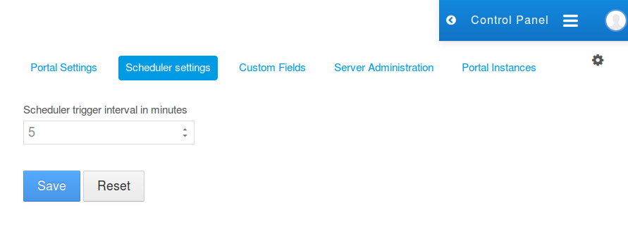

Configure the Display Tweets portlet

Add the Display Tweets portlet to your page to show your Tweets.

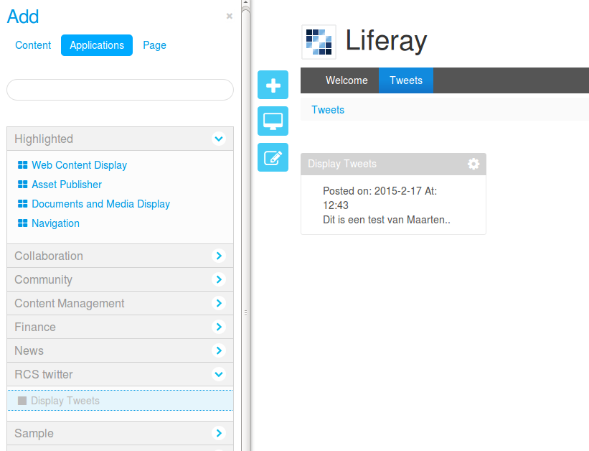

By clicking on Options – Configuration the Configuration window will open.

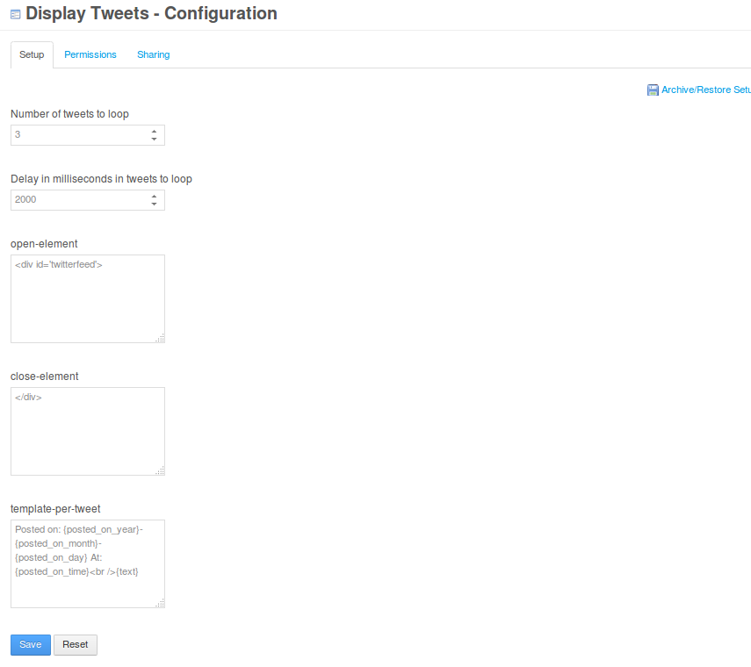
Use the open- and close elements and CSS to style your portlet.

Use the template to manipulate the contents of tweets to show.

