RCS Video Chat Portlet

Installation Guide

Document Revisions
Date | Revision | By
08/01/12 | 1 | Florencia Gadea
17/05/13 | 2 | Marcelo Aberastain

Table of Contents
RCS Video Chat Portlet 1
Document Revisions 2
General Description 4
Installation 4
Configuration 5
Usage 6
Limitations 11
Errors 12
Change Log 12

General Description

The Video Chat portlets make it easy to add group video chat to your Liferay portal. This tool provides two portlets, one to manage chat rooms and the other to video chat.

This portlet uses OpenTok, a flexible cloud-based API for video conferencing.

Installation and configuration are simple.

Installation
Deploy the Video Chat portlet into your portal:
- Download the video chat .war from http://www.rotterdam-cs.com/.
- Log in as an admin user and go to Control Panel.
- In the left panel, under the Server category select Plugins Installation.
- In the right panel, click on Install More Portlets.

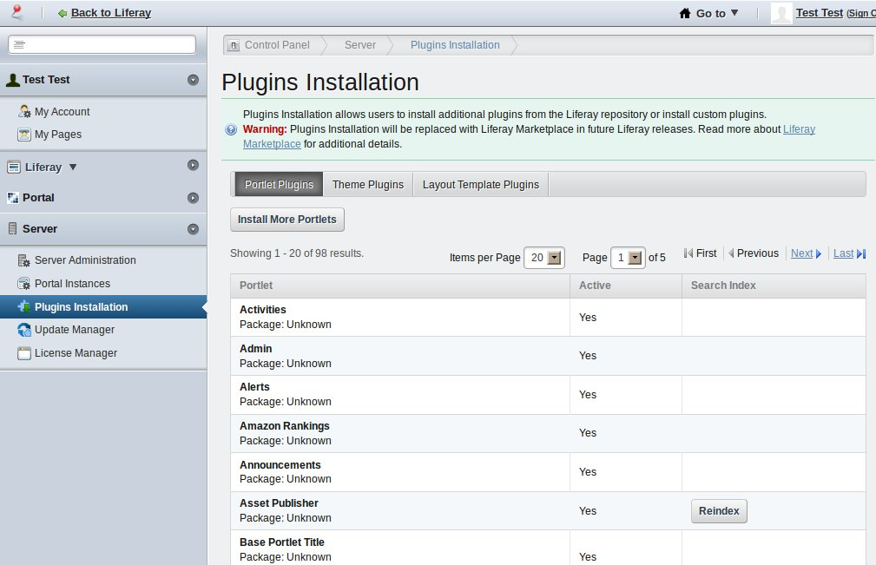

- Then click on Upload File. Select the war file you just downloaded.

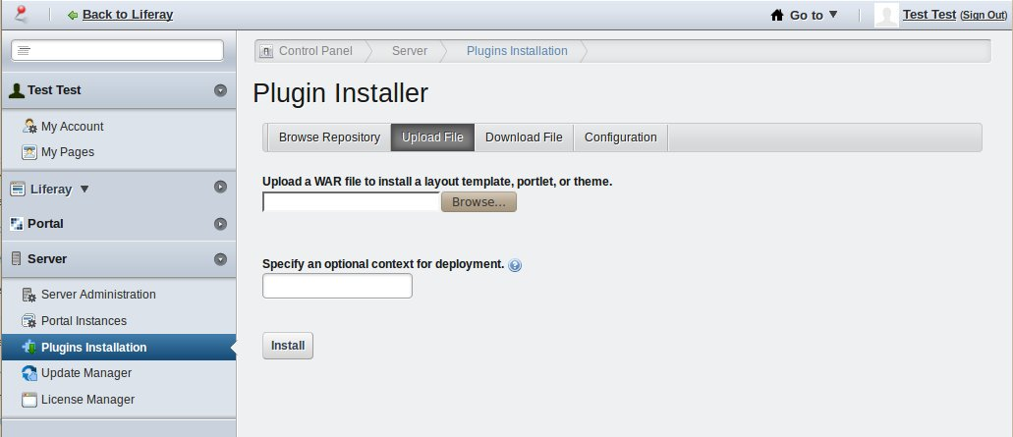

- Once the file is selected, click on the Install button.

Once the portlet is installed you can start configuring it.

Configuration

Configure the Video Chat portlet

Log in as an administrator and go to the Control Panel.

In the left panel, under the portal name, select Chat Rooms.

In the right panel, the Configuration panel will be shown.
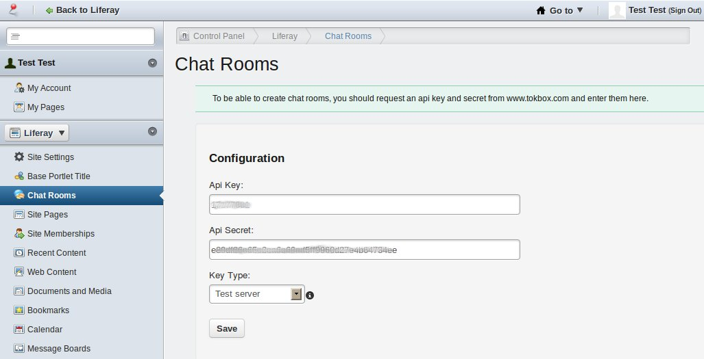

You should get an API Key and Secret from Tokbox in order to be able to use the video chat. Go to: https://dashboard.tokbox.com/users/sign_in and create your account in order to get that information. Now you have the possibility to create and use chat rooms using an OpenTok Production server (so you should select the Production server option from the dropdown). Keep in mind that the chat rooms you create for a production server won't work for the test server and the other way around.

Now you are ready to create and use chat rooms.

Usage

Create chat rooms

Once you provided the API key and secret, you can create chat rooms:

Log in as an administrator and go to the Control Panel.
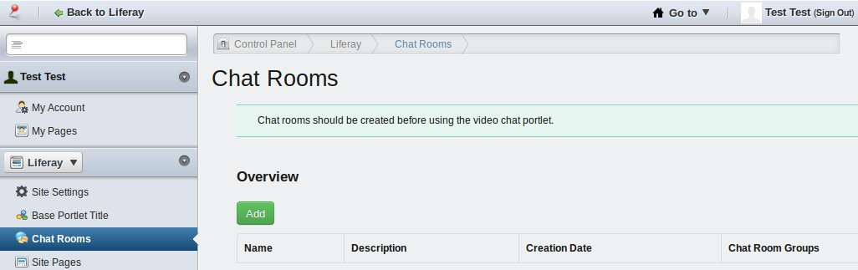

In the left panel, under the portal name, select Chat Rooms.

In the right panel, click on Chat Rooms.

Click on Add.

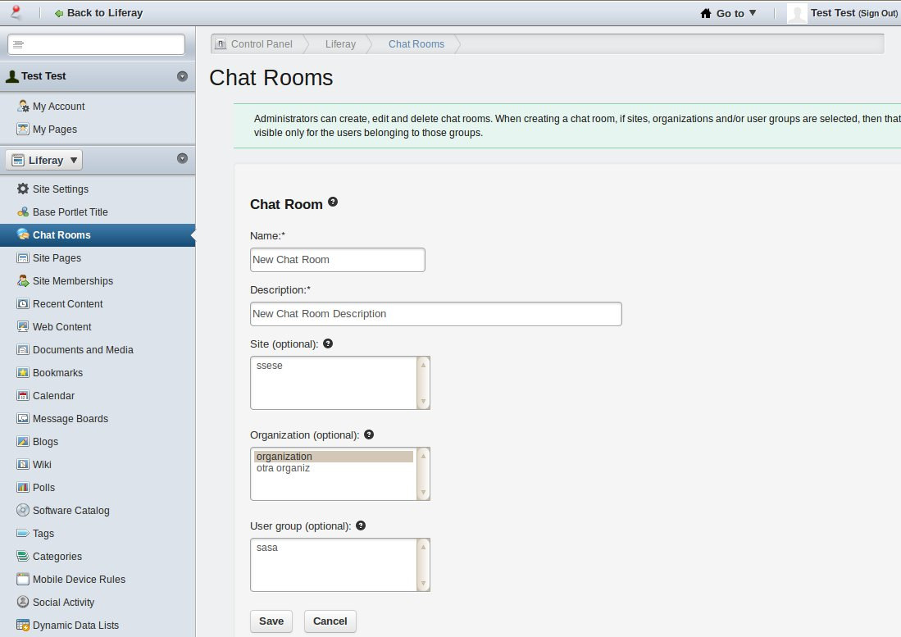

Fill the chat room name, description and, optionally, you can select an organization, site and/or user group, so the users belonging to those groups will be the ones that will be able to enter this chat room.

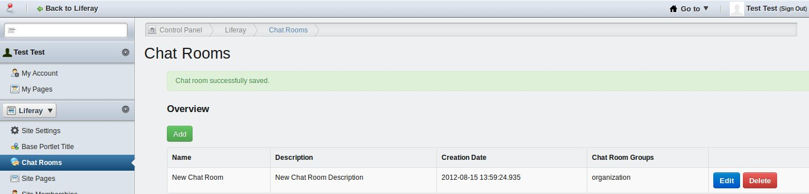

Editing and Deleting chat rooms is self-explanatory.

Install the video chat portlet

You can install this video chat portlet like any other portlet.

Log in as an administrator and go to the page where you want to install this portlet.

On the dockbar, click on Add, then click on More..., select Video -> VideoChat.

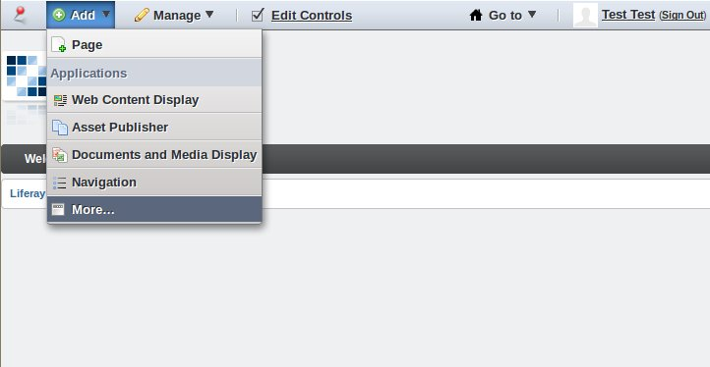

Now you have the video chat portlet in your page!

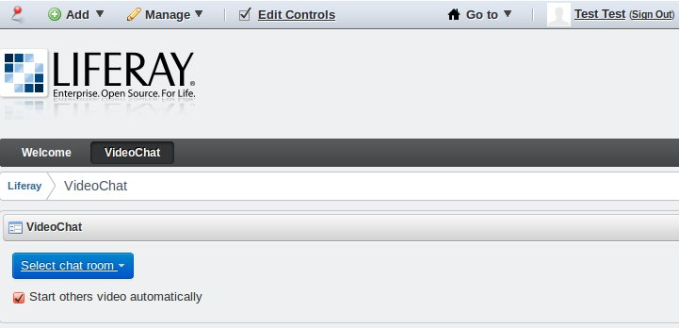

Video chat usage

Log in and go to the page where the portlet is installed.

Select a chat room.

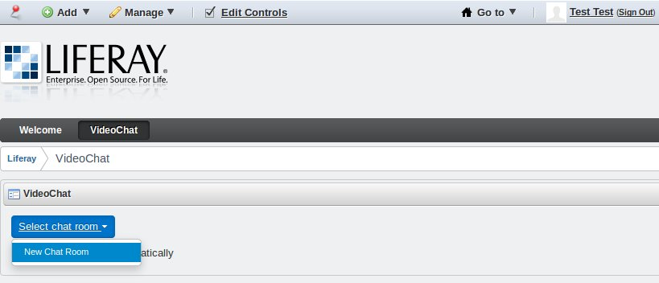

If you leave the “Start others video automatically “ checkbox selected, once you get in a chat room, the others' videos will be shown automatically, as soon as they enter the chat room. If you unselect it, you will see others' videos only if you click on their name.

After you select a chat room, you will see a Loading... message, while OpenTok starts the handshake with their servers.

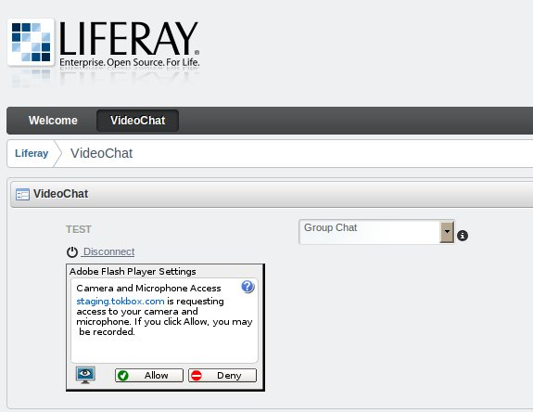

Then, you will be requested by Adobe Flash Player to accept that OpenTok will use your camera and microphone. You can let Tokbox use you camera and microphone without asking for permission every time, if you go to the Flash Player Website Privacy Settings panel (http://www.macromedia.com/support/documentation/en/flashplayer/help/settings_manager06.html), select the url static.opentok.com and then select the option Always allow. If you are using the OpenTok test server, you should do the same with the url staging.tokbox.com.

Once you are logged in, if there are other users connected, you can click on the users' username to show or remove their video streaming.

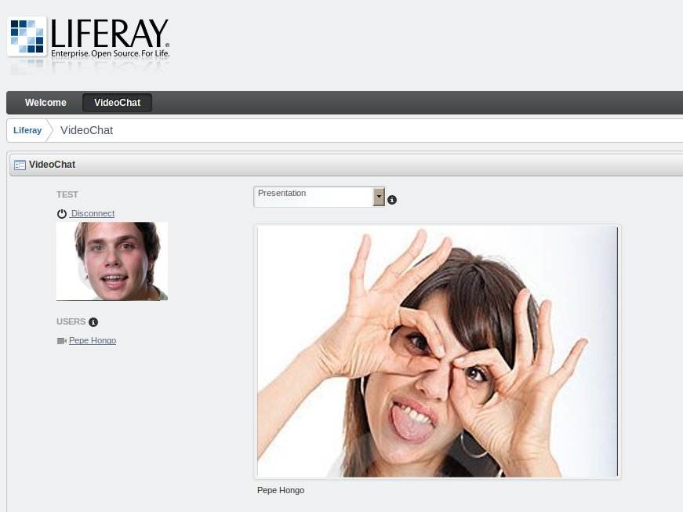

You can also drag and drop all the users video (except for yourself).

You have a dropdown, where you can select the chat mode. If you select the Presentation option, you will see one bigger video streaming, and the other videos will be smaller (having the same size). You can drag any small video and drop it in the presenter position, and that video will be enlarged automatically. If you select the Group chat option, all the video streamings will have the same size.

Limitations – Important!

Al already mentioned, this portlet uses OpenTok. This service is for FREE, but with limitations. Unless you use this portlet for 1-to-1 people chat, then you can use it for free without limitations. If you want to use it for group chat for 3+ people, you can use only 25,000 minutes per month. Minutes are calculated per person. As an example, if 10 people participate for 10 minutes, there would be 100 minutes in that conversation. If you need more minutes, you can purchase a package that fulfill your needs. More information at: http://www.tokbox.com/opentok/api/pricing.

Tokbox does not support Linux, BUT in our development we made it work in Ubuntu, with the only problem that some times the video streaming suddenly disconnects but it then reconnects. This is why we recommend you, as explained above, to go to the Flash Player Website Privacy Settings panel to always allow the use of the camera and mic from OpenTok.

Errors

If you have problems with the visualization of the videos, it may be related to an OpenTok error, since they are the ones that handle flash videos.

Change Log

Changes applied in version 1.0.0:

1 – Version 1.0.0

