RCS Liferay Google Analytics Portlet

Installation Guide

Document Revisions
Date | Revision | By
07/02/12 | 1 | Pablo Rendón
30/1/13 | 2 | Florencia Gadea

Table of Contents
RCS Liferay-Google Analytics 1
Document Revisions 2
General Description 4
Installation 4
Configuration 6
Usage 8
Change Log 12

General Description

One of the most important tools for a website administrator are the statistics, Google Analytics is one of the best options and this app provides a simple but powerful integration between Liferay and Google Analytics, showing the most relevant information from Google Analytics within the Liferay administration panel.
Installation and configuration is simple and provides powerful features such as comparison of statistics between different dates, selection of different Google Analytics accounts, properties and profiles.

The Dashboard shows information such as amount of visitors, unique visitors,Type of visitors (New or Returning), Traffic Sources, among other.

This app consists of two portlets. One portlet that will be displayed in the Control Panel, for cofiguration purposes. And another portlet that will only display the dashboard in any page we want.

Installation
Deploy the Liferay-Google-Analytics portlet into your portal. There are several ways to accomplish this. Here is one.
- Log in as an admin user and go to Control Panel.
- In the left panel, under Server category select Plugins Installation. Plugins Installation Page is shown.
- Select Portlet Plugins in the top of the page. Click on Install More Portlets button.

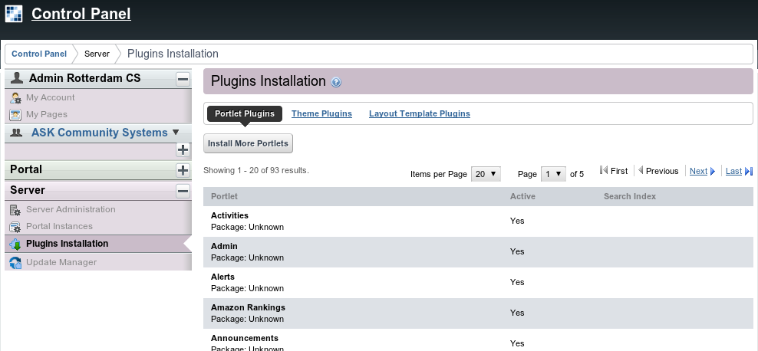Fig 1: Portlet Plugins list.

- Select Upload File in the top of the displayed page. Click on Choose File button, in order to get the file portlet rcs-liferayGoogleAnalytics-portlet-6.1.1.2.war uploaded from your computer.

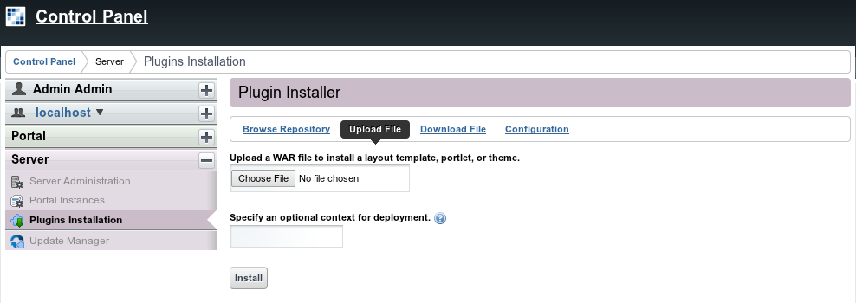Fig 2: Upload a new WAR file.
- Once the file is selected click on the Install button
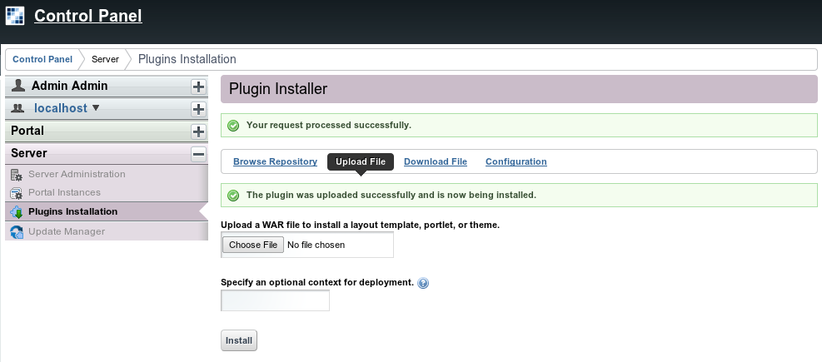Fig 3: WAR uploaded.

Once the portlet is installed you can start configuring it.

Configuration

Configure the Liferay-Google-Analytics portlet

In the left panel, under the portal name select Liferay Google Analytics.
The first time, the Configuration panel (right-menu) is selected, once it is configured the Google Analytics dashboard will be automatically selected.

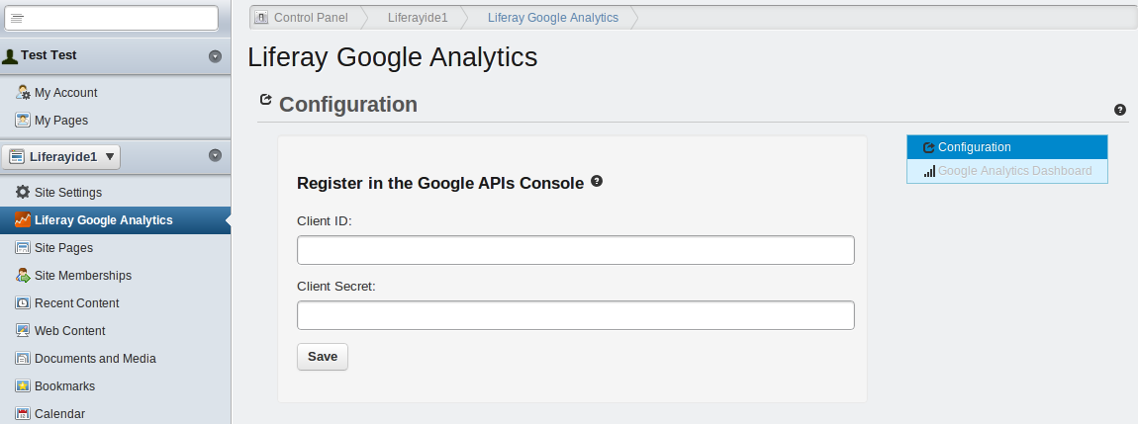
To retrieve data from Google Analytics, the Client ID and Client Secret are required, to get this values follow these steps:

Create an APIs Console Project:

Application type: Web Application
Authentication type: OAuth 2.0
- Visit the Google APIs Console
- Sign-in and create a project or use an existing project.
- In the Services panel, activate Analytics API for your project. If prompted, read and accept the terms of service.
- Go to the API Access panel:
- Click Create an OAuth 2.0 client ID...
- Fill out the Branding Information fields and click Next.
- Set Application type to Web application. in "Your site or hostname" click in (more options)
- In the Authorized Redirect URIs and Authorized Javascript Origins text fields copy and paste the information showed by clicking the help icon:
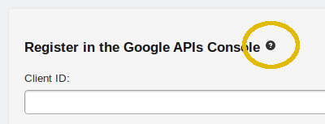

- Click Create client ID
- Copy and paste the Client ID and Client Secret in their respective fields.
- Click on the Save button and it will be replaced by an “Authorize” button.
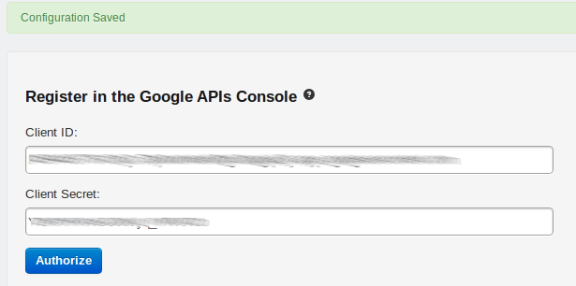

- Click on the Authorize button, you'll be redirect to the Google authorization page:
- If you are not logged in with your google account you will see a sign in page, please sign in.
- Click on the Allow access button.
- If you get a redirect_uri_mismatch Error, please review that the Authorized Redirect URIs is exactly the same in the Google APIs Console that in the help section (5 - III).
- Finally select the Google Analytics account, Property and Profile from the combo boxes and click on the Save button at the bottom of the page.
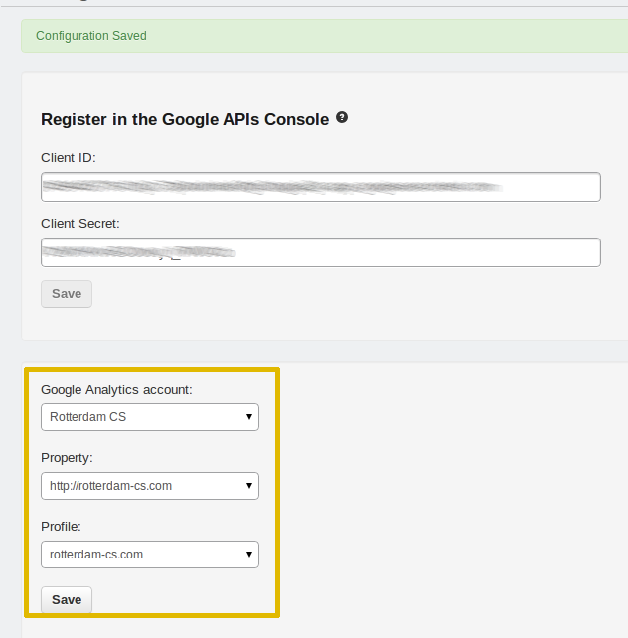

Usage

Once the portlet is installed and configured, the Google Analytics Dashboard will be selected by default in the Control Panel, if you want to change the configuration just click on the right menu Configuration.

The date range selected by default is one month backward.

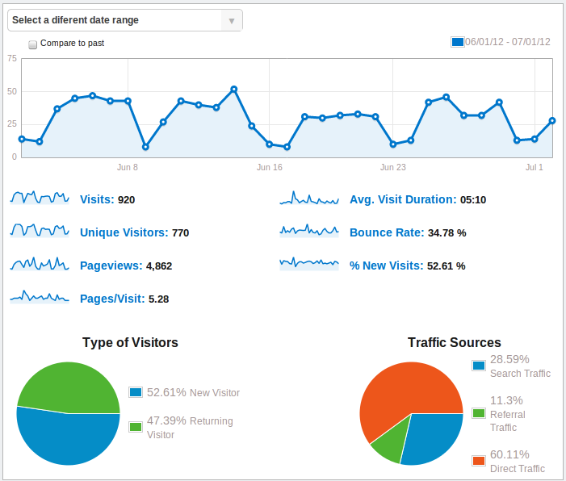
To see different statistics details such as Unique Visitors, Bounce Rate, Page Views, Etc. Just click on the graphic Thumbnail or the blue text.

To see detailed information for a data point roll the mouse over the data point on the graphic
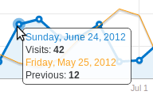

Changing the date range:
To change the date range just click on the combo box:

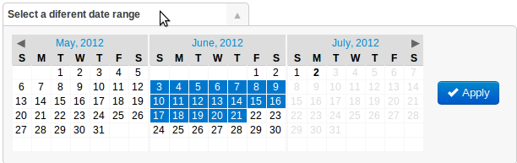
Click on the start date range, click on the end date range and finally click on the Apply button to retrieve the new data.

Compare two date ranges:
To compare 2 date ranges just check the “Compare to past” check-box:
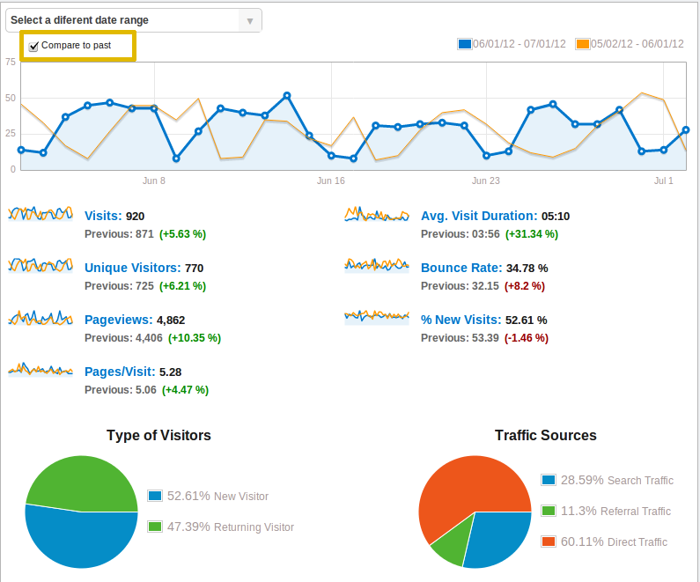

If you want to change the date range for both date ranges, just repeat the process for changing the date range, but with the compare to past checked:
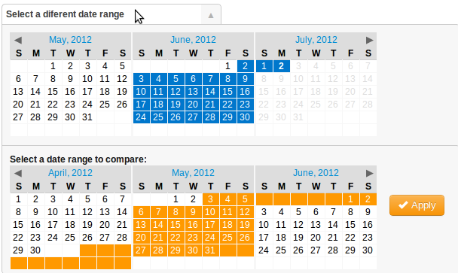

Dashboard in custom pages:
Once you have configured the Google Analytics Account from the Control Panel, you can display the dashboard in any page you want.

Log in as an administrator and go to the page where you want to install this portlet.

On the dockbar, click on Add, then click on More..., select Tools -> Google Analytics.

Change Log

Changes applied in version 6.1.1.2:

1 – The dashboard can be shown in any desired page for visitors and users, not only in the Control Panel.

2 – Error handling improved. Proper messages are shown to end user.

