RCS Liferay Google Analytics Portlet

Installation Guide

Document Revisions
Date | Revision | By
07/02/12 | 1 | Pablo Rendón
30/1/13 | 2 | Florencia Gadea
10/10/2014 | 3 | Florencia Gadea
05/01/2015 | 4 | Alejandro Alvarez

Table of Contents
Document Revisions 2
General Description 3
Installation 5
Configuration 6
Usage 8
Change Log 11

General Description

One of the most important tools for a website administrator are the statistics, Google Analytics is one of the best options and this application provides a simple but powerful integration between Liferay and Google Analytics, showing the most relevant information from Google Analytics within the Liferay administration panel.
Installation and configuration is simple and provides powerful features such as comparison of statistics between different dates, selection of different Google Analytics accounts, properties and profiles.

The Dashboard shows information such as amount of visitors, unique visitors,Type of visitors (New or Returning), Traffic Sources, among other.

This application consists of two portlets. One portlet that will be displayed in the Control Panel, for configuration purposes. And another portlet that will only display the dashboard in any page we want.

Installation
Deploy the Liferay-Google-Analytics portlet into your portal. There are several ways to accomplish this. Here is one.
- Log in as an admin user and go to Control Panel.
- Click on Apps → App Manager → Install.
- Click on File Upoad, then Browse and search for the google analytics war file.

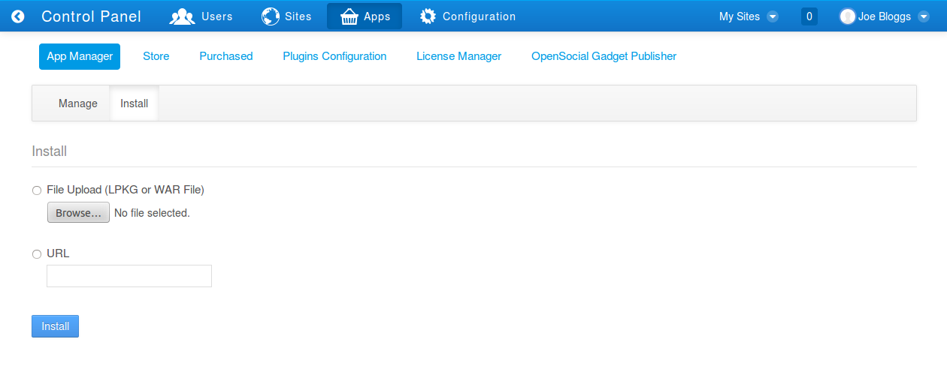Fig 1: App Manager

Once the war is selected, click on the Install button.

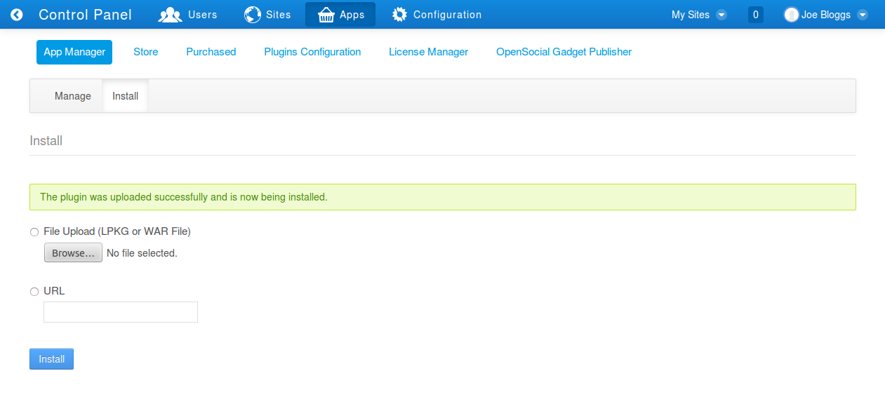Fig 2: Upload a new WAR file.

Once the portlet is installed you can start configuring it.

Configuration

Configure the Liferay-Google-Analytics portlet

In the Control Panel, click on Sites (on the dockbar), and then click on the portal name below (Liferay by default).

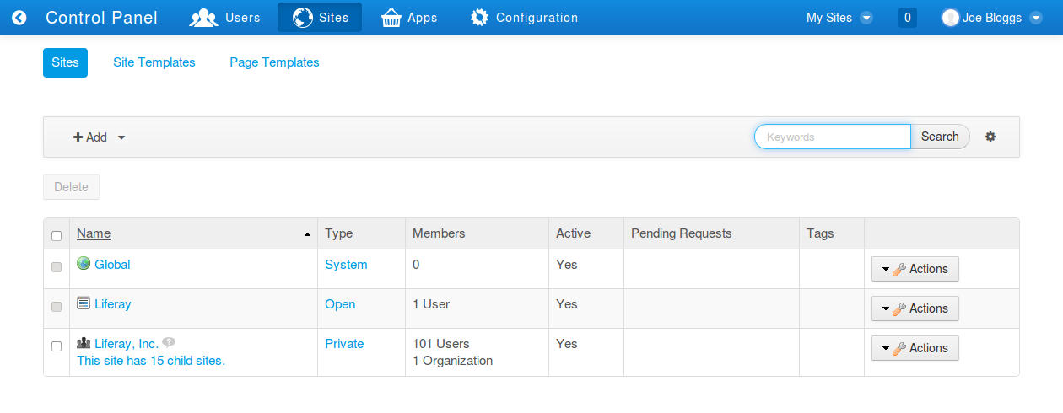
Then click on Content and select Liferay Google Analytics.

The first time it loads, the Configuration panel (right-menu) is selected. Once the configuration is set, the Google Analytics dashboard will be automatically selected.

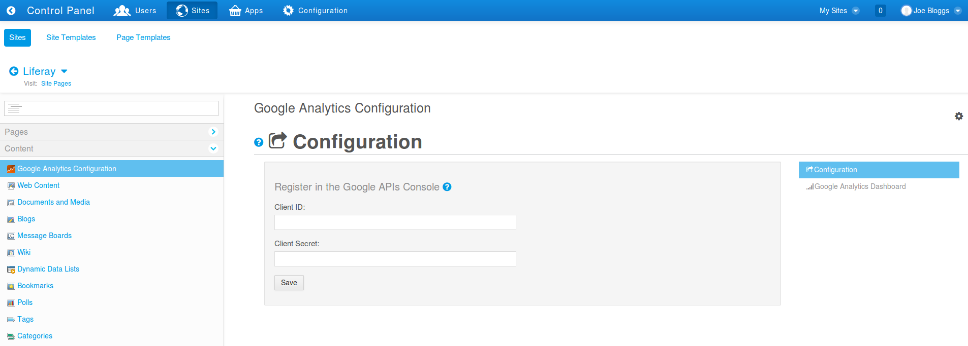
To retrieve data from Google Analytics, you first need a Google Analytics account. Then, you need a google account associated with that Google Analytics account. The portlet will request a Client ID and Client Secret to retrieve the information. You have to follow these steps:

Go to the Google Developers Console.
- Sign-in and create a project (clicking on Create Project) or use an existing project. Click on the project name.
- On the left panel, below the APIs & auth menu, click on APIs.
- Enable the Analytics API (once you enable it, it will be listed below the Enabled APIs list).
- On the left panel, below the APIs & auth menu, click on Consent screen.
- You have to fill the Email address and Product name fields. Then click Save.
- On the left panel, below the APIs & auth menu, click on Credentials.
- Click on Create new Client ID.
- Set Application type to Web application.
- In the Authorized Javascript Origins and Authorized Redirect URIs text fields copy and paste the information showed by clicking the help icon in the Google Analytics configuration portlet:

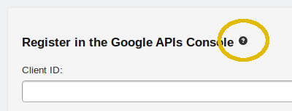

- Click Create client ID
- Copy and paste the Client ID and Client Secret in their respective fields.
- Click on the Save button and it will be replaced by an Authorize button.

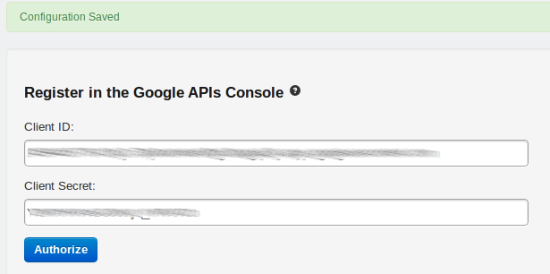

- Click on the Authorize button, you'll be redirect to the Google authorization page:
- If you are not logged in with your google account you will see a sign in page, please sign in.
- Click on the Allow access button.
- If Access Offline is required, accept it.
- If you get a redirect_uri_mismatch Error, please review that the Authorized Redirect URIs is exactly the same in the Google APIs Console that in the help section (5 - III).
- Finally select the Google Analytics account, Property and Profile from the combo boxes and click on the Save button at the bottom of the page.
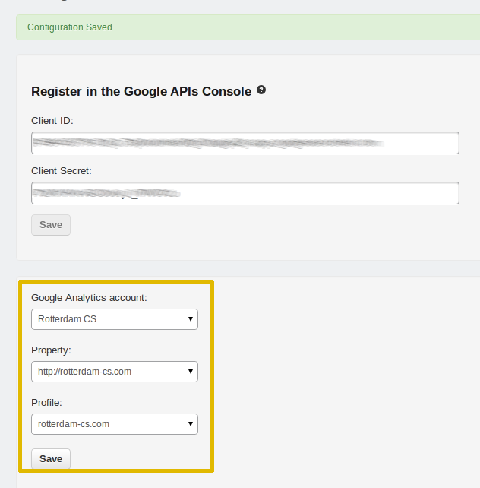

Usage

Once the portlet is installed and configured, the Google Analytics Dashboard will be selected by default in the Control Panel, if you want to change the configuration just click on the right menu Configuration.

The date range selected by default is one month backward.

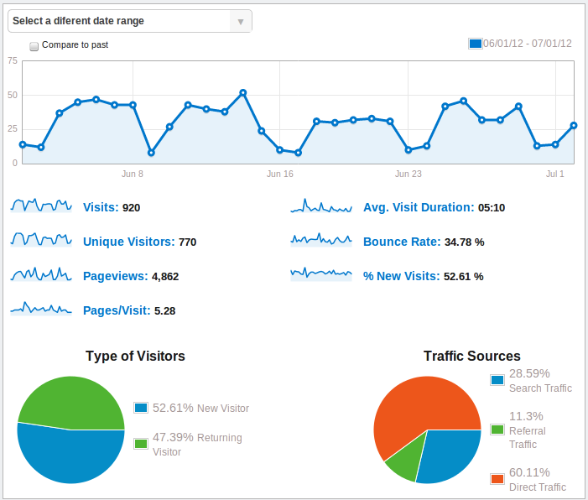
To see different statistics details such as Unique Visitors, Bounce Rate, Page Views, Etc. Just click on the graphic Thumbnail or the blue text.

To see detailed information for a data point roll the mouse over the data point on the graphic
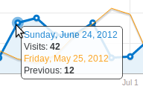

Changing the date range:
To change the date range just click on the combo box:

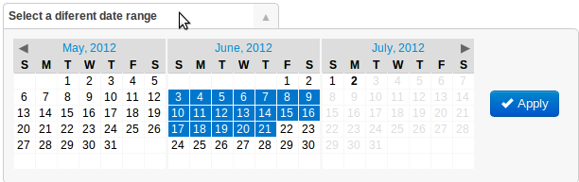
Click on the start date range, click on the end date range and finally click on the Apply button to retrieve the new data.

Compare two date ranges:
To compare 2 date ranges just check the “Compare to past” check-box:
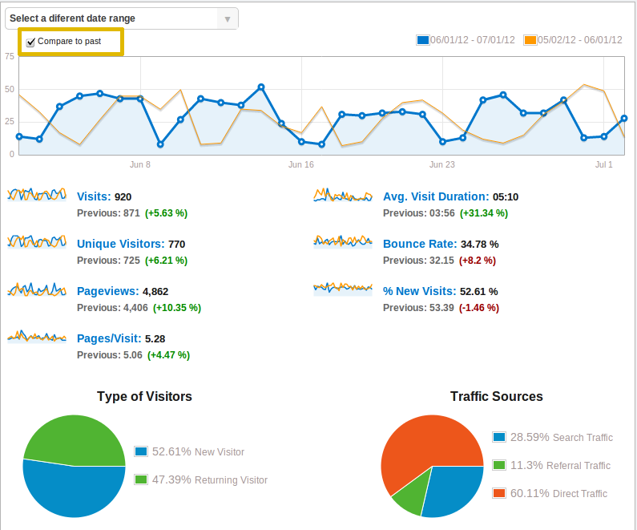

If you want to change the date range for both date ranges, just repeat the process for changing the date range, but with the compare to past checked:
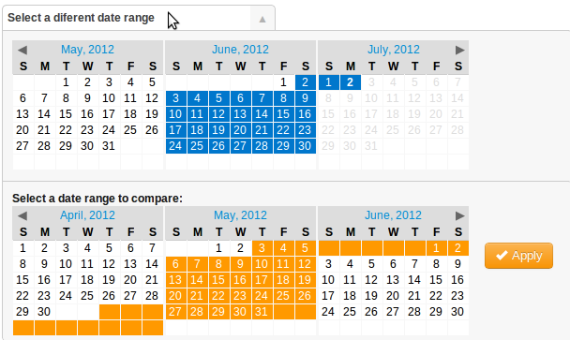

Dashboard in custom pages:

Once you have configured the Google Analytics Account from the Control Panel, you can display the dashboard in any page you want.

Log in as an administrator and go to the page where you want to install this portlet.

On the left dockbar, click on Add, then click on Applications..., select Rotterdam CS -> Google Analytics.

Change Log

Changes applied in version 6.2.1.1:

1 – Updated Spring jar files and Google jars.

2 – Optimized Log.

3 – Security manager disabled.

4 – Tested in Liferay 6.2 CE and EE.

