

RCS Liferay Image Slider Portlet

Installation Guide

Document Revisions
Date | Revision | By
28/10/2014 | 1 | Alejandro Alvarez

Table of Contents
RCS Liferay Image Slider Portlet Installation Guide 1

Document Revisions 2

General Description 4

Installation 5

Configuration 6

Configure *required “SLIDER_STRUCTURE” to be used by the portlet 6

Configure *required “SLIDER_TEMPLATE” to be used by the portlet's SLIDER_STRUCTURE 10

Configure RCS Slider Portlet 17

RCS Slider Portlet in Action 21

Change Log 23

General Description

The Liferay enterprise portal offers a lot of flexibility, allowing moderators to create predefined structures for data entry and templates for displaying the data. With these default features, a moderator is able to basically create anything possible.

However, sometimes Rotterdam CS still finds a feature that is missing, and makes an effort to build a custom plugin just to create that one good-looking feature that every moderator is looking for.

One such a plugin is that of an Image Slider. Pretty much every website nowadays has such a slider on their front page to display news or highlight key services. Until the release of this portlet, the configuration of these slides and most of all, the user-friendliness of those configuration pages, were a pain for every moderator.

With the release of this plugin, every portal moderator can add and customize an image slider, just by dragging & dropping the module and adding new slides using images from Liferay's Document Library.

The portlet was built using Jquery.

Installation
Deploy the RCS Liferay Image Slider portlet into your portal. There are several ways to accomplish this. Here is one.
- Log in as an admin user and go to Control Panel.
- Click on Apps → App Manager → Install.
- Click on File Upload, then Browse and search for the RCS Liferay Image Slider portlet war file. It has a name similar to “liferayImageSlider-portlet-6.2.0.1.war”.

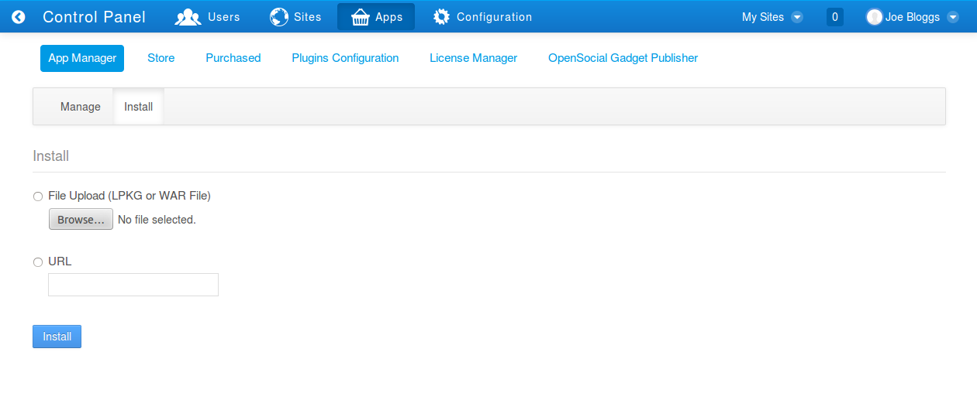
Fig 1: App Manager
- Once the war is selected, click on the Install button.

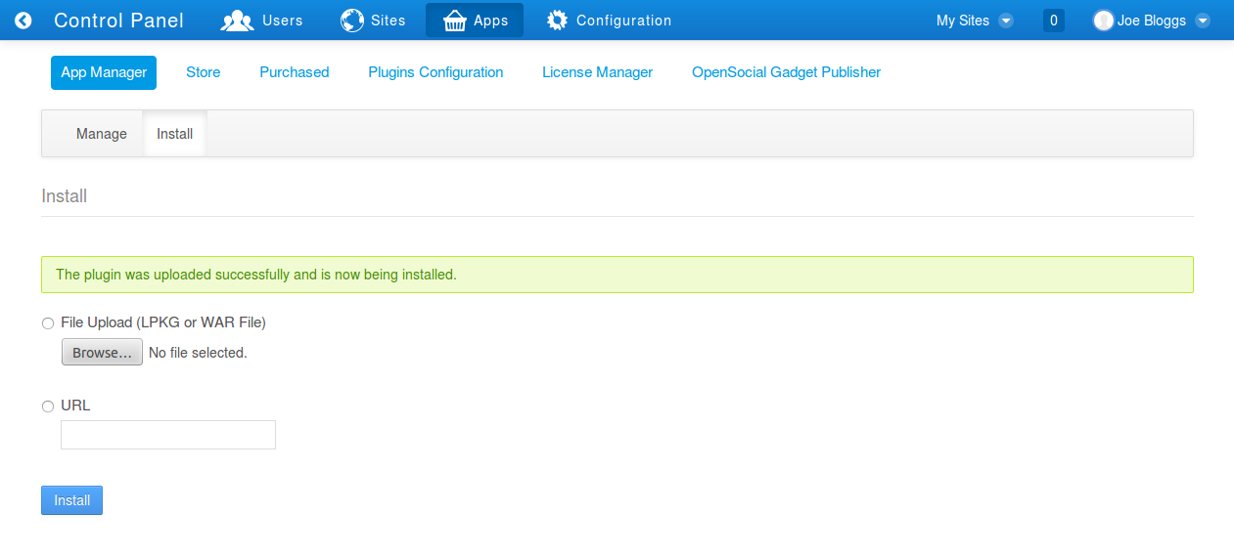
Fig 2: Upload a new WAR file.

Once the portlet is installed you can start configuring it.

Configuration

Configure *required “SLIDER_STRUCTURE” to be used by the portlet

- Log in as an admin user and in the Dock Bar go to Admin → Site Administration → Content.

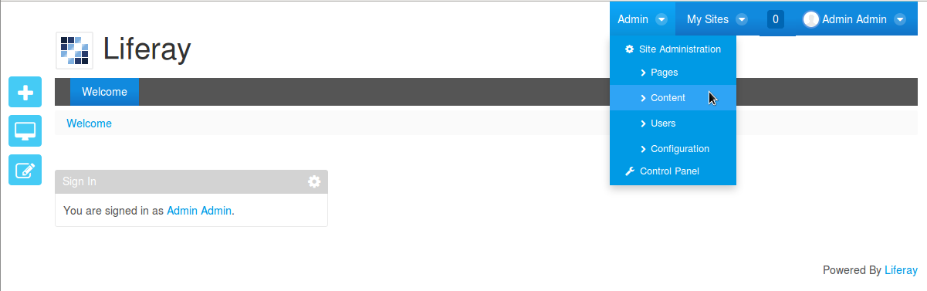
Fig 3: Content Menu

- Click on Web Content → Manage → Structures.

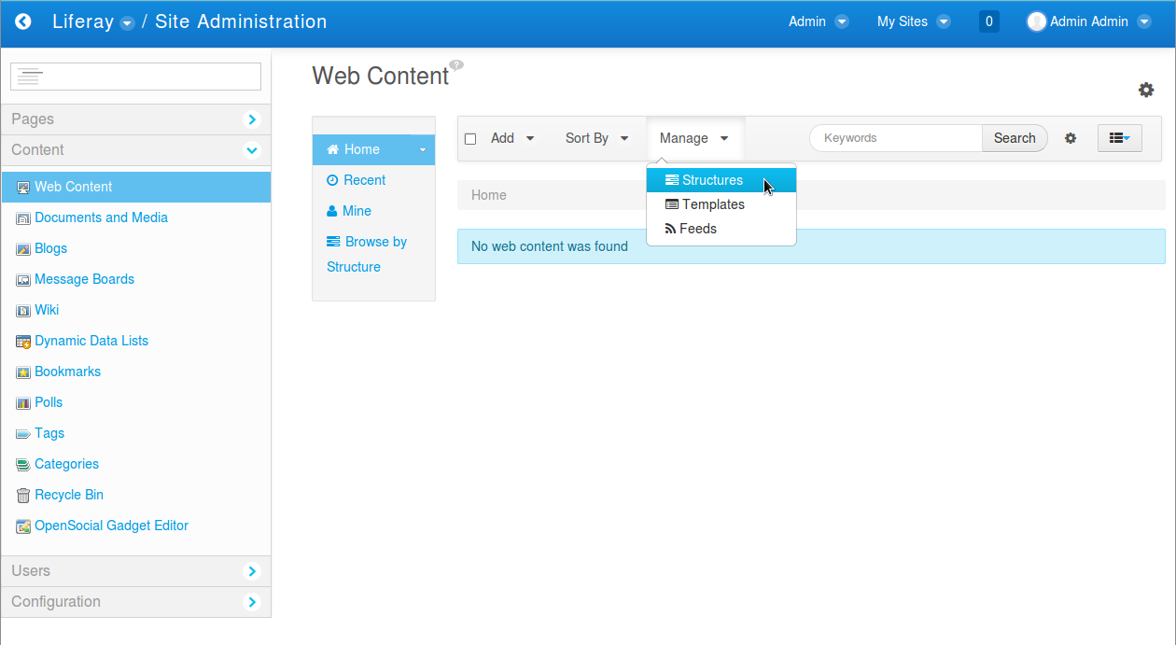
Fig 4: Structures Menu

- Click on +Add in the pop up to start filling the *required “SLIDER_STRUCTURE” Fields.

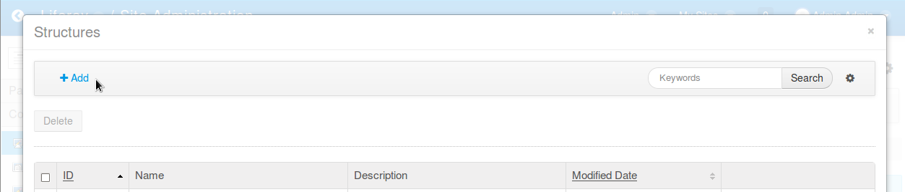
Fig 5: Add Structure

- Fill Name and Description fields with *required “SLIDER_STRUCTURE” value.

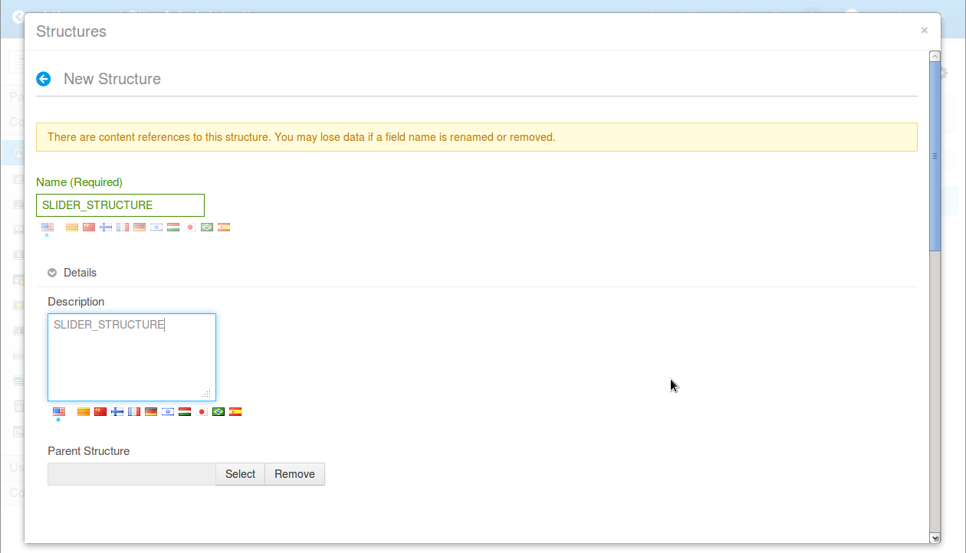
Fig 6: Structure Name and Description, required values.

- Now is time to create the Structure fields required for the slider.

Scroll down the Structures pop up until you see tabs “View” and “Source”.
Click over “Source”.

Then copy the xml that appears in next page and paste it in the text area replacing all existing xml content.

<root available-locales="en_US" default-locale="en_US">
<dynamic-element dataType="string" indexType="" name="title" readOnly="false" repeatable="false" required="false" showLabel="true" type="text" width="small">
<meta-data locale="en_US">
<entry name="label">
<![CDATA[Title]]>
</entry>
<entry name="predefinedValue">
<![CDATA[]]>
</entry>
<entry name="tip">
<![CDATA[]]>
</entry>
</meta-data>
</dynamic-element>
<dynamic-element dataType="string" indexType="" name="link" readOnly="false" repeatable="false" required="false" showLabel="true" type="text" width="small">
<meta-data locale="en_US">
<entry name="label">
<![CDATA[Link]]>
</entry>
<entry name="predefinedValue">
<![CDATA[]]>
</entry>
<entry name="tip">
<![CDATA[]]>
</entry>
</meta-data>
</dynamic-element>
<dynamic-element dataType="string" indexType="" name="text" readOnly="false" repeatable="false" required="false" showLabel="true" type="textarea" width="small">
<meta-data locale="en_US">
<entry name="label">
<![CDATA[Text]]>
</entry>
<entry name="predefinedValue">
<![CDATA[]]>
</entry>
<entry name="tip">
<![CDATA[]]>
</entry>
</meta-data>
</dynamic-element>
<dynamic-element dataType="image" fieldNamespace="wcm" indexType="" name="image" readOnly="false" repeatable="false" required="false" showLabel="true" type="wcm-image" width="">
<meta-data locale="en_US">
<entry name="label">
<![CDATA[Image]]>
</entry>
<entry name="predefinedValue">
<![CDATA[]]>
</entry>
<entry name="tip">
<![CDATA[]]>
</entry>
</meta-data>
</dynamic-element>
</root>

- Click “View” Tab and take a look to created Structure Fields. After that you can close the popup.

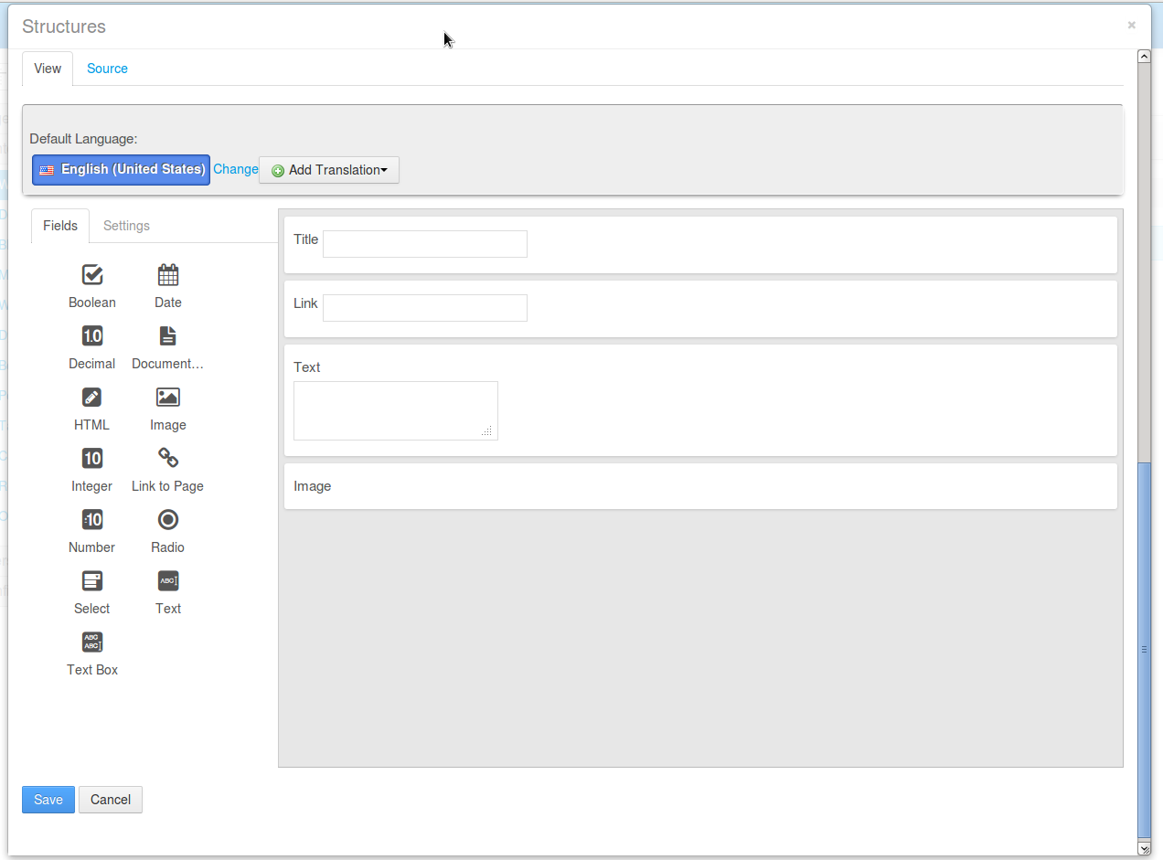
Fig 7: SLIDER_STRUCTURE Fields.

- Click “Save” button, pop up will change showing you recently created SLIDER_STRUCTURE.

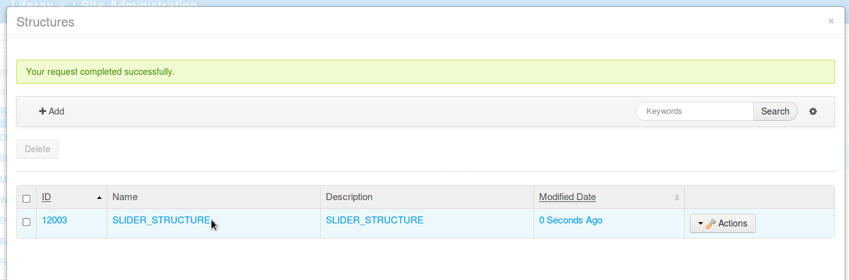
Fig 8: SLIDER_STRUCTURE Added.

- Click the “X”, top right pop up link in order to close the Structures pop up and continue with the Template creation.

Configure *required “SLIDER_TEMPLATE” to be used by the portlet's SLIDER_STRUCTURE

- Log in as an admin user and in the Dock Bar go to Admin → Site Administration → Content.

Fig 9: Content Menu

- Click on Web Content → Manage → Templates.

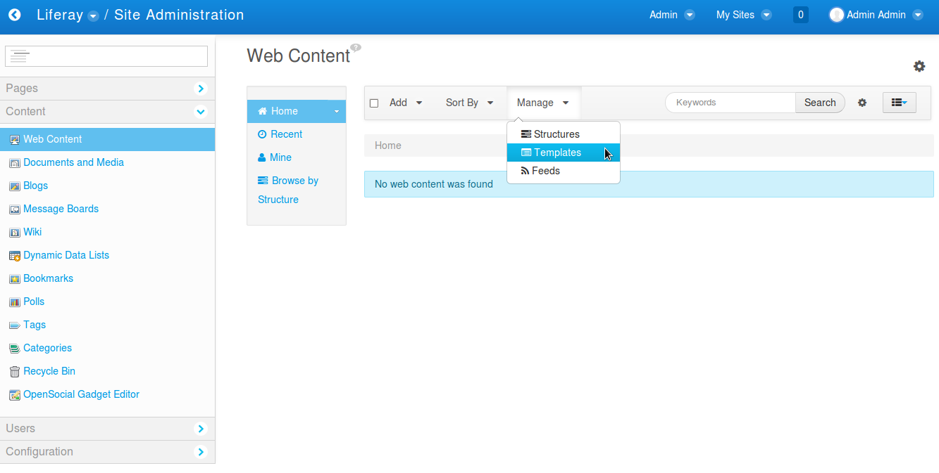
Fig 10: Templates Menu

- SLIDER_STRUCTURE's template creation.

All Liferay's Structures require a template.

- Click on +Add in the pop up to start filling the *required “SLIDER_TEMPLATE” Fields.

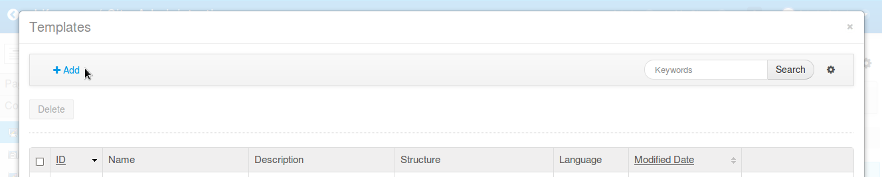
Fig 11: Add Template

- Fill Name field with *required “SLIDER_TEMPLATE” value.

Then select SLIDER_STRUCTURE clicking the “Select” button under Details.

Click “Choose” button in SLIDER_STRUCTURE row in the pop up.

Then, select “Velocity (.vm)” in the Language's Combo Box.

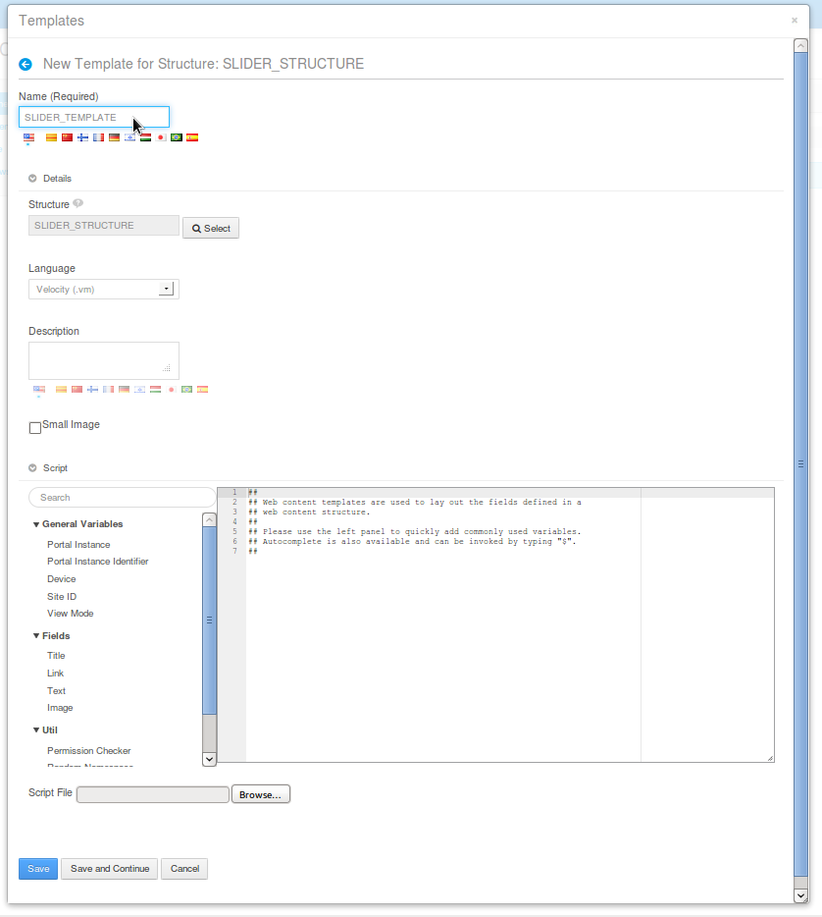
Fig 12: SLIDER_TEMPLATE Template
- Finally Click “Save” button that is at the end of the pop up.
Pop up will change showing you recently created SLIDER_TEMPLATE.

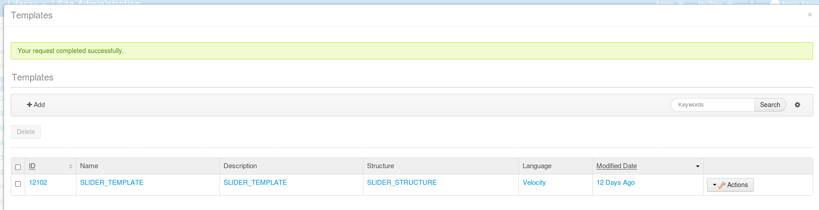
Fig 13: SLIDER_TEMPLATE added.

- Click the “X”, top right pop up link in order to close the Templates pop up.

After this configuration the RCS Slider Back End configuration is done.

Next steps consist of creating two test Web Contents to be used when deploying the portlet in a page.

Configure RCS Slider's Web Contents

- Log in as an admin user and in the Dock Bar go to Admin → Site Administration → Content.

Fig 14: Content Menu

- Click on Web Content → Add → Basic Web Content.

Yes, you first need to create a Basic Web Content, save it, and then update this one to use the SLIDER_STRUCTURE created in previous steps, this is because Liferay has an issue related to Structures saved first time.

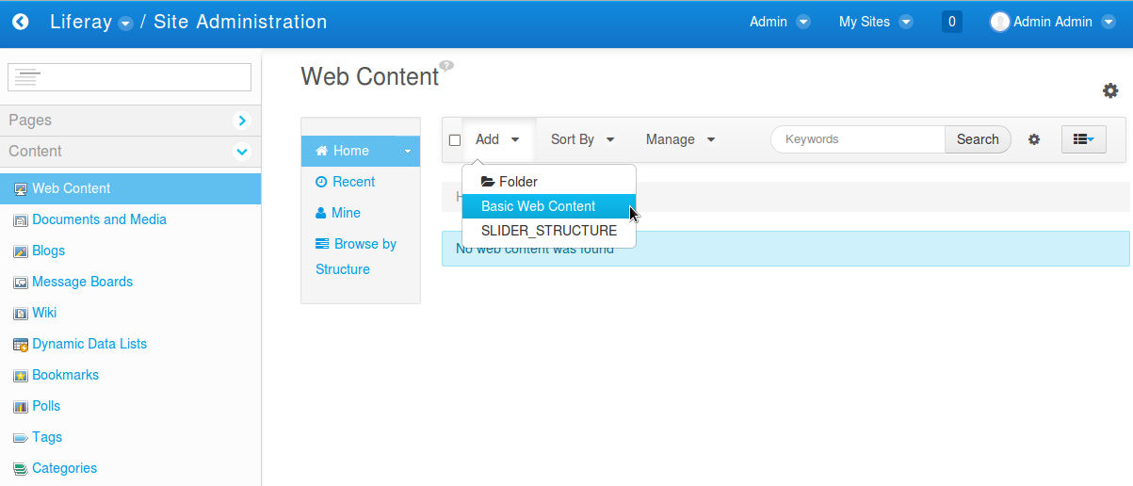
Fig 15: Add Basic Web Content Menu

- Insert a *required title that will be replaced with the final one, the click “Publish” button, in this way the new Web Content is saved to be reopened and edited changing its default structure to the portlet's SLIDER_STRUCTURE one.

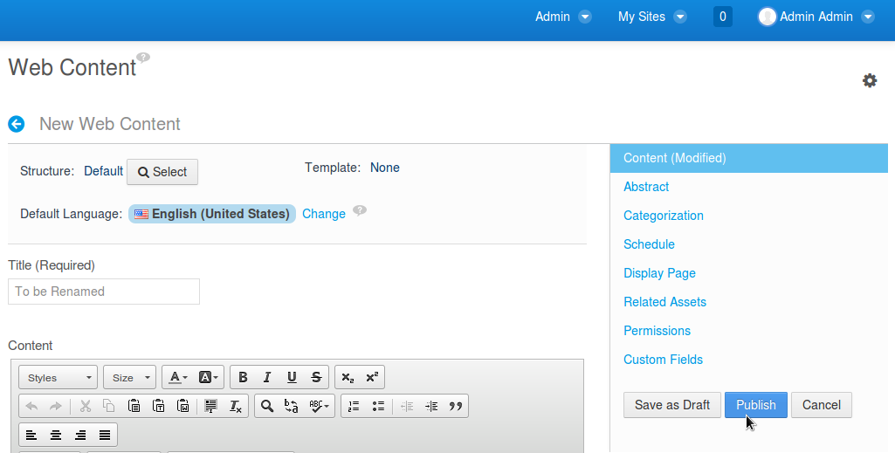
Fig 16: Publish Basic Web Content

- Reopen previous Web Content clicking over its title.

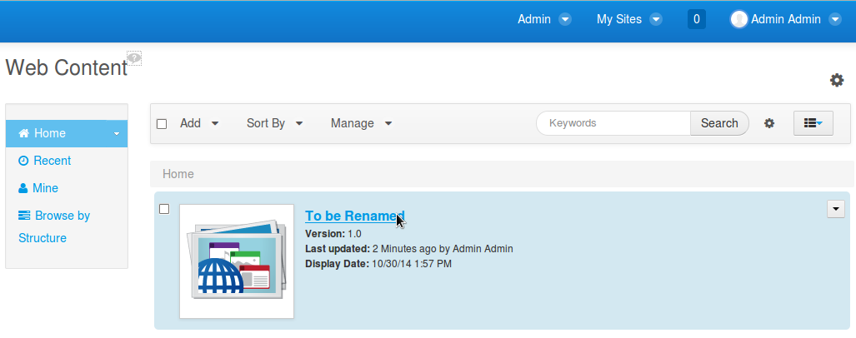
Fig 17: Reopen Basic Web Content

- Now we need to start editing it, first step is to change Web Content's structure to SLIDER_STRUCTURE. Click the Select button were Structure is set to Default. Then choose SLIDER_STRUCTURE in the grid. Click OK in the alert pop up.

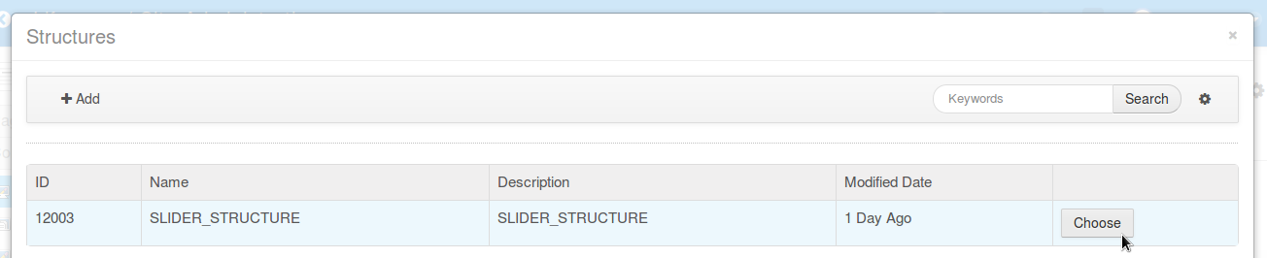
Fig 18: Choose SLIDER_STRUCTURE

- Verify the change and start filling the SLIDER_STRUCTURE fields.

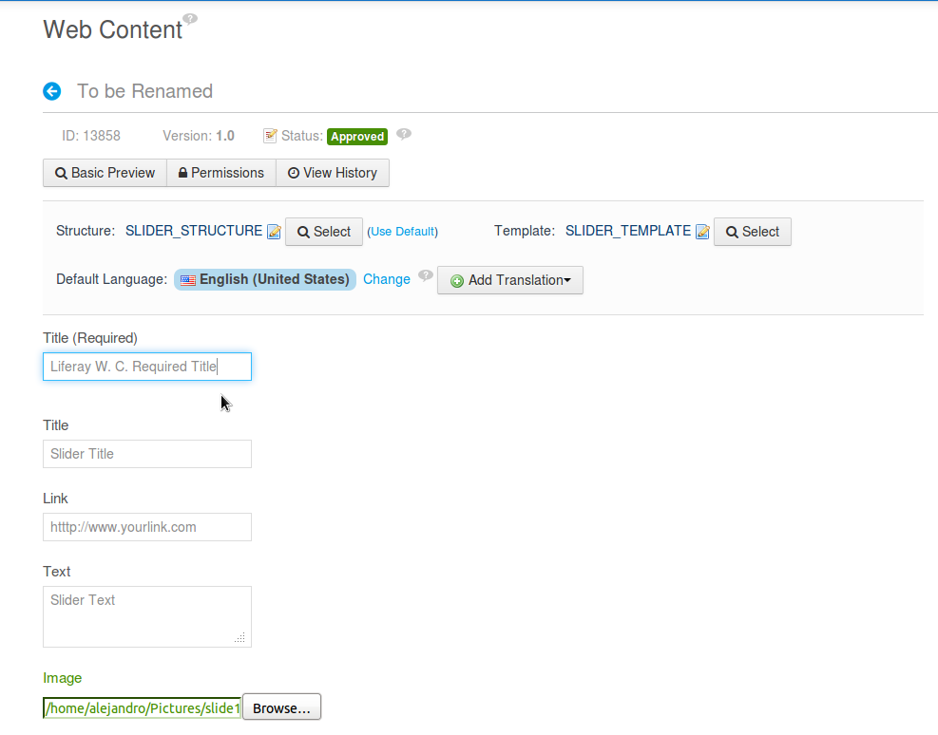
Fig 19: SLIDER_STRUCTURE fields.

- Create another similar Web Content having different data to make transitions between them when configuring the portlet.

After this configuration the RCS Slider demo Web Contents configuration is done.

Next steps consist of adding the RCS Slider Portlet to Welcome default Liferay's page and configure the portlet to show previously created Web Contents.

Configure RCS Slider Portlet

- Log in as an admin user, go to Welcome page or the one you want to use, in Page Left's Bar click the [+] Icon → Add → Applications → Browse the categories until find RCS → Slider Portlet → Click Add.

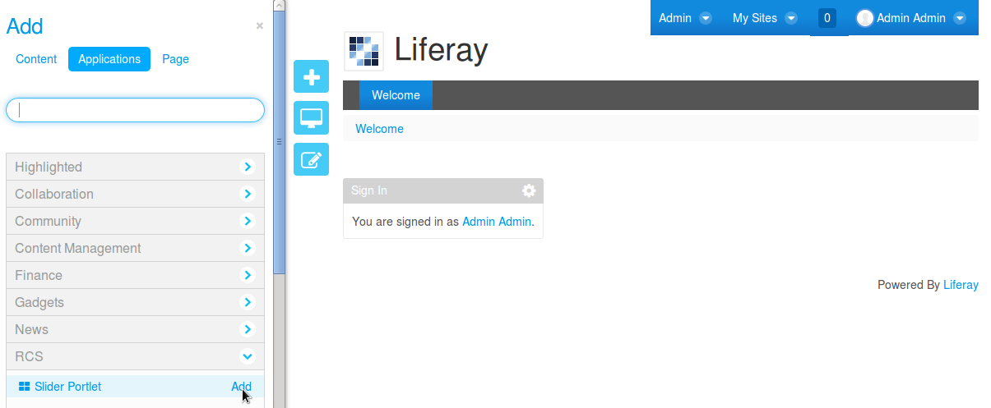
Fig 20: Adding Slider Portlet.

- Click on the top right portlet configuration Icon and then in the Drop Down menu select “Configuration”.

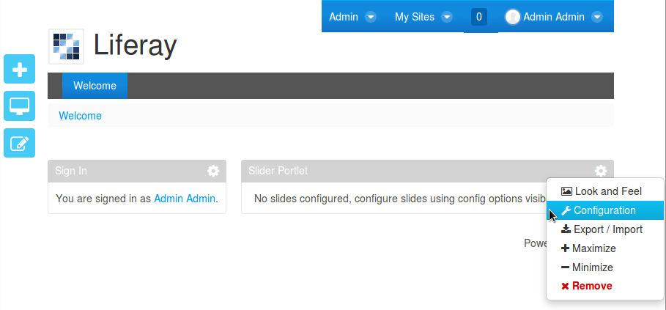
Fig 21: Adding Slider Portlet.

- Now the RCS Slider Portlet pop up appears letting us start to configure it.
- TAB Slides: From the Web Content Combo Box, Select Web Contents previously created, clicking “Add Slide” button, both of them, after that you will see them in a grid giving you the possibility to set their order. From the grid you can also delete any of them from the Slider Setup.
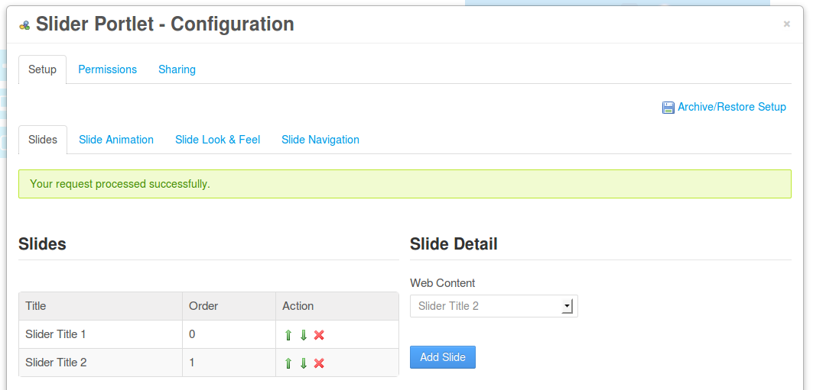
Fig 22: Slider Portlet – TAB Slides.

- TAB Slide Animation: Is the place to specify Slider Animation parameters.
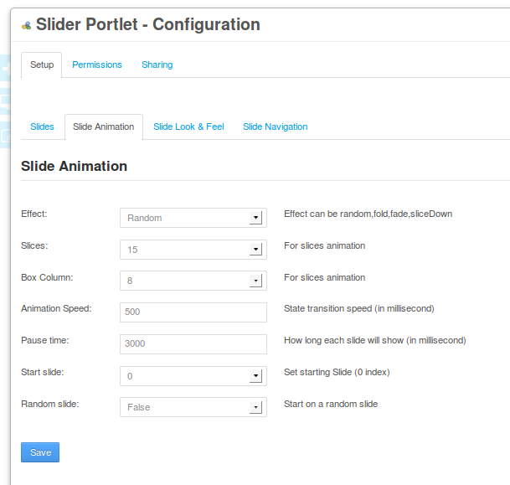

Fig 23: Slider Portlet – TAB Slide Animation.

- TAB Slide Look and Feel: Is the place where Image size, used theme, opacity and other css related stuff can be specified.

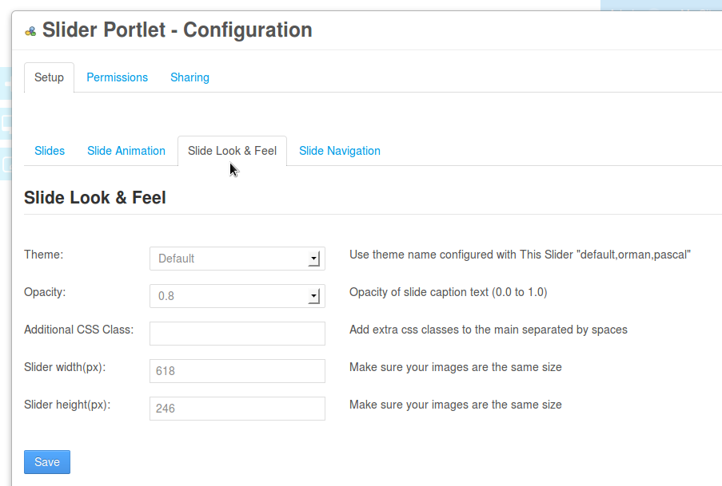
Fig 24: Slider Portlet – TAB Slide Look and Feel.

- TAB Slide Navigation: Is the place where different navigation parameters are set.

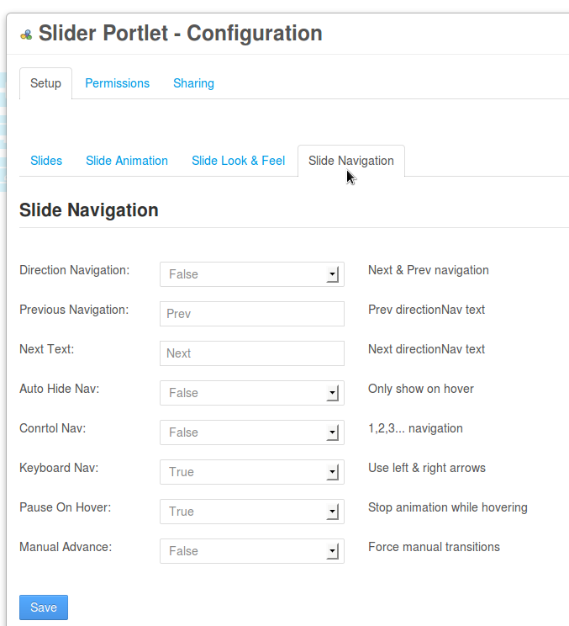
Fig 25: Slider Portlet – TAB Slide Navigation.

After closing the Slider Configuration Pop up, we will be able to see it in action.

RCS Slider Portlet in Action
Here you can see a couple of screen-shots running after the configuration was finished.



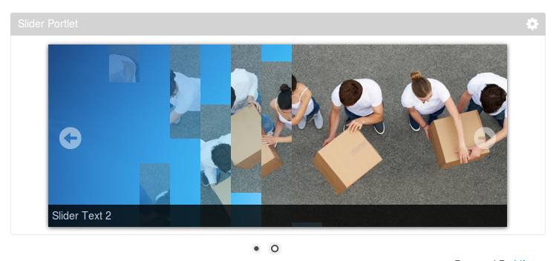

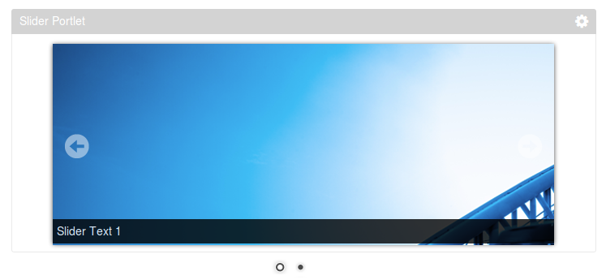

Change Log
Changes applied in version 6.2.1.0:

1 – Initial Version for RCS Slider Portlet running over Liferay 6.2.1 GA2 Versions developed using Ant in Liferay IDE.

