RCS I18N Editor

Installation Guide

Document Revisions
Date | Revision | By
11/12/12 | 1 | Florencia Gadea

Table of Contents
RCS I18N Editor 1
Document Revisions 2
General Description 4
Technical Description 4
Installation 4
Usage 6
Requirements 12
Limitations 12
Undeploy 13

General Description

Liferay is designed to handle as many languages as you want to support. This is done by pulling out all language specific text and storing them in language.properties files. This way, when a page loads, Liferay will detect the language, pull up the corresponding language file and display the text in the correct language. You can also change the way a certain word is translated. If you wanted, you could effectively rename the "message boards" portlet to be called "forums". If you do that, you will have to restart the server to be able to see the new changes. Plus, these language.properties files are some times hard to handle for non-technical users.

The I18N Editor application allows language display customization on the fly. This application, built by Rotterdam Community Solutions, allows portal administrators to easily change existing language entries, without the need to restart the server.

Technical Description

The I18N Editor works by storing all the Liferay core and portlets language.properties keys and values in the database and then the portal reads those properties from the database directly. So a user can easily change existing language entries in different languages.

The app consists of two parts, a portlet and an extension. The portlet reads the language.properties files and stores them in the database. The extension displays in the portal the properties stored in the database.

Languages are imported on server startup and when a plugin is deployed.

It covers the Liferay core language.properties and more than 95% of all the portlets.

WARNING: Extension plugins cannot be undeployed. You will have to reistall

Installation

Remove unwanted languages

First, you need to remove the languages you don't want to use in your portal. By default, Liferay supports all the follow languages:

ar_SA,ca_AD,ca_ES,zh_CN,zh_TW,cs_CZ,nl_NL,en_US,fi_FI,fr_FR,de_DE,el_GR,hu_HU,it_IT,ja_JP,ko_KR,fa_IR,pt_BR,ru_RU,es_ES,sv_SE,tr_TR,vi_VN

If you only want to support English, German and Spanish, follow this steps:

- Go to the Control Panel.
- In the left panel, under the Portal category, select Portal Settings.
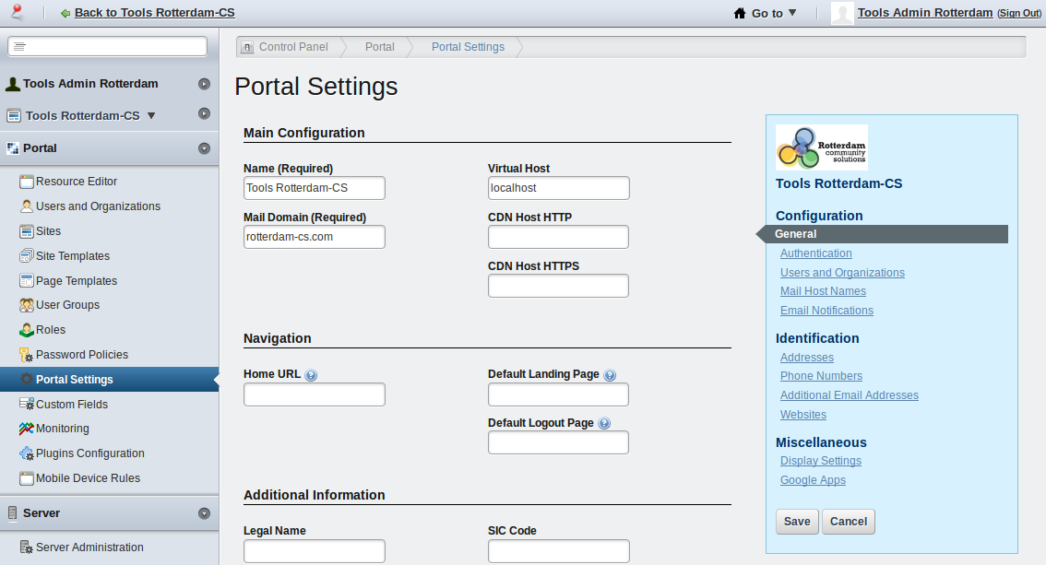

- In the right menu, under the Miscellaneous category, select Display Settings.

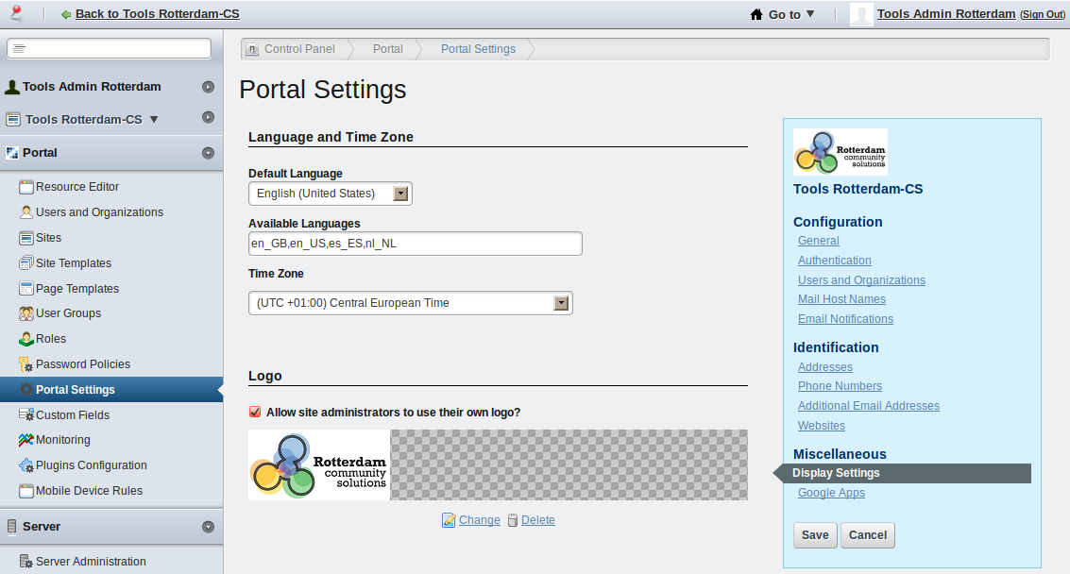
- In the Available Languages field, leave only en_US, de_DE, es_ES.

Depoyment

- Get the I18N editor portlet war from: @@...
- As the Liferay Marketplace is not ready yet for application uploads, the deployment has to be done manually. With the Liferay instance running, drop the portlet war in the deploy directory, under the Liferay installation. Now it will get installed. After installation, the I18N Editor will start importing the entries from the language.properties files and will store them in the database. If you selected many available languages, this may take a while. The server log will show the progress of the language importing.
- Get the I18N editor ext plugin war from: @@.add url
- Drop the war in the deploy directory, under the Liferay installation. It will get installed.
- Shutdown the server.
- Delete: tomcat-dir/webapps/lr-i18n-editor-portlet/WEB-INF/lib/lr-i18n-editor-portlet-service.jar
- Delete the work and temp directories under tomcat-dir.
- Restart the server.

Usage

Adding the portlet

- Login as an administrator and go to the page you want to add the I18N Editor.

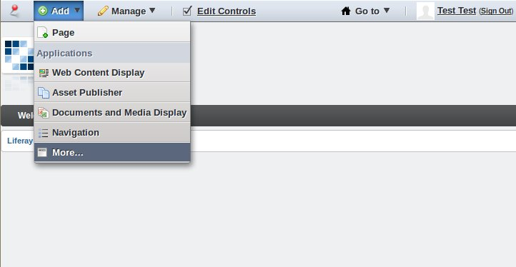

- On the dockbar, click on Add, then click on More..., select Tools -> I18N Editor.

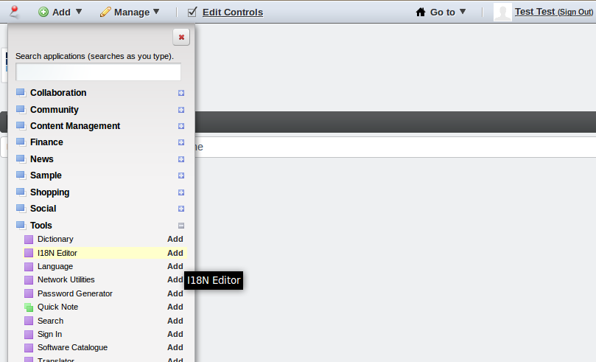

- Refresh the page, and you'll have the the i18n editor ready to be used!

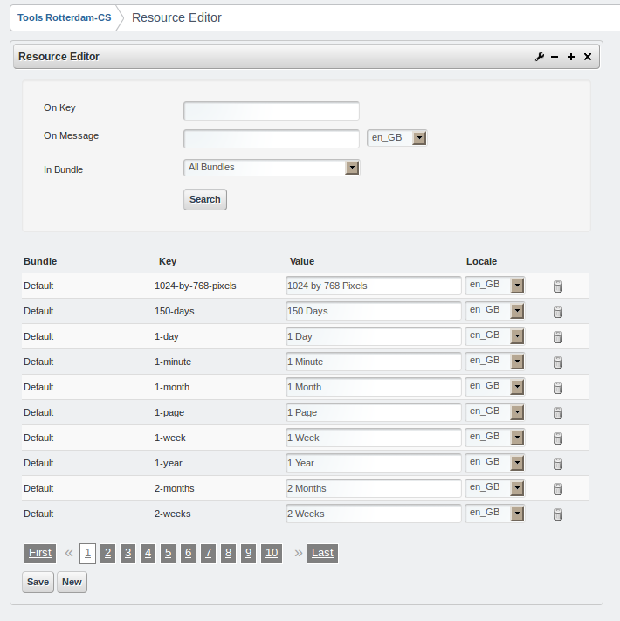

Changing existing language entries

Let's do it with a specific example: Changing the text of an existing Liferay core entry. We will change the “Go to” entry to “Where to” (this label is shown once you are logged in, in the upper right corner).

First, search for the term “Go to”, in the “On Message” field.

In the grid, under the Value field of the go-to row, change the value to “Where to”. Then, click on the Save button.

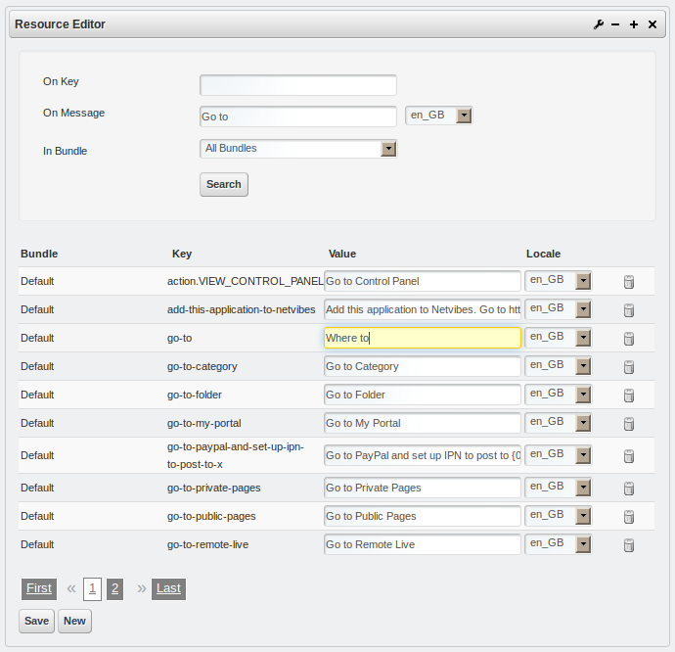

Refresh the page pressing F5. Now you will see the change in the upper right corner.

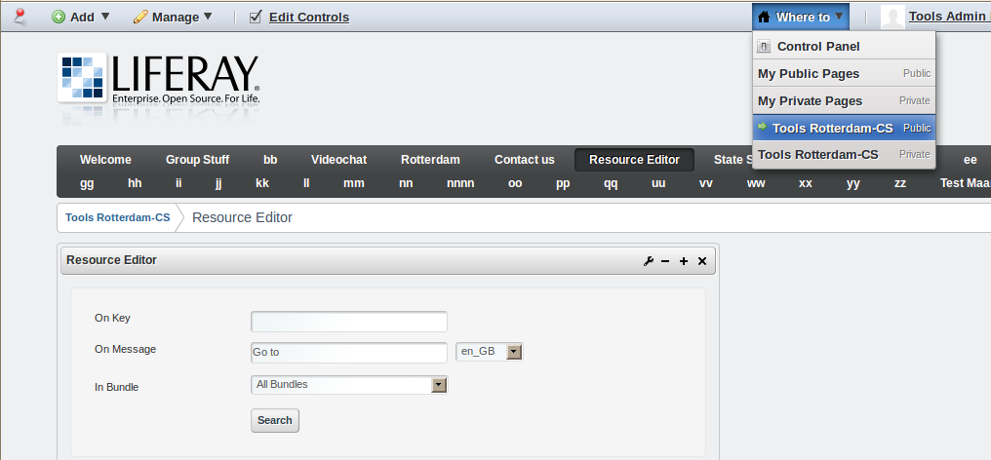

Requirements

Liferay 6.1.1. GA2

Limitations

Language.properties search

Here are the ways we search for Language.properties files:
- we check whether resource bundle exists in portlet.xml (we also support com.liferay.portlet.StrutsResourceBundle)
- we check whether resource bundle exists in liferay-hook.xml
- we check whether resource bundle exists in content/Language_XX.properties
- we check whether resource bundle exists in Language_XX.properties

It covers 95% of all portlets.

Key retrieval

It works only when portlet uses Liferay resource bundle system, i.e.

<liferay-ui:message code="xxx" />

or

<%=LanguageUtil.get(locale, "..")%>

Undeploy

- Login as administrator.

- Go to the Control Panel.

- In the left panel, under the Server category click on Update Manager.

- Select the I18N Editor Ext Plugin from the grid, and click on Uninstall. You may get a few exceptions, but they are expected.

- Select the I18N Editor Portlet from the grid, and click on Uninstall. You may get a few exceptions, but they are expected.

- Shutdown the server.

- Delete tomcat-dir/lib/ext/lr-i18n-editor-portlet-service.jar

- Delete tomcat-dir/lib/ext/ext-lr-i18n-editor-ext-service.jar

- Delete all the files tomcat-dir/webapps/ROOT/WEB-INF/lib/ext-lr-i18n-editor-ext-*

- Delete the directory tomcat-dir/temp

- Delete the directory tomcat-dir/work

- Start Liferay.

Source code

Here you can get the source code of the app:

I18N Editor Portlet

$git clone https://github.com/rotterdam-cs/lr-i18n-editor-portlet

I18N Editor Ext Plugin

$git clone https://github.com/rotterdam-cs/lr-i18n-editor-ext

