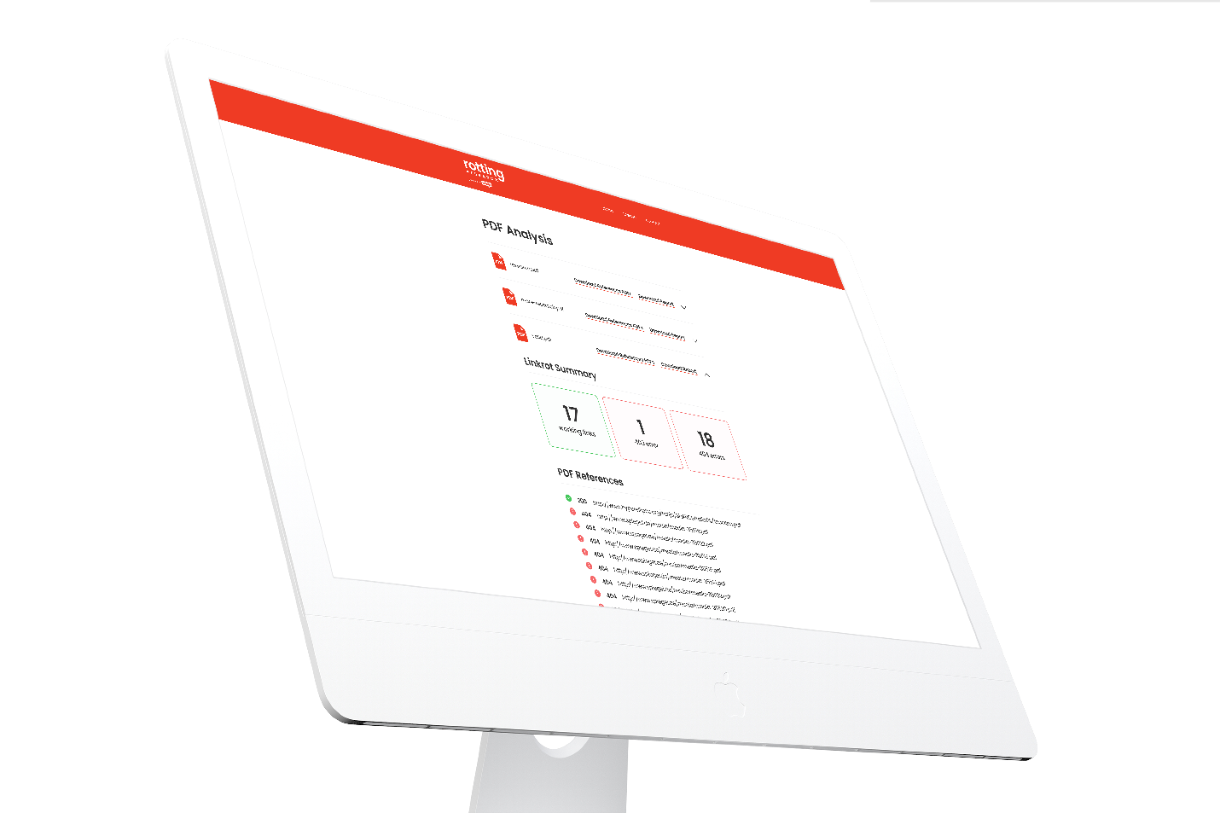

Tell us your story. We are always looking for articles on how you selected and deployed devices or systems, rolled out new tech-based solutions, and achieved desired outcomes via a technology framework, as well as case studies about OPACs, ILSs, and other library platforms.