Cagayan De Oro College- PHINMA Education Network

GRADE MONITOR SYSTEM

---------------------------------------------------------------------

Period 2 Project Milestone
Presented to the
Faculty of the College of Information Technology
Cagayan de Oro College
Cagayan de Oro City

---------------------------------------------------------------------
In Partial Fulfilment
of the Requirements for the Degree
Bachelor of Science in Information Technology
---------------------------------------------------------------------
NAME OF RESEARCHER

ROSELL, KYLE JATVEY S.
SUYOC, SHAURINE G.
CABATUAN, ROXANNE LORRAINE T.
GATCHALIAN, JASMEN MHEA T.
MAGADAN, JOHN MARK
CABATUAN, ZAMBEA
BELARMINO, GIAN CARLO

OCTOBER, 2026
Cagayan De Oro College- PHINMA Education Network

1.1 Introduction
Digital management applications are progressively replacing traditional manual record-keeping processes across academic institutions. Instead of spending hours calculating marks manually or logging scores on paper sheets, educators and students can now manage academic performance with efficiency and precision. Crucially, automated systems reduce human error and eliminate grading discrepancies. Al-Adwan et al. (2020) explore this dynamic in their analysis of educational technology adoption. This effort, the Grade Monitor System, targets precisely this in academic performance tracking. For students, particularly in PHINMA Cagayan de Oro College, tracking milestone scores and overall GPA manually creates confusion and delays in feedback. This system ensures that students spend less time worrying about unverified marks and have more time focusing on their academic responsibilities. The system introduces easy score tracking, letter grade mapping, real-time GPA calculation, and structured report cards. While connectivity gaps in remote areas pose challenges, it ultimately reduces administrative strain and minimizes computation errors (Wang et al., 2022).
From observations and interviews with faculty members and students, we pinpointed serious flaws in manual grading procedures. Instructors log marks directly onto physical logbooks or spreadsheets without a centralized role-based dashboard. This manual grind lacks structured access controls, causing overcrowding during grade evaluation periods, forgotten entries that disrupt academic tracking, and long waiting times that drag on endlessly (Al-Emran et al., 2018). Work becomes difficult to manage when records turn disorganized. Grade releases pile up, students experience unnecessary stress, and faculty shoulder crushing workloads and plain exhaustion (Hwang et al., 2021). Interviews showed us that untracked submissions and mismatched score entries worsened the mess. Furthermore, these daily disruptions prevent the school from maintaining a professional and orderly environment for its students and staff. In short, the old way feels unsustainable, making a reliable system necessary.
The proposed Grade Monitor System aims to streamline academic management at PHINMA Cagayan de Oro College through a modular console-based program. Teachers can log in using administrative credentials, register students, edit subject scores, and view full class summaries. Students can log in with their Student ID to view their individual grade report cards and computed GPA. This tackles calculation errors, delayed feedback, and consultation delays head-on by replacing paper logbooks with orderly digital records. Maala, Sebua, and Evangelista (2023) found digital academic tracking in schools cuts delays and boosts workflow. In the same way, Espinosa, Serrano, and Balmes (2024) showed automated systems improve efficiency and user satisfaction in education services. Though console-based, it delivers optimal operational efficiency and replaces paper mess with faster grade reports, less teacher stress, and higher student satisfaction overall.

1.2 Statement of the Problem
General Problem
The absence of a structured digital grade monitoring system leads to manual calculation errors, delayed grade availability, and disorganized record-keeping, resulting in administrative friction, student anxiety, and increased workload and exhaustion among faculty members.
Specific Problem
- Calculation Errors and Disorganized Data Flow: The lack of automated GPA calculation results in miscalculated weighted averages and conflicting grade records, causing crowding and confusion during academic consultations.
- Delayed Grade Feedback and Untracked Scores: Without real-time access to updated mark sheets, students remain unaware of their current academic standing, leaving teachers hurrying to readjust records during term ends.
- Administrative Strain and Faculty Burnout: Existing manual grading processes require continuous manual entry and re-verification, leading to increased administrative delays, student inconvenience, and severe staff exhaustion.

1.3 General Objectives
The main objective of this study is to develop a modular console-based Grade Monitor System that enables teachers to manage student records, update subject scores, and compute GPA metrics efficiently, while providing students with secure, read-only access to their grade report cards.

1.4 Specific Objectives
- To design a student profile registration feature that accurately records student identification numbers and names.
- To develop an automated grade conversion function that maps percentage scores (0–100) to letter grades (A–F) and 4.0 scale GPA points.
- To create a student report card dashboard that calculates overall Grade Point Average (GPA) in real time and displays structured mark sheets.

1.5 Scope & Limitation
Scope
The proposed Grade Monitor System is a console-based program designed to organize and automate grade management for students and faculty. It aims to streamline grade entry, reduce calculation errors, and improve overall academic tracking efficiency.
- Allow users (teachers and students) to access the system through a menu-driven console interface.
- Provide secure role-based authentication (Teacher password access and Student ID lookup).
- Enable teachers to add new student profiles to the system dynamic memory.
- Enable teachers to input, edit, and update subject percentage scores (0 to 100).
- Automatically convert numerical scores into letter grades (A, B, C, D, F) and 4.0 GPA scale weights.
- Display individual student grade report cards with computed overall GPA.
- Display a complete summary list of all registered students with subject counts and average GPAs.
- Perform input validation such as checking valid numeric scores and preventing duplicate student IDs.
Limitation
The Grade Monitor System is a console-based application intended for academic demonstration and basic grading operations only. It operates in local memory (`students_db` list structure) without an external SQL database or cloud file persistence, meaning records are temporary during the session. It is not connected to the internet and lacks multi-user concurrent networking, automated SMS/email alerts, and online payment integration. Security is restricted to basic password validation without encryption. Due to these limitations, the program is best suited for academic milestone evaluation and small-scale implementation.

1.6 System Requirements
Hardware Requirements
- Processor: Intel Core i3 or equivalent
- RAM: Minimum 4 GB (8 GB recommended)
- Storage: At least 100 MB of free disk space
- Monitor: 14-inch or larger with 1024×768 resolution or higher
- Input Devices: Keyboard and Mouse
Software Requirements
- Operating System: Windows 10 / Windows 11
- Programming Language: Python 3.x
- Development Environment: Visual Studio Code / Python IDLE / Online Compiler
Teacher Functional Requirements
- Log in using administrative password (`admin`)
- Register new student accounts
- Input and update subject scores
- View individual student grade reports and complete class summaries
Student Functional Requirements
- Log in using unique numeric Student ID
- View personal grade report card with subject scores and computed overall GPA

1.7 Data Structure Design
Scalar Variables Table
Variable | Data Type | Purpose
TEACHER_PASSWORD | str | Constant storing the admin login key ("admin").
s_id / student_id | int | Unique numeric identification number assigned to each student.
name | str | Stores the full name of the student.
subject | str | Stores the subject title / course code.
score | float | Stores entered subject percentage score (0.0 to 100.0).
letter | str | Letter grade equivalent ('A', 'B', 'C', 'D', 'F').
gpa | float | Grade Point Average weight (4.0 scale).

Complex Data Structures Table
Structure Name | Data Structure | Purpose
students_db | List | Primary global dynamic memory list storing all student dictionaries.
student | Dictionary | Represents individual student profile storing 'id', 'name', and 'grades' map.

1.8 Code Implementation Snippets

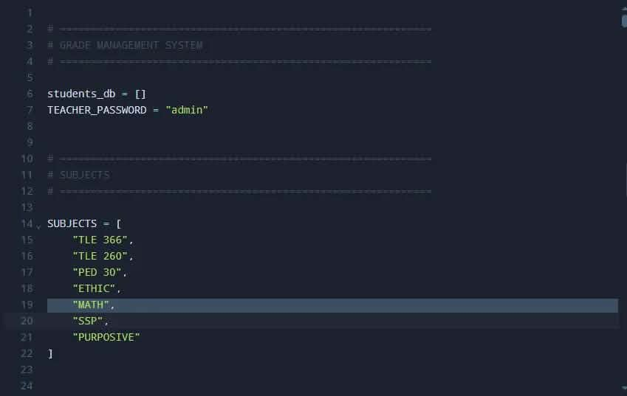
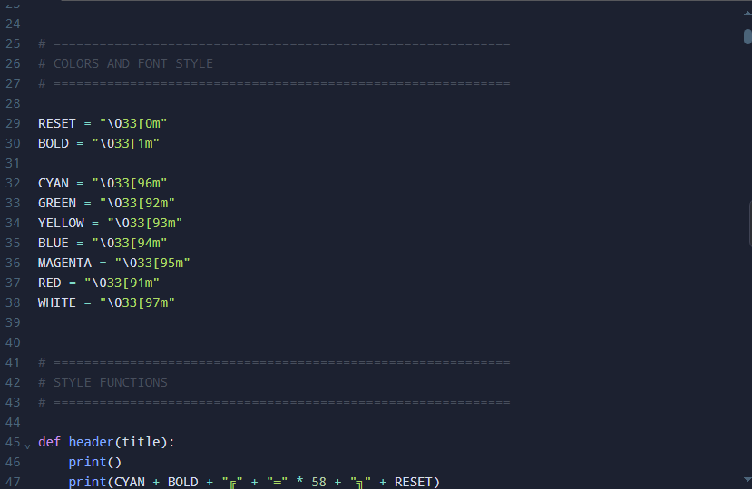

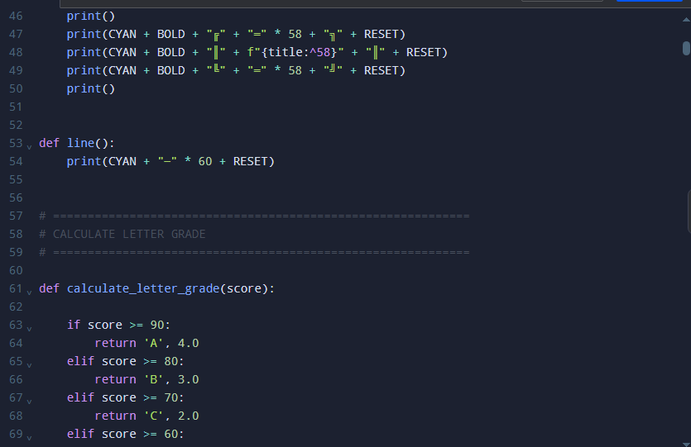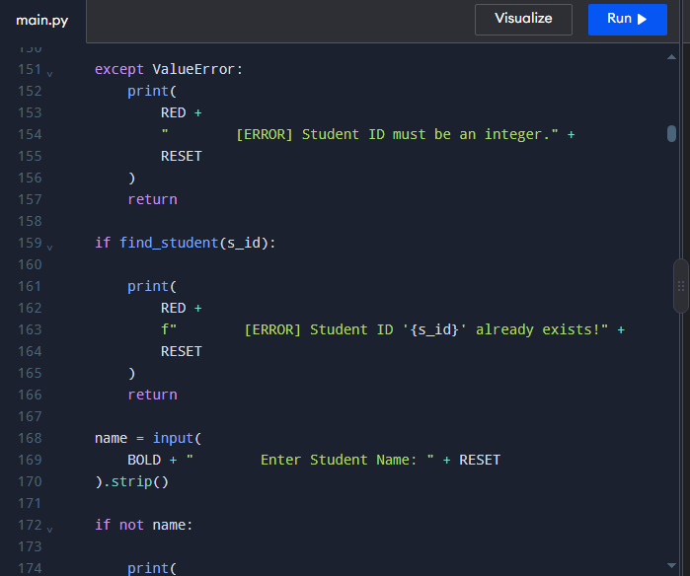

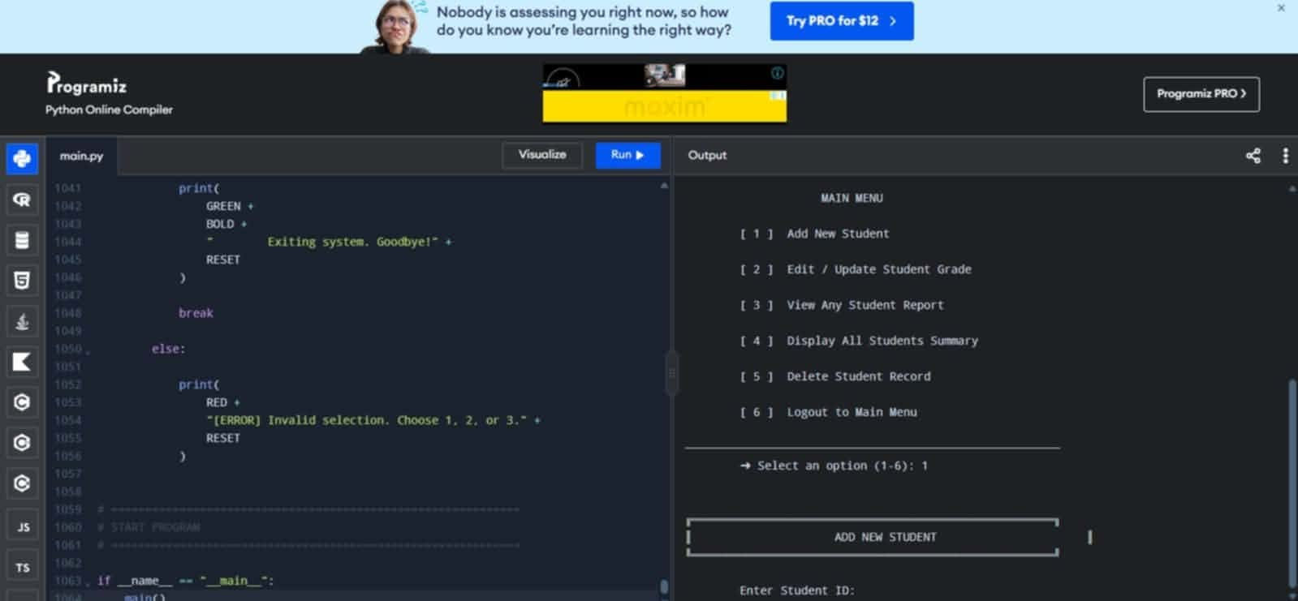

REFERENCE

Al-Emran, M., Mezhuyev, V., & Kamaludin, A. (2018). Technology Acceptance Modeling M-learning context: A systematic review. Computers & Education, 125, 389-412. https://doi.org/10.1016/j.compedu.2018.06.008
Espinosa, G. S., Serrano, M. R., & Balmes, H. A. (2024). Automated enrollment queueing system in a university towards student experience and operational efficiency. MSEUF Research Studies, 21(1). https://ejournals.ph/article.php?id=24562
Hwang, G. J., Xie, H., Wah, B. W., & Gašević, D. (2021). Vision, challenges, and impacts of achieving quality education with AI. Proceedings of the AAAI Conference on Artificial Intelligence, 35(17), 15433-15437. https://doi.org/10.1609/aaai.v35i17.17624
Maala, R. F., Sebua, N. B., & Evangelista, K. L. L. (2023). Queuing management system in Manuel S. Enverga University Foundation Candelaria Inc. International Journal of Advanced Research in Computer Science, 14(6), 44-53. https://doi.org/10.26483/ijarcs.v14i6.7039
Wang, Y., Liu, C., & Tu, Y. F. (2022). Factors affecting students' intention to continue using cloud-based learning platforms. Interactive Learning Environments, 30(5), 845-860. https://doi.org/10.1080/10494820.2020.1739075
Yawson, D. E., & Yamoah, F. A. (2020). Gender variability in E-learning utility essentials: Evidence from a multi-generational higher education cohort. Computers in Human Behavior, 114, 106558. https://doi.org/10.1016/j.chb.2020.106558
​Al-Adwan, A., Al-Adwan, A. S., & Smedley, J. (2020). Exploring students' acceptance of e-learning using Technology Acceptance Model in Jordanian universities. International Journal of Education and Development using ICT, 9(2).

